Lesson 6: Fingers and 10-frames
- Let’s show numbers on our fingers and 10-frames.

Warm-up: How Many Do You See: 5 and Some More
How many do you see?
How do you see them?



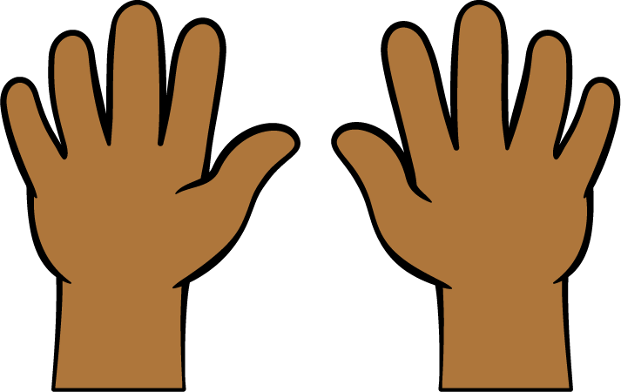

6.2: Fingers to 10-frames




6.3: Revisit Number Race, Numbers 11–20
Choose a center.
Number Race
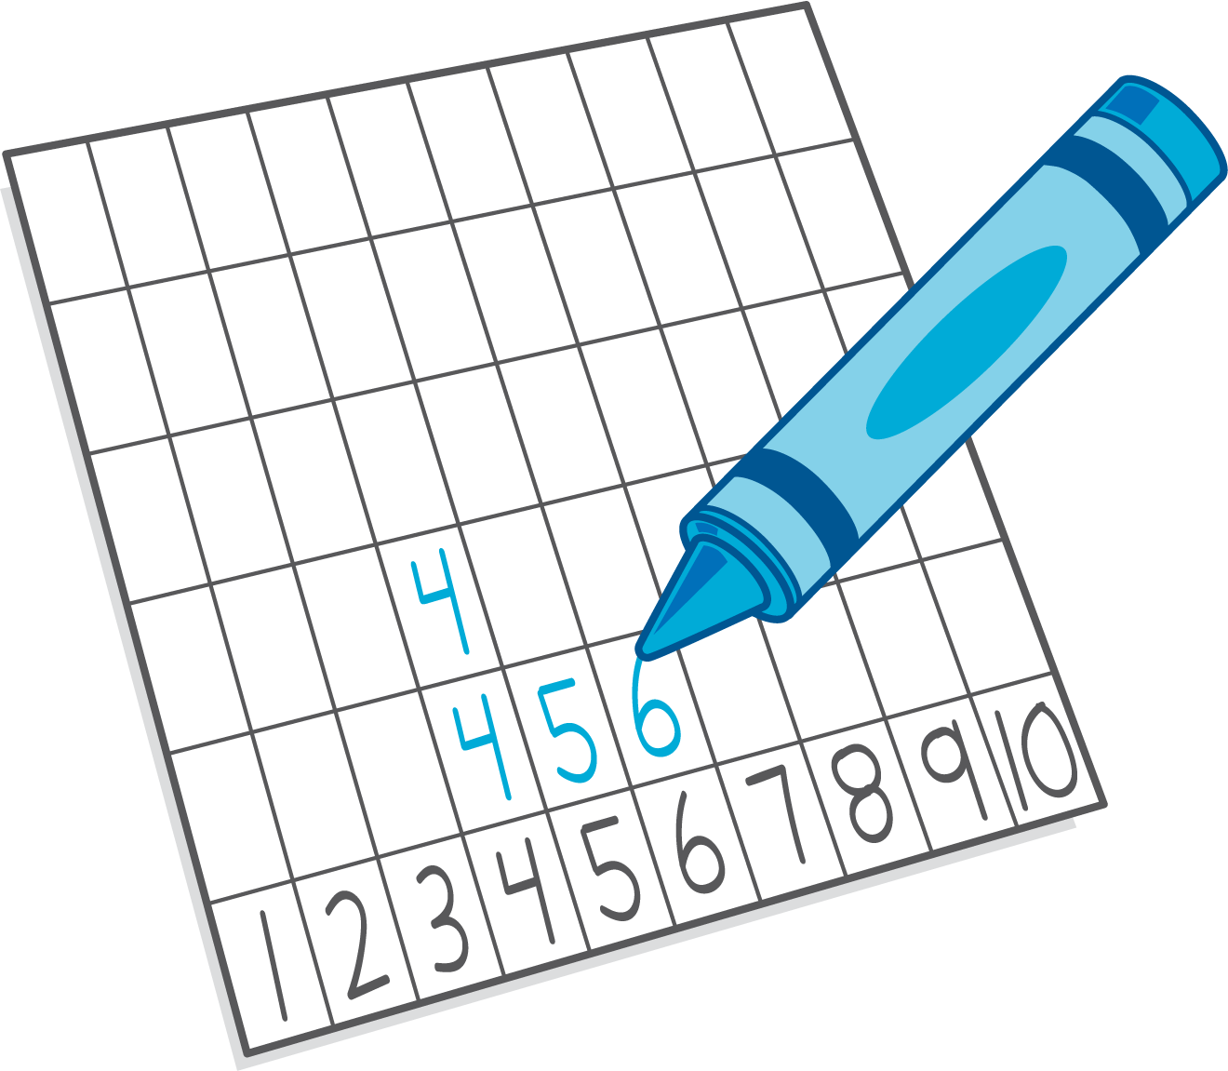
Grab and Count
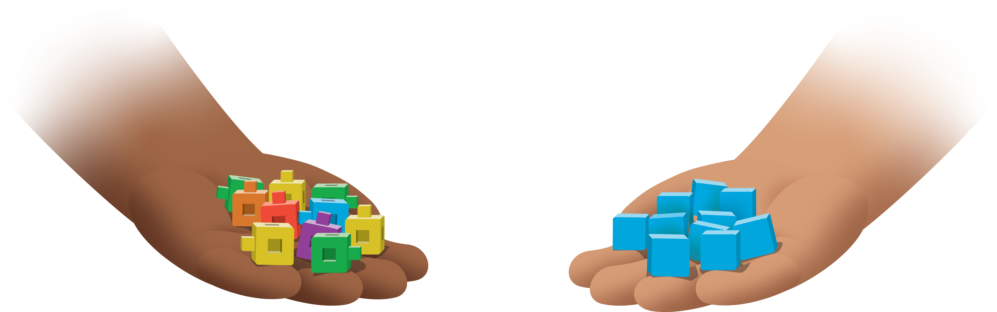
Find the Pair
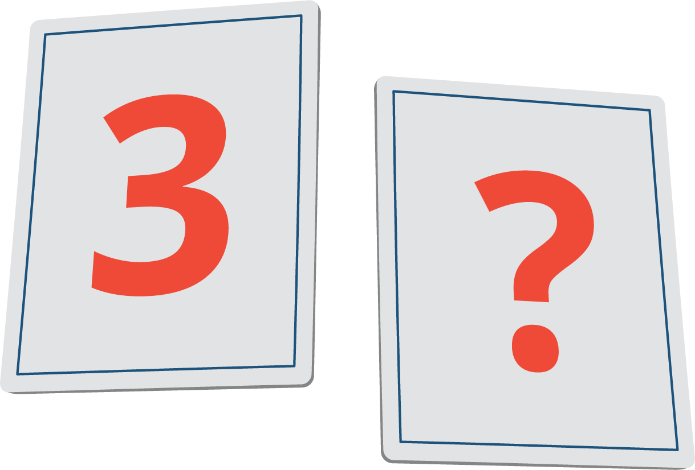
Tower Build
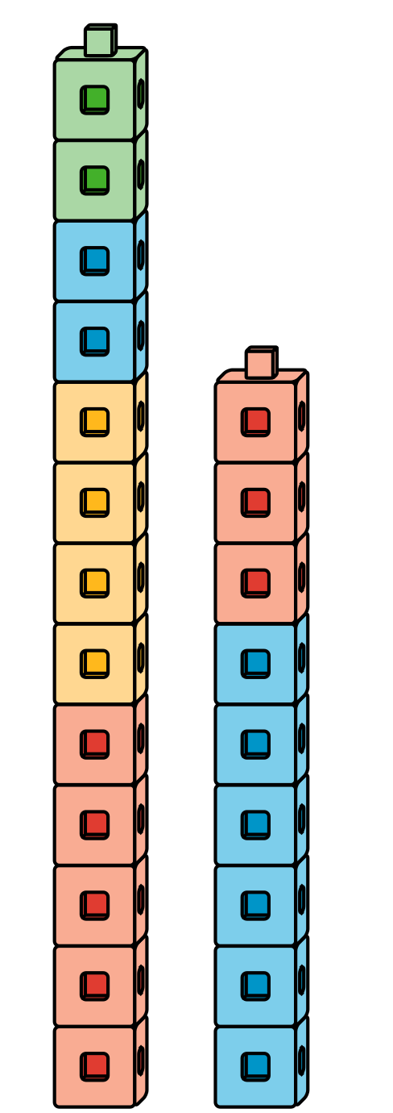
© CC BY 2021 Illustrative Mathematics®

