Algebra 1
Unit 5Lesson 11CC BY NC 2024 Illustrative Mathematics®
Unit 5, Lesson 11

Domain and Range (Part 2)
- Let’s analyze graphs of functions to learn about their domain and range.
Algebra 1
Unit 5Lesson 11CC BY NC 2024 Illustrative Mathematics®

11.1Which Three Go Together: Unlabeled Graphs
Which three go together? Why do they go together?

A
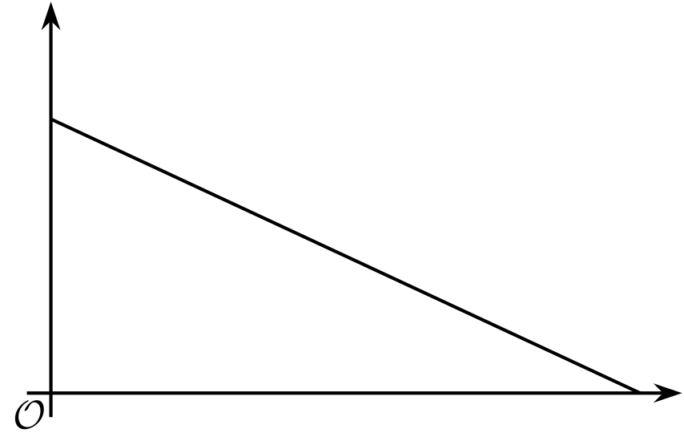

B
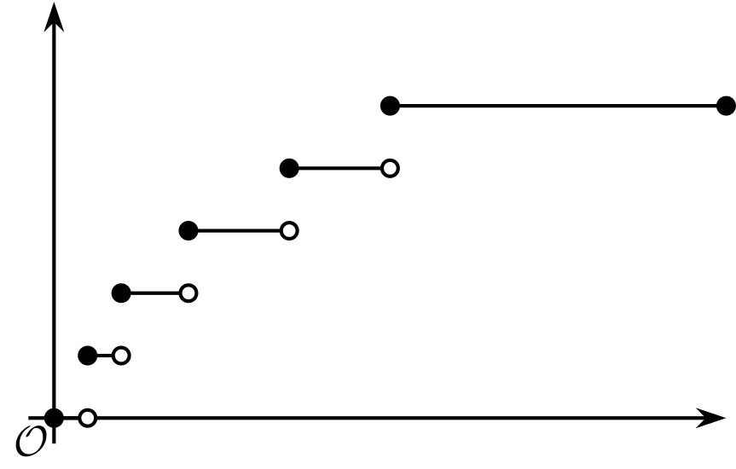

C
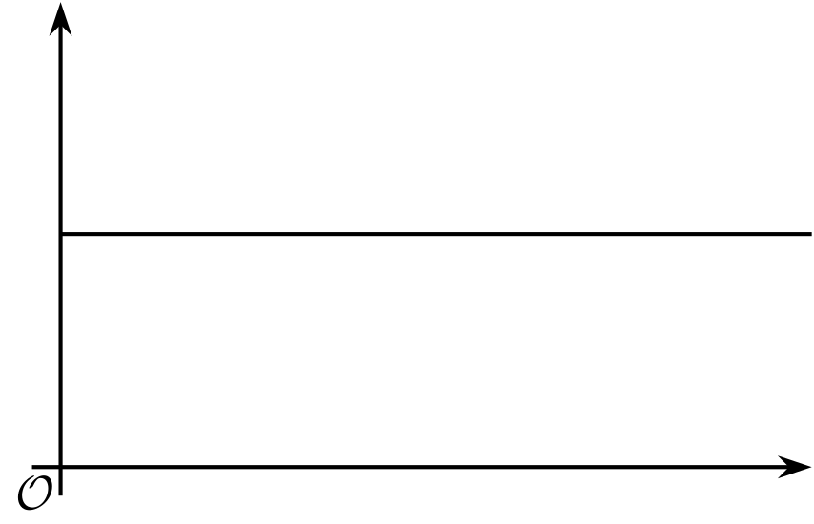

D
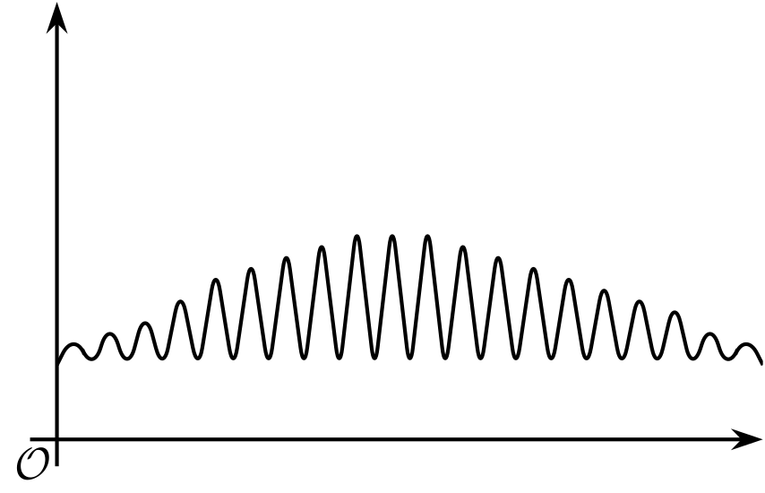
Algebra 1
Unit 5Lesson 11CC BY NC 2024 Illustrative Mathematics®

11.2Time on the Swing
A child gets on a swing in a playground, swings for 30 seconds, and then gets off the swing.
- Here are descriptions of four functions in the situation and four graphs representing them.
- The independent variable in each function is time, measured in seconds.
- 
- Match each function with a graph that could represent it. Then, label the axes with the appropriate variables. Be prepared to explain how you make your matches.
  - Function $h$: the height of the swing, in feet, as a function of time since the child gets on the swing
  - Function $r$: the amount of time left on the swing as a function of time since the child gets on the swing
  - Function $d$: the distance, in feet, of the swing from the top beam (from which the swing is suspended) as a function of time since the child gets on the swing
  - Function $s$: the total number of times an adult pushes the swing as a function of time since the child gets on the swing

- A

- B
- ​​​​​​

- C

- D
- On each graph, mark one or two points that—if you have the coordinates—could help you determine the domain and range of the function. Be prepared to explain why you chose those points.
- Once you receive the information you need from your teacher, describe the domain and range that would be reasonable for each function in this situation.
Algebra 1
Unit 5Lesson 11CC BY NC 2024 Illustrative Mathematics®

11.3Back to the Bouncing Ball
A tennis ball was dropped from a certain height. It bounced several times, rolled along for a short period, and then stopped. Function $H$ gives its height over time.
Here is a partial graph of $H$. Height is measured in feet. Time is measured in seconds.
Use the graph to help you answer the questions.
Be prepared to explain what each value or set of values means in this situation.
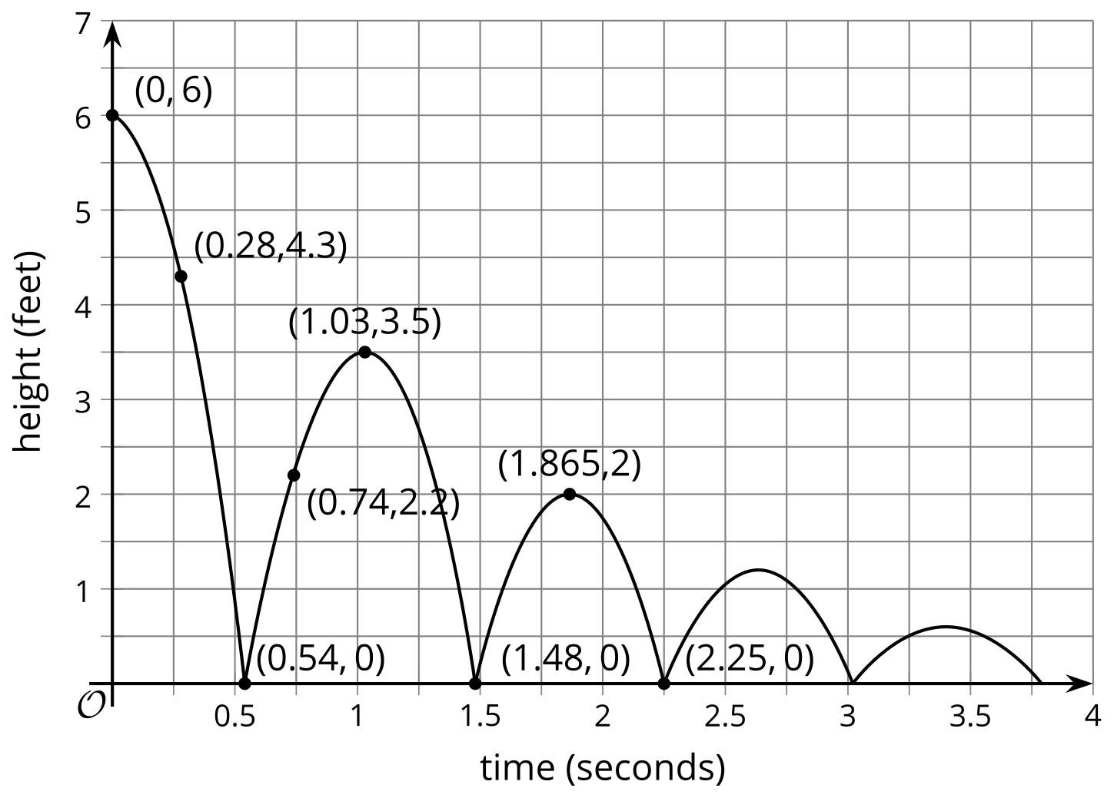
- Find $H\left(0\right)$.
- Solve $H\left(x\right)=0$.
- Describe the domain of the function.
- Describe the range of the function.

Are you ready for more?
In function $H$, the input was time in seconds and the output was height in feet.
Think about some other quantities that could be inputs or outputs in this situation.
- Describe a function whose domain includes only integers. Be sure to specify the units.
- Describe a function whose range includes only integers. Be sure to specify the units.
- Sketch a graph of each function.
- 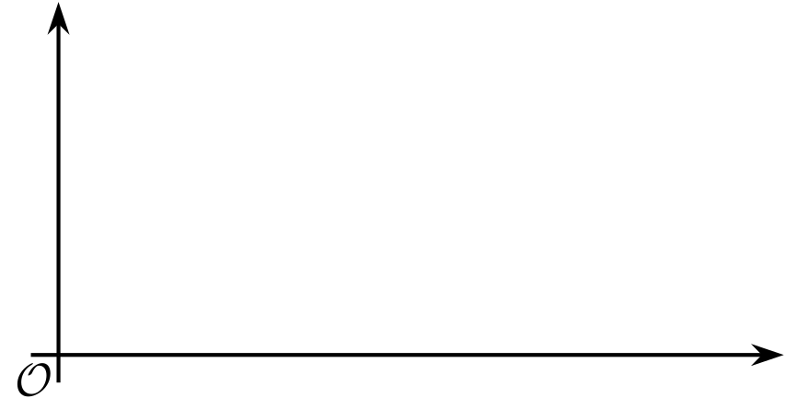

Lesson 11 Summary
The graph of a function can sometimes give us information about its domain and range.
Here are graphs of two functions we saw earlier in the unit. The first graph represents the best price of bagels as a function of the number of bagels bought. The second graph represents the height of a bungee jumper as a function of seconds since the jump began.
What are the domain and range of each function?
The number of bagels cannot be negative but does include 0 (no bagels bought). The domain of the function, therefore, includes 0 and positive whole numbers, or $n≥0$.
The best price can be $0 (for buying 0 bagels), certain multiples of $1.25, certain multiples of $6, and so on. Because the values don’t follow a pattern that is simple to write, the values for the range would need to be listed in this way to match the graph: 0, 1.25, 2.5, 3.75, 5, 6, 6.25, . . . .
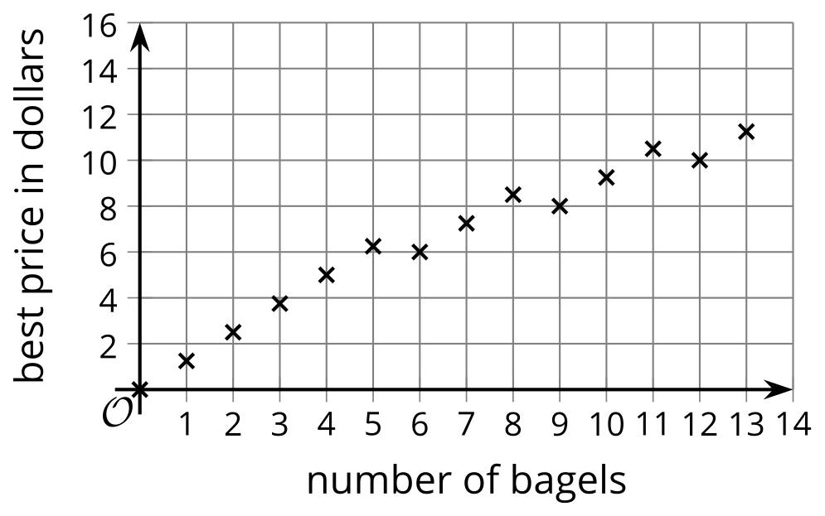
The domain of the height function would include any amount of time since the jump began, up until the jump is complete. From the graph, we can tell that the jump is complete more than 70 seconds after ​​​​​​the jump began, but we don't know the exact value of $t$.
The graph shows a maximum height of 80 meters and a minimum height of 10 meters. We can conclude that the range of this function includes all values that are at least 10 and at most 80.
