## Unit 4 Lesson 11: Drawings to Represent Story Problems

### WU Which One Doesn’t Belong: Butterflies (Warm up)

#### Student Task Statement

Which one doesn’t belong?

A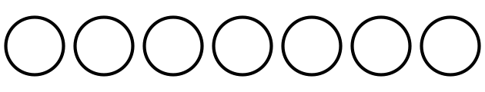

B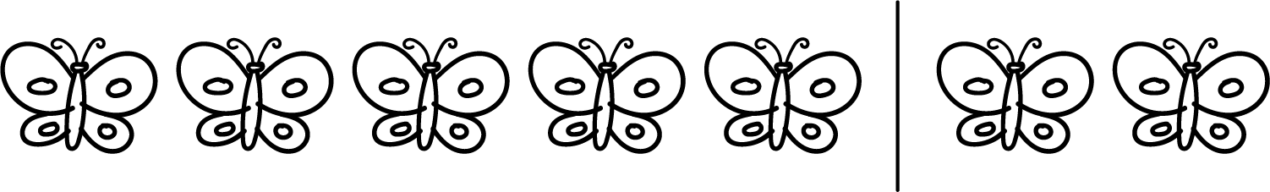

C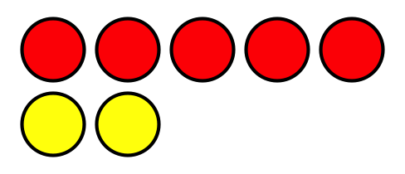

D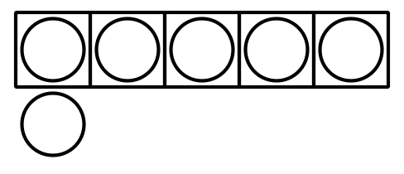

### 1 Draw a Picture

#### Student Task Statement

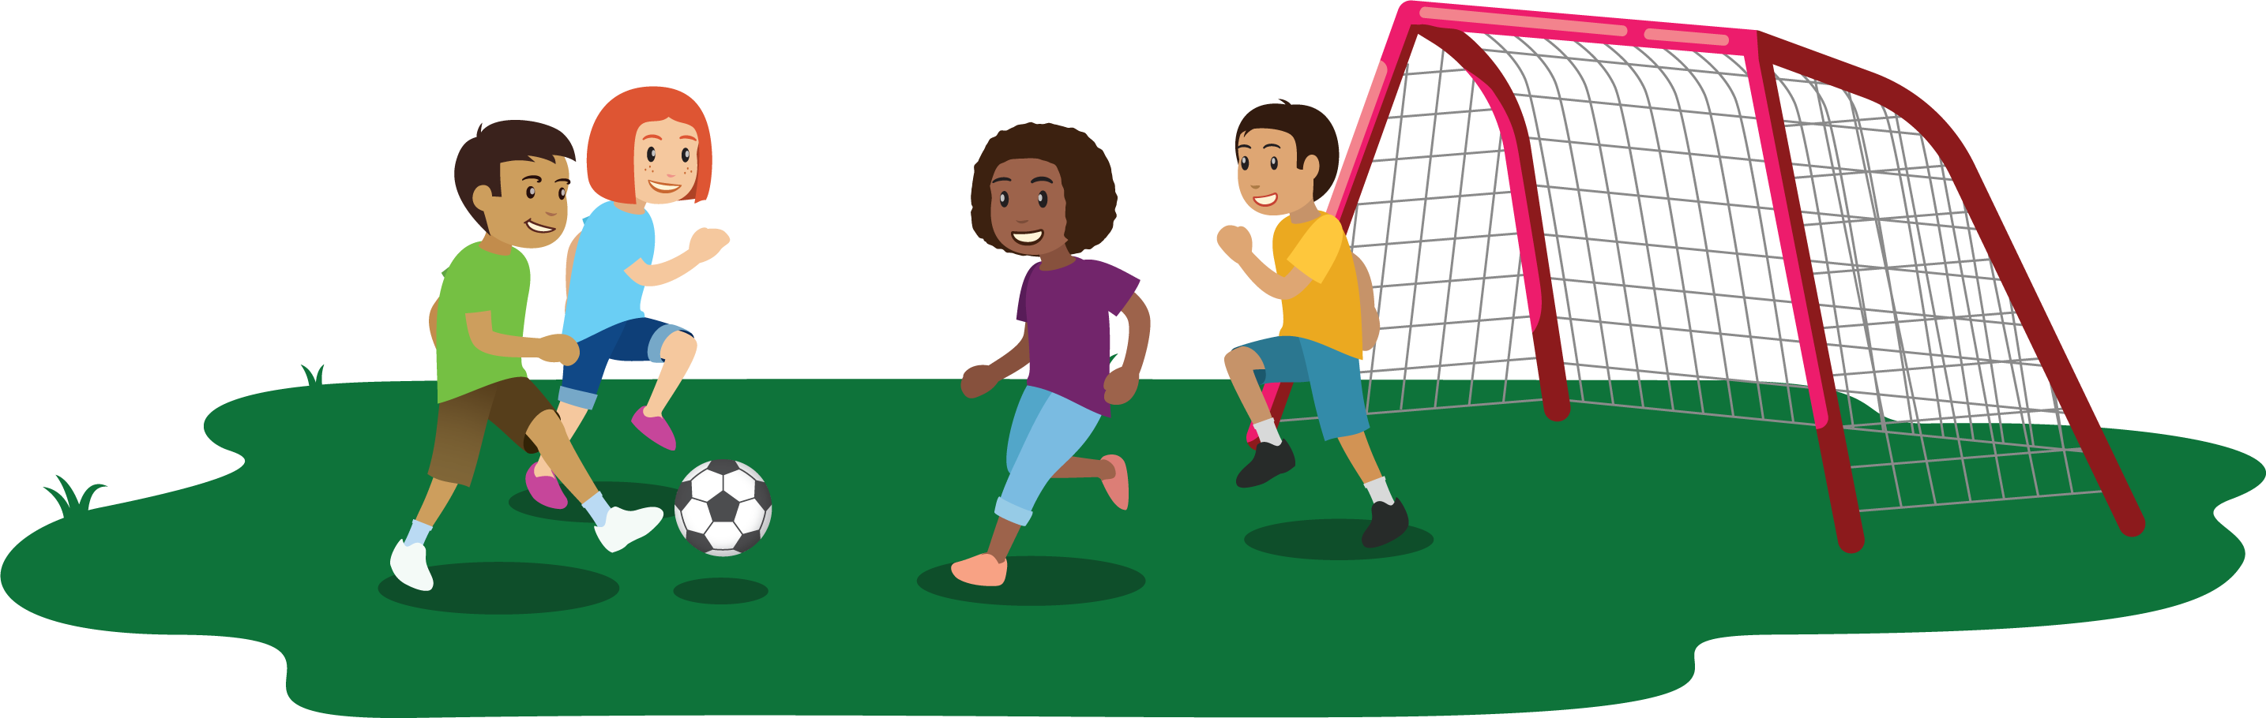

There were 7 kids playing soccer in the park.

3 of the kids left to go play on the swings.

How many kids are playing soccer in the park now?

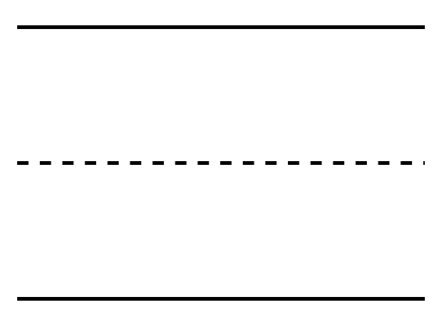

### 2 Picture Gallery Walk

#### Student Task Statement

### 3 Centers: Choice Time

#### Student Task Statement

Choose a center.

Bingo

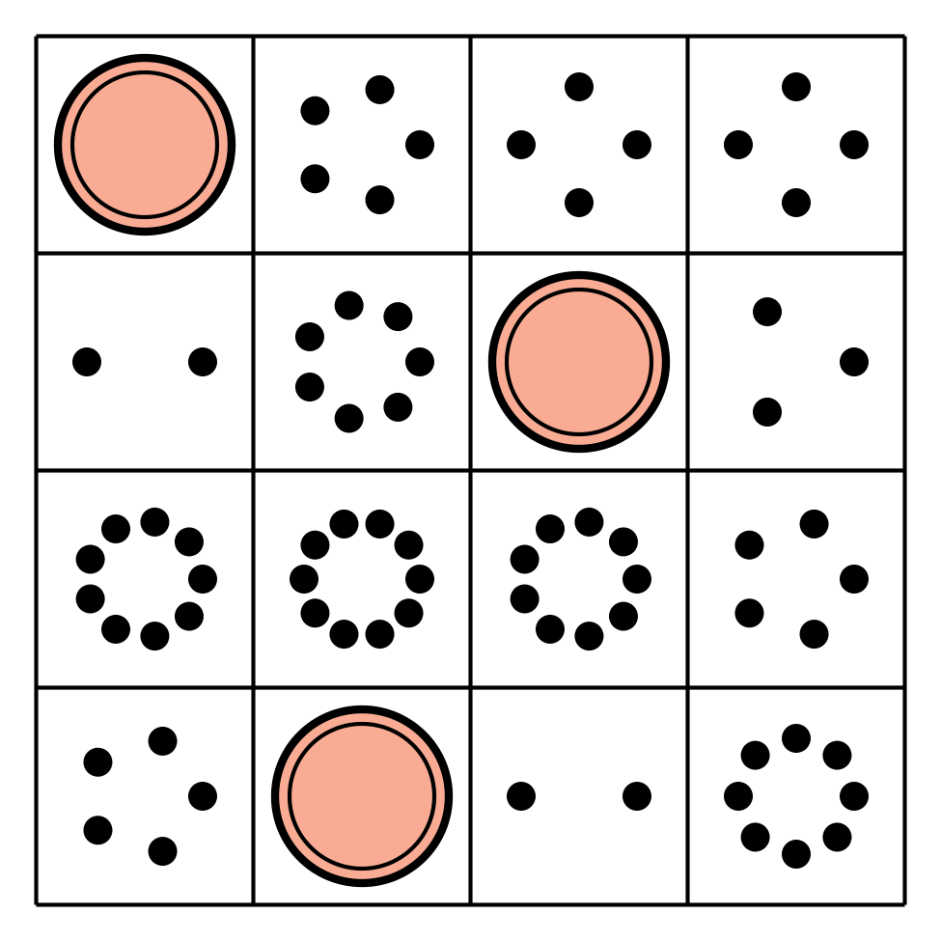

Math Fingers



Subtraction Towers

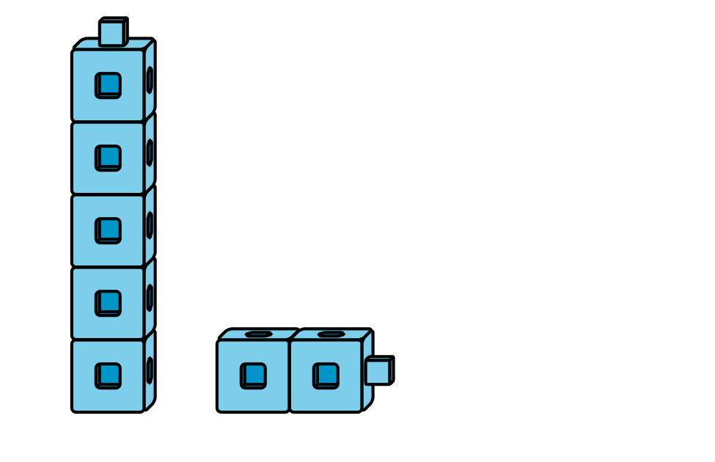

5-frames

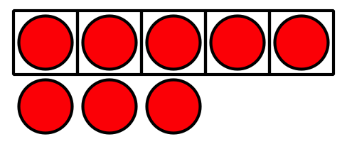

Math Stories



Counting Collections

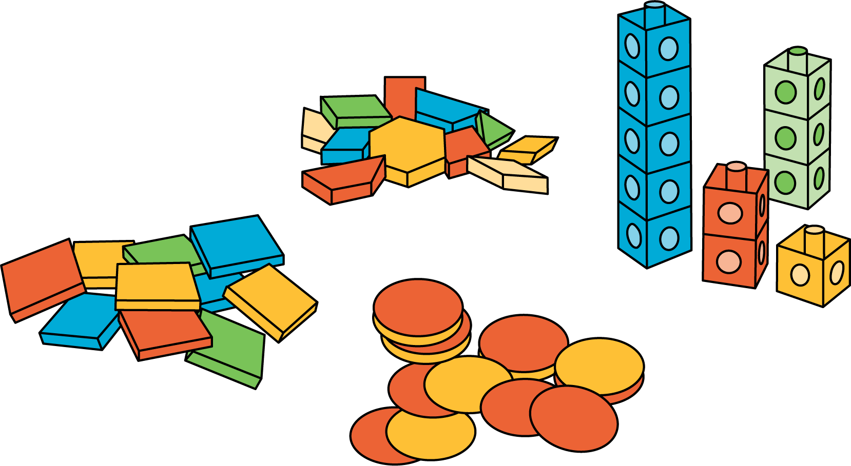



© CC BY 2021 Illustrative Mathematics®