Lesson 7: Solve Both Addends Unknown Story Problems
- Let’s solve story problems.

Warm-up: Which One Doesn’t Belong: Decompose with Math Tools
Which one doesn’t belong?
A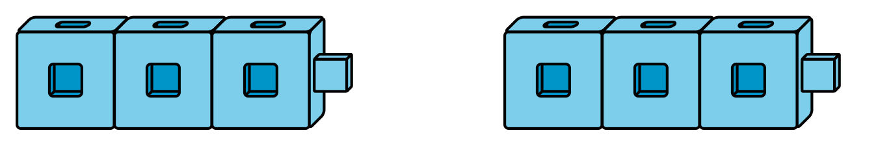
B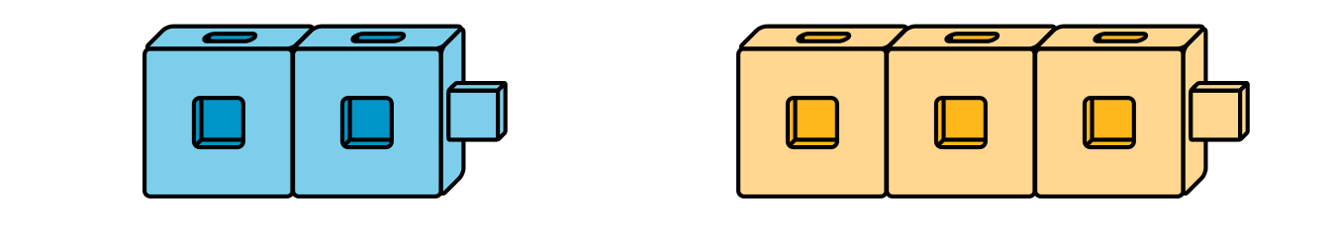
C
D

7.1: Fruit for Paletas
Jada made 6 paletas with her brother.
They made two flavors, lime and coconut.
How many of the paletas were lime?
Then how many of the paletas were coconut?
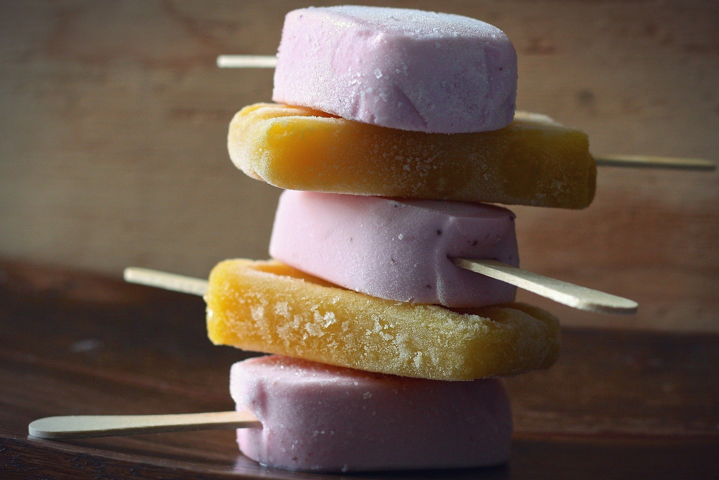

7.2: Pomegranates
Kiran had 7 pomegranates in his bag.
He put some of the pomegranates on the shelf.
He put the rest of the pomegranates in a basket.
How many of the pomegranates were on the shelf?
Then how many of the pomegranates were in the basket?
Expression: _________________________________
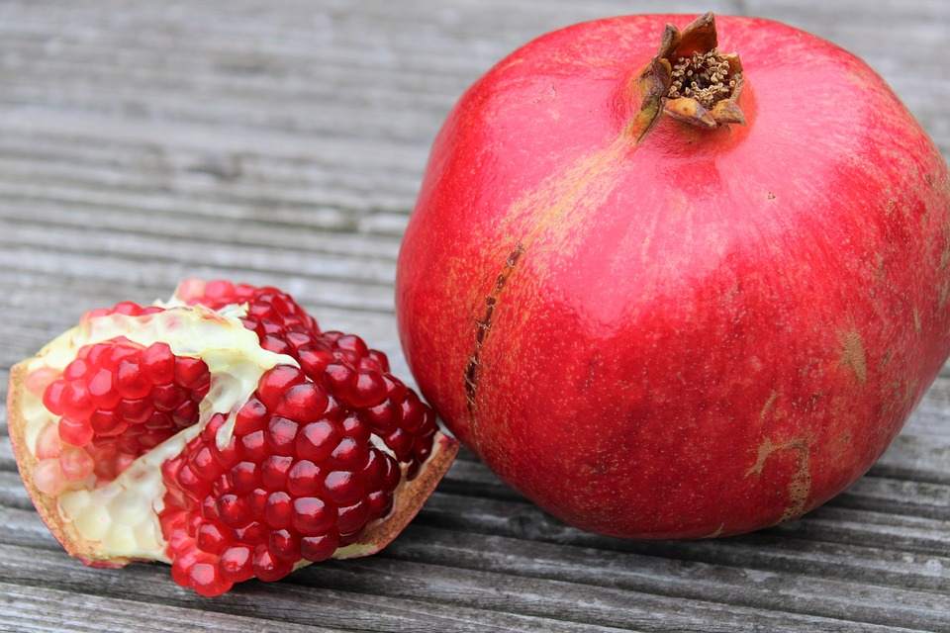

7.3: Introduce Math Stories, How Many of Each?
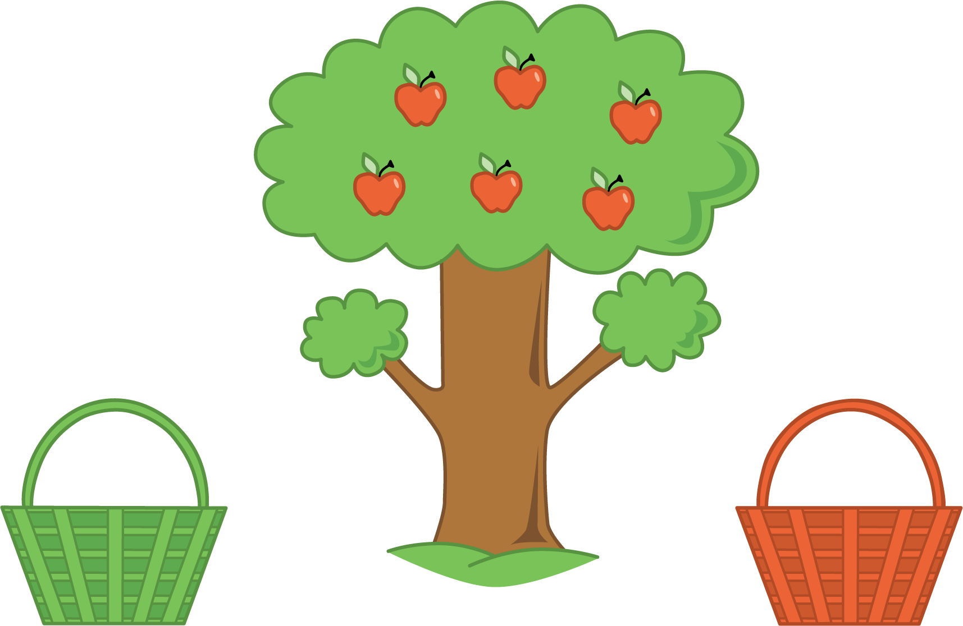
Choose a center.
What’s Behind My Back?
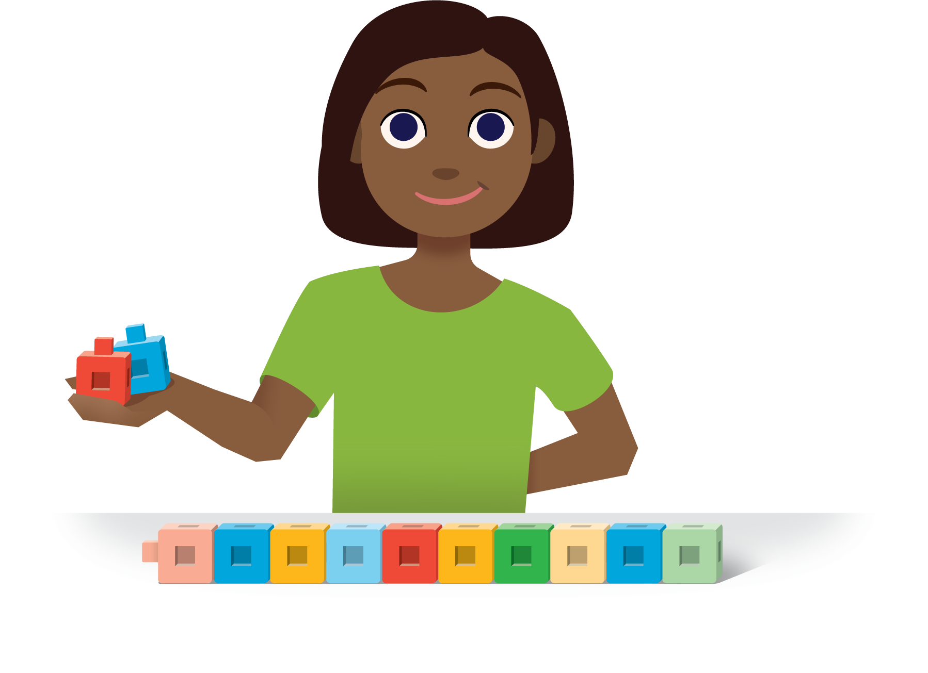
5-frames
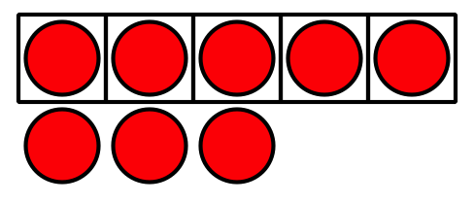
Make or Break Apart Numbers
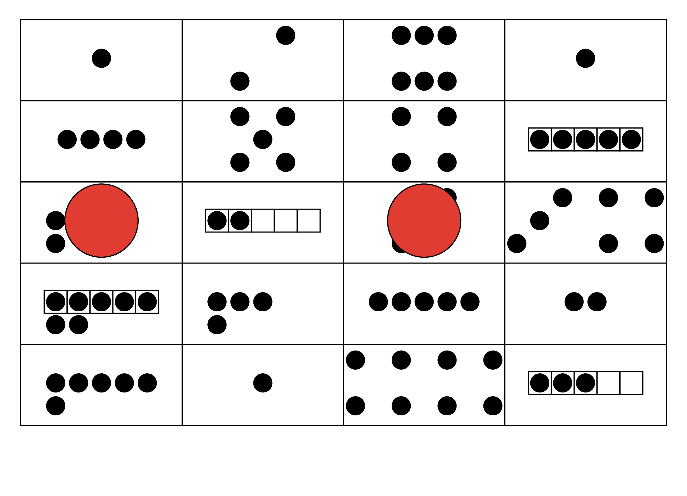
Math Stories
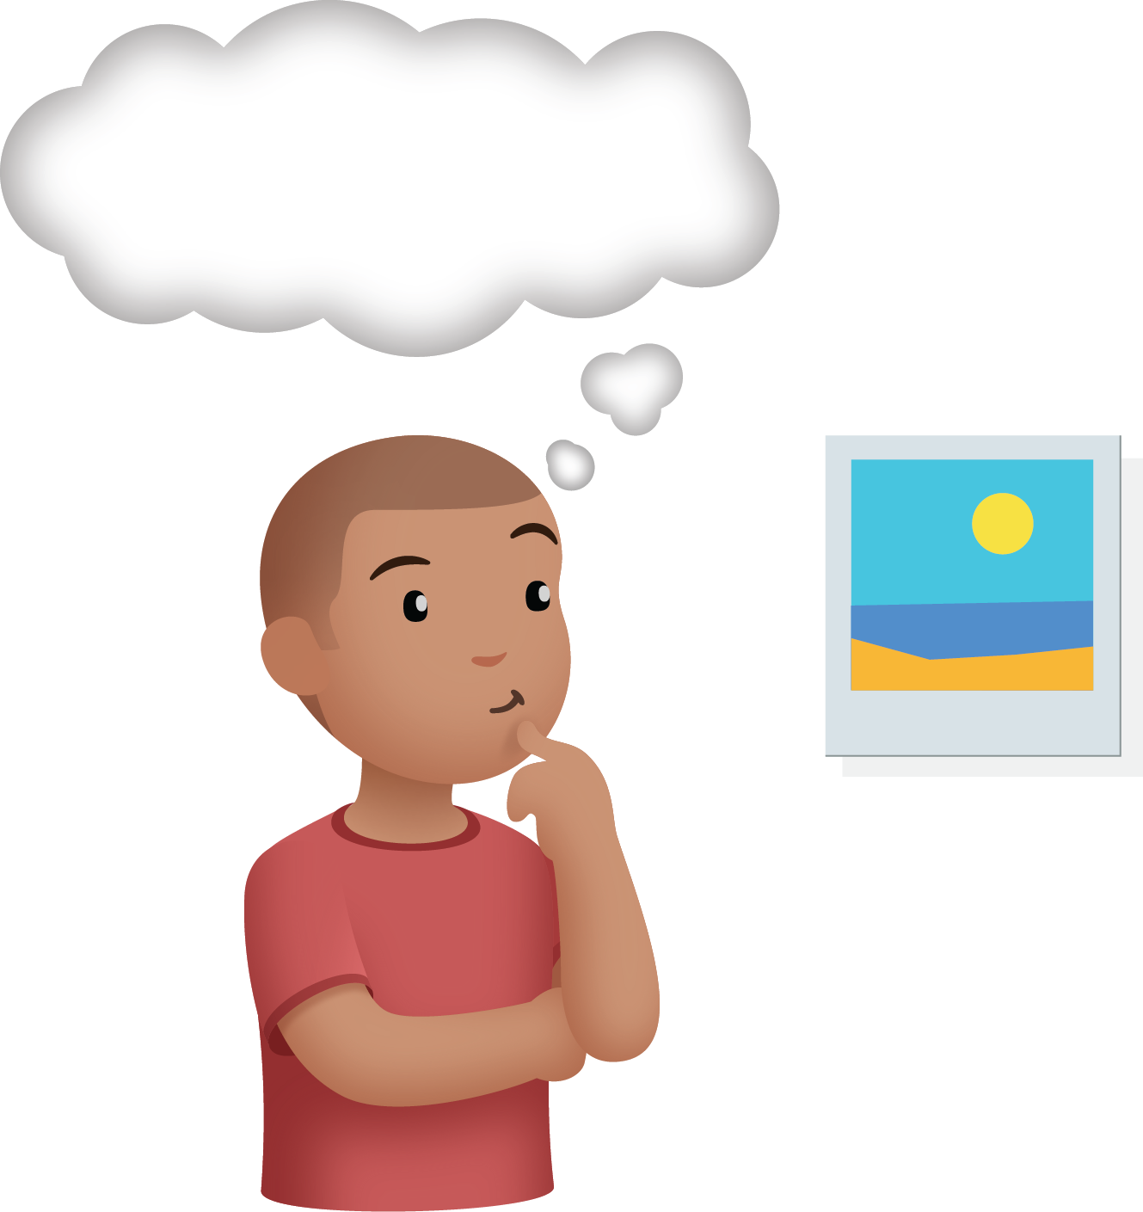
© CC BY 2021 Illustrative Mathematics®

