Grade 2
Unit 6Lesson 18CC BY NC 2024 Illustrative Mathematics®
Unit 6, Lesson 18

Money Problems
- Let’s solve money problems.
Grade 2
Unit 6Lesson 18CC BY NC 2024 Illustrative Mathematics®

Warm-up How Many Do You See: Groups of Coins
How many do you see? How do you see them?
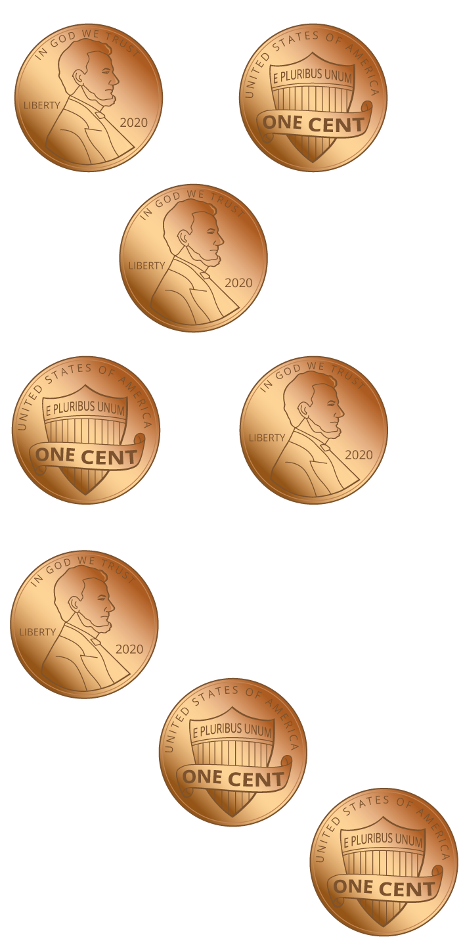
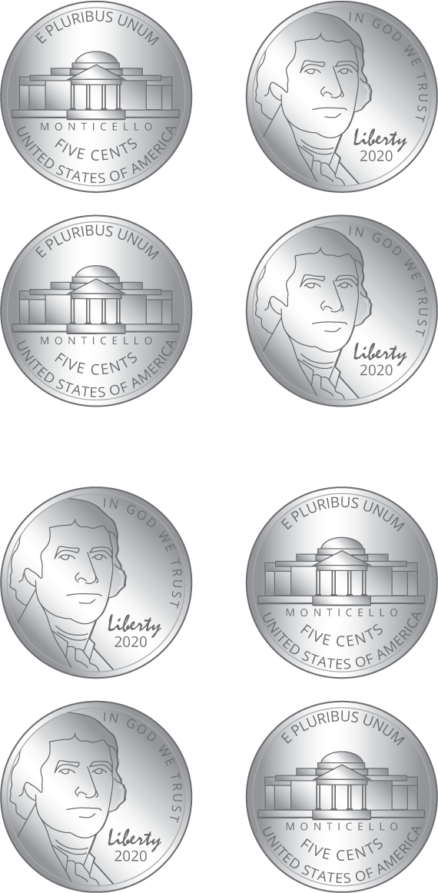
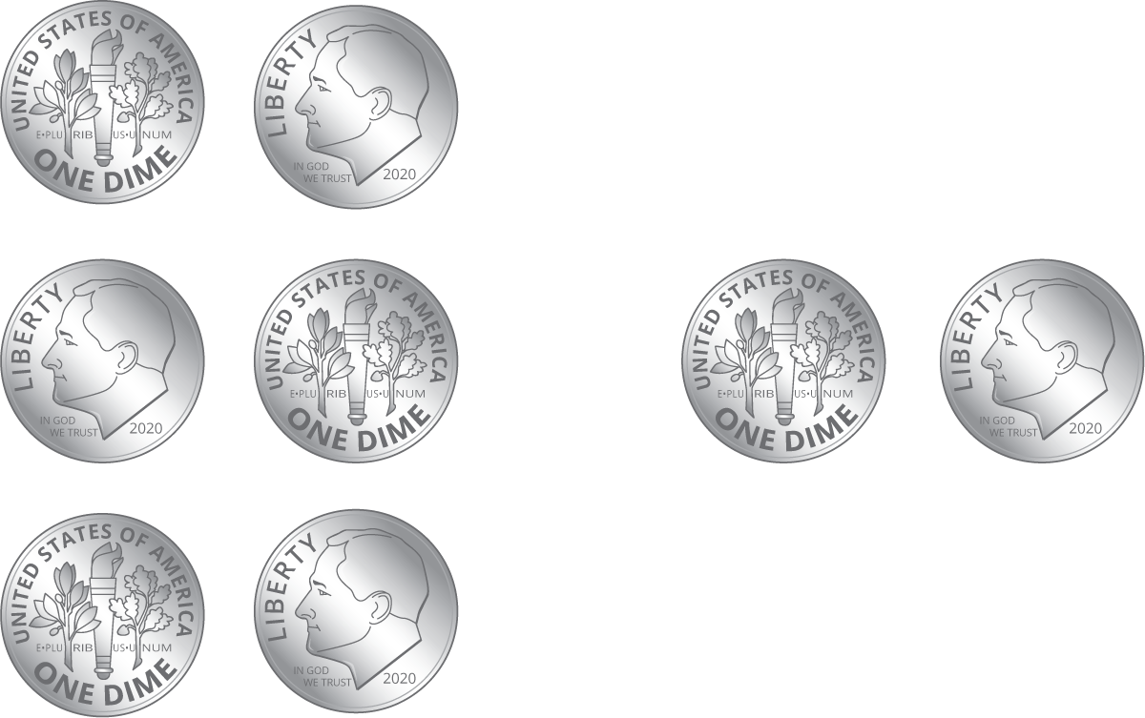
Grade 2
Unit 6Lesson 18CC BY NC 2024 Illustrative Mathematics®

Activity 1 Shop for School Supplies
items | cost
pack of pencils | 75¢
pencil sharpener | 35¢
eraser | 45¢
pen | 18¢
- Lin has these coins.
- 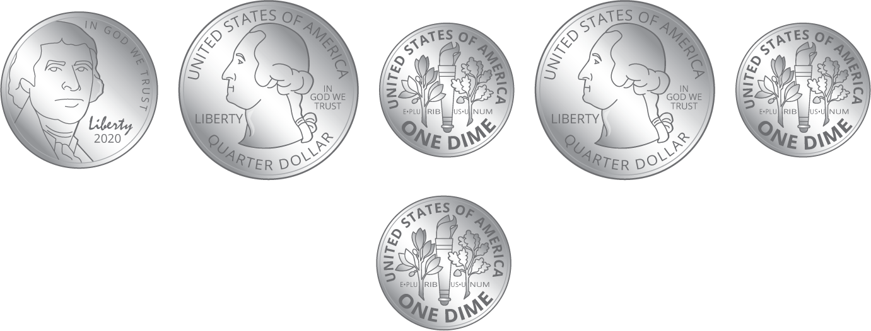
- Lin buys an eraser. How much money does she have left? Show your thinking, using drawings, numbers, or words.
- Diego has these coins.
- 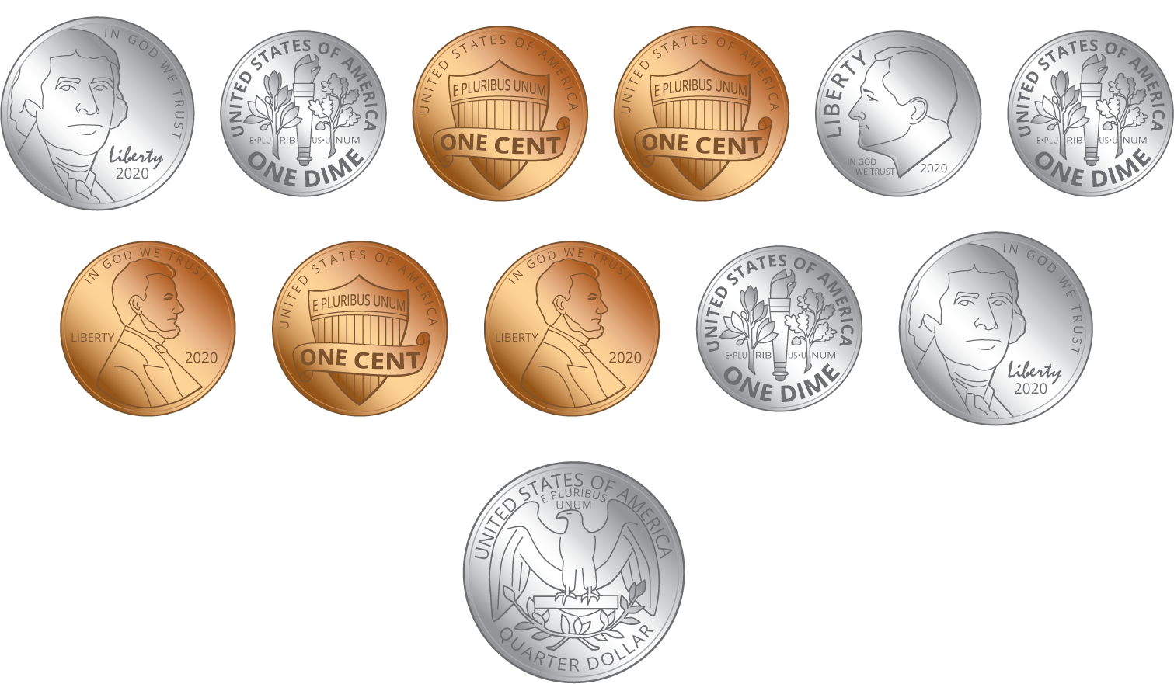
- Diego buys a pack of pencils. How much money does he have left? Show your thinking, using drawings, numbers, or words.
Grade 2
Unit 6Lesson 18CC BY NC 2024 Illustrative Mathematics®

Activity 2 Shop with a Dollar
Show your thinking, using drawings, numbers, or words.
supplies | cost
notebook | 26¢
colored pencils | 18¢
pencil box | 39¢
glue stick | 44¢
- Clare has $1. She buys a pencil box and colored pencils. How much money does she have left?
- Tyler has $1. He buys a notebook and a pencil box. How much money does he have left?
- Andre has $1. He wants to buy a glue stick, a pencil box, and colored pencils. Does he have enough money?

