Grade 6
Unit 3Lesson 5CC BY NC Illustrative Mathematics, based on IM 6–8 Math, CC BY Open Up Resources.
Unit 3, Lesson 5

Interpreting Rates
Let’s explore unit rates.
Grade 6
Unit 3Lesson 5CC BY NC Illustrative Mathematics, based on IM 6–8 Math, CC BY Open Up Resources.

5.1Math Talk: Division and Fractions
Decide mentally whether each statement is true.
- $5÷10=0.5$
- $\frac{5}{20}=0.25$
- $4÷20=\frac{2}{5}$
- $\frac{4}{20}=0.2$
Grade 6
Unit 3Lesson 5CC BY NC Illustrative Mathematics, based on IM 6–8 Math, CC BY Open Up Resources.

5.2Cooking Kinche
Priya and Han are making kinche for a breakfast event at school. The instructions for a large batch of kinche say, “Bring 15 cups of water to a boil. Then add 6 cups of crushed wheat.”
- Priya says, “The ratio of cups of wheat to cups of water is $6:15$. That’s 0.4 cup of wheat per cup of water.”
- Han says, “The ratio of cups of water to cups of wheat is $15:6$. That’s 2.5 cups of water per cup of wheat.”
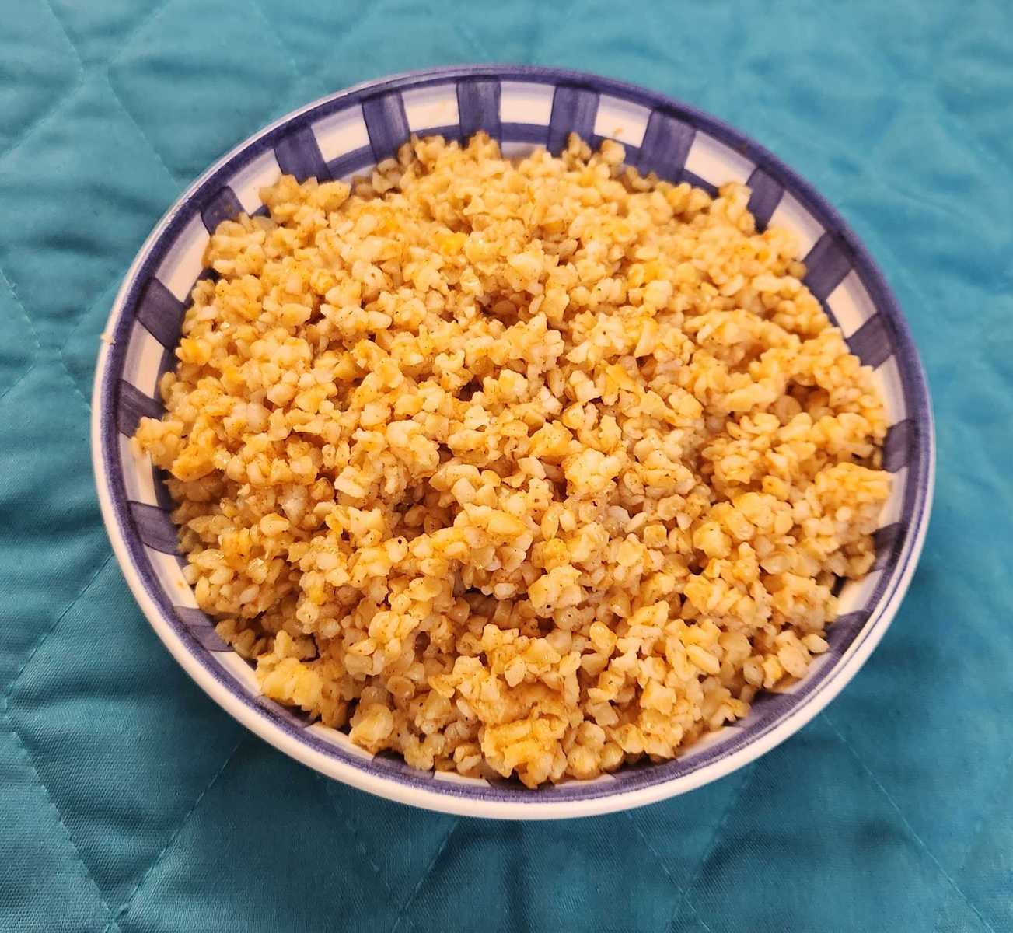
- Who is correct? Explain your reasoning. If you get stuck, consider using the table.
- water (cups) | - wheat (cups)
- 15 | - 6
- 1
 | - 1
- Priya and Han are each making a pot of kinche.
  - Priya has 5 cups of wheat. How many cups of water should she boil? Show your reasoning.
  - Han boils 10 cups of water. How many cups of wheat should he add into the water? Show your reasoning.
Grade 6
Unit 3Lesson 5CC BY NC Illustrative Mathematics, based on IM 6–8 Math, CC BY Open Up Resources.

5.3Laundry Detergent and Raffle Tickets
For each situation, find the unit rates. Then choose a unit rate to solve the problem in part c. Show your reasoning.
- A laundry service uses 10 gallons of detergent every 6 weeks.
  - How many gallons of detergent does the laundry service use per week?
  - How many weeks does it take the laundry service to use 1 gallon of detergent?
  - How many weeks will it take the laundry service to finish 3 gallons of detergent?
- Tyler paid $16 for 4 raffle tickets.
  - What is the price per ticket?
  - How many tickets is that per dollar?
  - How much would 1,000 raffle tickets cost?

Are you ready for more?
Write a “deal” on tickets for Tyler’s raffle that sounds good, but is actually a little worse than just buying tickets at the normal price.

Lesson 5 Summary
Suppose a farm lets us pick 2 pounds of blueberries for 5 dollars. We can say:
- We get $\frac{2}{5}$ pound of blueberries per dollar.
- The blueberries cost $\frac{5}{2}$ or $2\frac{1}{2}$dollars per pound.
The “price per pound of blueberries” and the “weight of blueberries per dollar” are the two unit rates describing this situation.
weight of blueberries  (pounds) | price  (dollars)
2 | 5
1 | $\frac{5}{2}$
$\frac{2}{5}$ | 1
A unit rate tells us how much of one quantity for 1 of the other quantity. Each of these numbers is useful in the right situation.
If we want to find out how much 8 pounds of blueberries will cost, it helps to know how much 1 pound of blueberries will cost.
weight of blueberries  (pounds) | price  (dollars)
1 | $\frac{5}{2}$
8 | $8⋅\frac{5}{2}$
If we want to find out how many pounds we can buy for 10 dollars, it helps to know how many pounds we can buy for 1 dollar.
weight of blueberries  (pounds) | price  (dollars)
$\frac{2}{5}$ | 1
$10⋅\frac{2}{5}$ | 10
Which unit rate is most useful depends on what question we want to answer, so be ready to find either one!

