Unit 7 Lesson 10: Interpret Relationships

WU True or False: Multiply and Divide (Warm up)

Student Task Statement
Decide if each statement is true or false. Be prepared to explain your reasoning.
- $276÷3=\frac{1}{3}×276$
- $276÷3=\frac{276}{6}$
- $\left(276÷3\right)×2=\frac{2}{3}×276$

1 Mix and Match: 3 Patterns

Student Task Statement
- Complete the patterns for each set of rules.
- What are some relationships between the patterns for each set of rules? Be prepared to explain your thinking.
Set A
Rule 1: Start at 0. Keep adding 3.

Rule 2: Start at 0. Keep adding 6.
Set B
Rule 1: Start at 4. Keep adding 3.
Rule 2: Start at 9. Keep adding 6.
Set C
Rule 1: Start at 0. Keep adding 5.
Rule 2: Start at 0. Keep adding 3.

2 Generate Patterns

Student Task Statement
Partner A
- Generate patterns for the two rules.
- Rule 1: Start with 0. Keep adding 4.
- 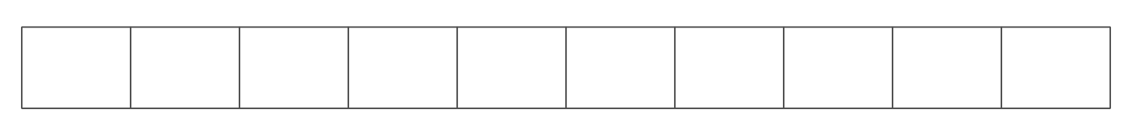
- Rule 2: Start with 0. Keep adding 6.
- Compare your patterns. What relationships do you notice?
- What number will be in pattern 2 when the number in the pattern 1 box is 40?
- What number will be in pattern 1 when the number in the pattern 2 box is 120?
Partner B
- Generate patterns for the two rules.
- Rule 1: Start with 0. Keep adding 2.
- Rule 2: Start with 0. Keep adding 3.
- Compare your patterns. What relationships do you notice?
- What number will be in pattern 2 when the number in the pattern 1 box is 30?
- What number will be in pattern 1 when the number in the pattern 2 box is 60?
© CC BY 2021 Illustrative Mathematics®

