Grade 2
Unit 7Lesson 7CC BY NC 2024 Illustrative Mathematics®
Unit 7, Lesson 7

Compose a Greater Unit
- Let’s add 3-digit numbers and compose tens or hundreds.
Grade 2
Unit 7Lesson 7CC BY NC 2024 Illustrative Mathematics®

Warm-up How Many Do You See: Are They the Same?
How many do you see? How do you see them?
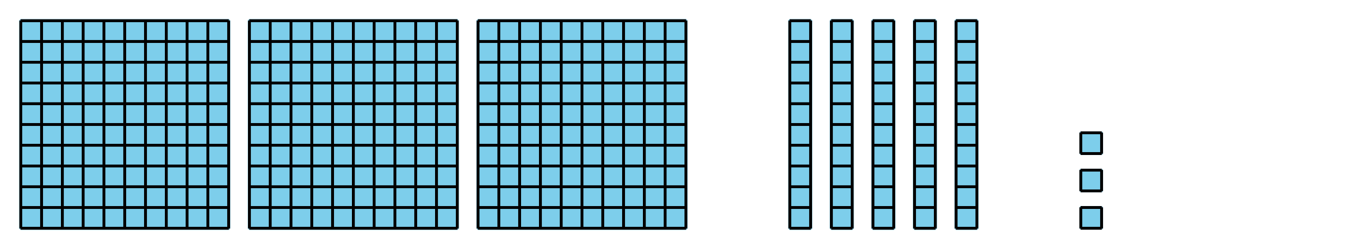
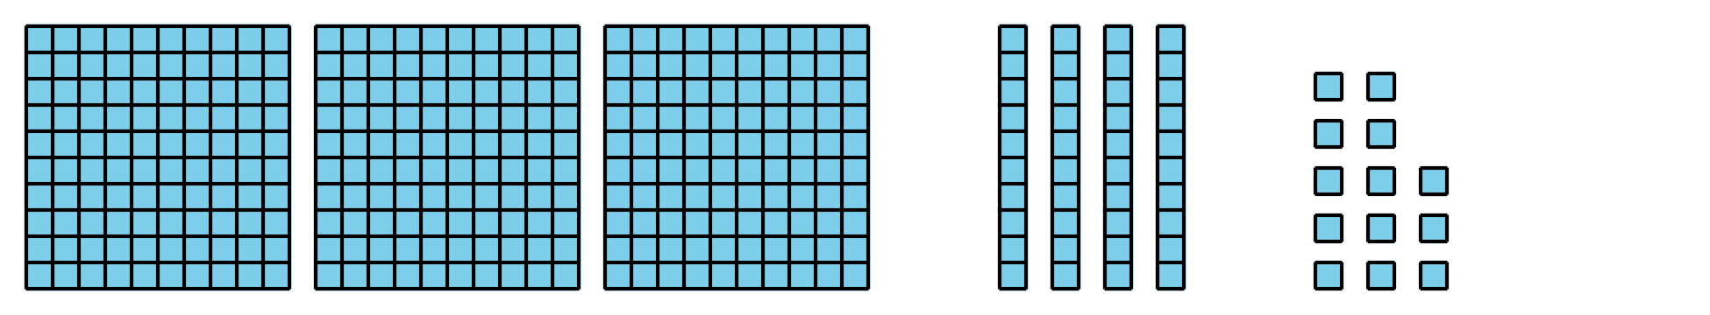
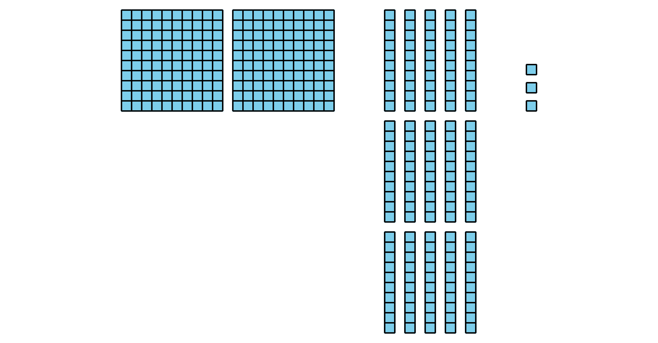
Grade 2
Unit 7Lesson 7CC BY NC 2024 Illustrative Mathematics®

Activity 1 Compose a Ten or a Hundred
- Find the value of each expression. Show your thinking, using objects, drawings, numbers, or words.
  - $364+28$
  - $364+82$
- Compare your thinking with your partner.
Grade 2
Unit 7Lesson 7CC BY NC 2024 Illustrative Mathematics®

Activity 2 Walk about and Add
Work with a partner.
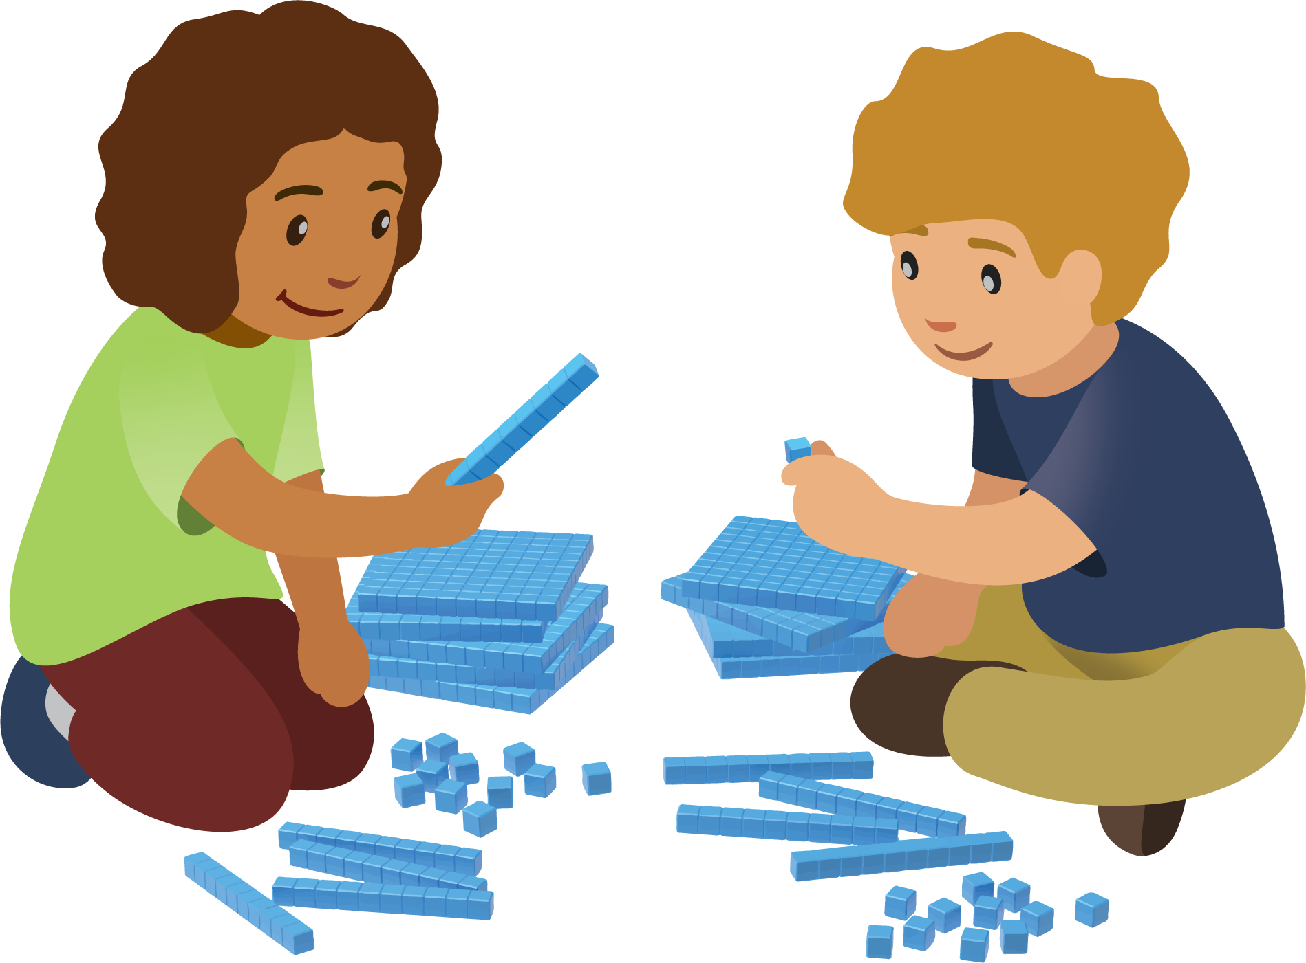

  - Record your numbers to make an expression.
  - ______________ + ______________
  - Do you need to compose a ten?
  - Yes or No
  - Do you need to compose a hundred?
  - Yes or No
  - Find the value of the sum. Show your thinking, using drawings, numbers, or words.

  - Record your numbers to make an expression.
  - ______________ + ______________
  - Do you need to compose a ten?
  - Yes or No
  - Do you need to compose a hundred?
  - Yes or No
  - Find the value of the sum. Show your thinking, using drawings, numbers, or words.

  - Record your numbers to make an expression.
  - ______________ + ______________
  - Do you need to compose a ten?
  - Yes or No
  - Do you need to compose a hundred?
  - Yes or No
  - Find the value of the sum. Show your thinking, using drawings, numbers, or words.

