Lesson 8: Interpretemos gráficas de dibujos

Standards Alignments
Building On | 1.OA.C.5, 2.MD.D.10
Addressing | 2.MD.D.10

Teacher-facing Learning Goals
- Answer questions based on a picture graph.
- Determine whether a question can be answered by a given picture graph.
- Interpret data represented in a picture graph.

Student-facing Learning Goals
- Respondamos preguntas usando gráficas de dibujos.

Lesson Purpose
The purpose of this lesson is for students to read and interpret a picture graph, which is a standard way of representing data.
In the previous lesson, students looked at different ways to organize data to make it easier to ask and answer questions about data. In this lesson, students are introduced to a picture graph as a way to represent data. Throughout the lesson, students make sense of the structure and features of a picture graph as they consider what they can learn from a picture graph and the types of questions a picture graph can and cannot be used to answer. They use picture graphs to answer questions about how many are in a category as well as questions that ask them to combine or compare categories.

Access for:

Students with Disabilities
- Representation (Activity 2)

English Learners
- MLR8 (Activity 1)

Instructional Routines
How Many Do You See? (Warm-up)

Lesson Timeline
Warm-up | 10 min
Activity 1 | 20 min
Activity 2 | 15 min
Lesson Synthesis | 10 min
Cool-down | 5 min

Teacher Reflection Question
Reflect on who participated in math class today. What assumptions are you making about those who did not participate? How can you leverage each of your students’ ideas to support them in being seen and heard in tomorrow’s math class?

Cool-down
(to be completed at the end of the lesson) 5min
Usa una gráfica de dibujos

Standards Alignments
Addressing | 2.MD.D.10

Student-facing Task Statement
A un grupo de estudiantes les preguntaron: “¿Cuál es su mascota favorita?”. Sus respuestas se muestran en esta gráfica de dibujos.
- Marca las 2 preguntas que se pueden responder con la gráfica de dibujos.
  - ¿Cuántos estudiantes escogieron un gato como su mascota favorita?
  - ¿Cuántos estudiantes más prefieren los conejos que los perros?
  - ¿Quién tiene una lagartija?
  - ¿Cuántos estudiantes más escogieron gatos que perros?
  - ¿Por qué los perros no les gustan a más estudiantes?
- Escoge una pregunta que no se pueda responder con los datos en la gráfica. Explica por qué no se puede responder.
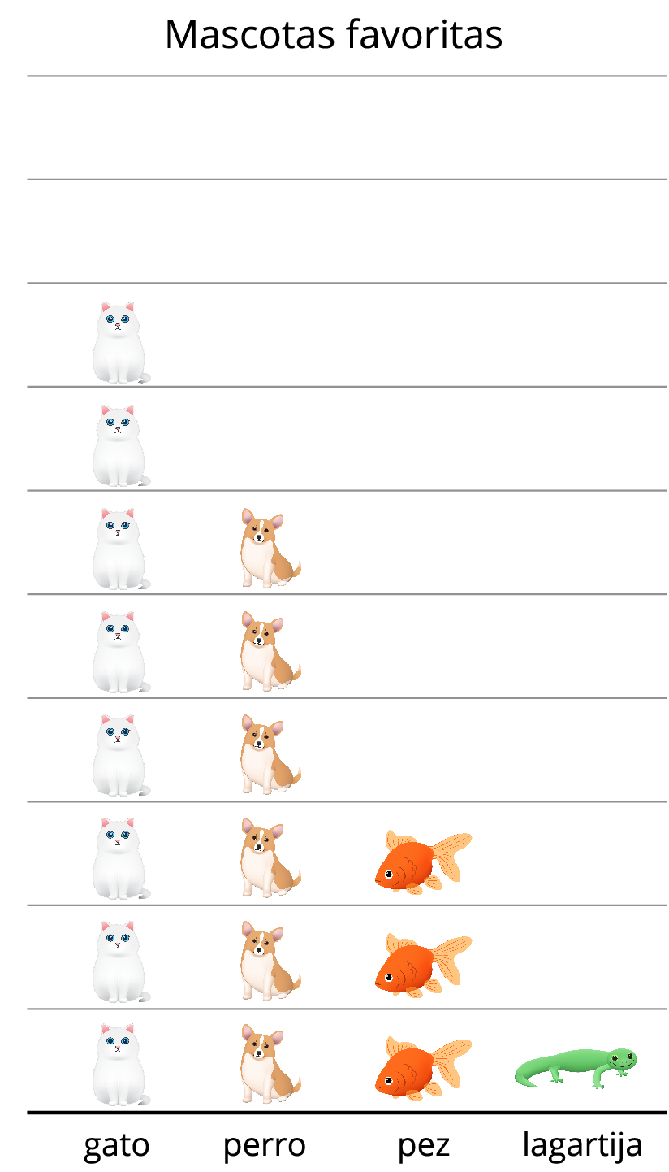

Student Responses
- A, D
- For B, the graph doesn’t tell us the number of rabbits.
For C, the graph doesn’t tell us the names of the owners.
For E, the graph doesn’t tell us why the students choose their pets.

