Unit 4 Lesson 1: Describing Graphs

1 Notice and Wonder: A Rocket Path (Warm up)

Student Task Statement

A rocket is shot into the air and some aspects of its flight are shown in the graph.
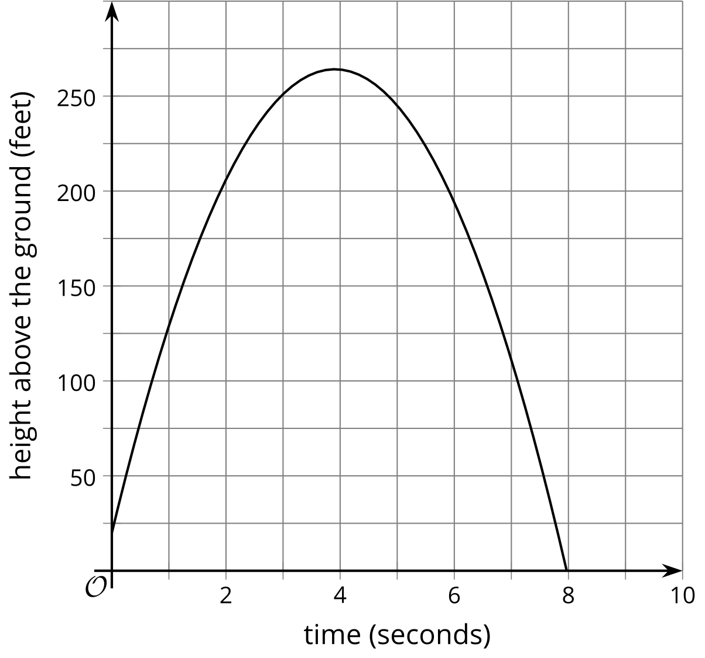
What do you notice? What do you wonder?

2 Matching Descriptions and Graphs

Student Task Statement
Match the graph to the description of the situation.
Match each description in column A with a graph from column B that represents the situation. Be prepared to explain your reasoning.
- Take turns with your partner to match a description with a graph.
  - For each match that you find, explain to your partner how you know it’s a match.
  - For each match that your partner finds, listen carefully to their explanation. If you disagree, discuss your thinking and work to reach an agreement.
- Mai begins at home and walks away from her home at a constant rate.
- Jada begins at a neighbor’s house and walks away from home at a constant rate.
- Clare begins her walk at school and walks home at a constant rate.
- Elena begins at home and runs away from her home at a constant rate.
- Lin begins at home and walks away from home for a while, then walks back home.
- Priya begins at home and runs away from home, then walks for a while.

A
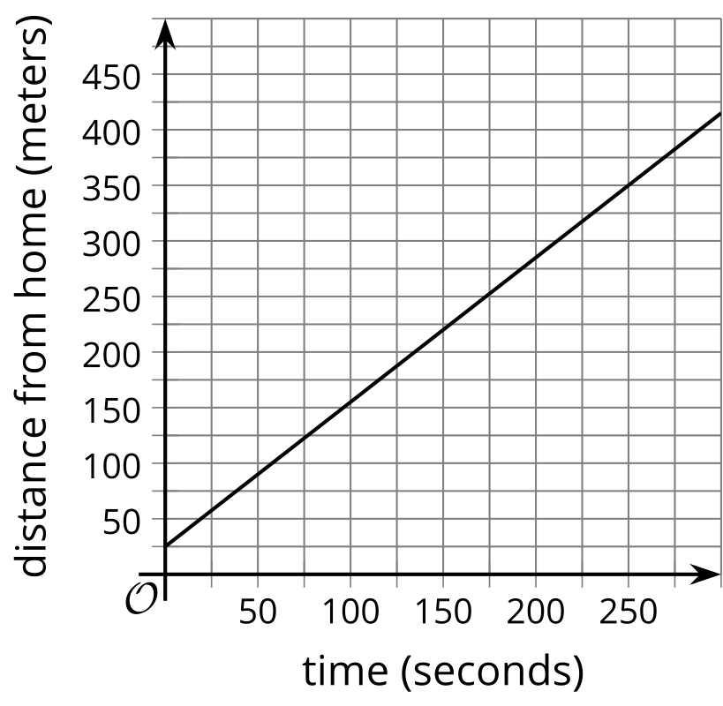

B
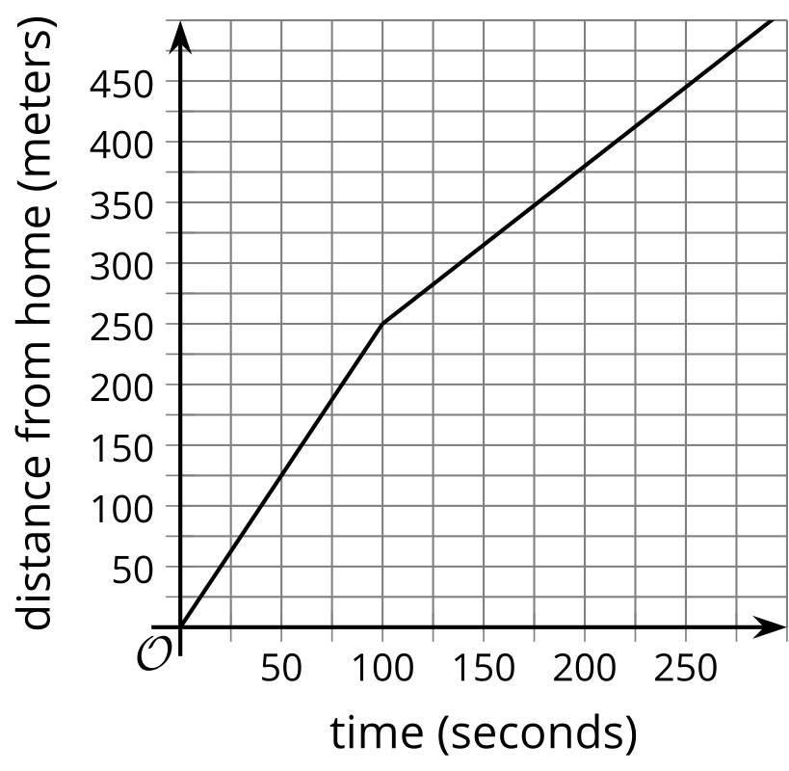

C
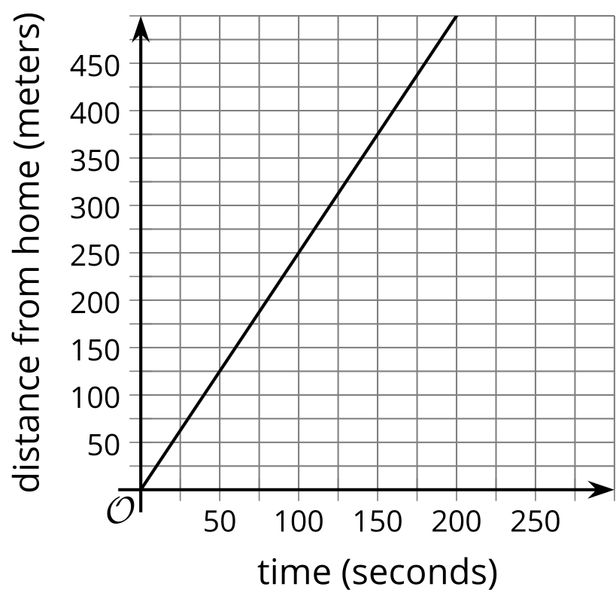

D
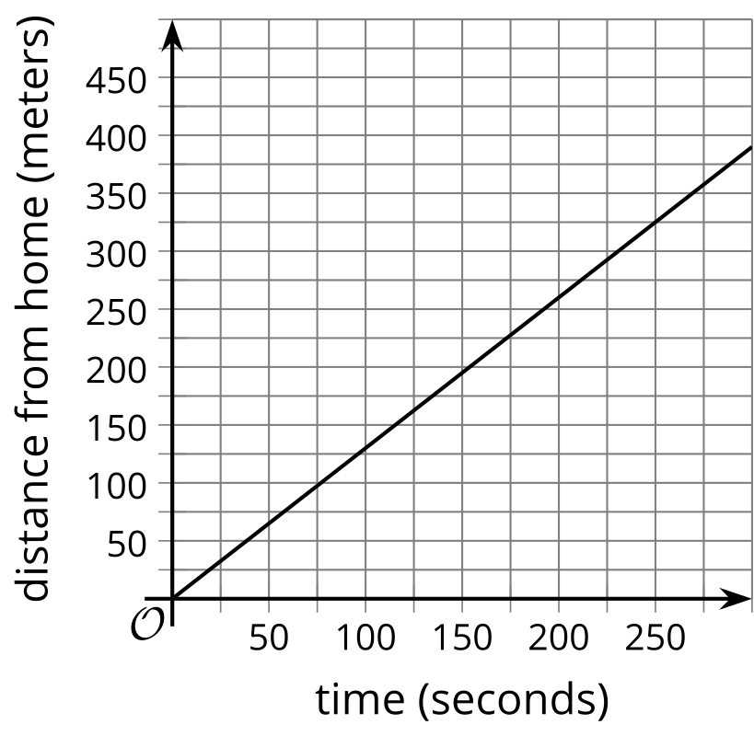

E
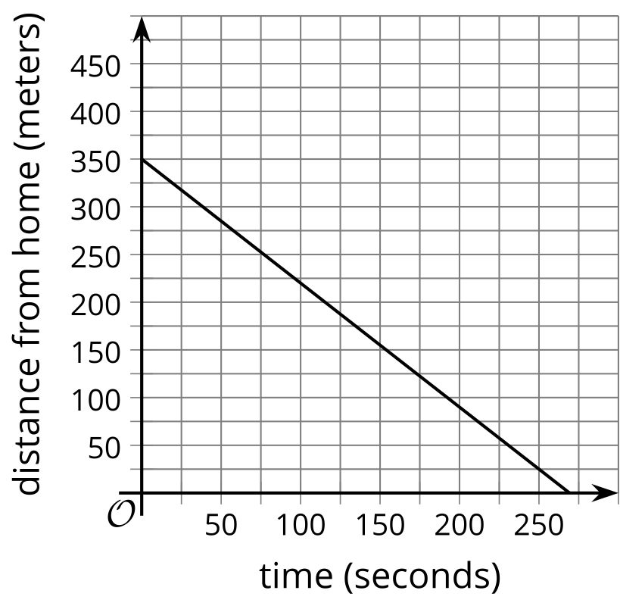

F
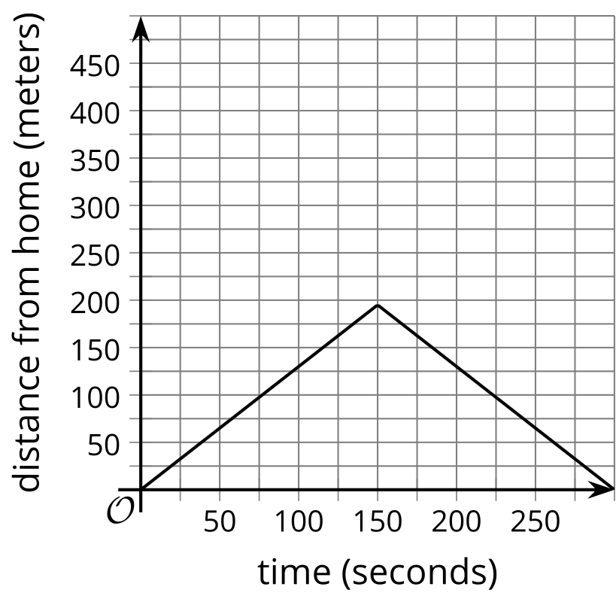

3 Say What You See

Student Task Statement
In your own words, describe these graphs.
- 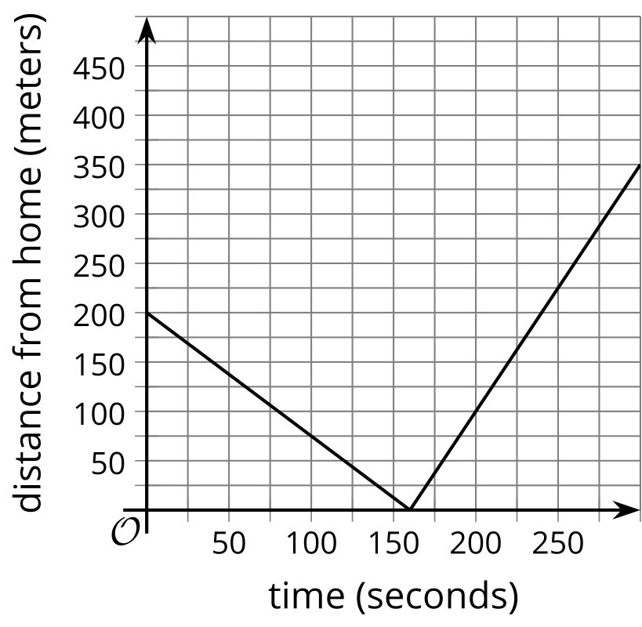
- 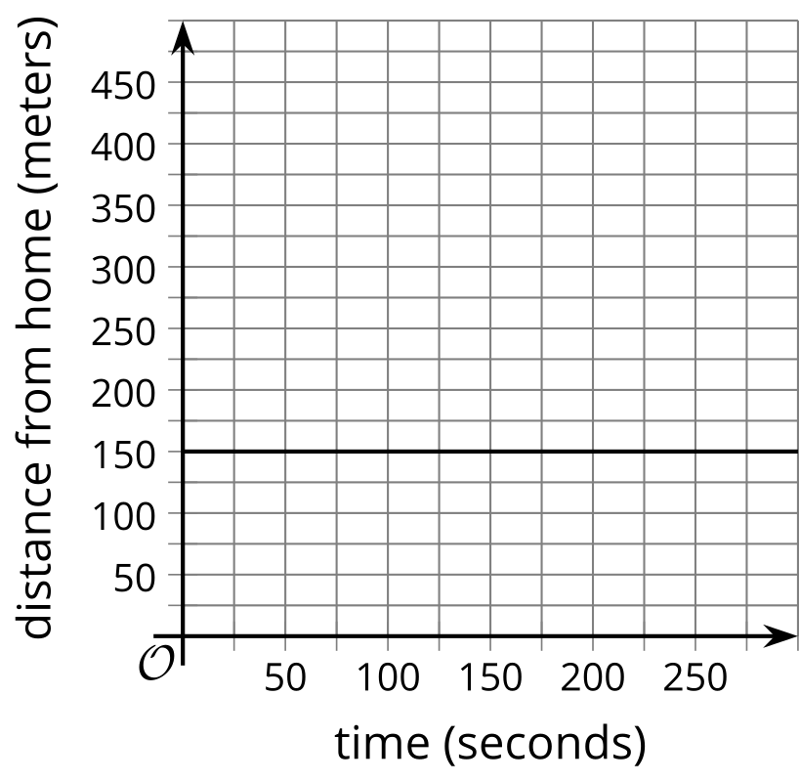
- 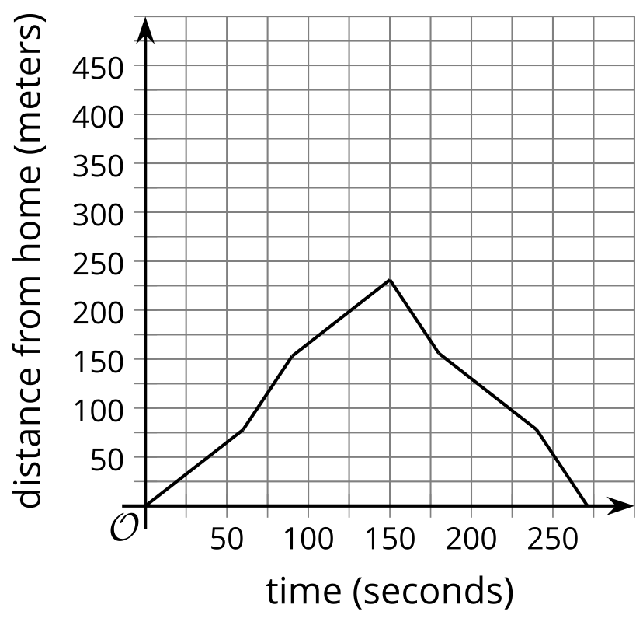
- 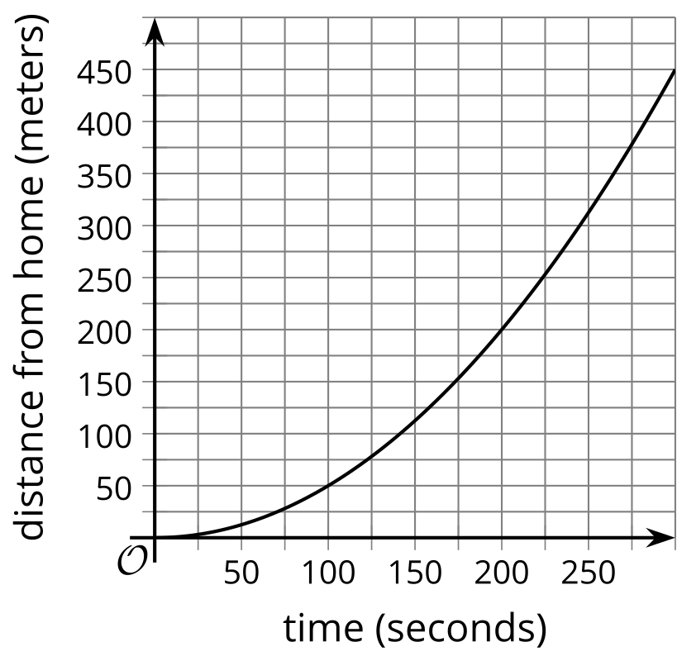
© CC BY 2019 by Illustrative Mathematics®

