Grade 2
Unit 8Lesson 9CC BY NC 2024 Illustrative Mathematics®
Unit 8, Lesson 9

A Sum of Equal Addends
- Let’s match expressions with arrays.
Grade 2
Unit 8Lesson 9CC BY NC 2024 Illustrative Mathematics®

Warm-up Estimation Exploration: How Many Waffles?
How many waffles are on the tray?
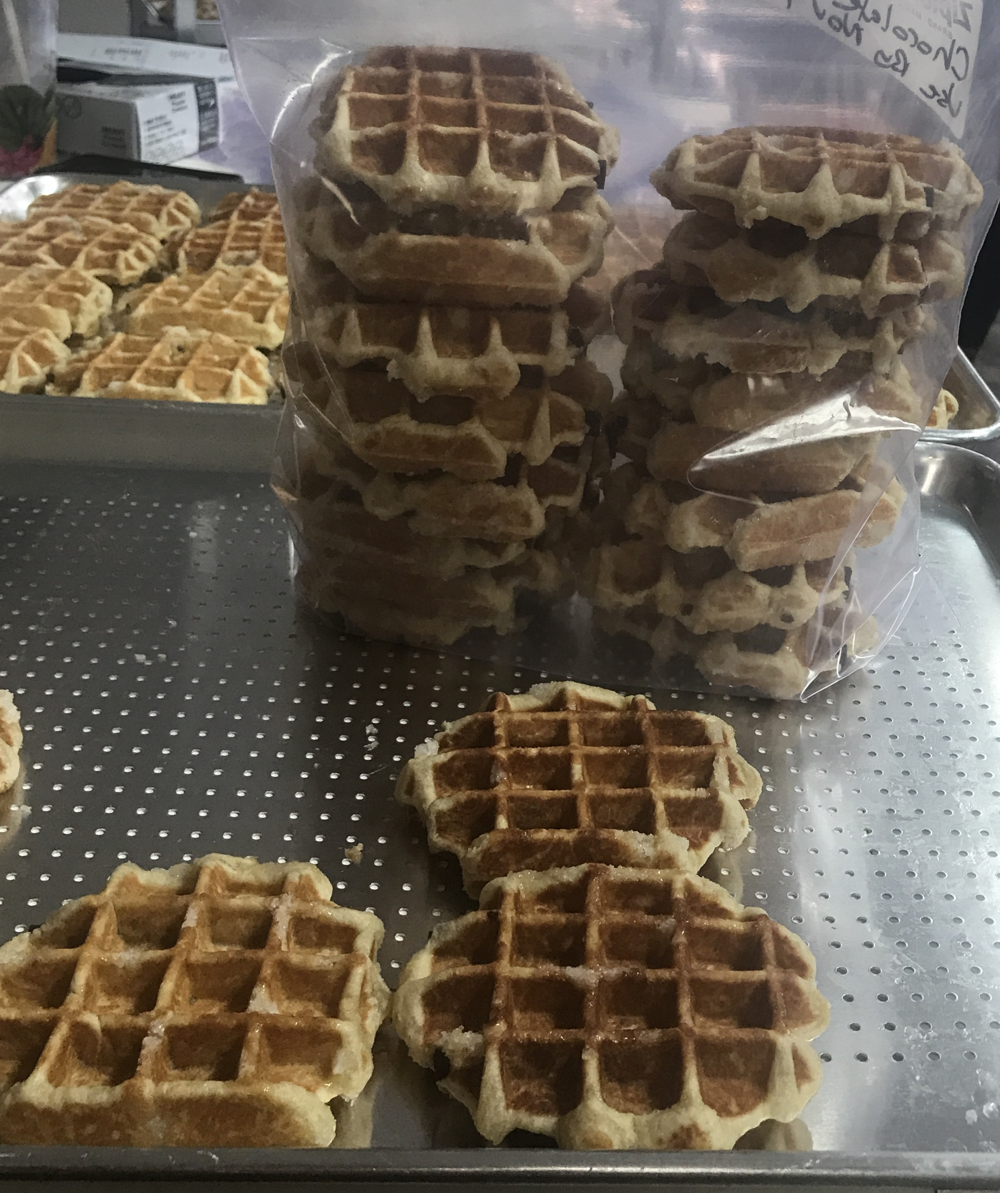
Record an estimate that is:
too low | about right | too high
How many waffles are on the tray?
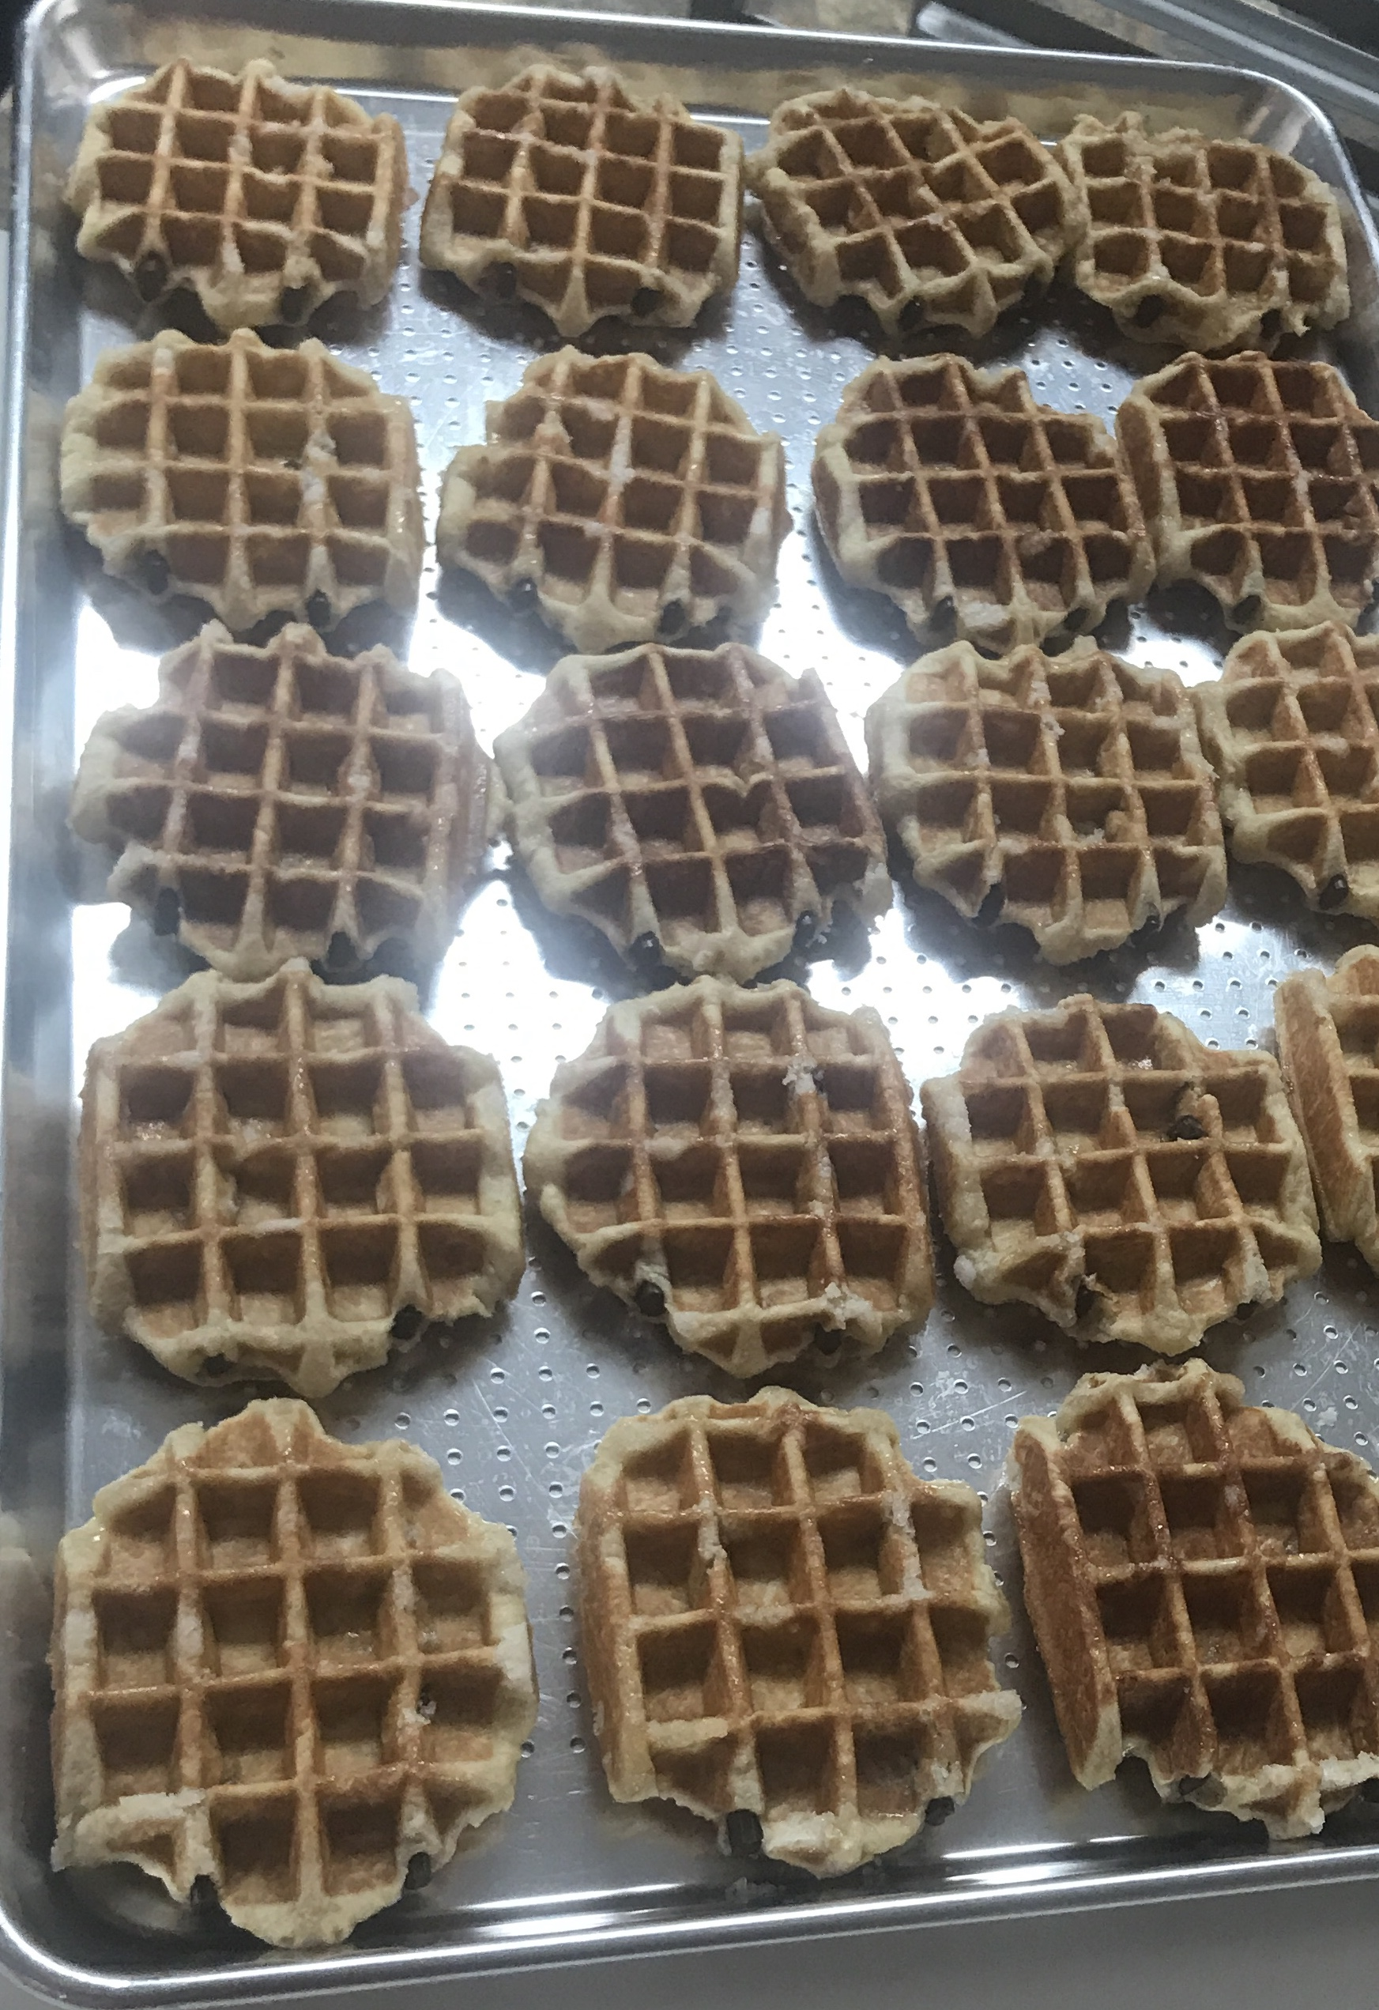
Record an estimate that is:
too low | about right | too high
Grade 2
Unit 8Lesson 9CC BY NC 2024 Illustrative Mathematics®

Activity 1 Sums of Rows and Sums of Columns
Mai and Diego represent this array. They use different expressions.
Unable to process <img src="/tikz_files/240137.svg">Failed: rsvg-convert --format png --dpi-x 300 --dpi-y 300 /app/tmp/svgtopng-1786381382.6010048.svg --output /app/tmp/svgtopng-1786381382.6010048.png Backtrace: /app/app/services/script/runner.rb:34:in `block in run_cmd' <internal:kernel>:90:in `tap' /app/app/services/script/runner.rb:32:in `run_cmd' /app/app/services/script/svg_to_png.rb:27:in `convert_svg_to_png' /app/app/services/script/svg_to_png.rb:17:in `to_png' /app/vendor/bundle/ruby/3.3.0/gems/embeddable_content-1.1.0/app/services/embeddable_content/images/image_downloader.rb:37:in `png_rendered_from_svg' /app/vendor/bundle/ruby/3.3.0/gems/embeddable_content-1.1.0/app/services/embeddable_content/images/image_downloader.rb:33:in `raw_image_data' /app/vendor/bundle/ruby/3.3.0/gems/embeddable_content-1.1.0/app/services/embeddable_content/images/image_downloader.rb:13:in `block in save' <internal:kernel>:90:in `tap' /app/vendor/bundle/ruby/3.3.0/gems/embeddable_content-1.1.0/app/services/embeddable_content/images/image_downloader.rb:13:in `save'
Diego’s expression
$2+2+2+2+2+2$
Mai’s expression
$6+6$
Do you agree with Diego or Mai?
Show your thinking using drawings, numbers, or words.
Grade 2
Unit 8Lesson 9CC BY NC 2024 Illustrative Mathematics®

Activity 2Card Sort: Arrays and Expressions
Your teacher will give you a set of cards. Match each array card with 2 expression cards and 1 number card. Be ready to explain your reasoning.
Grade 2
Unit 8Lesson 9CC BY NC 2024 Illustrative Mathematics®

Activity 3 Add It All Up

  - How many counters are in the array?
  - Unable to process <img src="/tikz_files/240138.svg">Failed: rsvg-convert --format png --dpi-x 300 --dpi-y 300 /app/tmp/svgtopng-1786381382.662159.svg --output /app/tmp/svgtopng-1786381382.662159.png Backtrace: /app/app/services/script/runner.rb:34:in `block in run_cmd' <internal:kernel>:90:in `tap' /app/app/services/script/runner.rb:32:in `run_cmd' /app/app/services/script/svg_to_png.rb:27:in `convert_svg_to_png' /app/app/services/script/svg_to_png.rb:17:in `to_png' /app/vendor/bundle/ruby/3.3.0/gems/embeddable_content-1.1.0/app/services/embeddable_content/images/image_downloader.rb:37:in `png_rendered_from_svg' /app/vendor/bundle/ruby/3.3.0/gems/embeddable_content-1.1.0/app/services/embeddable_content/images/image_downloader.rb:33:in `raw_image_data' /app/vendor/bundle/ruby/3.3.0/gems/embeddable_content-1.1.0/app/services/embeddable_content/images/image_downloader.rb:13:in `block in save' <internal:kernel>:90:in `tap' /app/vendor/bundle/ruby/3.3.0/gems/embeddable_content-1.1.0/app/services/embeddable_content/images/image_downloader.rb:13:in `save'
  - Explain how you found the total.
  - Circle 2 expressions that represent the array.
  - $3+3+3+3$
  - $3+3+3$
  - $4+3$
  - $4+4+4$
  - $4+4+4+4$

  - How many counters are in the array?
  - Unable to process <img src="/tikz_files/240139.svg">Failed: rsvg-convert --format png --dpi-x 300 --dpi-y 300 /app/tmp/svgtopng-1786381382.767203.svg --output /app/tmp/svgtopng-1786381382.767203.png Backtrace: /app/app/services/script/runner.rb:34:in `block in run_cmd' <internal:kernel>:90:in `tap' /app/app/services/script/runner.rb:32:in `run_cmd' /app/app/services/script/svg_to_png.rb:27:in `convert_svg_to_png' /app/app/services/script/svg_to_png.rb:17:in `to_png' /app/vendor/bundle/ruby/3.3.0/gems/embeddable_content-1.1.0/app/services/embeddable_content/images/image_downloader.rb:37:in `png_rendered_from_svg' /app/vendor/bundle/ruby/3.3.0/gems/embeddable_content-1.1.0/app/services/embeddable_content/images/image_downloader.rb:33:in `raw_image_data' /app/vendor/bundle/ruby/3.3.0/gems/embeddable_content-1.1.0/app/services/embeddable_content/images/image_downloader.rb:13:in `block in save' <internal:kernel>:90:in `tap' /app/vendor/bundle/ruby/3.3.0/gems/embeddable_content-1.1.0/app/services/embeddable_content/images/image_downloader.rb:13:in `save'
  - Explain how you found the total.
  - Circle 2 expressions that represent the array.
  - $2+2+2+2+2+2+2$
  - $6+6$
  - $7+7$
  - $2+2+2+2+2$

