Grade 6
Unit 4Lesson 14CC BY NC Illustrative Mathematics, based on IM 6–8 Math, CC BY Open Up Resources.
Unit 4, Lesson 14

Fractional Lengths in Triangles and Prisms
Let’s explore area and volume when fractions are involved.
Grade 6
Unit 4Lesson 14CC BY NC Illustrative Mathematics, based on IM 6–8 Math, CC BY Open Up Resources.

14.1Area of Triangle
Find the area of Triangle A in square centimeters.
Show your reasoning.
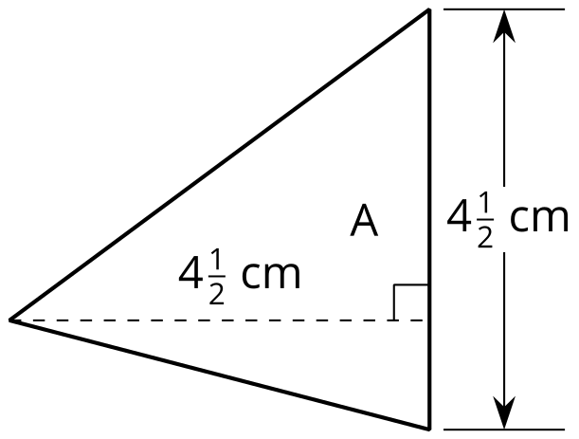
Grade 6
Unit 4Lesson 14CC BY NC Illustrative Mathematics, based on IM 6–8 Math, CC BY Open Up Resources.

14.2Bases and Heights of Triangles
- The area of Triangle B is 8 square units. Find the length of $b$. Show your reasoning.
- 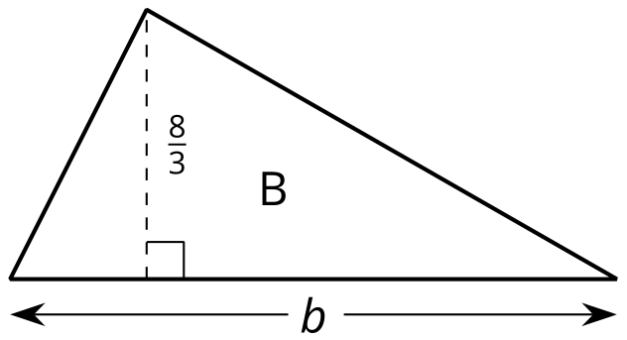
- The area of Triangle C is $\frac{54}{5}$ square units.
What is the length of $h$? Show your reasoning.
- 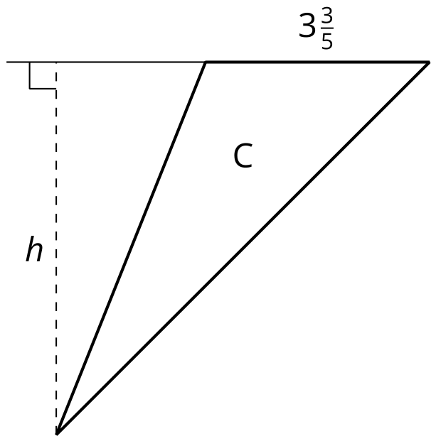
Grade 6
Unit 4Lesson 14CC BY NC Illustrative Mathematics, based on IM 6–8 Math, CC BY Open Up Resources.

14.3Volumes of Cubes and Prisms
Your teacher will give you cubes that have edge lengths of $\frac{1}{2}$ inch.
- Here is a drawing of a cube with edge lengths of 1 inch.
  - How many cubes with edge lengths of $\frac{1}{2}$ inch are needed to fill this cube?
  - 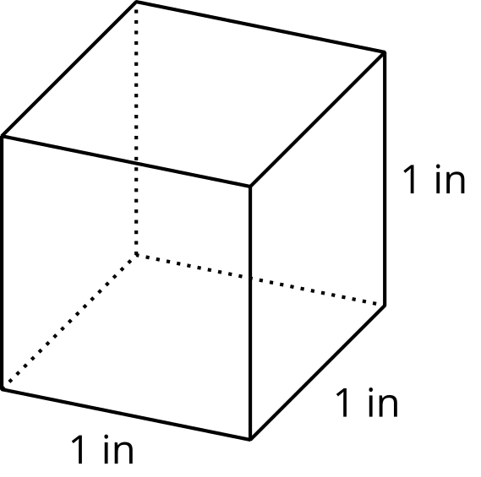
  - What is the volume, in cubic inches, of a cube with edge lengths of $\frac{1}{2}$ inch? Explain or show your reasoning.
- Four cubes are piled in a single stack to make a prism. Each cube has an edge length of $\frac{1}{2}$ inch. Sketch the prism, and find its volume in cubic inches.
- Use cubes with an edge length of $\frac{1}{2}$ inch to build prisms with the lengths, widths, and heights shown in the table.
- For each prism, record in the table how many $\frac{1}{2}$-inch cubes can be packed into the prism and the volume of the prism.
- prism  length (in) | - prism  width (in) | - prism  height (in) | - number of $\frac{1}{2}$-inch  cubes in prism | - volume of  prism (in³)
- $\frac{1}{2}$ | - $\frac{1}{2}$ | - $\frac{1}{2}$
- 1 | - 1 | - $\frac{1}{2}$
- 2 | - 1 | - $\frac{1}{2}$
- 2 | - 2 | - 1
- 4 | - 2 | - $\frac{3}{2}$
- 5 | - 4 | - 2
- 5 | - 4 | - $2\frac{1}{2}$

Are you ready for more?
A unit fraction has a 1 in the numerator.
- These are unit fractions: $\frac{1}{3},\frac{1}{100},\frac{1}{1}$.
- These are not unit fractions: $\frac{2}{9},\frac{8}{1},2\frac{1}{5}$.
- Find three unit fractions whose sum is $\frac{1}{2}$. An example is: $\frac{1}{8}+\frac{1}{8}+\frac{1}{4}=\frac{1}{2}$. How many examples like this can you find?
- Find a box whose surface area in square units equals its volume in cubic units. How many like this can you find?

Lesson 14 Summary
If a rectangular prism has edge lengths of 2 units, 3 units, and 5 units, we can think of it as 2 layers of unit cubes, with each layer having $\left(3⋅5\right)$ unit cubes in it. So the volume, in cubic units, is:
$2⋅3⋅5$
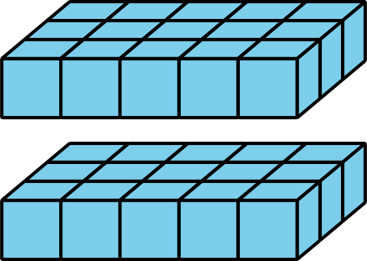
To find the volume of a rectangular prism with fractional edge lengths, we can think of it as being built of cubes that have a unit fraction for their edge length. For instance, if we build a prism that is $\frac{1}{2}$-inch tall, $\frac{3}{2}$-inch wide, and 4 inches long using cubes with a $\frac{1}{2}$-inch edge length, we would have:
- A height of 1 cube, because $1⋅\frac{1}{2}=\frac{1}{2}$.
- A width of 3 cubes, because $3⋅\frac{1}{2}=\frac{3}{2}$.
- A length of 8 cubes, because $8⋅\frac{1}{2}=4$.
The volume of the prism would be $1⋅3⋅8$, which is 24 cubic units.
How do we find its volume in cubic inches? We know that each cube with a $\frac{1}{2}$-inch edge length has a volume of $\frac{1}{8}$ cubic inch, because $\frac{1}{2}⋅\frac{1}{2}⋅\frac{1}{2}=\frac{1}{8}$. Since the prism is built using 24 of these cubes, its volume, in cubic inches, would then be $24⋅\frac{1}{8}$, which is 3 cubic inches.
The volume of the prism, in cubic inches, can also be found by multiplying the fractional edge lengths in inches: ​​​​​​$\frac{1}{2}⋅\frac{3}{2}⋅4=3$

