Grade 2
Unit 5Lesson 8CC BY NC 2024 Illustrative Mathematics®
Unit 5, Lesson 8

Three-Digit Numbers on the Number Line
- Let’s locate and represent 3-digit numbers on the number line.
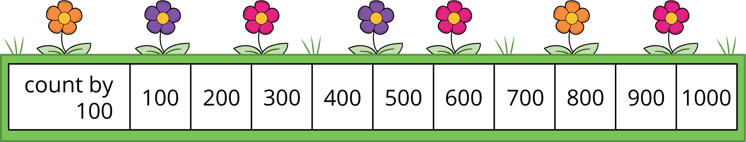
Grade 2
Unit 5Lesson 8CC BY NC 2024 Illustrative Mathematics®

Activity 1Label 3-Digit Numbers
What do you notice? What do you wonder?
Locate and label 30, 300, and 3 on the number lines.
Label each point with the number it represents.
Grade 2
Unit 5Lesson 8CC BY NC 2024 Illustrative Mathematics®

Activity 2Represent 3-Digit Numbers on a Number Line
Locate and label the number on the number line. You can label each tick mark with the number it represents if it helps.
- 700
- 472
- 940
- 356
- 590

