Grade 6
Unit 3Lesson 14CC BY NC Illustrative Mathematics, based on IM 6–8 Math, CC BY Open Up Resources.
Unit 3, Lesson 14

Solving Percentage Problems
Let’s solve more percentage problems.
Grade 6
Unit 3Lesson 14CC BY NC Illustrative Mathematics, based on IM 6–8 Math, CC BY Open Up Resources.

14.1Matching the Percentage
Match each question in the left column with a percentage in the right column. One percentage will be left over. Be prepared to explain your reasoning.
- 5 is what percentage of 20?
- 3 is what percentage of 30?
- 6 is what percentage of 8?
- 20 is what percentage of 5?
- 4%
- 10%
- 25%
- 75%
- 400%
Grade 6
Unit 3Lesson 14CC BY NC Illustrative Mathematics, based on IM 6–8 Math, CC BY Open Up Resources.

14.2Info Gap: Music Devices
Your teacher will give you either a problem card or a data card. Do not show or read your card to your partner.
If your teacher gives you the problem card:
- Silently read your card and think about what information you need to answer the question.
- Ask your partner for the specific information that you need. “Can you tell me $\underset{_}{​}$?”
- Explain to your partner how you are using the information to solve the problem. “I need to know $\underset{_}{​}$ because . . . .”
- Continue to ask questions until you have enough information to solve the problem.
- Once you have enough information, share the problem card with your partner, and solve the problem independently.
- Read the data card, and discuss your reasoning.
If your teacher gives you the data card:
- Silently read your card. Wait for your partner to ask for information.
- Before telling your partner any information, ask, “Why do you need to know $\underset{_}{​}$?”
- Listen to your partner’s reasoning and ask clarifying questions. Only give information that is on your card. Do not figure out anything for your partner!
- These steps may be repeated.
- Once your partner says they have enough information to solve the problem, read the problem card, and solve the problem independently.
- Share the data card, and discuss your reasoning.

Lesson 14 Summary
In a situation that involves percentages, there are often three questions we are interested in answering.
Suppose a tank is filled with some water.
- If we know that the tank is 25% filled and can hold 36 liters, we can ask: What is 25% of 36 liters?
- If we know that the tank has 9 liters and is 25% filled, we can ask: How many liters are in a full tank?
- If we know that the tank has 9 liters but can hold 36 liters when full, we can ask: What percentage of 36 liters is 9 liters?
We can use a double number line diagram, a table, or a tape diagram to help us reason about each question.
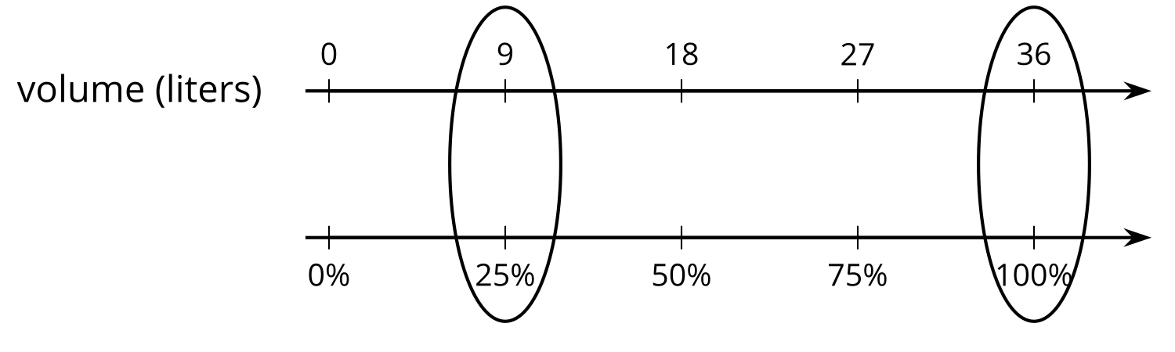
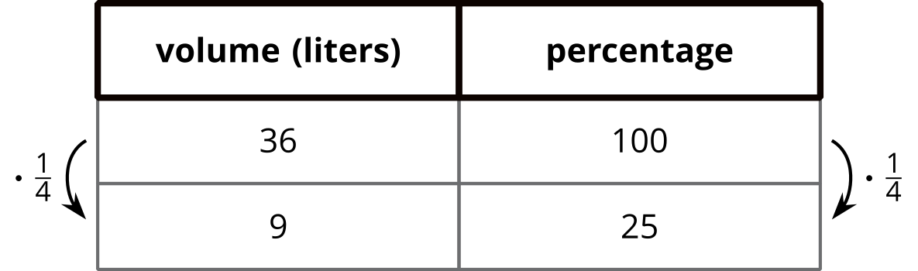
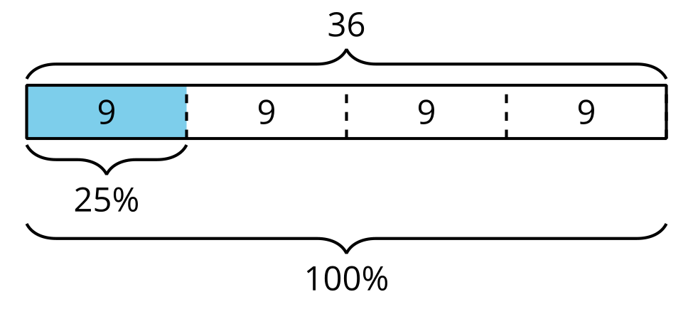
We can also use our knowledge of fractions or relationships between numbers. For instance, we know that 9 is $\frac{1}{4}$ of 36, or $36÷4$, so it is $\frac{1}{4}$ of 100% or 25%.
In general, in a situation where $A$ of $B$ is $C$, we can find the value of $A$, $B$, or $C$ if we know the other two values.

