Grade 6
Unit 5Lesson 13CC BY NC Illustrative Mathematics, based on IM 6–8 Math, CC BY Open Up Resources.
Unit 5, Lesson 13

Dividing a Decimal by a Decimal
Let’s divide a decimal by a decimal.
Grade 6
Unit 5Lesson 13CC BY NC Illustrative Mathematics, based on IM 6–8 Math, CC BY Open Up Resources.

13.1Dividends and Divisors
Analyze the dividends, divisors, and quotients in the calculations, and then answer the questions.
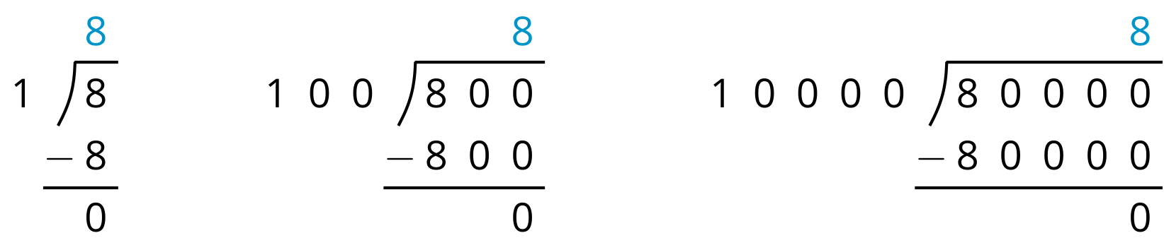
- Complete each sentence. In the calculations shown:
  - Each dividend is $\underset{_}{}$ times the dividend to the left of it.
  - Each divisor is $\underset{_}{}$ times the divisor to the left of it.
  - Each quotient is $\underset{_}{}$ the quotient to the left of it.
- Select all expressions that would also have a quotient of 8. Be prepared to explain your reasoning.
  - $80÷10$
  - $80÷100$
  - $8,​000÷1,​000$
  - $800,​000÷1,​000,​000$
  - $0.8÷0.1$
  - $0.08÷0.001$
- Write two expressions that have the same value as $250÷10$. One of your expressions should include decimals.
Grade 6
Unit 5Lesson 13CC BY NC Illustrative Mathematics, based on IM 6–8 Math, CC BY Open Up Resources.

13.2Dividing with Equivalent Expressions
Calculate each quotient. Show your reasoning. If you get stuck, think about what equivalent division expression you could write.
- $3÷0.12$
- $1.8÷0.004$

Are you ready for more?
Suppose we multiply both the dividend and the divisor in a division expression by the same number that is not a multiple of 10. Would the new expression give the same quotient as the original expression? Explain or show your reasoning.
Grade 6
Unit 5Lesson 13CC BY NC Illustrative Mathematics, based on IM 6–8 Math, CC BY Open Up Resources.

13.3Two Ways to Calculate Quotients of Decimals
- Here are two calculations of $48.78÷9$. Work with your partner to answer the following questions.
- Calculation A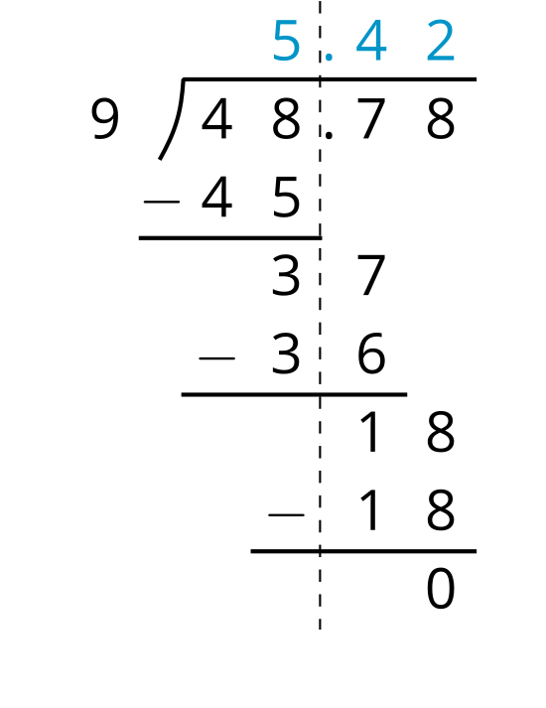
- Calculation B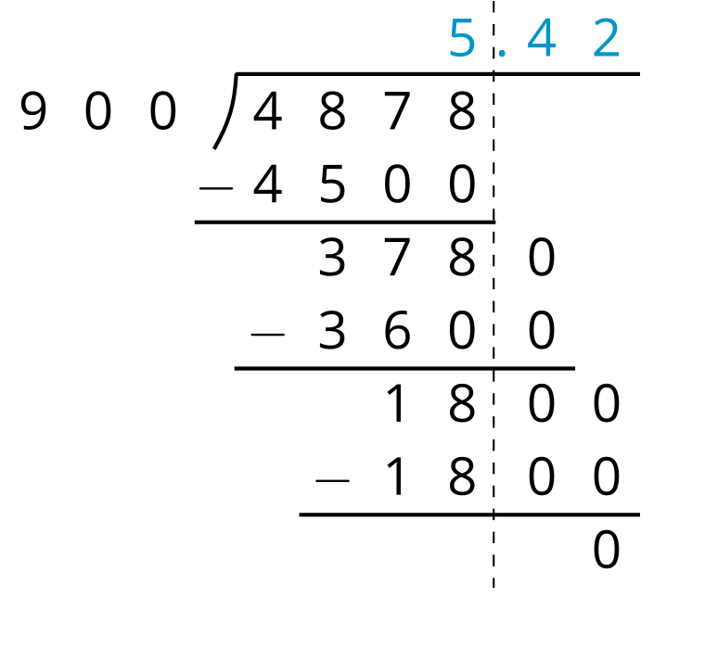
  - How does the dividend in Calculation B compare to the dividend in A?
  - How does the divisor in Calculation B compare to the divisor in A?
  - Look at Calculation A. Explain how you can tell that the 36 means “36 tenths” and the 18 means “18 hundredths.”
  - Look at Calculation B. What do the 3600 and 1800 mean? How do their values compare to the 36 and 18 in Calculation A?
  - We can think of $48.78÷9=5.42$ to mean $9⋅\left(5.42\right)=48.78$ or “9 groups of 5.42 make 48.78.” If this statement is true, why is it also true that “900 groups of 5.42 make 4878?”

  - Explain why $51.2÷6.4$ has the same value as $5.12÷0.64$.
  - Write a division expression that has the same value as $51.2÷6.4$ but is easier to use to find the value. Then, find the value using long division.
Grade 6
Unit 5Lesson 13CC BY NC Illustrative Mathematics, based on IM 6–8 Math, CC BY Open Up Resources.

13.4Practicing Division with Decimals
- Calculate each quotient, and show your reasoning.
  - $106.5÷3$
  - $58.8÷0.7$
  - $257.4÷1.1$
- Mai is making friendship bracelets. Each bracelet is made from 24.3 cm of string. If she has 170.1 cm of string, how many bracelets can she make? Explain or show your reasoning.

Lesson 13 Summary
We know that two fractions are equivalent when the numerators and denominators are related by the same factor, and when dividing the numerator by the denominator gives the same quotient. For example, we can tell that $\frac{6}{4}$ and $\frac{60}{40}$ are equivalent fractions because:
- Dividing 6 by 4 and dividing 60 by 40 both give 1.5.
- The numerators and denominators of $\frac{6}{4}$ and $\frac{60}{40}$ are related by the same factor of 10: $\frac{6⋅10}{4⋅10}=\frac{60}{40}$.
Division expressions can also be equivalent. For example, the expression $5,​400÷900$ is equivalent to $54÷9$ because:
- They both have a quotient of 6.
- The dividends and divisors in $5,​400÷900$ and $54÷9$ are related by the same factor of 100: $54⋅100=5,​400$ and $9⋅100=900$.
This means that an expression such as $5.4÷0.9$ also has the same value as $54÷9$. The dividend and divisor in $54÷9$ are each 10 times those in $5.4÷0.9$, but their quotients are the same.
This understanding can help us divide a decimal dividend by a decimal divisor: We can multiply each decimal by the same power of 10 so that both the dividend and the divisor are whole numbers, and then we divide the whole numbers.
For example, to calculate $7.65÷1.2$ we can multiply each decimal by 100, and then calculate $765÷120$. Here is the calculation with long division:
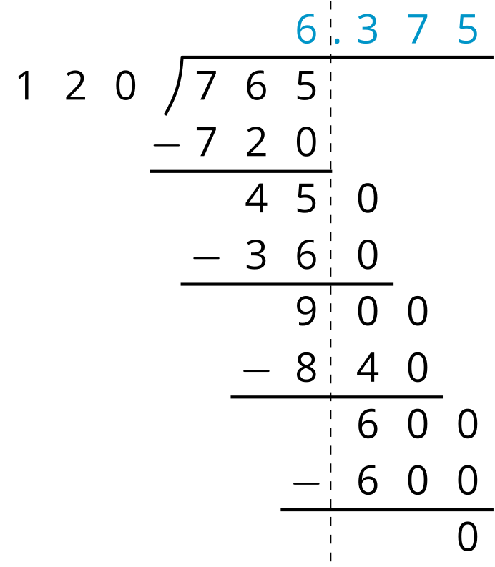
Because the expression $765÷120$ is equivalent to $7.65÷1.2$, we know that 6.375 is also a quotient of $7.65÷1.2$.

