Lesson 6: Use Strategies and Algorithms to Add
- Let’s consider when to use algorithms and when to use other strategies to add.

Warm-up: Number Talk: Little More, Little Less
Find the value of each expression mentally.
- $300+156$
- $299+156$
- $303+156$
- $204+376$

6.1: Just Ones
Two methods of recording the addition of $657+286$ are shown.
Method 1
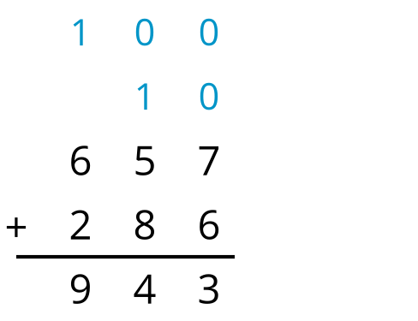
Method 2
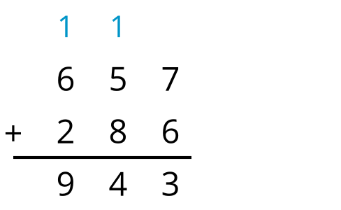
- How is the newly composed ten and hundred recorded differently in each method?
- Try the second method of recording to add these numbers:
  - $602+179$
  - $493+161$
  - $438+364$
  - $329+381$

6.2: How Would You Add?
Use a strategy of your choice to find the value of each sum. Show your reasoning. Organize it so it can be followed by others.
- $199+348$
- $264+359$
- $203+75$
- $316+198$
- $399+499$


Section Summary
Section Summary
In this section, we learned that an algorithm is a set of steps that works every time as long as the steps are carried out correctly. Then, we learned algorithms to add numbers within 1,000.
We also learned that we can choose to add using a strategy or an algorithm based on the numbers being added.
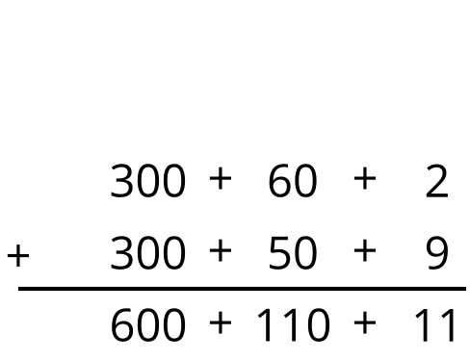
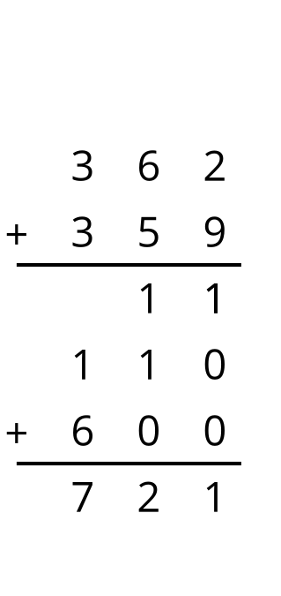
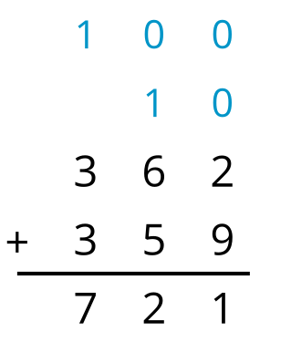
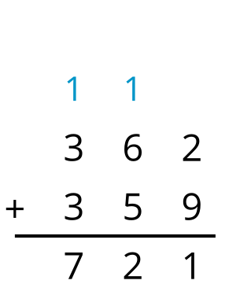
© CC BY 2021 Illustrative Mathematics®

