Grade 6
Unit 3Lesson 15CC BY NC Illustrative Mathematics, based on IM 6–8 Math, CC BY Open Up Resources.
Unit 3, Lesson 15

Finding This Percent of That
Let’s solve percentage problems like a pro.
Grade 6
Unit 3Lesson 15CC BY NC Illustrative Mathematics, based on IM 6–8 Math, CC BY Open Up Resources.

15.1Math Talk: Multiply and Divide
Find the value of each expression mentally.
- $70÷100$
- $35⋅\frac{1}{100}$
- $\left(0.35\right)⋅100$
- $\frac{105}{100}$
Grade 6
Unit 3Lesson 15CC BY NC Illustrative Mathematics, based on IM 6–8 Math, CC BY Open Up Resources.

15.2Audience Size
A school held several evening activities last month—a music concert, a basketball game, literacy night, and a drama play. The music concert was attended by 250 people.
- Attendance at the basketball game was 30% of attendance at the concert.
- Attendance at literacy night was 44% of attendance at the concert.
- Attendance at the drama play was 102% of attendance at the concert.
How many people came to each of these activities? Show your reasoning.

Are you ready for more?
6% of the people who attended the music concert also attended the basketball game.
What percentage of the people who attended the basketball game also attended the music concert?
Grade 6
Unit 3Lesson 15CC BY NC Illustrative Mathematics, based on IM 6–8 Math, CC BY Open Up Resources.

15.3Some Percentage for Charity
- Three music artists plan to donate a percentage of the money they make from selling merchandise.
- Complete the tables to show how much each artist would donate for different amounts of merchandise sales.
- 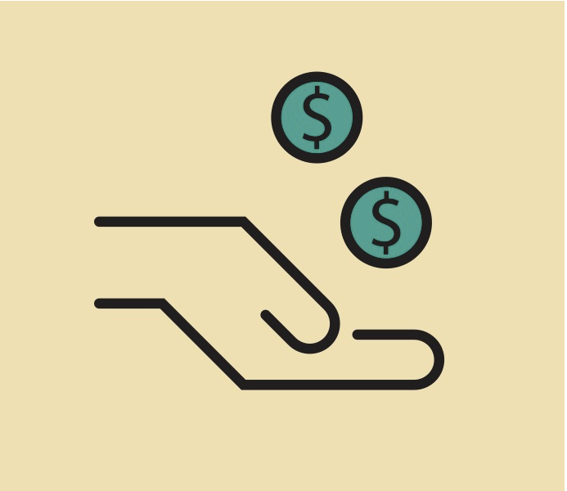
  - Artist A plans to donate 1% of the amount of merchandise sales.
- sales ($) | - 1 | - 40 | - 100 | - 3,200 | - $x$
  - donation ($)
  - Artist B plans to donate 15% of the amount of merchandise sales.
- sales ($) | - 1 | - 40 | - 100 | - 3,200 | - $x$
  - donation ($)
  - Artist C plans to donate 67% of the amount of merchandise sales.
- sales ($) | - 1 | - 40 | - 100 | - 3,200 | - $x$
  - donation ($)
- Another artist plans to donate $P\%$ of the money made from selling merchandise. In the table, write an expression for the amount of donation for each sales amount.
- sales ($) | - 1 | - 40 | - 100 | - 3,200 | - $x$
- donation ($)

Lesson 15 Summary
Suppose a business donates 1% of its profits to charity each year. How much would it donate if it made $7,500 in profits?
To find 1% of 7,500, we can multiply 7,500 by $\frac{1}{100}$ or 0.01.
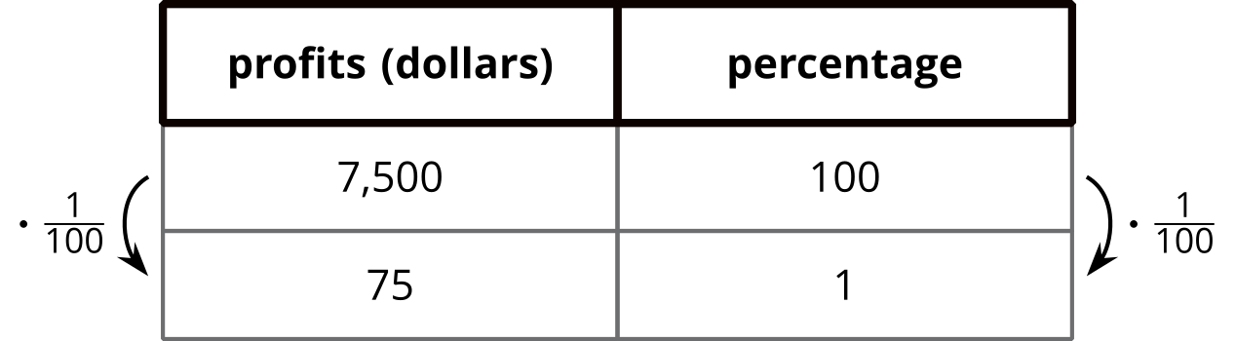
$\frac{1}{100}⋅7,​500=75$, so the business would donate $75.
What if the business donates 6% of its profits to charity? Because 6% of 7,500 is 6 times as much as 1% of 7,500, we can calculate $6⋅\frac{1}{100}⋅7,​500$ or $\frac{6}{100}⋅7,​500$.
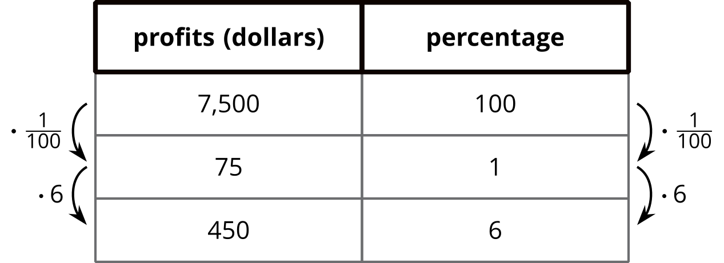
$\frac{6}{100}⋅7,​500=450$, so the business would donate $450.
The same reasoning can help us find 1%, 6%, and other percentages of another number:
- To find 1% of a number, we can multiply that number by $\frac{1}{100}$ or 0.01.
- To find 6% of a number, we can multiply the number by $\frac{6}{100}$ or 0.06.
- To find 49% of a number, we can multiply the number by $\frac{49}{100}$ or 0.49.
- To find 135% of a number, we can multiply the number by $\frac{135}{100}$ or 1.35.
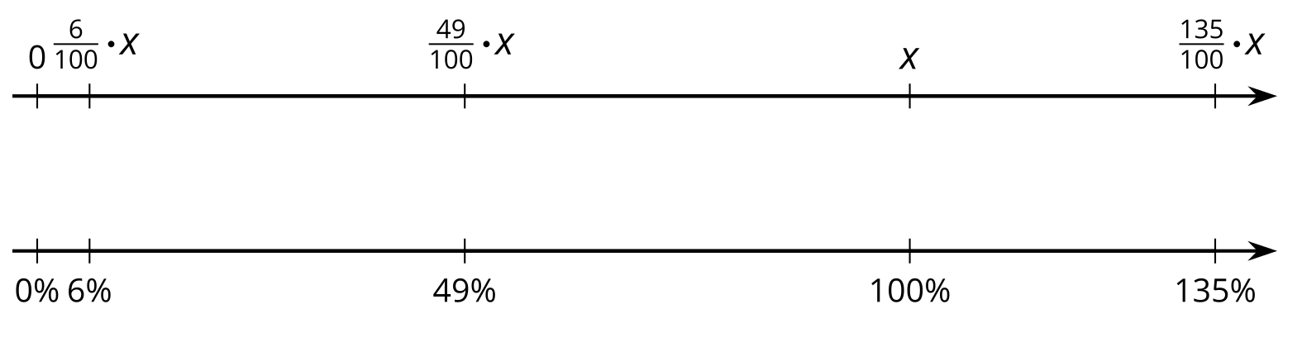
In general, to find $P\%$ of any number, $x$, we can calculate: $\frac{P}{100}⋅x$.

