Grade 2
Unit 3Lesson 15CC BY NC 2024 Illustrative Mathematics®
Unit 3, Lesson 15

Create Line Plots
- Let’s represent data in line plots.
Grade 2
Unit 3Lesson 15CC BY NC 2024 Illustrative Mathematics®

Warm-upNumber Talk: Subtraction within 50
Find the value of each expression mentally.
- $47−20$
- $47−24$
- $36−10$
- $36−15$
Grade 2
Unit 3Lesson 15CC BY NC 2024 Illustrative Mathematics®

Activity 1Measure and Plot Pencil Lengths
- Measure the pencils. Use centimeters. Work with a partner. Check each other’s measurements. Record each measurement in the table.
- pencil length (cm)
- Create a line plot to represent the lengths of all the pencils in your group.
Grade 2
Unit 3Lesson 15CC BY NC 2024 Illustrative Mathematics®

Activity 2Plot Pencil Lengths
Unable to process <img src="/tikz_files/238112.svg">Failed: rsvg-convert --format png --dpi-x 300 --dpi-y 300 /app/tmp/svgtopng-1786380857.4020913.svg --output /app/tmp/svgtopng-1786380857.4020913.png Backtrace: /app/app/services/script/runner.rb:34:in `block in run_cmd' <internal:kernel>:90:in `tap' /app/app/services/script/runner.rb:32:in `run_cmd' /app/app/services/script/svg_to_png.rb:27:in `convert_svg_to_png' /app/app/services/script/svg_to_png.rb:17:in `to_png' /app/vendor/bundle/ruby/3.3.0/gems/embeddable_content-1.1.0/app/services/embeddable_content/images/image_downloader.rb:37:in `png_rendered_from_svg' /app/vendor/bundle/ruby/3.3.0/gems/embeddable_content-1.1.0/app/services/embeddable_content/images/image_downloader.rb:33:in `raw_image_data' /app/vendor/bundle/ruby/3.3.0/gems/embeddable_content-1.1.0/app/services/embeddable_content/images/image_downloader.rb:13:in `block in save' <internal:kernel>:90:in `tap' /app/vendor/bundle/ruby/3.3.0/gems/embeddable_content-1.1.0/app/services/embeddable_content/images/image_downloader.rb:13:in `save'
Unable to process <img src="/tikz_files/236820.svg">Failed: rsvg-convert --format png --dpi-x 300 --dpi-y 300 /app/tmp/svgtopng-1786380857.4429228.svg --output /app/tmp/svgtopng-1786380857.4429228.png Backtrace: /app/app/services/script/runner.rb:34:in `block in run_cmd' <internal:kernel>:90:in `tap' /app/app/services/script/runner.rb:32:in `run_cmd' /app/app/services/script/svg_to_png.rb:27:in `convert_svg_to_png' /app/app/services/script/svg_to_png.rb:17:in `to_png' /app/vendor/bundle/ruby/3.3.0/gems/embeddable_content-1.1.0/app/services/embeddable_content/images/image_downloader.rb:37:in `png_rendered_from_svg' /app/vendor/bundle/ruby/3.3.0/gems/embeddable_content-1.1.0/app/services/embeddable_content/images/image_downloader.rb:33:in `raw_image_data' /app/vendor/bundle/ruby/3.3.0/gems/embeddable_content-1.1.0/app/services/embeddable_content/images/image_downloader.rb:13:in `block in save' <internal:kernel>:90:in `tap' /app/vendor/bundle/ruby/3.3.0/gems/embeddable_content-1.1.0/app/services/embeddable_content/images/image_downloader.rb:13:in `save'
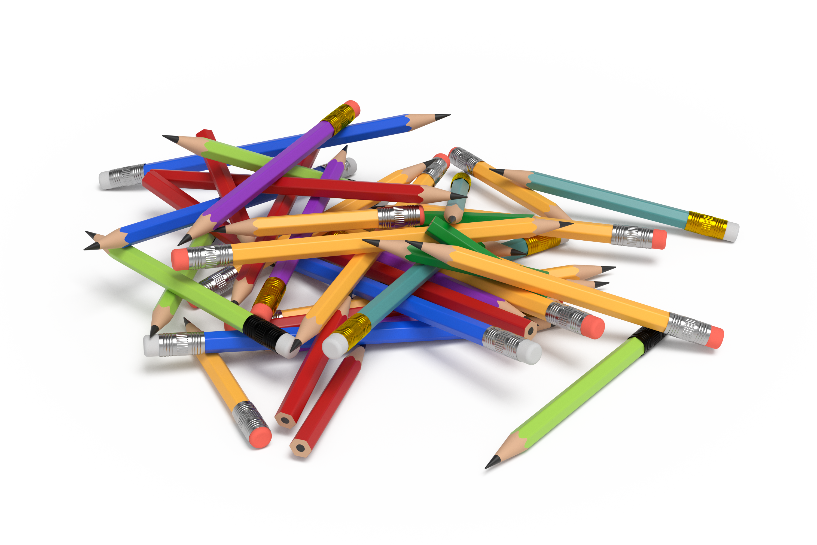
Use this data to create a line plot.
Group C | pencil length (centimeters)
Andre | 12
Clare | 10
Diego | 10
Elena | 10
Han | 13
Jada | 12
Kiran | 14
Noah | 16
Priya | 14
Tyler | 13
Unable to process <img src="/tikz_files/238113.svg">Failed: rsvg-convert --format png --dpi-x 300 --dpi-y 300 /app/tmp/svgtopng-1786380857.8244276.svg --output /app/tmp/svgtopng-1786380857.8244276.png Backtrace: /app/app/services/script/runner.rb:34:in `block in run_cmd' <internal:kernel>:90:in `tap' /app/app/services/script/runner.rb:32:in `run_cmd' /app/app/services/script/svg_to_png.rb:27:in `convert_svg_to_png' /app/app/services/script/svg_to_png.rb:17:in `to_png' /app/vendor/bundle/ruby/3.3.0/gems/embeddable_content-1.1.0/app/services/embeddable_content/images/image_downloader.rb:37:in `png_rendered_from_svg' /app/vendor/bundle/ruby/3.3.0/gems/embeddable_content-1.1.0/app/services/embeddable_content/images/image_downloader.rb:33:in `raw_image_data' /app/vendor/bundle/ruby/3.3.0/gems/embeddable_content-1.1.0/app/services/embeddable_content/images/image_downloader.rb:13:in `block in save' <internal:kernel>:90:in `tap' /app/vendor/bundle/ruby/3.3.0/gems/embeddable_content-1.1.0/app/services/embeddable_content/images/image_downloader.rb:13:in `save'

