Grade 2
Unit 6Lesson 10CC BY NC 2024 Illustrative Mathematics®
Unit 6, Lesson 10

Center Day 2
- Let’s work with shapes.
Grade 2
Unit 6Lesson 10CC BY NC 2024 Illustrative Mathematics®

Warm-up How Many Do You See: Base-Ten Blocks
How many do you see? How do you see them?
Unable to process <img src="/tikz_files/239347.svg">Failed: rsvg-convert --format png --dpi-x 300 --dpi-y 300 /app/tmp/svgtopng-1786381138.8750558.svg --output /app/tmp/svgtopng-1786381138.8750558.png Backtrace: /app/app/services/script/runner.rb:34:in `block in run_cmd' <internal:kernel>:90:in `tap' /app/app/services/script/runner.rb:32:in `run_cmd' /app/app/services/script/svg_to_png.rb:27:in `convert_svg_to_png' /app/app/services/script/svg_to_png.rb:17:in `to_png' /app/vendor/bundle/ruby/3.3.0/gems/embeddable_content-1.1.0/app/services/embeddable_content/images/image_downloader.rb:37:in `png_rendered_from_svg' /app/vendor/bundle/ruby/3.3.0/gems/embeddable_content-1.1.0/app/services/embeddable_content/images/image_downloader.rb:33:in `raw_image_data' /app/vendor/bundle/ruby/3.3.0/gems/embeddable_content-1.1.0/app/services/embeddable_content/images/image_downloader.rb:13:in `block in save' <internal:kernel>:90:in `tap' /app/vendor/bundle/ruby/3.3.0/gems/embeddable_content-1.1.0/app/services/embeddable_content/images/image_downloader.rb:13:in `save'
Unable to process <img src="/tikz_files/239348.svg">Failed: rsvg-convert --format png --dpi-x 300 --dpi-y 300 /app/tmp/svgtopng-1786381138.9290855.svg --output /app/tmp/svgtopng-1786381138.9290855.png Backtrace: /app/app/services/script/runner.rb:34:in `block in run_cmd' <internal:kernel>:90:in `tap' /app/app/services/script/runner.rb:32:in `run_cmd' /app/app/services/script/svg_to_png.rb:27:in `convert_svg_to_png' /app/app/services/script/svg_to_png.rb:17:in `to_png' /app/vendor/bundle/ruby/3.3.0/gems/embeddable_content-1.1.0/app/services/embeddable_content/images/image_downloader.rb:37:in `png_rendered_from_svg' /app/vendor/bundle/ruby/3.3.0/gems/embeddable_content-1.1.0/app/services/embeddable_content/images/image_downloader.rb:33:in `raw_image_data' /app/vendor/bundle/ruby/3.3.0/gems/embeddable_content-1.1.0/app/services/embeddable_content/images/image_downloader.rb:13:in `block in save' <internal:kernel>:90:in `tap' /app/vendor/bundle/ruby/3.3.0/gems/embeddable_content-1.1.0/app/services/embeddable_content/images/image_downloader.rb:13:in `save'
Unable to process <img src="/tikz_files/239349.svg">Failed: rsvg-convert --format png --dpi-x 300 --dpi-y 300 /app/tmp/svgtopng-1786381138.9883363.svg --output /app/tmp/svgtopng-1786381138.9883363.png Backtrace: /app/app/services/script/runner.rb:34:in `block in run_cmd' <internal:kernel>:90:in `tap' /app/app/services/script/runner.rb:32:in `run_cmd' /app/app/services/script/svg_to_png.rb:27:in `convert_svg_to_png' /app/app/services/script/svg_to_png.rb:17:in `to_png' /app/vendor/bundle/ruby/3.3.0/gems/embeddable_content-1.1.0/app/services/embeddable_content/images/image_downloader.rb:37:in `png_rendered_from_svg' /app/vendor/bundle/ruby/3.3.0/gems/embeddable_content-1.1.0/app/services/embeddable_content/images/image_downloader.rb:33:in `raw_image_data' /app/vendor/bundle/ruby/3.3.0/gems/embeddable_content-1.1.0/app/services/embeddable_content/images/image_downloader.rb:13:in `block in save' <internal:kernel>:90:in `tap' /app/vendor/bundle/ruby/3.3.0/gems/embeddable_content-1.1.0/app/services/embeddable_content/images/image_downloader.rb:13:in `save'
Unable to process <img src="/tikz_files/239350.svg">Failed: rsvg-convert --format png --dpi-x 300 --dpi-y 300 /app/tmp/svgtopng-1786381139.0402145.svg --output /app/tmp/svgtopng-1786381139.0402145.png Backtrace: /app/app/services/script/runner.rb:34:in `block in run_cmd' <internal:kernel>:90:in `tap' /app/app/services/script/runner.rb:32:in `run_cmd' /app/app/services/script/svg_to_png.rb:27:in `convert_svg_to_png' /app/app/services/script/svg_to_png.rb:17:in `to_png' /app/vendor/bundle/ruby/3.3.0/gems/embeddable_content-1.1.0/app/services/embeddable_content/images/image_downloader.rb:37:in `png_rendered_from_svg' /app/vendor/bundle/ruby/3.3.0/gems/embeddable_content-1.1.0/app/services/embeddable_content/images/image_downloader.rb:33:in `raw_image_data' /app/vendor/bundle/ruby/3.3.0/gems/embeddable_content-1.1.0/app/services/embeddable_content/images/image_downloader.rb:13:in `block in save' <internal:kernel>:90:in `tap' /app/vendor/bundle/ruby/3.3.0/gems/embeddable_content-1.1.0/app/services/embeddable_content/images/image_downloader.rb:13:in `save'
Grade 2
Unit 6Lesson 10CC BY NC 2024 Illustrative Mathematics®

Activity 2 Centers: Choice Time
Choose a center:
How Are They the Same?

Capture Squares
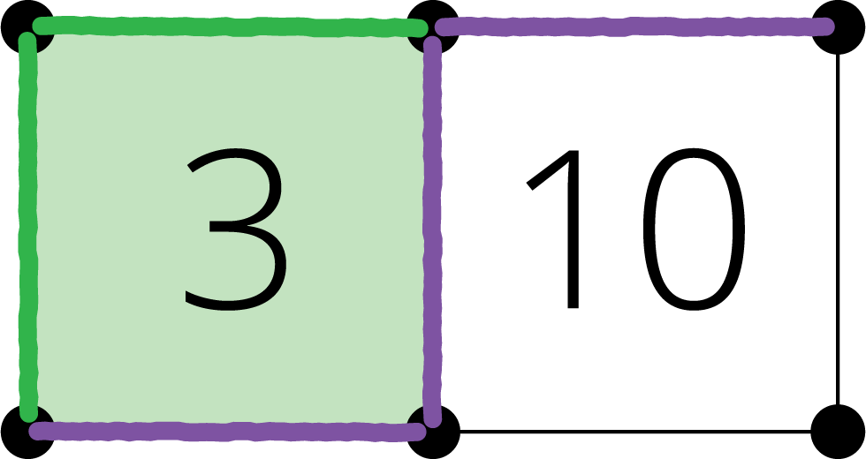
Can You Draw It?


