Lesson 10: Put Together Pattern Blocks
- Let’s put together pattern blocks.

Warm-up: Notice and Wonder: Quilts
What do you notice?
What do you wonder?
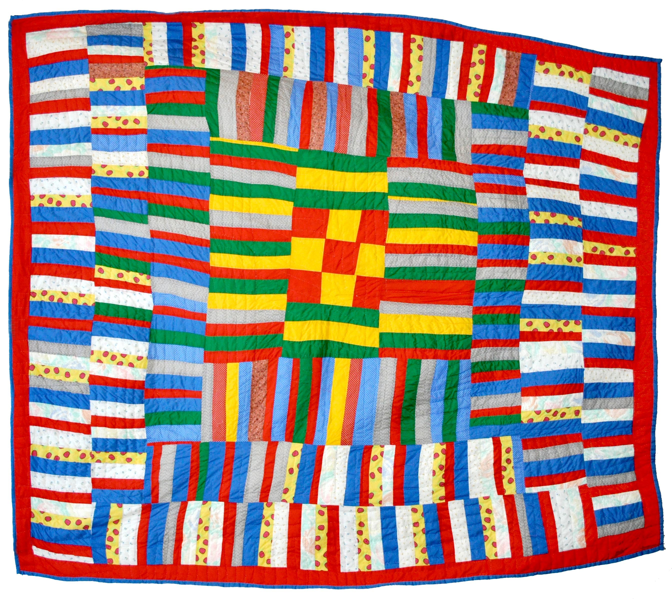
Synthesis:
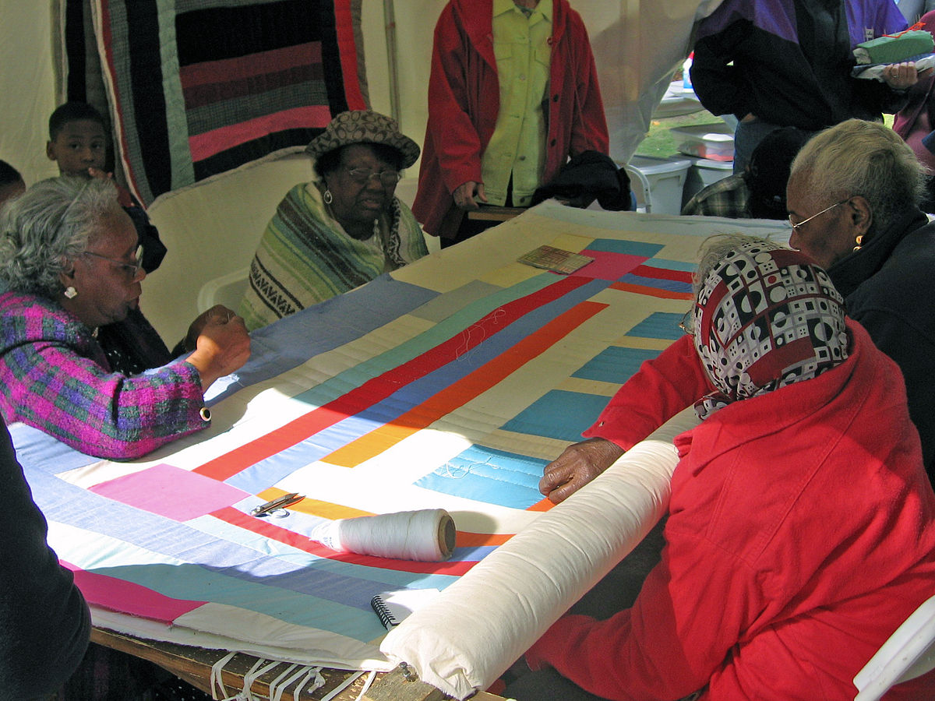

10.1: Introduce Pattern Blocks, Count Out and Build
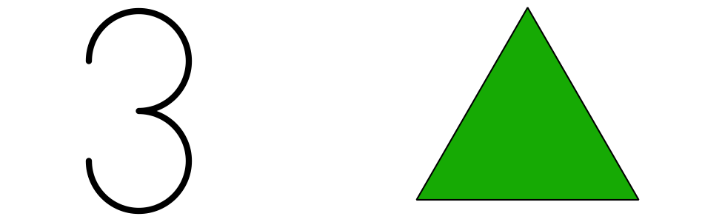
green triangles
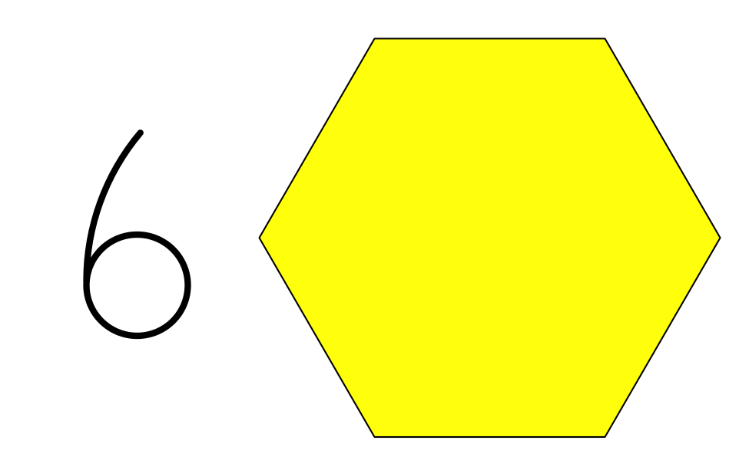
yellow hexagons
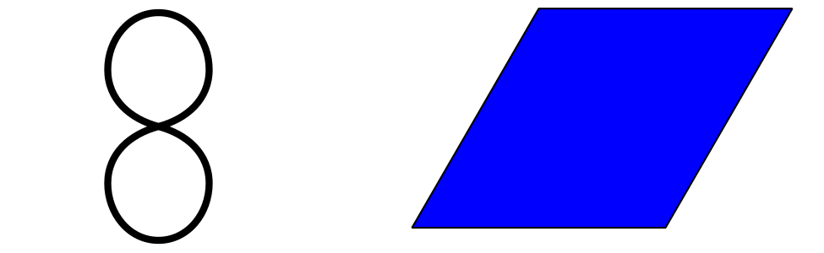
blue rhombuses
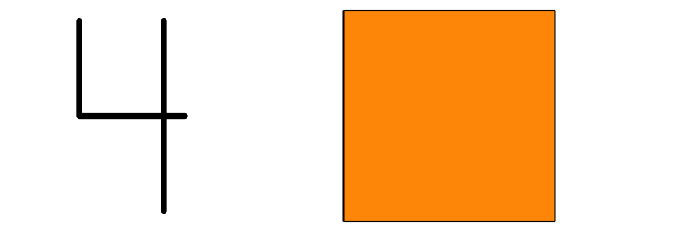
orange squares
I used more ____________________ than ____________________.
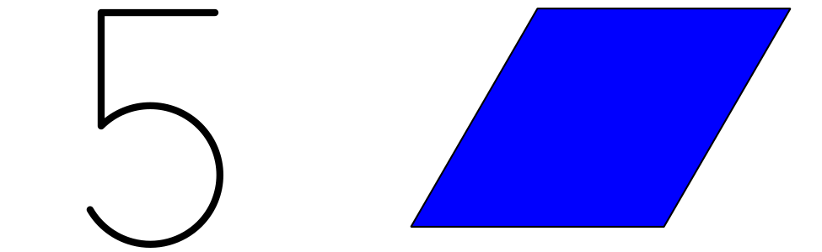
blue rhombuses
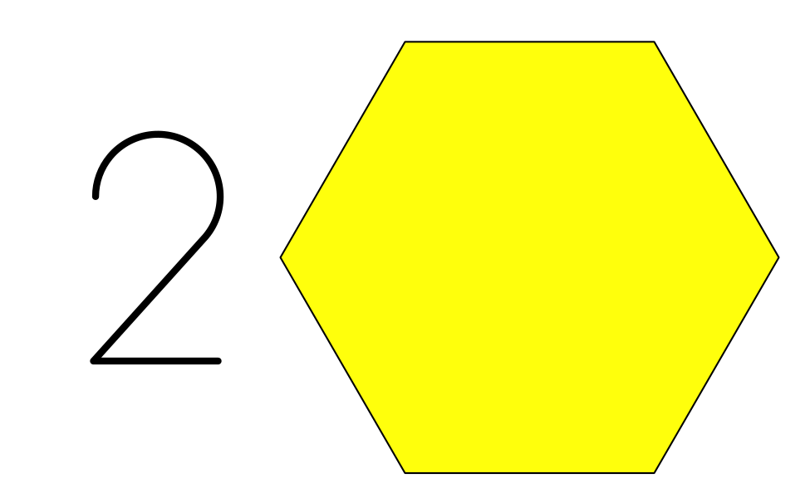
yellow hexagons
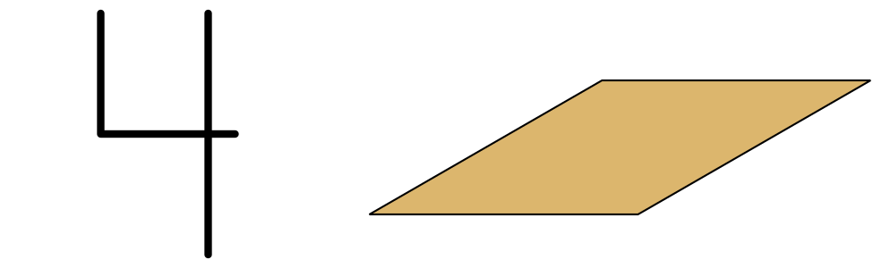
tan rhombuses
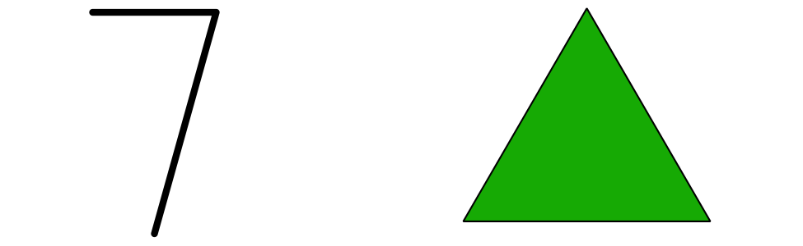
green triangles
I used more ____________________ than ____________________.

10.2: Pattern Block Puzzles
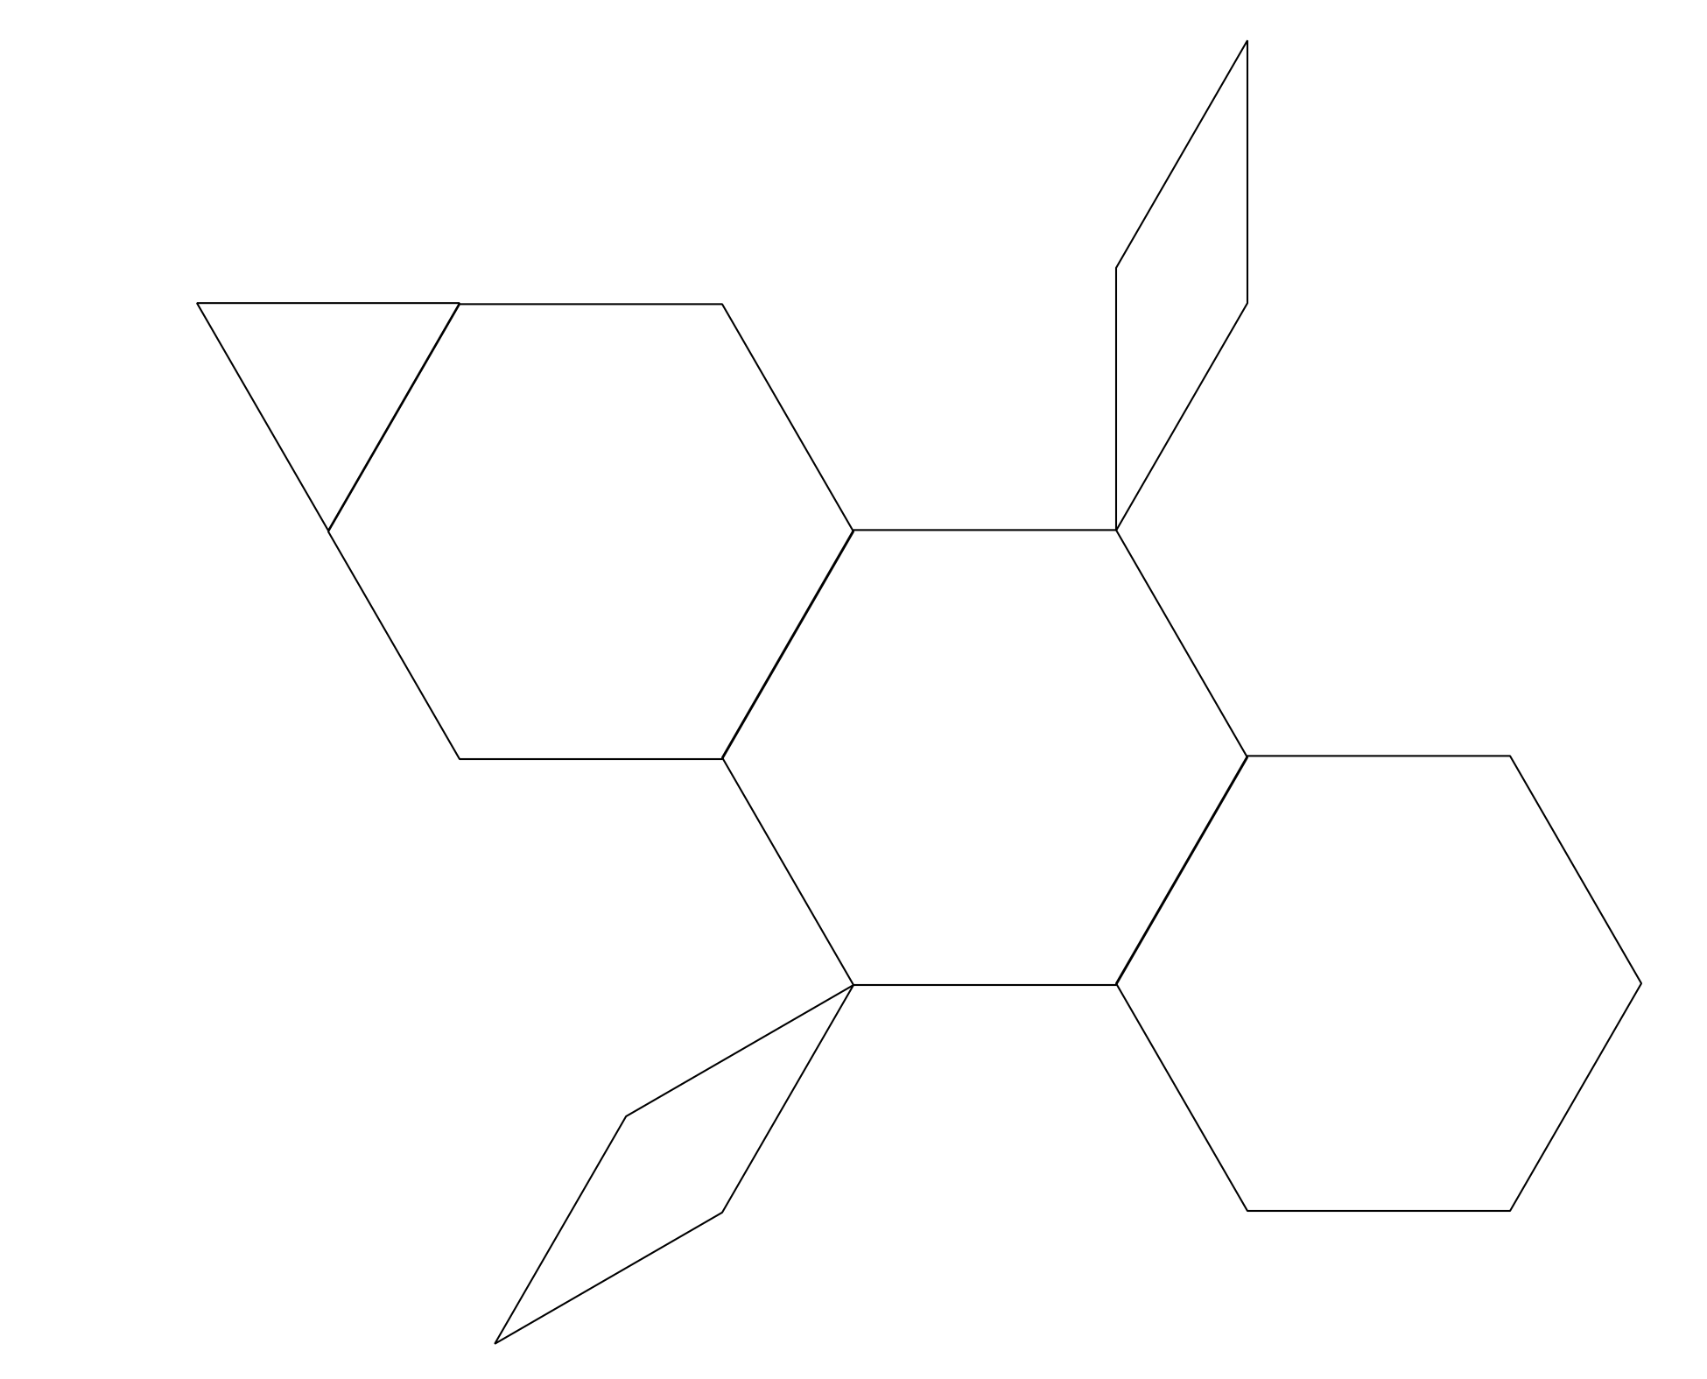
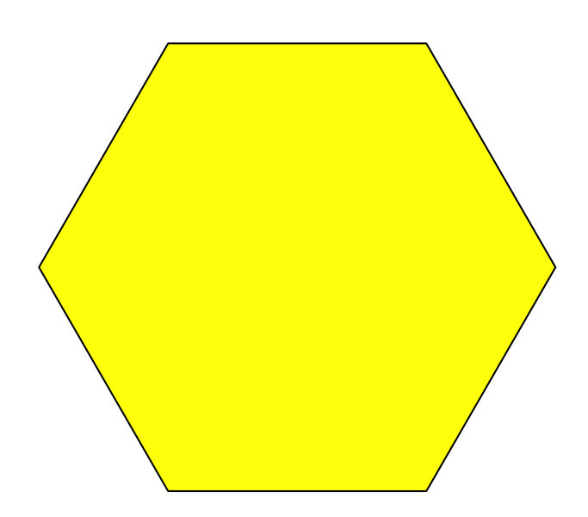
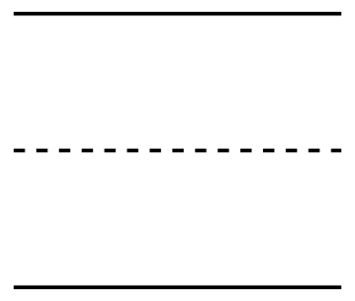
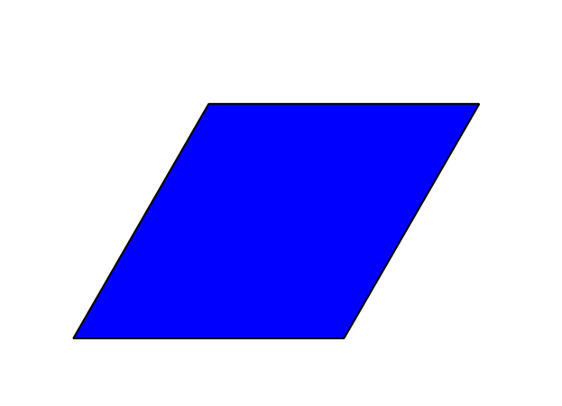
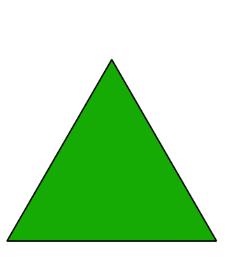
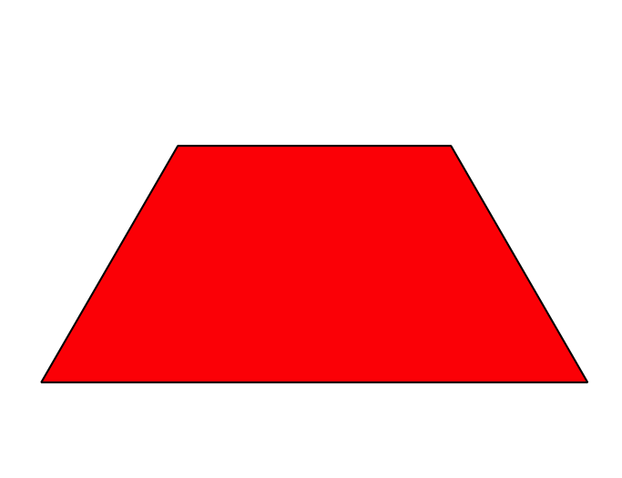
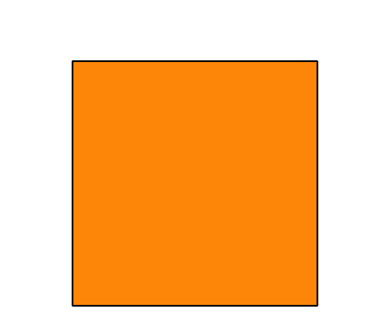
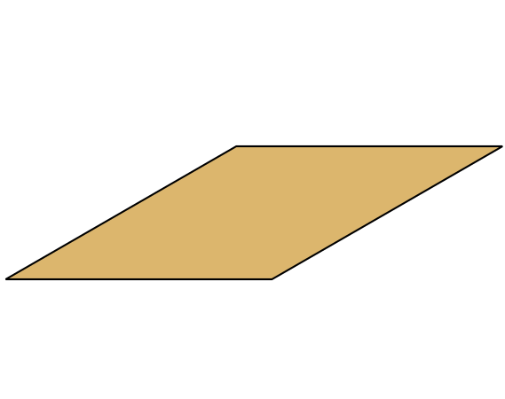

10.3: Centers: Choice Time
Choose a center.
Geoblocks
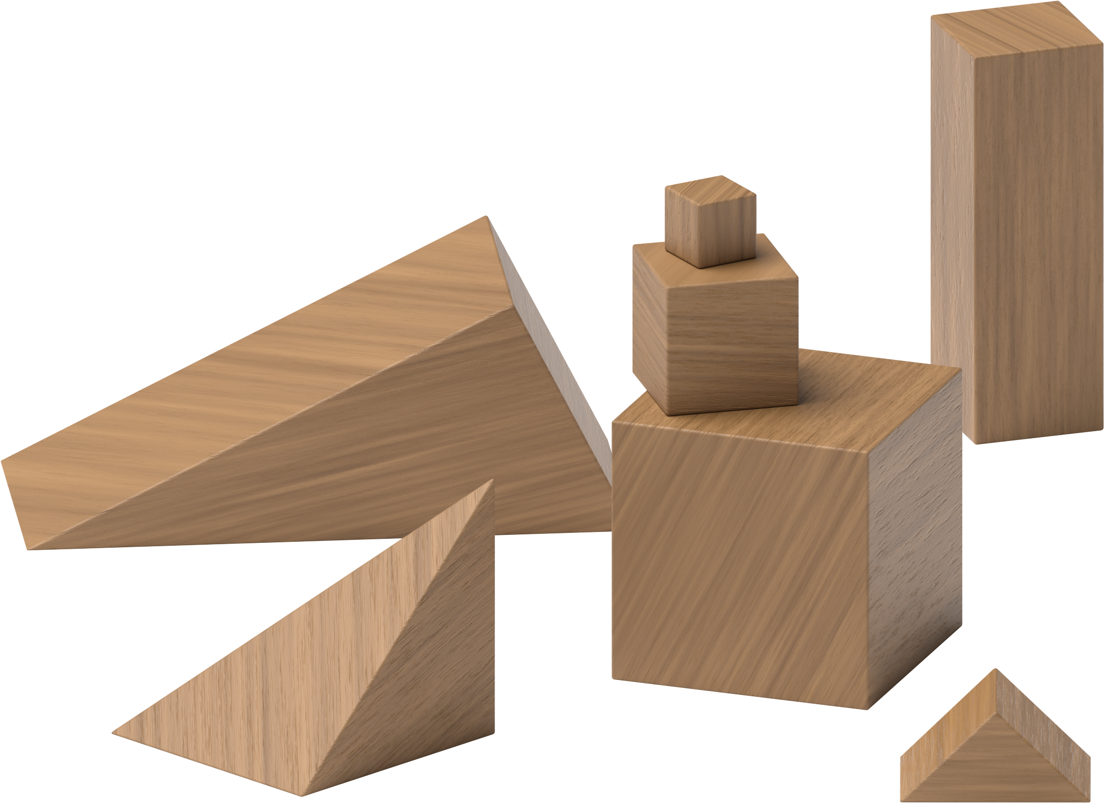
Build Shapes
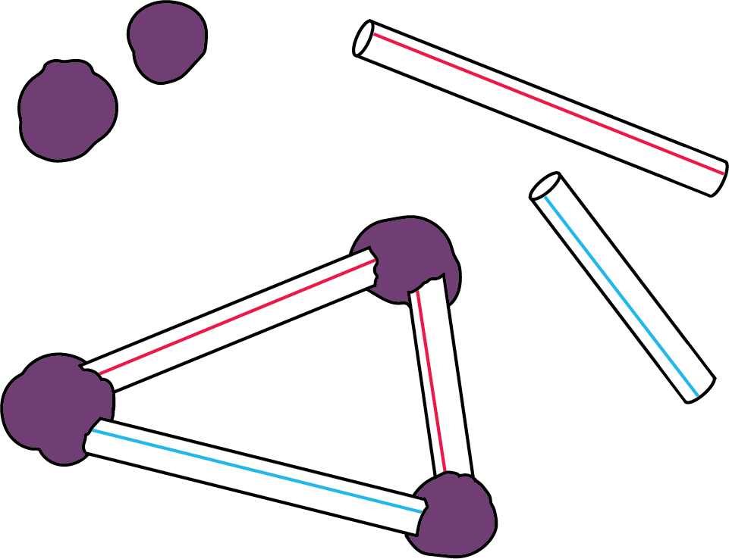
Pattern Blocks
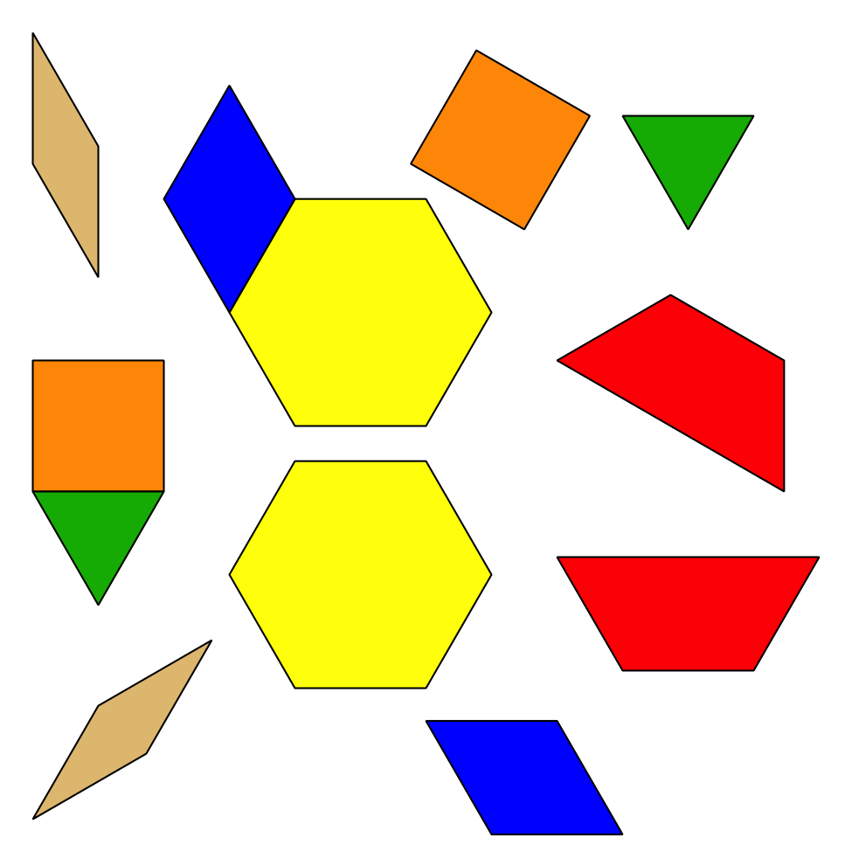
Less, Same, More
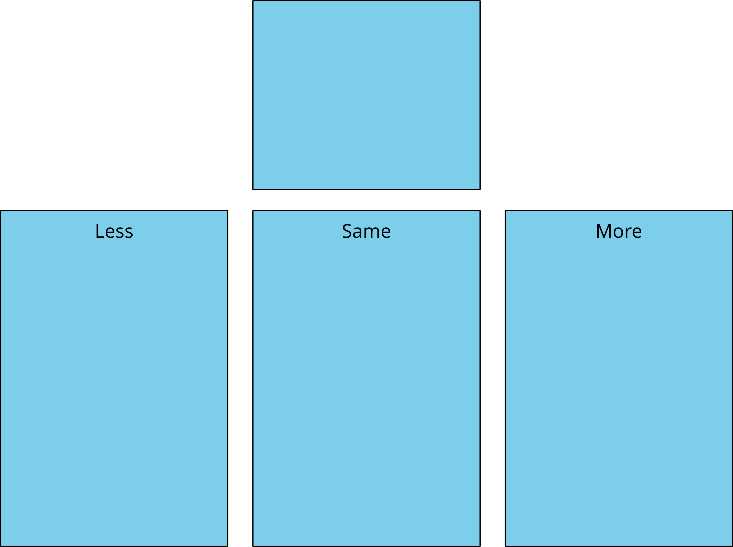
© CC BY 2021 Illustrative Mathematics®

