Lesson 5: Fractions on Number Lines

Standards Alignments
Building On | 3.OA.B.5
Addressing | 4.NF.A.1

Teacher-facing Learning Goals
- Identify equivalent fractions on a number line.
- Recognize that fractions that describe the same point on the number line are equivalent.

Student-facing Learning Goals
- Let’s investigate equivalent fractions on a number line.

Lesson Purpose
The purpose of this lesson is for students to recognize that equivalent fractions describe the same point on the number line and to identify such fractions on the number line.
Prior to this lesson, students used fraction strips and tape diagrams to visualize and represent fractions that are the same size. Here they use number lines to do so. Students are reminded that equivalent fractions describe the same point on the number line, or are the same distance from 0.
To determine whether two fractions are equivalent, students rely on their understanding of fractions with related denominators (in which one denominator is a multiple of another). They practice thinking of certain fractions in terms of other fractions (for instance, thinking that they can split 1 third into 2 sixths, or 1 fifth into 2 tenths).

Access for:

Students with Disabilities
- Representation (Activity 1)

Instructional Routines
MLR3 Clarify, Critique, Correct (Activity 1), Number Talk (Warm-up)

Materials to Gather
- Straightedges: Activity 1

Lesson Timeline
Warm-up | 10 min
Activity 1 | 20 min
Activity 2 | 15 min
Lesson Synthesis | 10 min
Cool-down | 5 min

Teacher Reflection Question
In the next lesson, students will be comparing fractions to $\frac{1}{2}$ and 1, applying what they know about equivalence and distance on a number line. How did today’s work prepare them for that lesson?

Cool-down
(to be completed at the end of the lesson) 5min
Two of the Same

Standards Alignments
Addressing | 4.NF.A.1

Student-facing Task Statement
Show $\frac{5}{6}$ on the number line. Be sure to include labels. Then, explain or show that the fraction $\frac{10}{12}$ is equivalent to $\frac{5}{6}$.

Student Responses
Sample response:
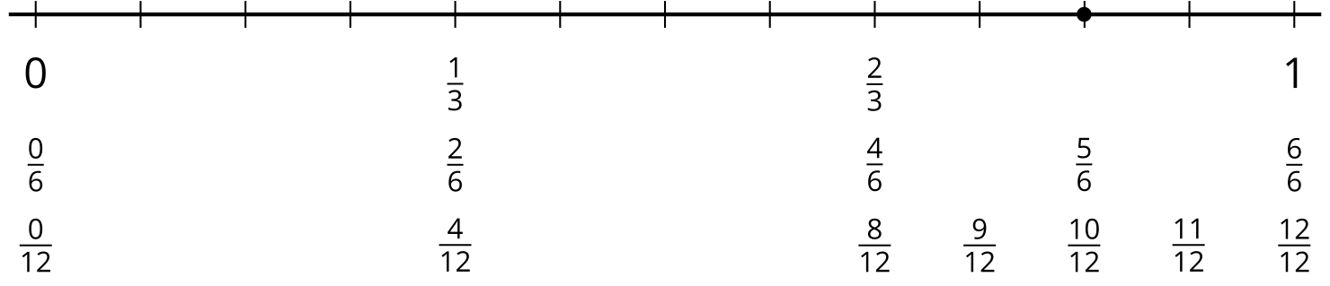
Each third can be partitioned into 2 sixths, and each sixth into 2 twelfths. There are 10 twelfths in 5 sixths.

