Algebra 1
Unit 5Lesson 3CC BY NC 2024 Illustrative Mathematics®
Unit 5, Lesson 3

Interpreting and Using Function Notation
- Let’s use function notation to talk about functions.
Algebra 1
Unit 5Lesson 3CC BY NC 2024 Illustrative Mathematics®

3.1Observing a Drone
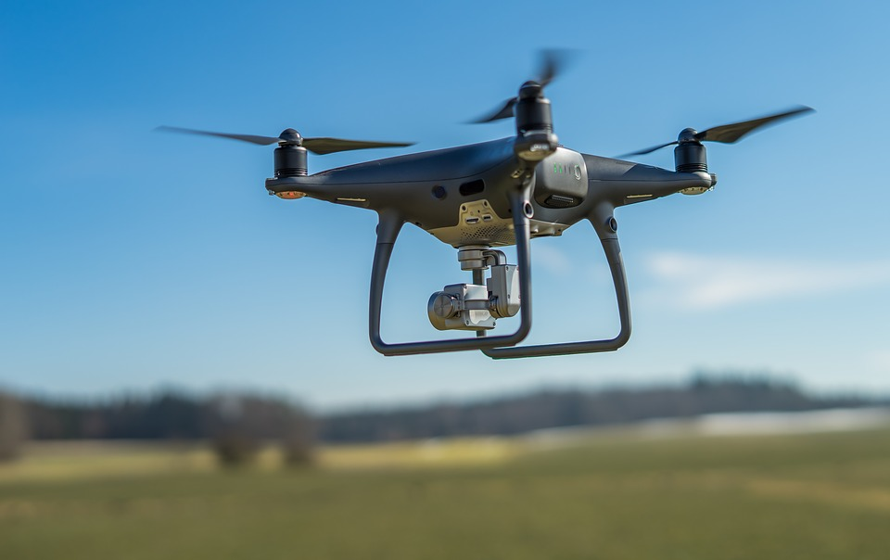
Here is a graph that represents function $f$, which gives the height of a drone, in meters, $t$ seconds after it leaves the ground.
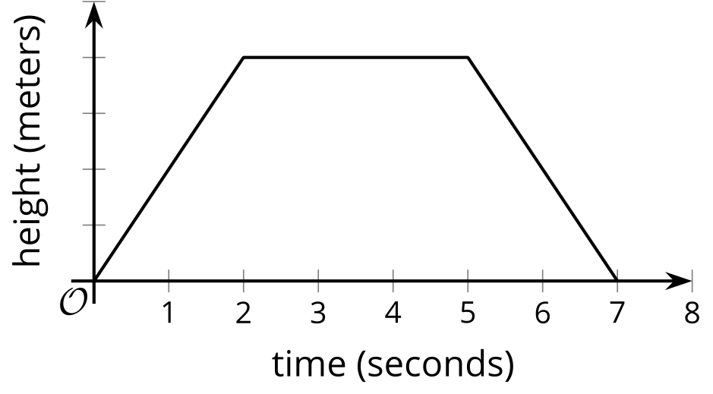
Use the symbol <, >, or = to make a correct statement about these values.
- $f\left(0\right)\underset{_}{​}f\left(4\right)$
- $f\left(2\right)\underset{_}{​}f\left(5\right)$
- $f\left(3\right)\underset{_}{​}f\left(7\right)$
- $f\left(t\right)\underset{_}{​}f\left(t+1\right)$
Algebra 1
Unit 5Lesson 3CC BY NC 2024 Illustrative Mathematics®

3.2Smartphones

The function $P$ gives the number of people, in millions, who own a smartphone $t$ years after year 2000.
- What does each equation tell us about smartphone ownership?
  - $P\left(17\right)=2,​320$
  - $P\left(\text{-}10\right)=0$
- Use function notation to represent each statement.
  - In 2010, the number of people who owned a smartphone was 296,600,000.
  - In 2015, about 1.86 billion people owned a smartphone.
- Mai is curious about the value of $t$ in $P\left(t\right)=1,​000$.
  - What would the value of $t$ tell Mai about the situation?
  - Is 4 a possible value of $t$ here?
- Use the information you have so far to sketch a graph of the function.
- 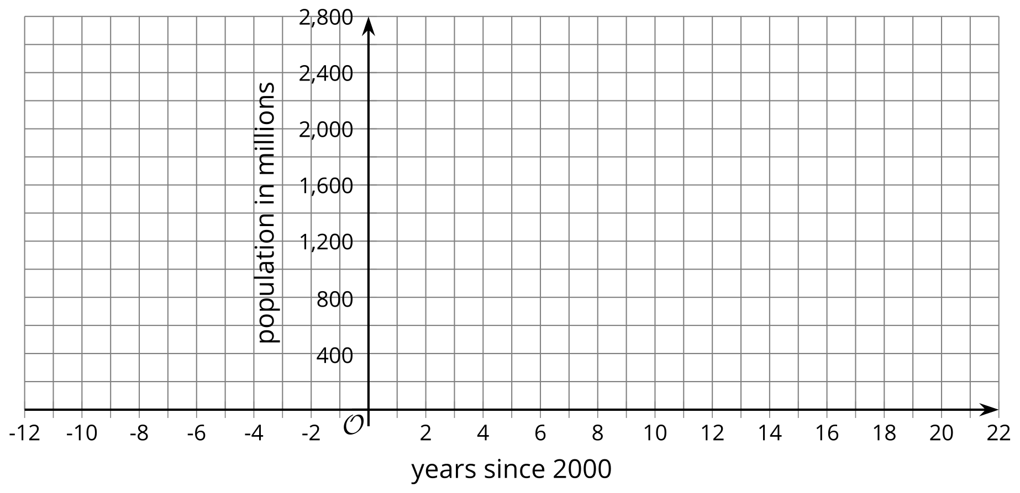

Are you ready for more?
What can you say about the value or values of $t$ when $P\left(t\right)=1,​000$?
Algebra 1
Unit 5Lesson 3CC BY NC 2024 Illustrative Mathematics®

3.3Boiling Water
The function $W$ gives the temperature, in degrees Fahrenheit, of a pot of water on a stove, $t$ minutes after the stove is turned on.
- Take turns with your partner to explain the meaning of each statement in this situation. When it’s your partner’s turn, listen carefully to their interpretation. If you disagree, discuss your thinking and work to reach an agreement.
  - $W\left(0\right)=72$
  - $W\left(5\right)>W\left(2\right)$
  - $W\left(10\right)=212$
  - $W\left(12\right)=W\left(10\right)$
  - $W\left(15\right)>W\left(30\right)$
  - $W\left(0\right)<W\left(30\right)$
- If all statements in the previous question represent the situation, sketch a possible graph of function $W$.
- Be prepared to show where each statement can be seen on your graph.
- 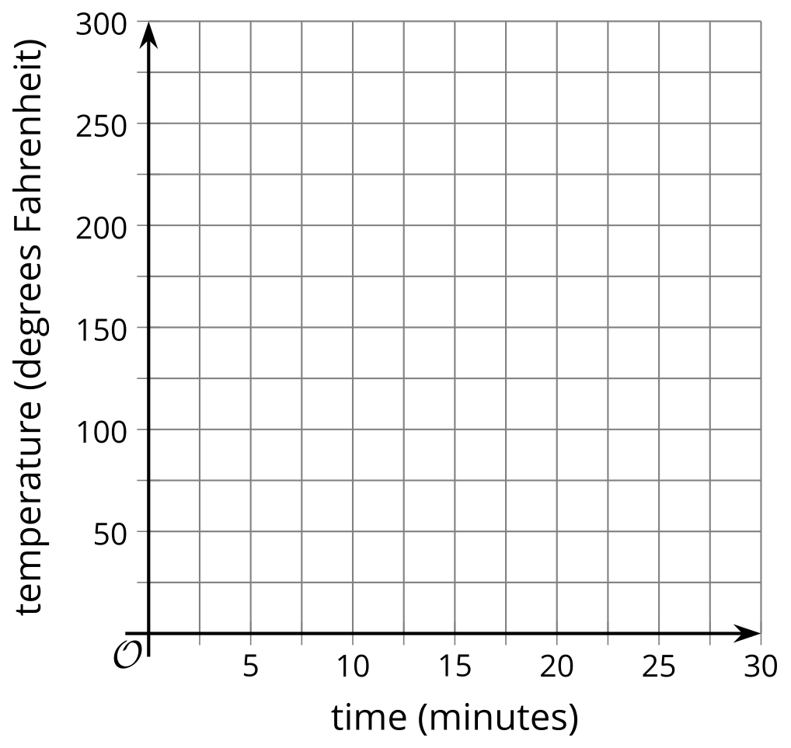

Lesson 3 Summary
What does a statement like $p\left(3\right)=12$ mean?
On its own, $p\left(3\right)=12$ only tells us that when $p$ takes 3 as its input, its output is 12.
If we know what quantities the input and output represent, however, we can learn much more about the situation that the function represents.
- If function $p$ gives the perimeter of a square whose side length is $x$ and both measurements are in inches, then we can interpret $p\left(3\right)=12$ to mean “a square whose side length is 3 inches has a perimeter of 12 inches.”
- We can also interpret statements like $p\left(x\right)=32$ to mean “a square with side length $x$ has a perimeter of 32 inches,” which then allows us to reason that $x$ must be 8 inches and to write $p\left(8\right)=32$.
- If function $p$ gives the number of blog subscribers, in thousands, $x$ months after a blogger started publishing online, then $p\left(3\right)=12$ means “3 months after a blogger starts publishing online, the blog has 12,000 subscribers.”
It is important to pay attention to the units of measurement when analyzing a function. Otherwise, we might mistake what is happening in the situation. If we miss that $p\left(x\right)$ is measured in thousands, we might misinterpret $p\left(x\right)=36$ to mean “there are 36 blog subscribers after $x$ months,” while it actually means “there are 36,000 subscribers after $x$ months.”
A graph of a function can likewise help us interpret statements in function notation.
Function $f$ gives the depth, in inches, of water in a tub as a function of time, $t$, in minutes, since the tub started being drained.
Here is a graph of $f$.
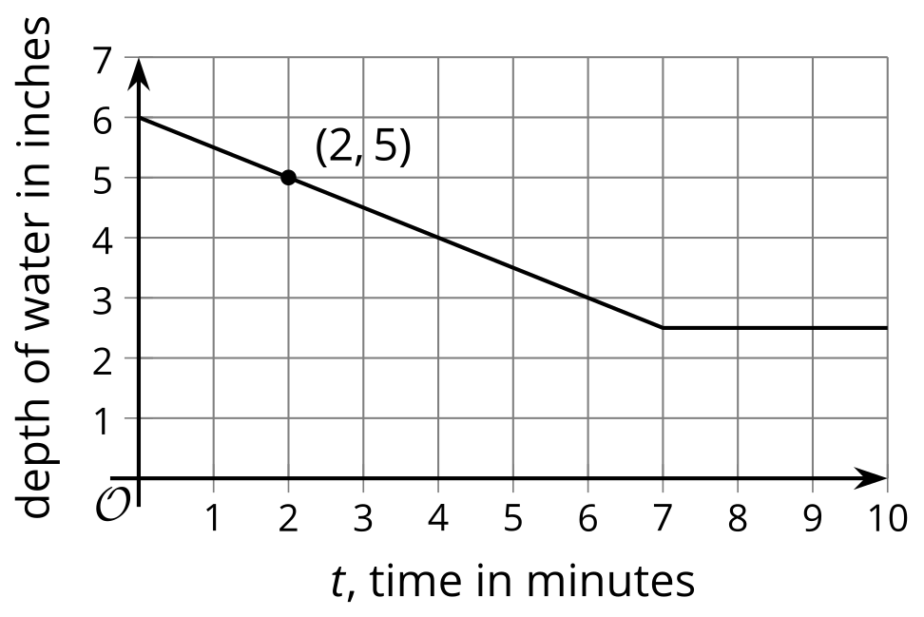
Each point on the graph has the coordinates $\left(t,f\left(t\right)\right)$, where the first value is the input of the function and the second value is the output.
- $f\left(2\right)$ represents the depth of water 2 minutes after the tub started being drained. The graph passes through $\left(2,5\right)$, so the depth of water is 5 inches when $t=2$. The equation $f\left(2\right)=5$ captures this information.
- $f\left(0\right)$ gives the depth of the water when the draining began, when $t=0$. The graph shows the depth of water to be 6 inches at that time, so we can write $f\left(0\right)=6$.
- $f\left(t\right)=3$ tells us that $t$ minutes after the tub started draining, the depth of the water is 3 inches. The graph shows that this happens when $t$ is 6.

