Grade 2
Unit 6Lesson 3CC BY NC 2024 Illustrative Mathematics®
Unit 6, Lesson 3

Specific Side Lengths
- Let’s find and draw shapes with specific side lengths.
Grade 2
Unit 6Lesson 3CC BY NC 2024 Illustrative Mathematics®

Warm-up Which Three Go Together: Different Shapes
Which 3 go together?
A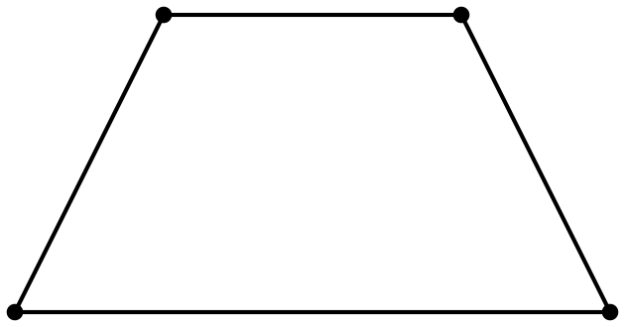
B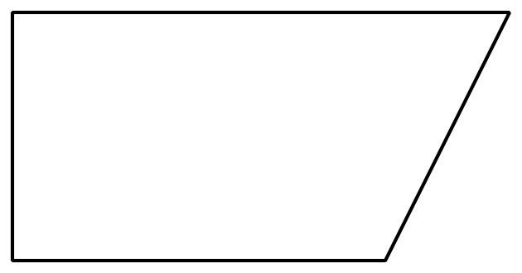
C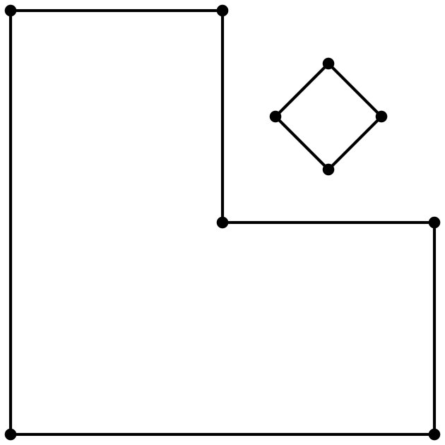
D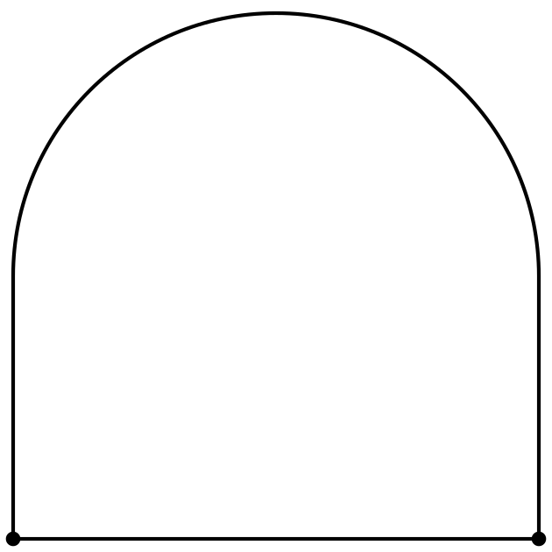
Grade 2
Unit 6Lesson 3CC BY NC 2024 Illustrative Mathematics®

Activity 1Measure Twice, Draw Once
- Diego draws a shape with fewer than 5 sides. Two sides are 3 centimeters long. Circle shapes that could be his shape.
- 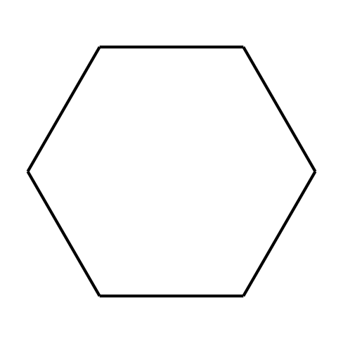
- 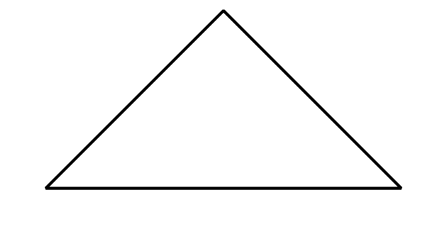
- 
- 
- Tyler draws a shape with 4 sides. Each side is 2 inches long.
  - Circle shapes that could be his shape.
  - 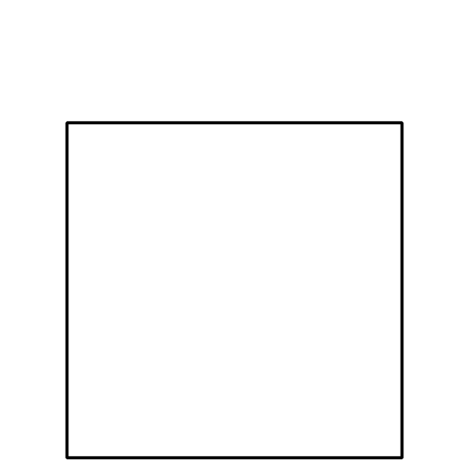
  - 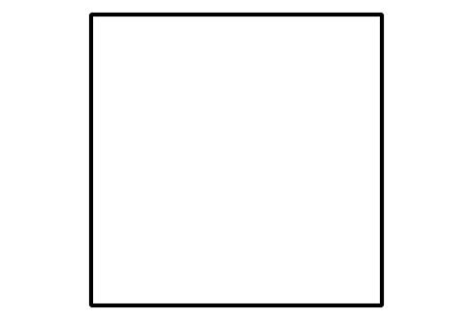
  - 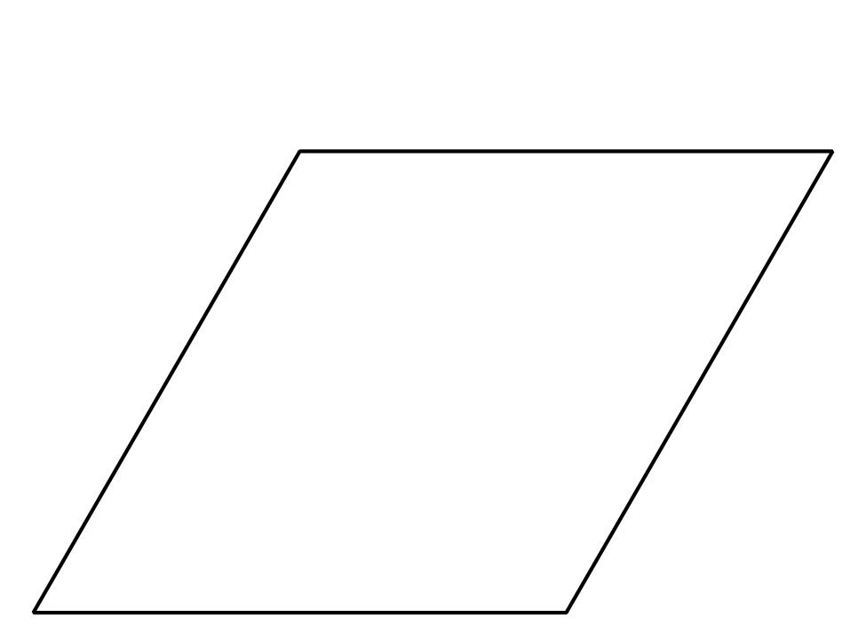
  - Draw another shape that could be Tyler’s shape.
- Priya draws a shape with more sides than Tyler’s shape. Only 1 side of her shape is 2 inches long. Draw 2 shapes that could be her shape.
Grade 2
Unit 6Lesson 3CC BY NC 2024 Illustrative Mathematics®

Activity 2 Build a Shape
- Choose your own attributes. Circle 1 in each row.
- sides | - 3 | - 4 | - 5 | - 6
- corners | - 3 | - 4 | - 5 | - 6
- side  length | - 1 side is 2 in. | - 2 sides are 2 in. | - 2 sides are 3 in. | - 4 sides are 2 in.
- square  corners | - 0 | - 1 | - 2 | - all square corners
- Draw and name a shape with your attributes. If you can’t draw the shape, explain your reasoning.
- Shape:
- Name: ______________________________
- Choose new attributes. Circle 1 in each row.
- sides | - 3 | - 4 | - 5 | - 6
- corners | - 3 | - 4 | - 5 | - 6
- side  length | - 1 side is 2 in. | - 2 sides are 2 in. | - 2 sides are 3 in. | - 4 sides are 2 in.
- square  corners | - 0 | - 1 | - 2 | - all square corners
- Draw and name a shape with your attributes. If you can’t draw the shape, explain your reasoning.
- Shape:
- Name: ______________________________
- Choose new attributes. Circle 1 in each row.
- sides | - 3 | - 4 | - 5 | - 6
- corners | - 3 | - 4 | - 5 | - 6
- side  length | - 1 side is 2 in. | - 2 sides are 2 in. | - 2 sides are 3 in. | - 4 sides are 2 in.
- square  corners | - 0 | - 1 | - 2 | - all square corners
- Draw and name a shape with your attributes. If you can’t draw the shape, explain your reasoning.
- Shape:
- Name: ______________________________
- Cover your attribute table. Trade papers with your partner. Guess which attributes they used.
- If you have time: Are there any attributes that are impossible to put together to make a shape? Show your thinking, using drawings, numbers, or words.

