Lesson 8 Practice Problems
- For each situation, complete the tape diagram to represent and answer the question.
  - Mai has picked 1 cup of strawberries for a cake, which is enough for $\frac{3}{4}$ of the cake. How many cups does she need for the whole cake?
  - 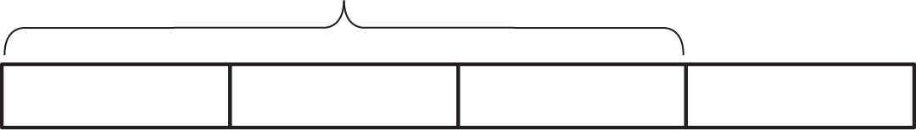
  - Priya has picked $1\frac{1}{2}$ cups of raspberries, which is enough for $\frac{3}{4}$ of a cake. How many cups does she need for the whole cake?
- Consider the problem: Tyler painted $\frac{9}{2}$ square yards of wall area with 3 gallons of paint. How many gallons of paint does it take to paint each square yard of wall?
  - Write multiplication and division equations to represent the situation.
  - Draw a diagram to represent and answer the question.
- Consider the problem: After walking $\frac{1}{4}$ mile from home, Han is $\frac{1}{3}$ of his way to school. What is the distance between his home and school?
  - Write multiplication and division equations to represent this situation.
  - Complete the diagram to represent and answer the question.
  - 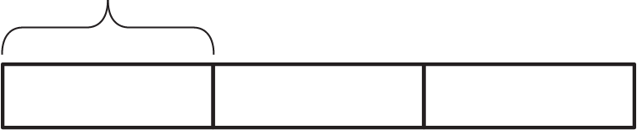
- Here is a division equation: $\frac{4}{5}÷\frac{2}{3}=?$
  - Write a multiplication equation that corresponds to the division equation.
  - Draw a diagram to represent and answer the question.
- (From Unit 4, Lesson 7.)
- Consider the problem: A set of books that are each 1.5 inches wide are being organized on a bookshelf that is 36 inches wide. How many books can fit on the shelf?
  - Write multiplication and division equations to represent the situation.
  - Find the answer. Draw a diagram, if needed.
  - Use the multiplication equation to check your answer.
- (From Unit 4, Lesson 3.)

  - Without calculating, order the quotients from smallest to largest.
  - $56÷8$
  - $56÷8,​000,​000$
  - $56÷0.000008$
  - Explain how you decided the order of the three expressions.
  - Find a number $n$ so that $56÷n$ is greater than 1 but less than 7.
- (From Unit 4, Lesson 1.)
© CC BY Open Up Resources. Adaptations CC BY IM.

