Grade 6
Unit 4Lesson 16CC BY NC Illustrative Mathematics, based on IM 6–8 Math, CC BY Open Up Resources.
Unit 4, Lesson 16

Solving Problems Involving Fractions
Let’s add, subtract, multiply, and divide fractions.
Grade 6
Unit 4Lesson 16CC BY NC Illustrative Mathematics, based on IM 6–8 Math, CC BY Open Up Resources.

16.1Operations with Fractions
Without calculating, order the expressions according to their values from least to greatest.
Be prepared to explain your reasoning.
$\frac{3}{4}+\frac{2}{3}$
$\frac{3}{4}−\frac{2}{3}$
$\frac{3}{4}⋅\frac{2}{3}$
$\frac{3}{4}÷\frac{2}{3}$
Grade 6
Unit 4Lesson 16CC BY NC Illustrative Mathematics, based on IM 6–8 Math, CC BY Open Up Resources.

16.2Situations with $\frac{3}{4}$ and $\frac{1}{2}$
Here are four situations that involve $\frac{3}{4}$ and $\frac{1}{2}$.
- Before calculating, estimate if each answer is greater than 1 or less than 1.
- Write a multiplication equation or division equation for the situation.
- Answer the question. Show your reasoning. Draw a tape diagram, if needed.
- There was $\frac{3}{4}$ liter of water in Andre’s water bottle. Andre drank $\frac{1}{2}$ of the water. How many liters of water did he drink?
- The distance from Han’s house to his school is $\frac{3}{4}$ kilometer. Han walked $\frac{1}{2}$ kilometer. What fraction of the distance from his house to the school did Han walk?
- Priya’s goal was to collect $\frac{1}{2}$ kilogram of cans to recycle. She collected $\frac{3}{4}$ kilogram of cans. How many times her goal was the amount of cans she collected?
- Mai’s class volunteered to clean a park with an area of $\frac{1}{2}$ square mile. Before they took a lunch break, the class had cleaned $\frac{3}{4}$ of the park. How many square miles had they cleaned before lunch?
Grade 6
Unit 4Lesson 16CC BY NC Illustrative Mathematics, based on IM 6–8 Math, CC BY Open Up Resources.

16.3Pairs of Problems
Here are two sets of problems.
A1. Lin’s bottle holds $3\frac{1}{4}$ cups of water. She drank 1 cup of water. What fraction of the water in the bottle did she drink?
A2. Lin’s bottle holds $3\frac{1}{4}$ cups of water. After she drank some, there were $1\frac{1}{2}$ cups of water in the bottle. How many cups did she drink?
B1. Plant A is $\frac{16}{3}$ feet tall. This is $\frac{4}{5}$ as tall as Plant B. How tall is Plant B?
B2. Plant A is $\frac{16}{3}$ feet tall. Plant C is $\frac{4}{5}$ as tall as Plant A. How tall is Plant C?
C1. $\frac{8}{9}$ kilogram of berries is put into a container that already has $\frac{7}{3}$ kilograms of berries. How many kilograms are in the container?
C2. A container with $\frac{8}{9}$ kilogram of berries is $\frac{2}{3}$ full. How many kilograms can the container hold?
D1. The area of a rectangle is $14\frac{1}{2}$ sq cm and one side is $4\frac{1}{2}$ cm. How long is the other side?
D2. The side lengths of a rectangle are $4\frac{1}{2}$ cm and $2\frac{2}{5}$ cm. What is the area of the rectangle?
E1. A stack of magazines is $4\frac{2}{5}$ inches high. The stack needs to fit into a box that is $2\frac{1}{8}$ inches high. How many inches too high is the stack?
E2. A stack of magazines is $4\frac{2}{5}$ inches high. Each magazine is $\frac{2}{5}$-inch thick. How many magazines are in the stack?
- Take turns with your partner to write equations to represent the situations.
  - For each equation that you write, explain to your partner how you know it describes the situation correctly.
  - For each equation that your partner writes, listen carefully to their explanation. If you disagree, discuss your thinking and work to reach an agreement.
- Your teacher will assign 2 or 3 questions for you to answer. For each question:
  - Estimate the answer before calculating it.
  - Find the answer, and show your reasoning.
Grade 6
Unit 4Lesson 16CC BY NC Illustrative Mathematics, based on IM 6–8 Math, CC BY Open Up Resources.

16.4Making Ornaments
Mai, Kiran, and Clare are making dough ornaments together. To make one batch of the dough, they need $\frac{3}{4}$ cup of flour and $\frac{1}{3}$ cup of salt. They each brought the ingredients they had at home.
- Mai brought 2 cups of flour and $\frac{1}{4}$ cup of salt.
- Kiran brought 1 cup of flour and $\frac{1}{2}$ cup of salt.
- Clare brought $1\frac{1}{4}$ cups of flour and $\frac{3}{4}$ cup of salt.
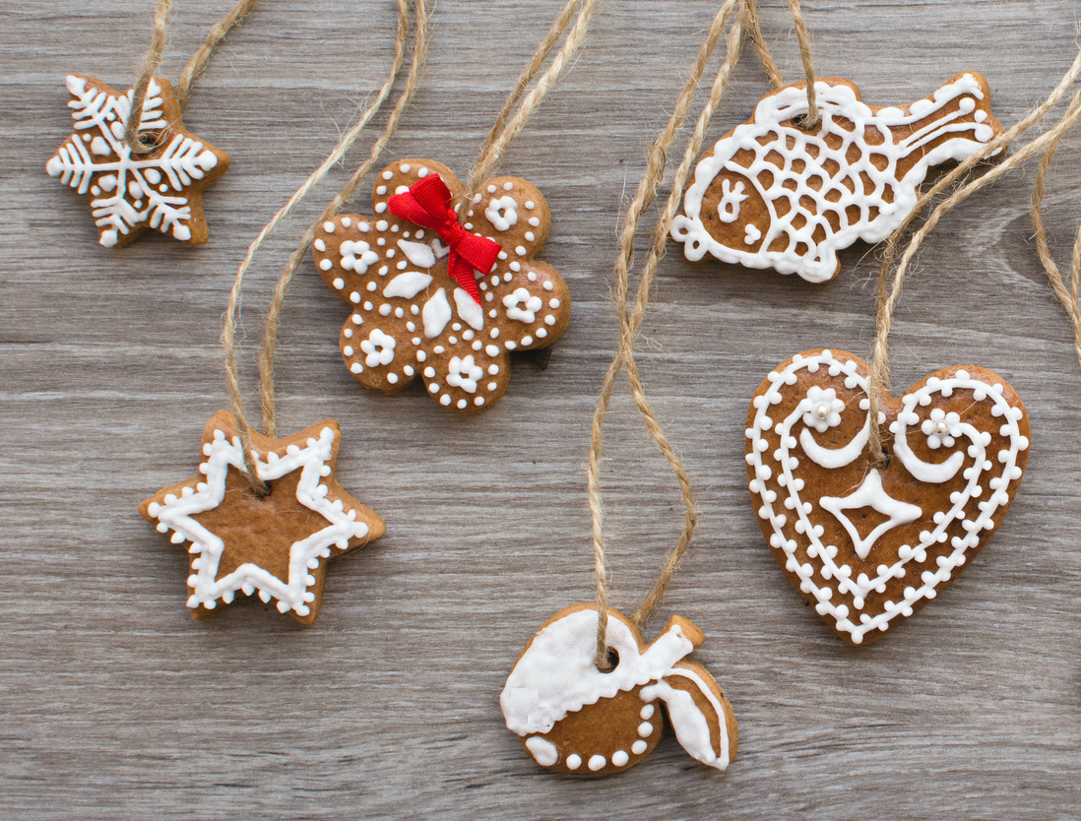
If the students have plenty of the other ingredients in the recipe, how many whole batches of ornaments can they make? Explain your reasoning.

Lesson 16 Summary
We can add, subtract, multiply, and divide both whole numbers and fractions. Here is a summary of how we add, subtract, multiply, and divide fractions.
- To add or subtract fractions, we often look for a common denominator so the pieces involved are the same size. This makes it easy to add or subtract the pieces.
$\frac{3}{2}−\frac{4}{5}=\frac{15}{10}−\frac{8}{10}$
- To multiply fractions, we often multiply the numerators and the denominators.
$\frac{3}{8}⋅\frac{5}{9}=\frac{3⋅5}{8⋅9}$
- To divide a number by a fraction $\frac{a}{b}$, we can multiply the number by $\frac{b}{a}$, which is the reciprocal of $\frac{a}{b}$.
$\frac{4}{7}÷\frac{5}{3}=\frac{4}{7}⋅\frac{3}{5}$

