Unit 6 Lesson 17: Comparing Transformations

1 Three Functions (Warm up)

Student Task Statement
For each pair of graphs, be prepared to describe a transformation from the graph on top to the graph on bottom.
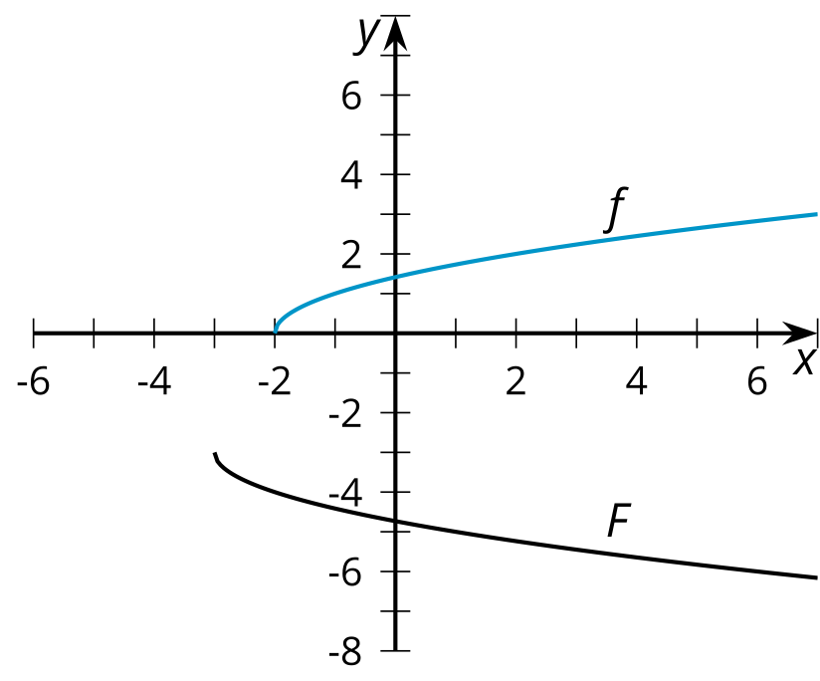
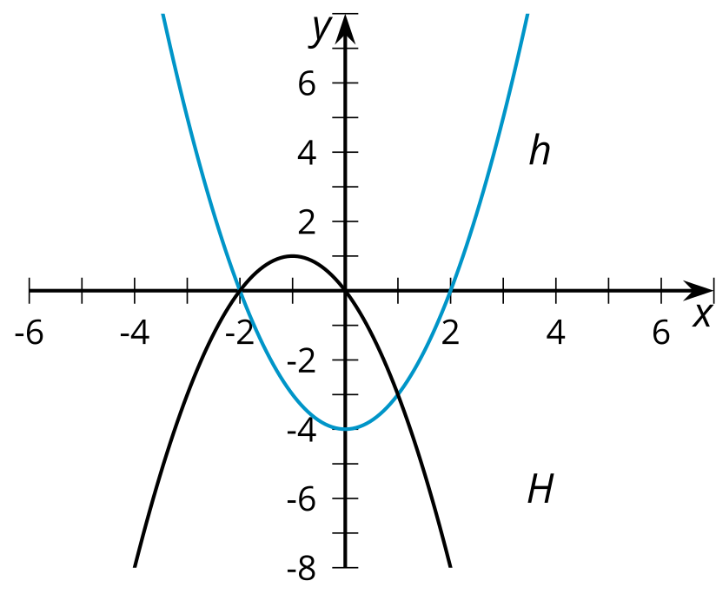
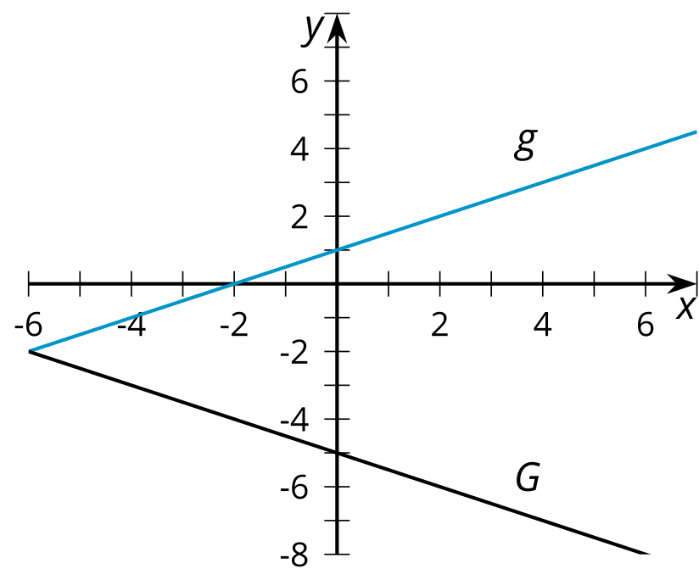

2 Info Gap: What's the Transformation?

Student Task Statement
Your teacher will give you either a problem card or a data card. Do not show or read your card to your partner.
If your teacher gives you the data card:
- Silently read the information on your card.
- Ask your partner “What specific information do you need?” and wait for your partner to ask for information. Only give information that is on your card. (Do not figure out anything for your partner!)
- Before telling your partner the information, ask “Why do you need to know (that piece of information)?”
- Read the problem card, and solve the problem independently.
- Share the data card, and discuss your reasoning.
If your teacher gives you the problem card:
- Silently read your card and think about what information you need to answer the question.
- Ask your partner for the specific information that you need.
- Explain to your partner how you are using the information to solve the problem.
- When you have enough information, share the problem card with your partner, and solve the problem independently.
- Read the data card, and discuss your reasoning.

3 Match the Graph (Optional)

Student Task Statement
Here is the graph of $f\left(x\right)=cos\left(x\right)$ and the graph of $g$, which is a transformation of $f$.
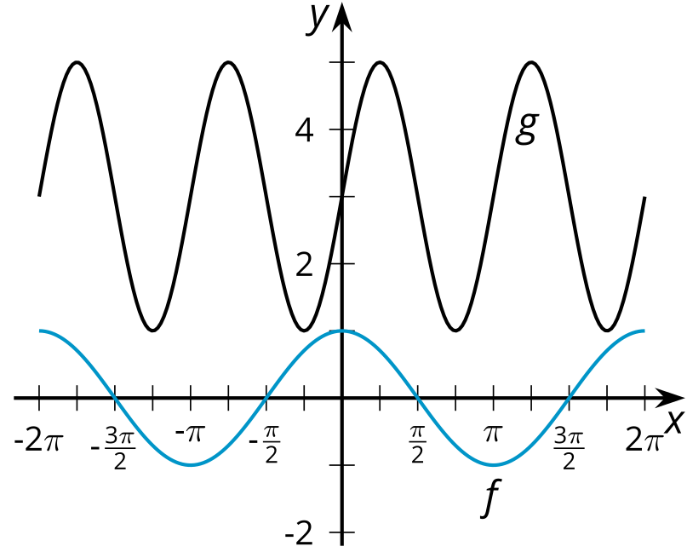
- Identify a transformation that takes $f$ to $g$ and write an equation for $g$ in terms of $f$ matching the transformation.
- Identify at least one other transformation that takes $f$ to $g$ and write an equation for $g$ in terms of $f$ matching the transformation.
© CC BY 2019 by Illustrative Mathematics®

