Lesson 12: Exploring Circumference
Let’s explore the circumference of circles.

12.1: Which Is Greater?
Clare wonders if the height of the toilet paper tube or the distance around the tube is greater. What information would she need in order to solve the problem? How could she find this out?
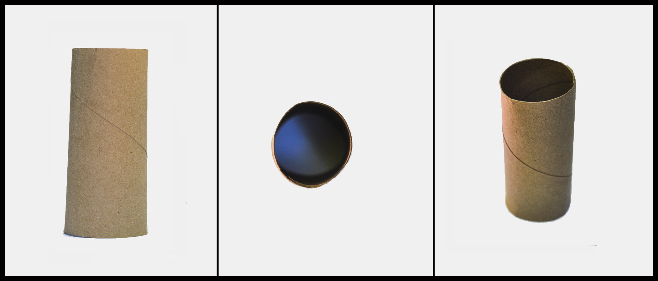

12.2: Measuring Circumference and Diameter
Your teacher will give you several circular objects.
- Measure the diameter and the circumference of the circle in each object to the nearest tenth of a centimeter. Record your measurements in the table.
- object | - diameter (cm) | - circumference (cm)
- Plot the diameter and circumference values from the table on the coordinate plane. What do you notice?
- 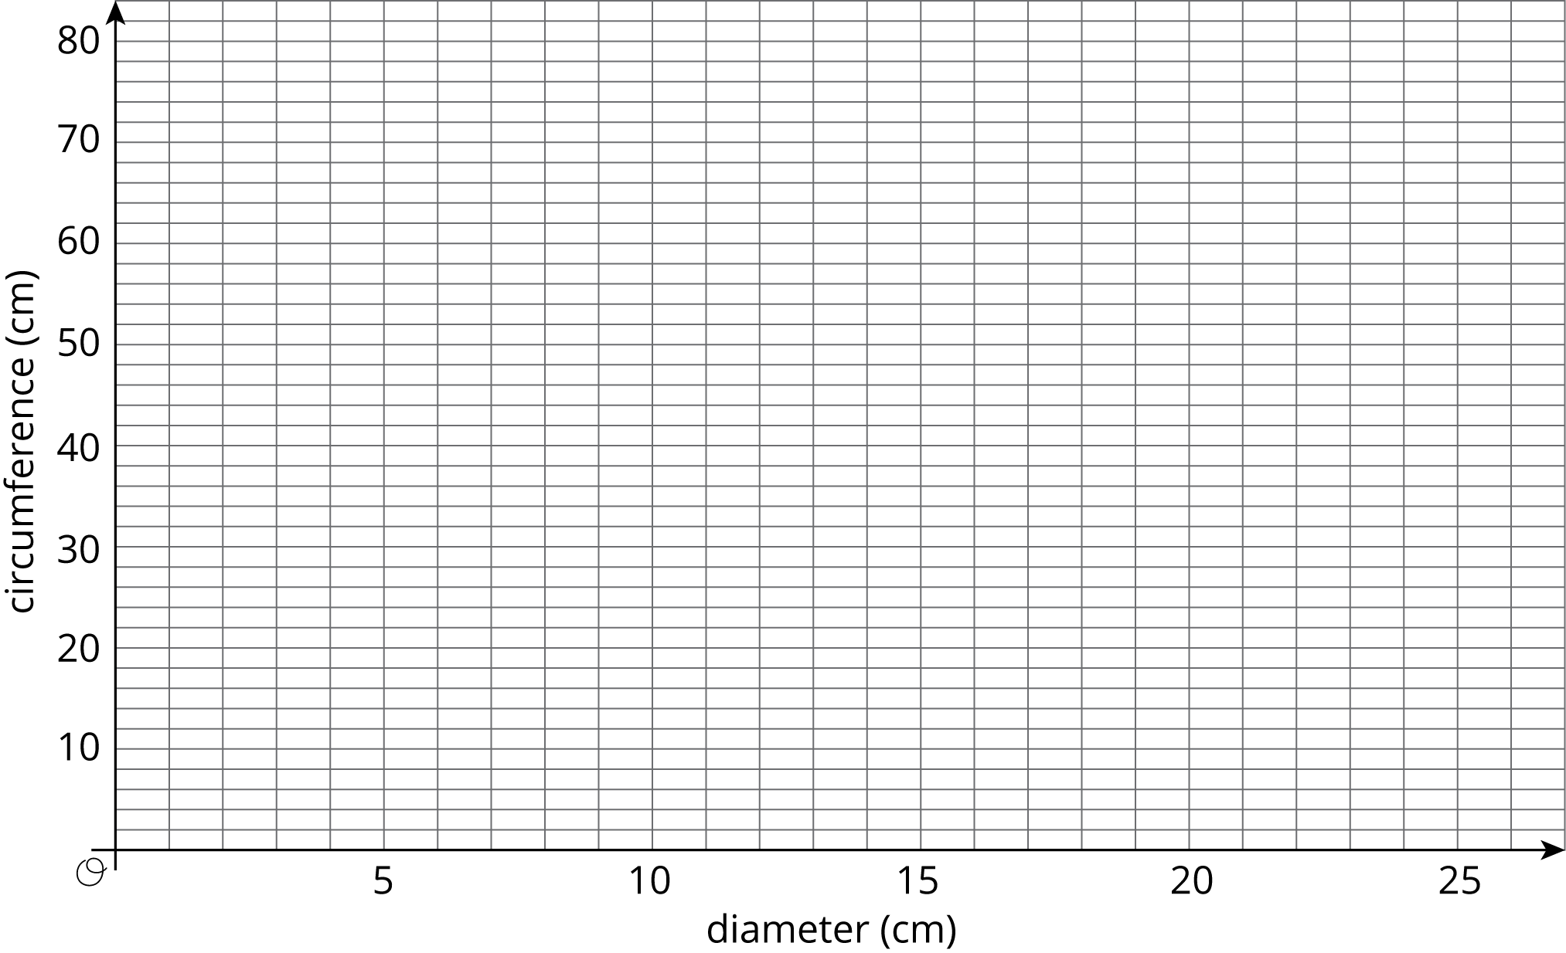
- Plot the points from two other groups on the same coordinate plane. Do you see the same pattern that you noticed earlier?

12.3: Calculating Circumference and Diameter
Here are five circles. One measurement for each circle is given in the table.
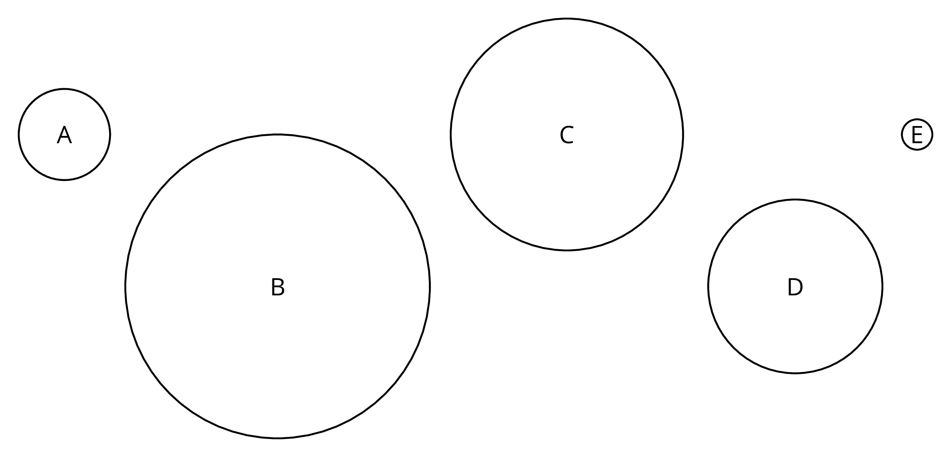
Use the constant of proportionality estimated in the previous activity to complete the table.
 | diameter (cm) | circumference (cm)
circle A | 3
circle B | 10
circle C |  | 24
circle D |  | 18
circle E | 1

Are you ready for more?
The circumference of Earth is approximately 40,000 km. If you made a circle of wire around the globe, that is only 10 meters (0.01 km) longer than the circumference of the globe, could a flea, a mouse, or even a person creep under it?

Lesson 12 Summary
There is a proportional relationship between the diameter and circumference of any circle. That means that if we write $C$ for circumference and $d$ for diameter, we know that $C=kd$, where $k$ is the constant of proportionality.
The exact value for the constant of proportionality is called $π$. Some frequently used approximations for $π$ are $\frac{22}{7}$, 3.14, and 3.14159, but none of these is exactly $π$.
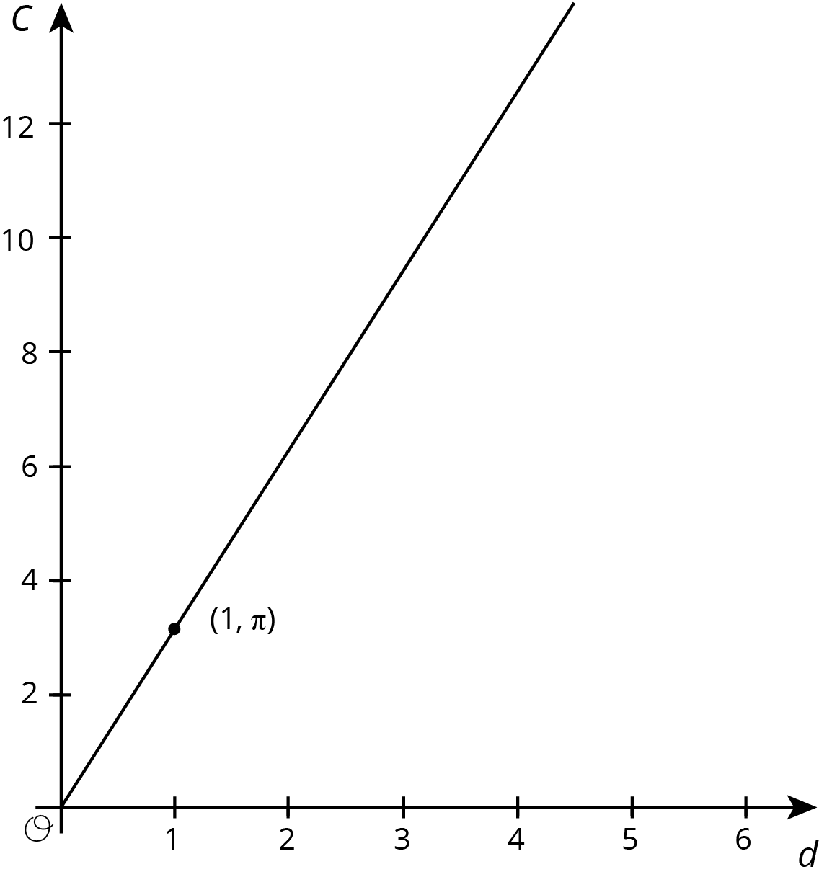
We can use this to estimate the circumference if we know the diameter, and vice versa. For example, using 3.1 as an approximation for $π$, if a circle has a diameter of 4 cm, then the circumference is about $\left(3.1\right)⋅4=12.4$ or 12.4 cm.
The relationship between the circumference and the diameter can be written as
$C=πd$
© CC BY Open Up Resources. Adaptations CC BY IM.

