Algebra 1
Unit 4Lesson 9CC BY NC 2024 Illustrative Mathematics®
Unit 4, Lesson 9

Modeling with Systems of Inequalities in Two Variables
- Let’s create mathematical models using systems of inequalities.
Algebra 1
Unit 4Lesson 9CC BY NC 2024 Illustrative Mathematics®

9.1An Enjoyment Quotient
Complete the table with your own relative values, giving walk the same baseline value of 1.
 | Jada's enjoyment per mi | your enjoyment per mi
bus | 0.5
train | 1.5
bike rental | 2
scooter rental | 0.8
walk | 1 | 1
car | 1.3
Algebra 1
Unit 4Lesson 9CC BY NC 2024 Illustrative Mathematics®

9.2Custom Trip
Here is some information about different types of travel in the city where Tyler and Jada live.
 | cost | minutes per mi | emissions per mi (g CO₂ per mi) | Tyler's enjoyment per mi | Jada's enjoyment per mi
bus | $2.50 | 4.6 | 660 | 1.2 | 0.5
train | $2.50 | 3 | 125 | 2.2 | 1.5
bike rental | $20 | 4 | 0 | 1.3 | 2
scooter rental | $1 to start then  $0.80 per mi | 4 | 202 | 1.5 | 0.8
walk | $0 | 20 | 0 | 1 | 1
car | $0.13 | 2 | 375 | 2 | 1.3
Tyler and Jada each choose their own methods of transport using two of these options. They write inequalities and create graphs to represent their constraints.
Tyler
- $x+y>50$
- $2.50+0x+0.13y≤6$
- $660x+375y<30,​000$
- $x>0$
- $y>0$
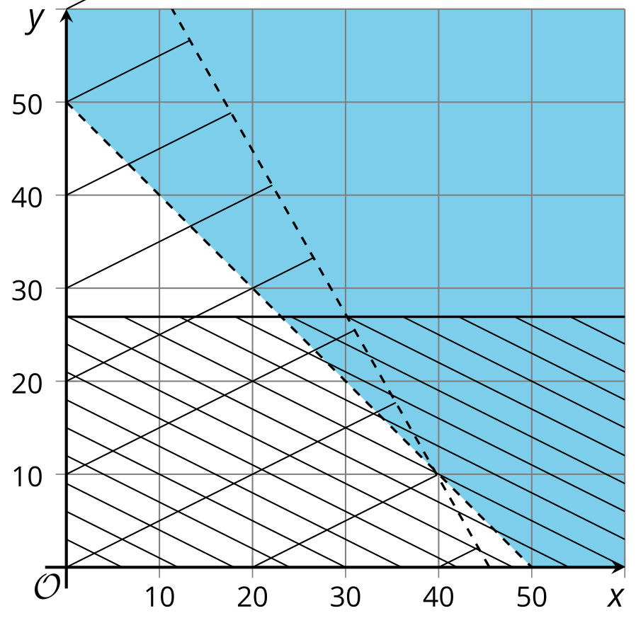
Jada
- $w+z>20$
- $2w+1.5z>35$
- $5w+3z<120$
- $w>0$
- $z>0$
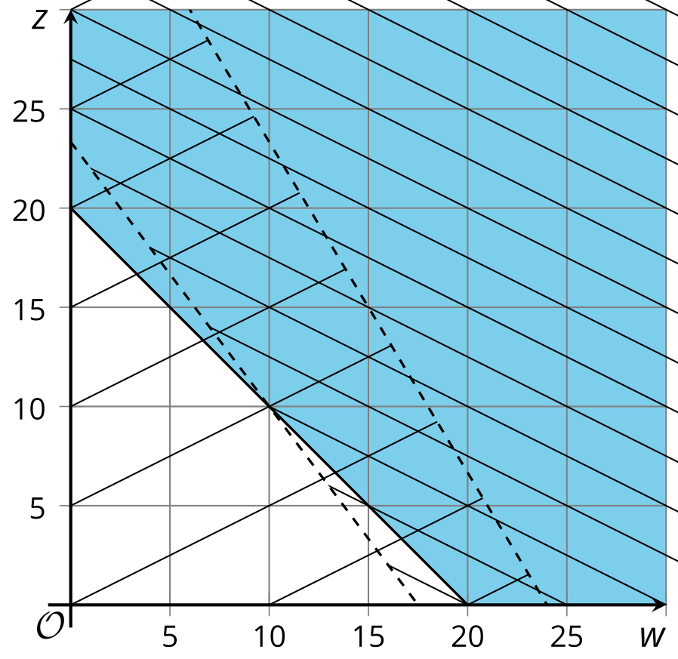
Use the inequalities and graphs to answer these questions about each student’s travel methods. Be prepared to explain your reasoning.
- Which modes of transport did they choose?
- What do their variables represent?
- What does each constraint mean?
- Which region of the graph represents which constraint?
- Name one possible combination of values for the variables that satisfy all the constraints.
Algebra 1
Unit 4Lesson 9CC BY NC 2024 Illustrative Mathematics®

9.3Design Your Own Trip
It's time to design your own trip!
- Choose two modes of transit that you like. (You can choose from the options in the previous activity, or you can look up information for other methods.)
- Think about the constraints for your trip. What do you want to be true about its total distance, speed, emissions, or happiness? Feel free to research additional constraints that you are interested in and that can be expressed as a per mile rate.
- Write inequalities to represent your constraints. Then graph the inequalities.
- 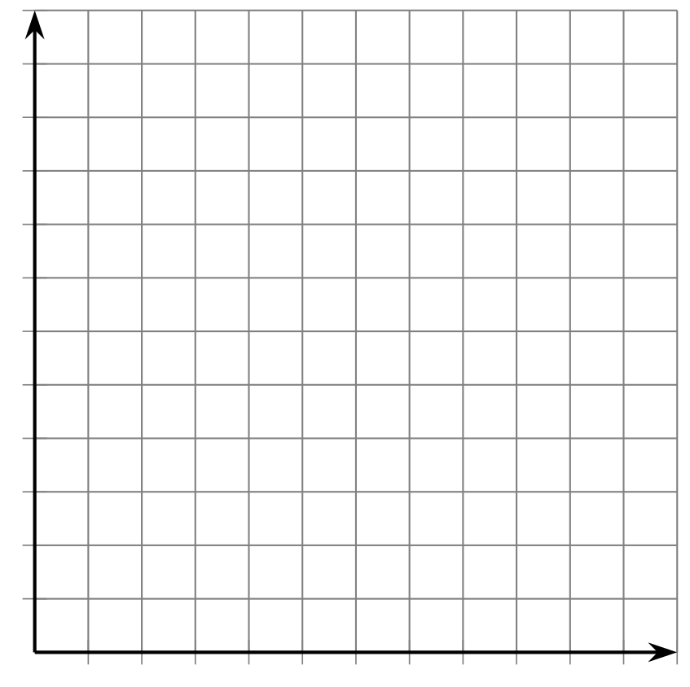
- Is it possible to plan a trip that meets all of your constraints? If not, make changes to your constraints or your transit methods, and record them here.
- Write a possible combination of distances on each method of transit that satisfies all the constraints.
Create a display explaining your work.

