Grade 2
Unit 9Lesson 10CC BY NC 2024 Illustrative Mathematics®
Unit 9, Lesson 10

What’s the Question?
- Let’s determine the question in story problems.
Grade 2
Unit 9Lesson 10CC BY NC 2024 Illustrative Mathematics®

Warm-up Notice and Wonder: A Day in the Park
There are 37 kids on the soccer field. There are 18 kids on the tennis courts. There are 25 kids at the picnic tables.
What do you notice? What do you wonder?
Grade 2
Unit 9Lesson 10CC BY NC 2024 Illustrative Mathematics®

Activity 1Asked and Answered
Elena picks 29 apples. She picks 14 fewer apples than Han. Han picks 15 more apples than Diego.
- Write a question someone could answer with this information.
- Answer your question. Show your thinking using drawings, numbers, or words.
Grade 2
Unit 9Lesson 10CC BY NC 2024 Illustrative Mathematics®

Activity 2What Is the Question?
Clare picks 51 apples. Lin picks 18 apples. Andre picks 19 apples.
- This work shows the answer to a question about the apples.
- 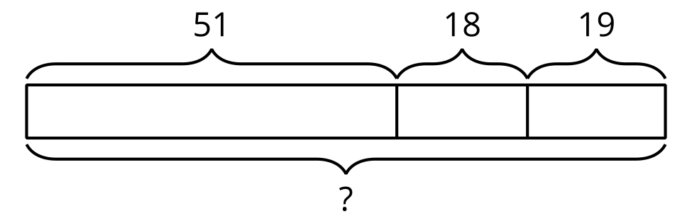
- $51+19=70$
- $70+18=88$
- What’s the question?
- Explain how you know.
- This work shows the answer to a question about the apples.
- 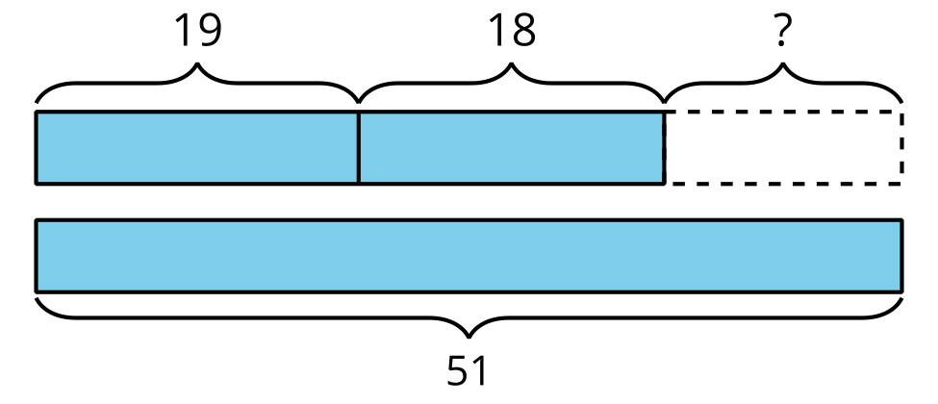
- $19+18=37$
- $51−37=14$
- What’s the question?
- Explain how you know.

