Lesson 5 Practice Problems
- Explain what the slope and intercept mean in each situation.
  - A graph represents the perimeter, $y$, in units, for an equilateral triangle with side length $x$ units. The slope of the line is 3 and the $y$-intercept is 0.
  - The amount of money, $y$, in a cash box after $x$ tickets are purchased for carnival games. The slope of the line is $\frac{1}{4}$ and the $y$-intercept is 8.
  - The number of chapters read, $y$, after $x$ days. The slope of the line is $\frac{5}{4}$ and the $y$-intercept is 2.
  - The graph shows the cost in dollars, $y$, of a muffin delivery and the number of muffins, $x$, ordered. The slope of the line is 2 and the $y$-intercept is 3.
- Customers at the gym pay a membership fee to join and then a fee for each class they attend. Here is a graph that represents the situation.
  - What does the slope of the line shown by the points mean in this situation?
  - What does the vertical intercept mean in this situation?
- 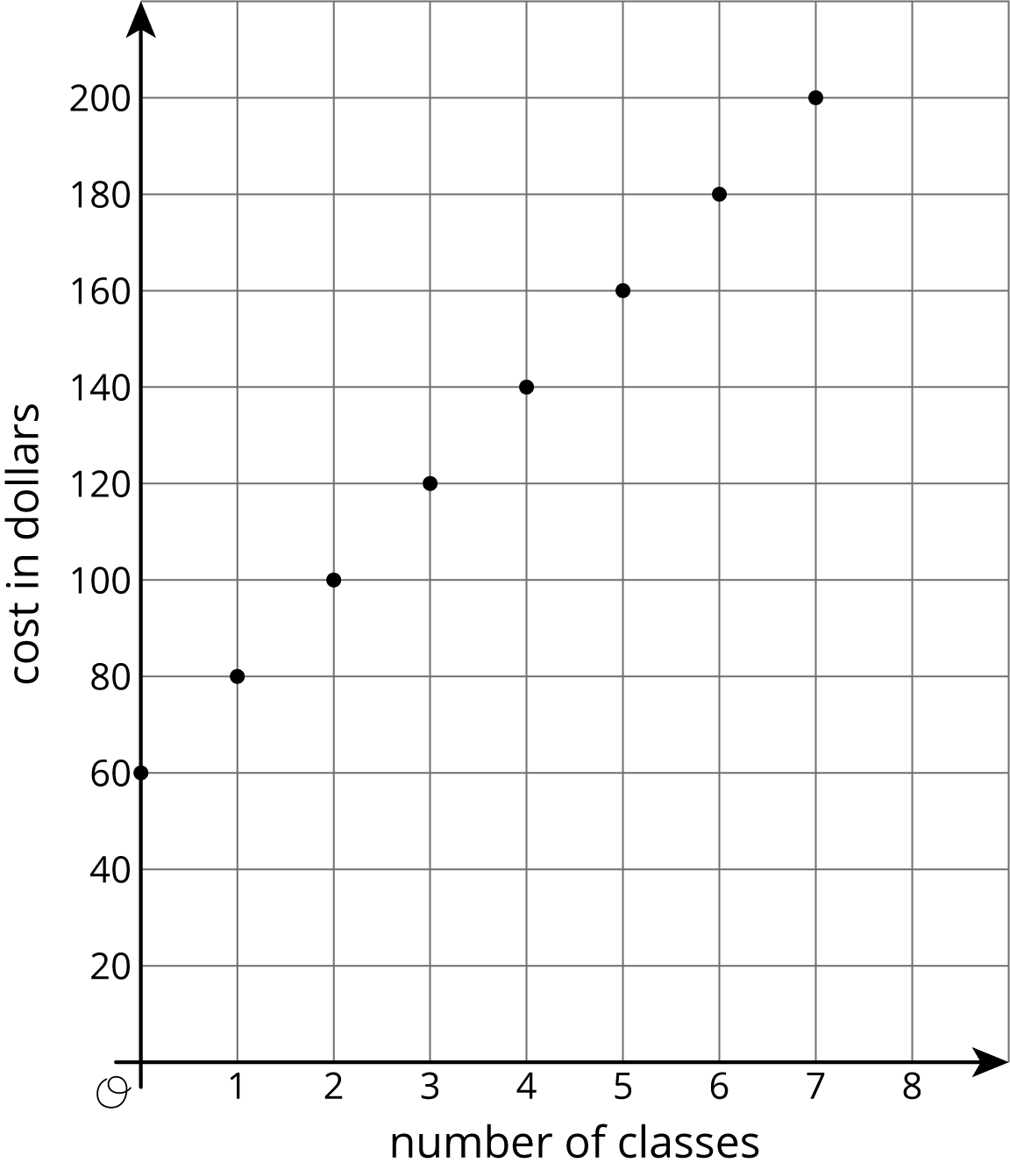
- The graph shows the relationship between the number of cups of flour and the number of cups of sugar in Lin’s favorite brownie recipe.
- 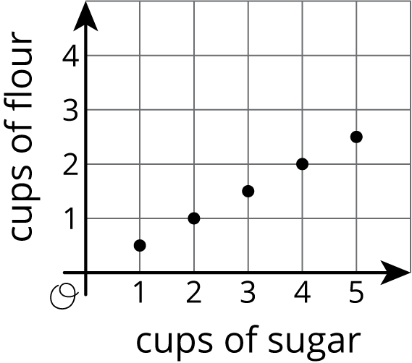
- The table shows the amounts of flour and sugar needed for Noah’s favorite brownie recipe.
- cups of sugar | - cups of flour
- $\frac{3}{2}$ | - 1
- 3 | - 2
- $4\frac{1}{2}$ | - 3
  - Noah and Lin buy a 12-cup bag of sugar and divide it evenly to make their recipes. If they each use all their sugar, how much flour do they each need?
  - Noah and Lin buy a 10-cup bag of flour and divide it evenly to make their recipes. If they each use all their flour, how much sugar do they each need?
- (From Unit 5, Lesson 3.)
- The diagram can be represented by the equation $25=2+6x$. Explain where you can see the 6 in the diagram.
- 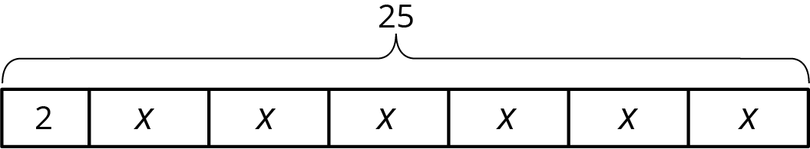
- (From Unit 3, Lesson 3.)
© CC BY Open Up Resources. Adaptations CC BY IM.

