Grade 2
Unit 7Lesson 15CC BY NC 2024 Illustrative Mathematics®
Unit 7, Lesson 15

Decompose a Ten and a Hundred to Subtract
- Let’s subtract within 1,000.
Grade 2
Unit 7Lesson 15CC BY NC 2024 Illustrative Mathematics®

Activity 1 Elena’s Thinking
Elena’s thinking
Step 1

Step 2

Step 3
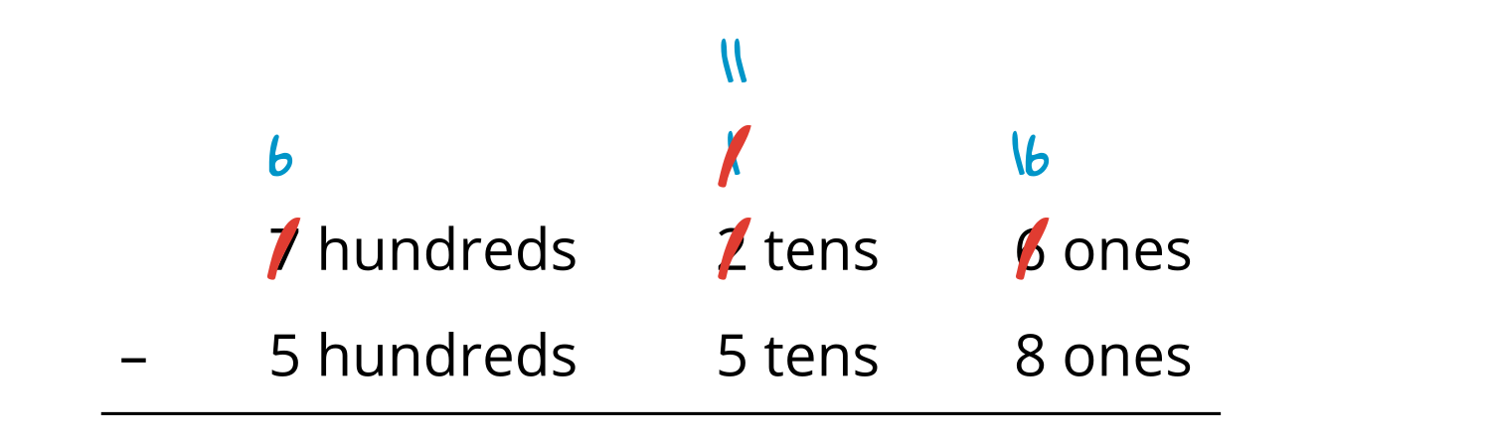
- Use a base-ten diagram or blocks to show Elena’s steps.
- Finish her work. Find the value of $726−558$.
- What is another way to use numbers or equations to show subtracting by place to find the value of $726−558$?
Grade 2
Unit 7Lesson 15CC BY NC 2024 Illustrative Mathematics®

Activity 2 Walk about and Subtract
- Find someone with a different number than you.
- Find the difference between your numbers.
- Show your thinking, using drawings, numbers, or words.
- Trade cards. Find a new partner.
- Partner 1:
- Partner 2:
- Partner 3:


