Grade 6
Unit 4Lesson 6CC BY NC Illustrative Mathematics, based on IM 6–8 Math, CC BY Open Up Resources.
Unit 4, Lesson 6

Using Diagrams to Find the Number of Groups
Let’s draw tape diagrams to think about division with fractions.
Grade 6
Unit 4Lesson 6CC BY NC Illustrative Mathematics, based on IM 6–8 Math, CC BY Open Up Resources.

6.1How Many of These in That?
We can think of the division expression $10÷2\frac{1}{2}$ as the question: “How many groups of $2\frac{1}{2}$ are
in 10?” Complete the tape diagram to represent this question. Then find the answer.
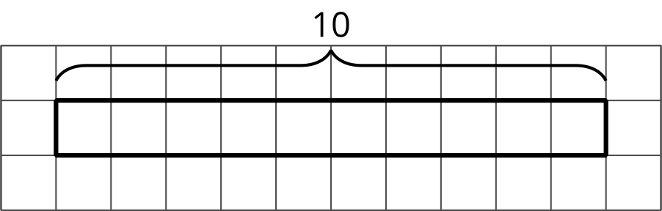
Complete the tape diagram to represent the question: “How many groups of 2 are in 7?” Then find the answer.
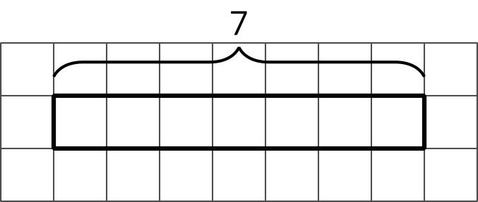
Grade 6
Unit 4Lesson 6CC BY NC Illustrative Mathematics, based on IM 6–8 Math, CC BY Open Up Resources.

6.2Representing Groups of Fractions with Tape Diagrams
To make sense of the question “How many $\frac{2}{3}$s are in 1?” Andre wrote equations and drew a tape diagram.
$?⋅\frac{2}{3}=1$
$1÷\frac{2}{3}=?$
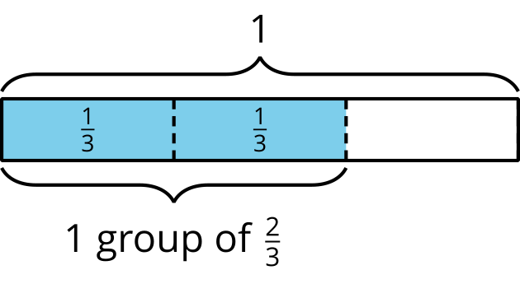
- In an earlier task, we used pattern blocks to help us solve the equation $1÷\frac{2}{3}=?$.
Explain how Andre’s tape diagram can also help us solve the equation.
- Write a multiplication equation and a division equation for each question.
Then draw a tape diagram and find the answer.
  - How many $\frac{3}{4}$s are in 1?
  - 
  - How many $\frac{2}{3}$s are in 3?
  - How many $\frac{3}{2}$s are in 5?
Grade 6
Unit 4Lesson 6CC BY NC Illustrative Mathematics, based on IM 6–8 Math, CC BY Open Up Resources.

6.3Finding the Number of Groups
Write a multiplication equation or a division equation for each question, and then find the answer. Explain or show your reasoning.
- How many groups of $\frac{1}{2}$ pound are in $2\frac{3}{4}$ pounds?
- How many $\frac{3}{8}$-inch thick books make a stack that is 6 inches tall?

Are you ready for more?
Write a story with a question that can be represented by the equation $5÷1\frac{1}{2}=?$, and then find the answer. Show your reasoning.

Lesson 6 Summary
One batch of a recipe calls for $\frac{2}{5}$ kg of flour. If a baker used 2 kg of flour, how many batches did she make?
We can think of the question as “How many groups of $\frac{2}{5}$ kg make 2 kg?” and represent it with the equations:
$?⋅\frac{2}{5}=2$
$2÷\frac{2}{5}=?$
To help us make sense of the question, we
can draw a tape diagram. This diagram shows 2 whole kilograms, with each kilogram partitioned into fifths.
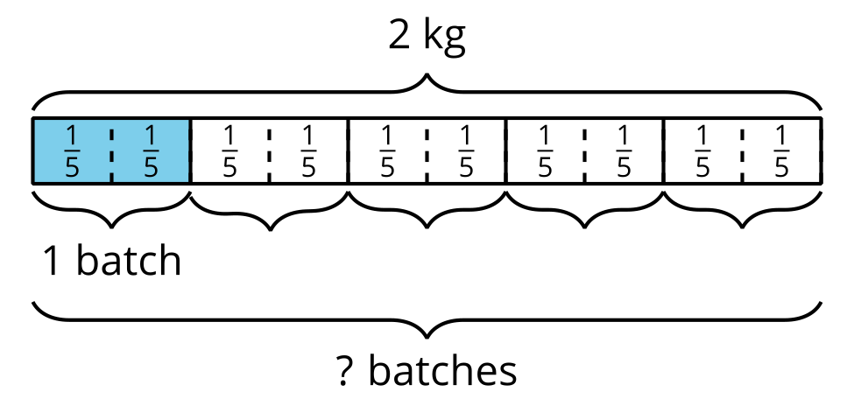
We can see that there are 5 groups of $\frac{2}{5}$ in 2. Multiplying 5 and $\frac{2}{5}$ gives $\frac{10}{5}$ or 2, so $2÷\frac{2}{5}$ is 5.
Sometimes the number of groups or the result of dividing is not a whole number. Suppose one serving of rice is $\frac{3}{4}$ cup. How many servings are there in $3\frac{1}{2}$ cups?
Here are two equations and a diagram that represent the situation:
$?⋅\frac{3}{4}=3\frac{1}{2}$
$3\frac{1}{2}÷\frac{3}{4}=?$
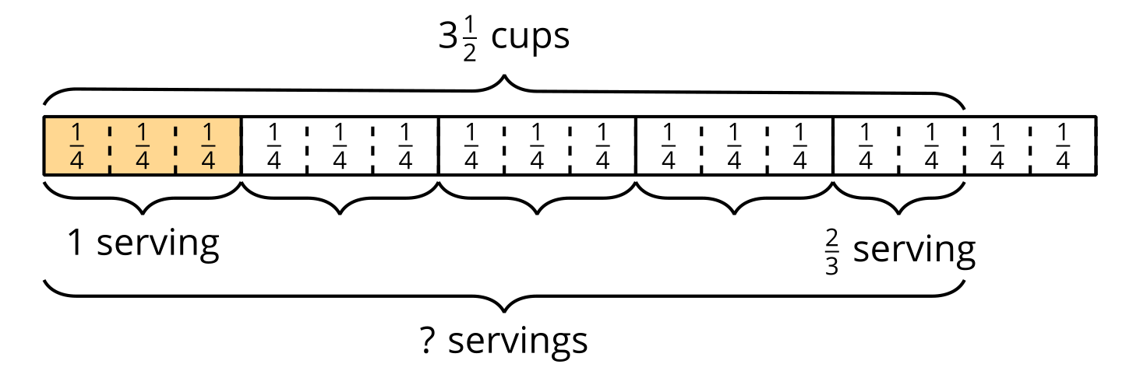
The diagram shows 4 full groups of $\frac{3}{4}$, plus 2 extra $\frac{1}{4}$s, which make $\frac{2}{3}$ of a group. So $3\frac{1}{2}÷\frac{3}{4}$ is $4\frac{2}{3}$. We can check this quotient by multiplying $4\frac{2}{3}$ and $\frac{3}{4}$.
$4\frac{2}{3}⋅\frac{3}{4}=\frac{14}{3}⋅\frac{3}{4}$, and $\frac{14}{3}⋅\frac{3}{4}=\frac{14}{4}$, which is $3\frac{2}{4}$ or $3\frac{1}{2}$.

