Unit 7 Lesson 1: Explore the Coordinate Grid

WU Notice and Wonder: The Grid (Warm up)

Student Task Statement
What do you notice? What do you wonder?
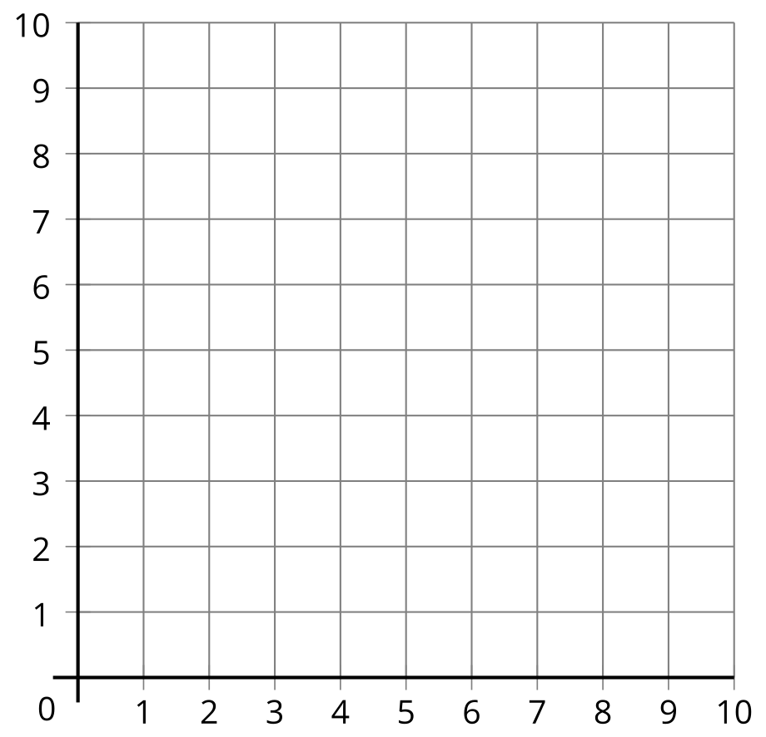

1 Can You Draw It: Shapes on the Coordinate Grid

Student Task Statement
- Play three rounds of Draw My Shape using the three sets of cards from your teacher.
- For each round:
  - Partner A choose a card—without showing your partner—and describe the shape on the card.
  - Partner B draw the shape as described.
  - Partner A reveal the card and partner B reveal the drawing.
  - Compare the shapes and discuss: What’s the same? What’s different?
- Round 1
- Round 2
- 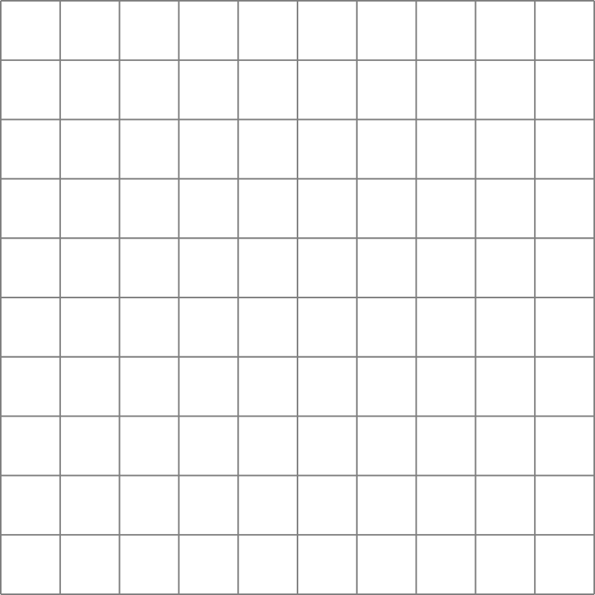
- Round 3
- Look at partner B's drawings for each round. When does partner B's drawing look most like the shape on the card? Explain why you think that is so.

2 Guess Which One: Shapes on the Coordinate Grid

Student Task Statement
- Play a round of Guess Which One.
  - Sit next to your partner.
  - Partner A:
Mentally choose a shape card without indicating which shape card you chose.
  - Partner B:
Ask yes or no questions to determine which shape card partner A has chosen.
  - A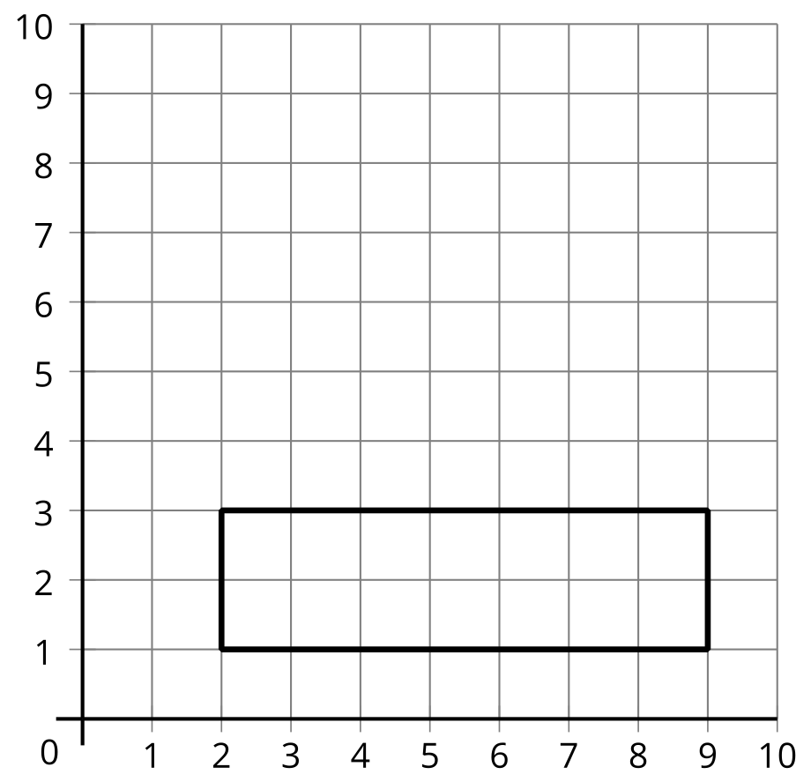
  - B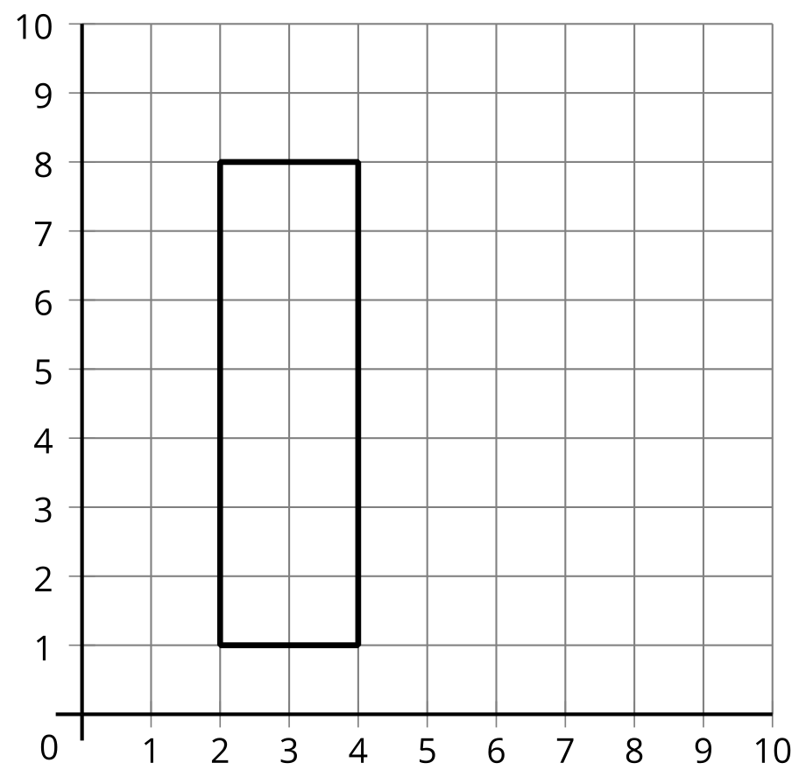
  - C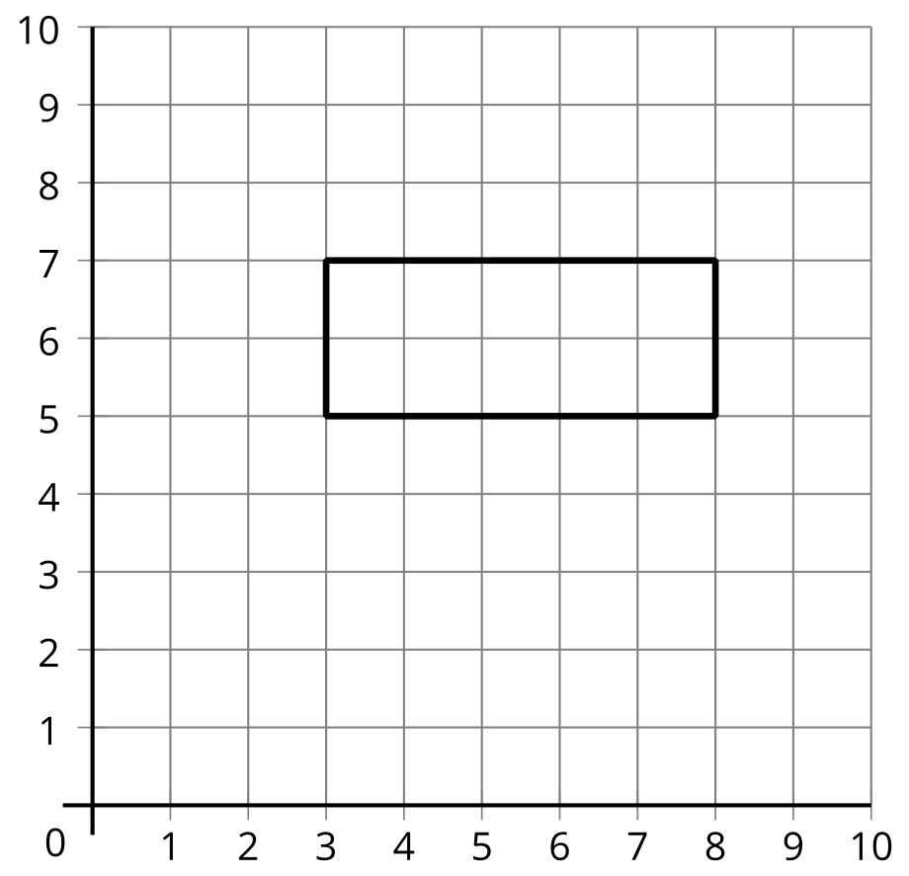
  - D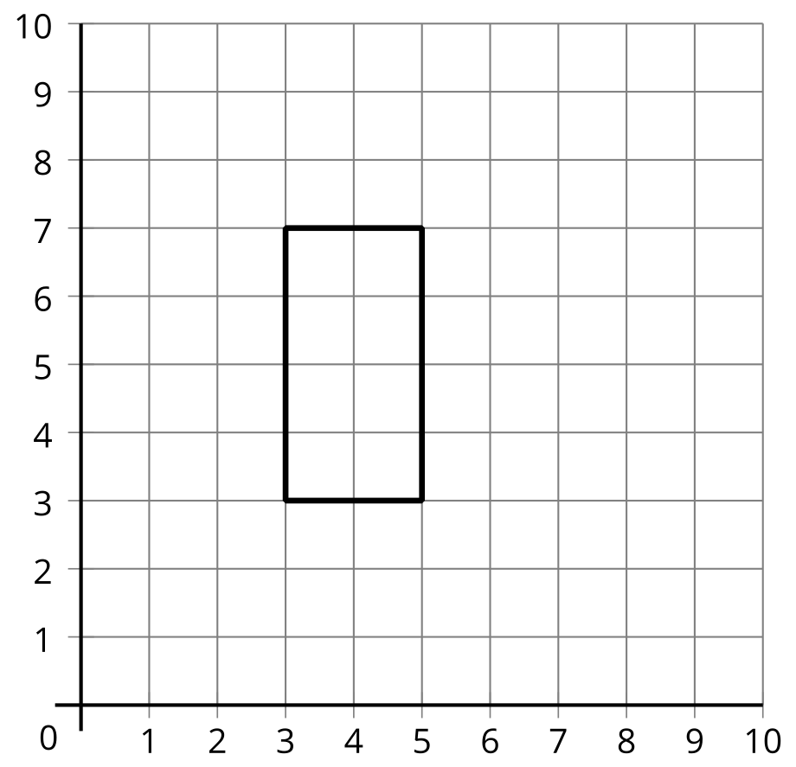
  - E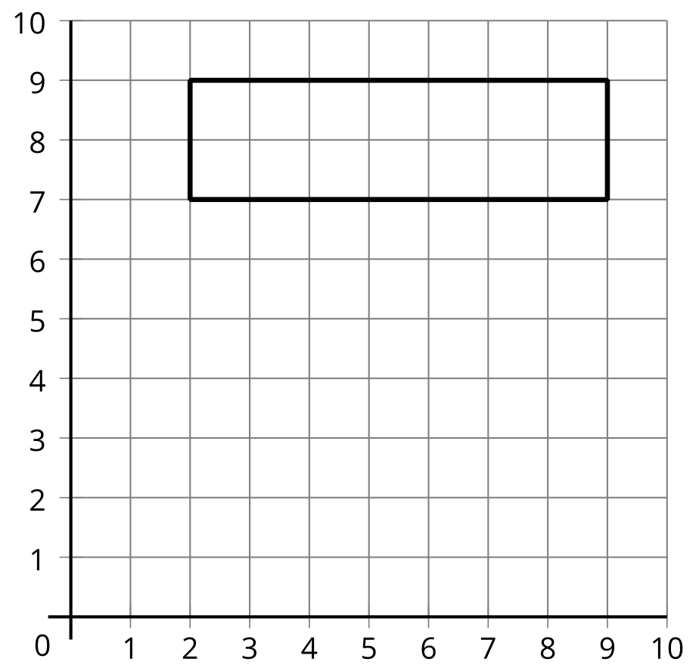
  - F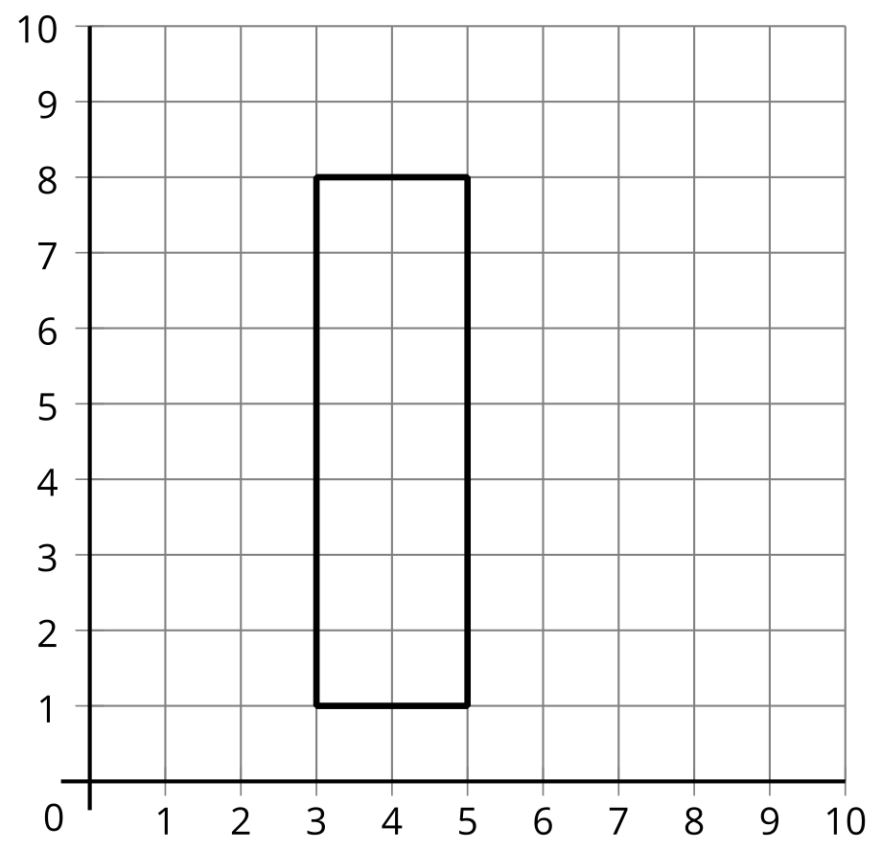
  - G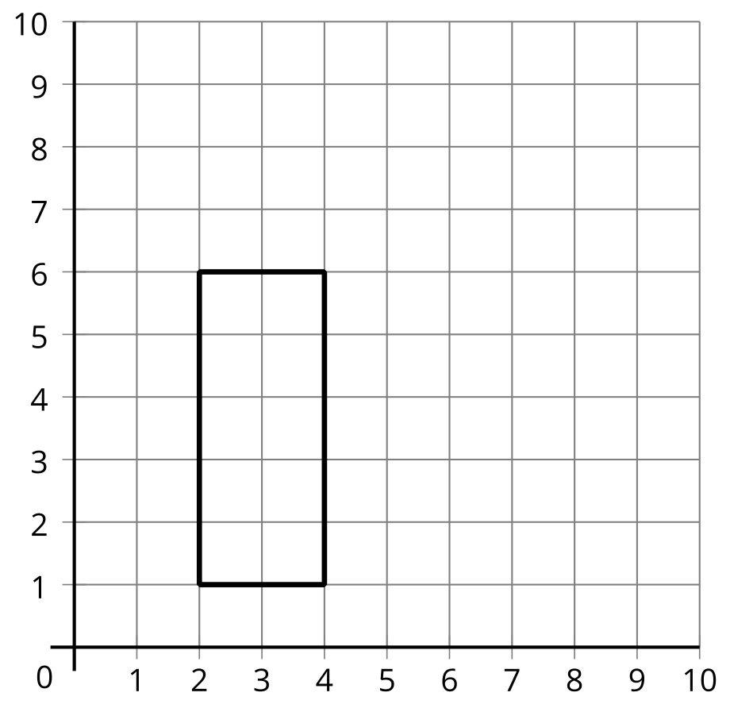
  - H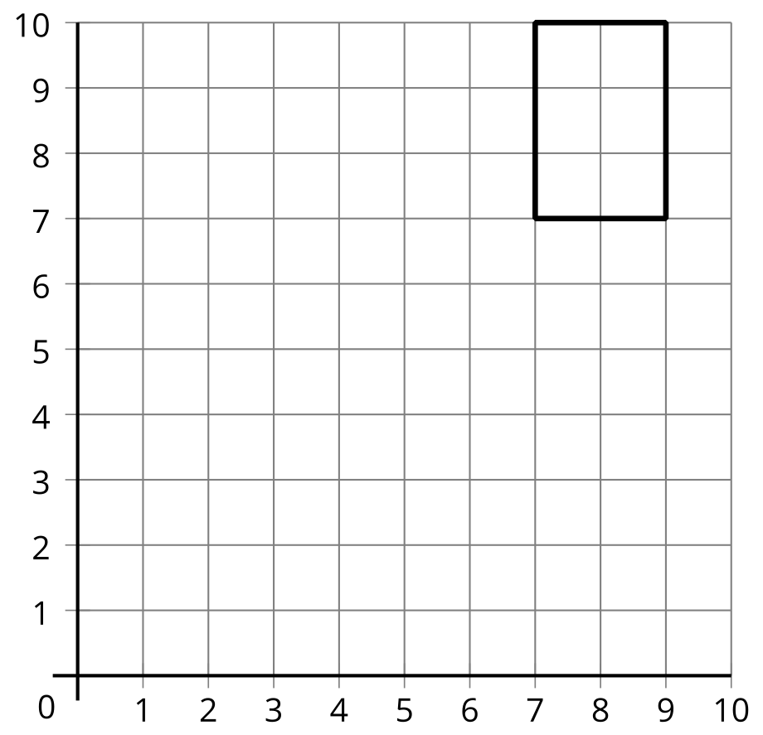
  - I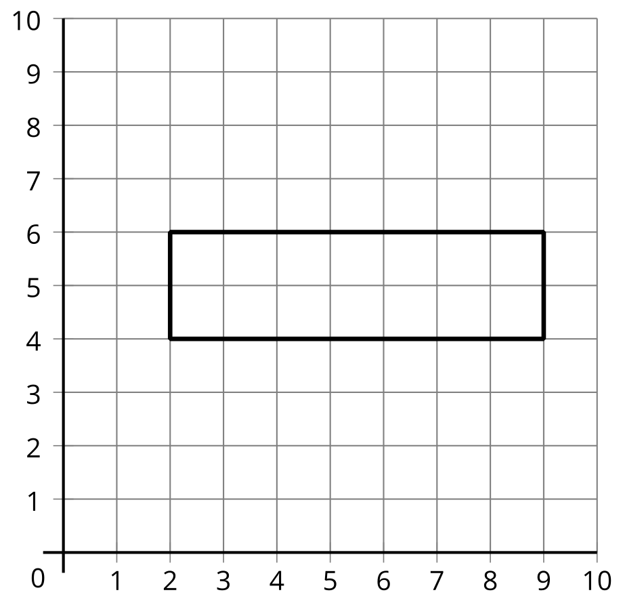
  - J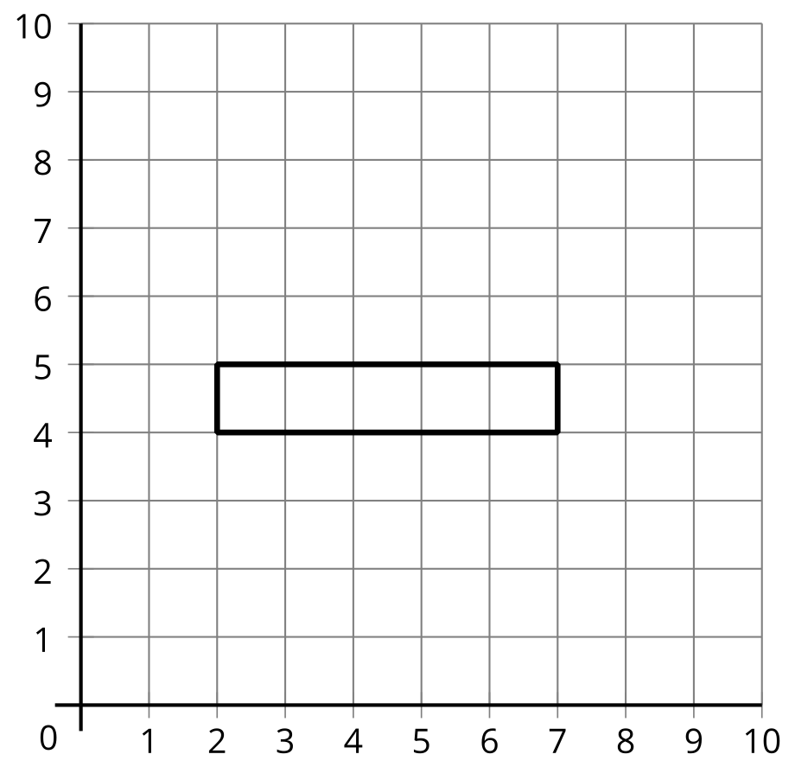
  - K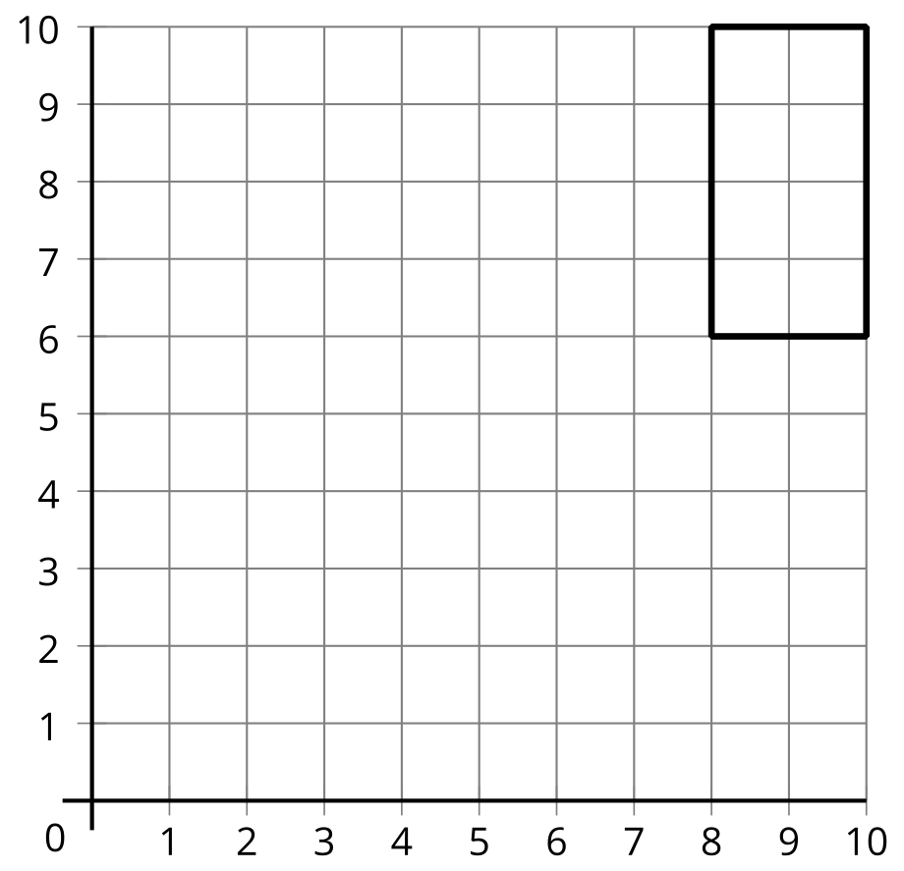
  - L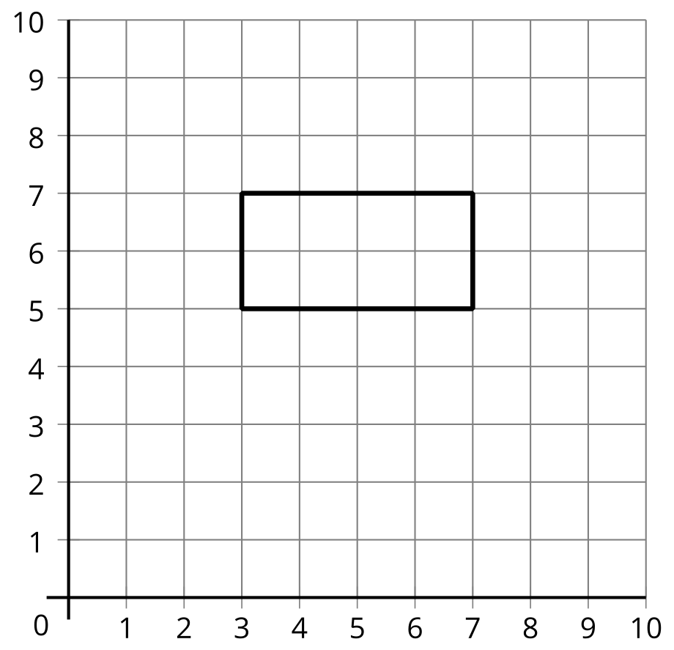
- Switch roles and play another round of Guess Which One.
- Diego and Kiran were playing a round of Guess Which One. These are the last two shapes. What question can Kiran ask to determine which shape is the one that Diego picked?
© CC BY 2021 Illustrative Mathematics®

