Grade 6
Unit 1Lesson 14CC BY NC Illustrative Mathematics, based on IM 6–8 Math, CC BY Open Up Resources.
Unit 1, Lesson 14

Nets and Surface Area
Let’s use nets to find the surface area of polyhedra.
Grade 6
Unit 1Lesson 14CC BY NC Illustrative Mathematics, based on IM 6–8 Math, CC BY Open Up Resources.

14.1Matching Nets
Each of the nets can be assembled into a polyhedron. Match each net with its corresponding polyhedron, and name the polyhedron. Be prepared to explain how you know the net and polyhedron go together.
A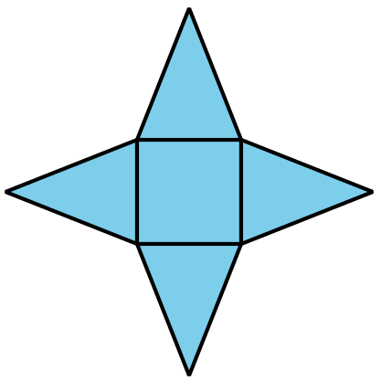
B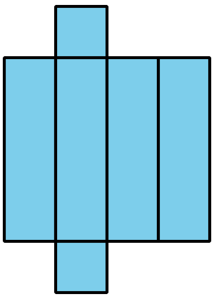
C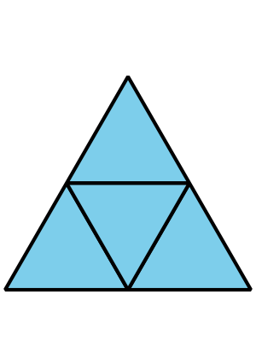
D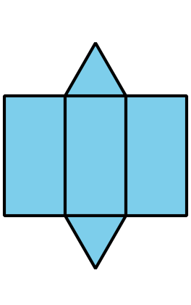
E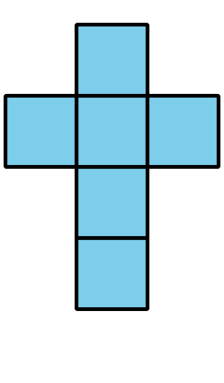
1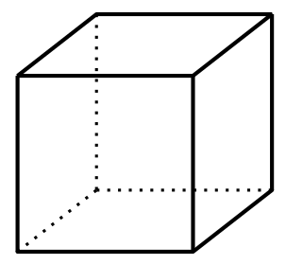
2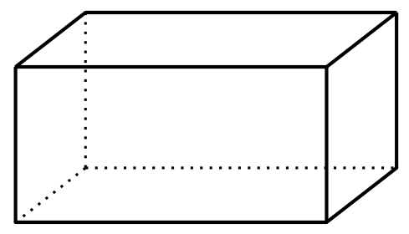
3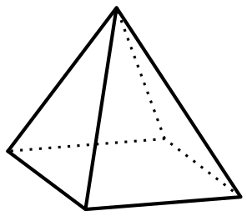
4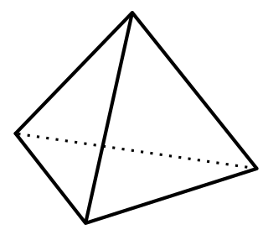
5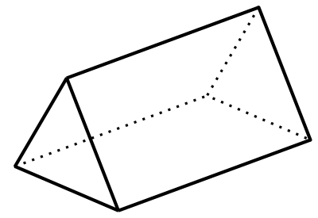
Grade 6
Unit 1Lesson 14CC BY NC Illustrative Mathematics, based on IM 6–8 Math, CC BY Open Up Resources.

14.2Using Nets to Find Surface Area
- Name the polyhedron that each net would form when assembled.
- 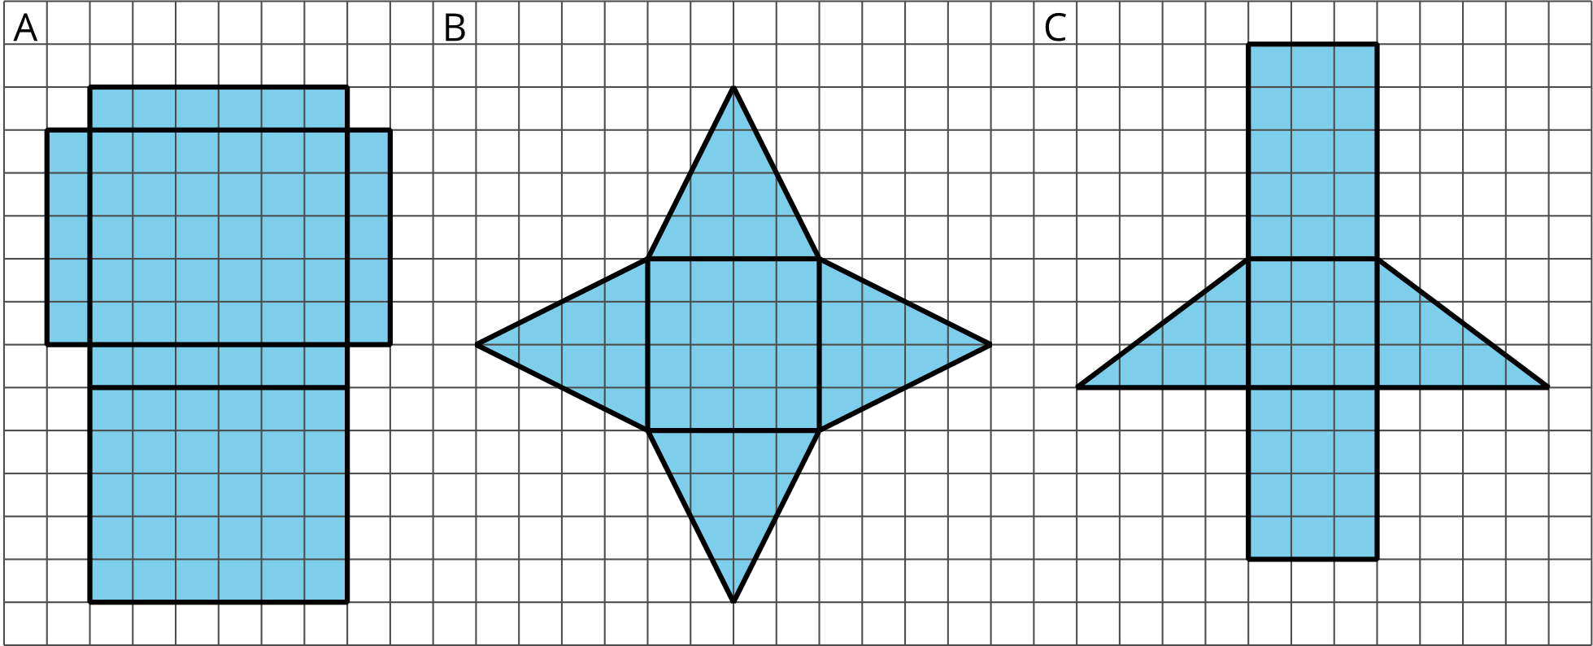
- Your teacher will give you the nets of three polyhedra. Cut out the nets and assemble the three-dimensional shapes.
- Find the surface area of each polyhedron. Explain or show your reasoning.

Are you ready for more?
- For each net, decide if it can be assembled into a rectangular prism.
- 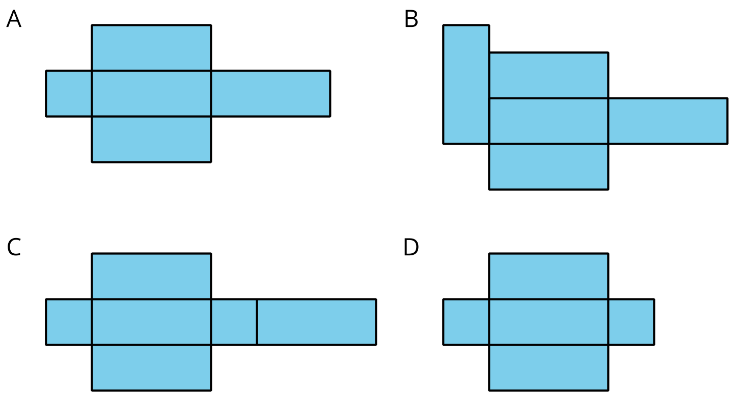
- For each net, decide if it can be folded into a triangular prism.
- 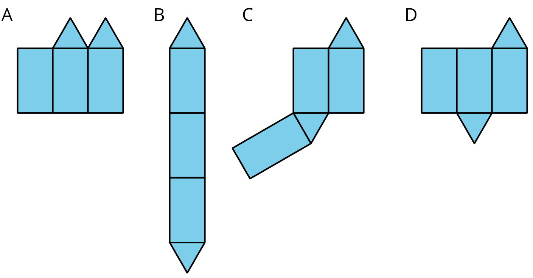

Lesson 14 Summary
A net of a pyramid has one polygon that is the base. The rest of the polygons are triangles. A pentagonal pyramid and its net are shown here.
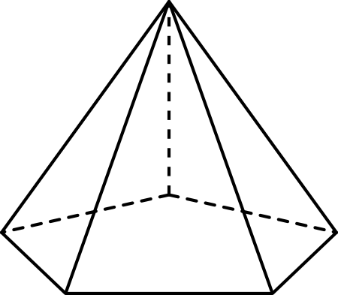
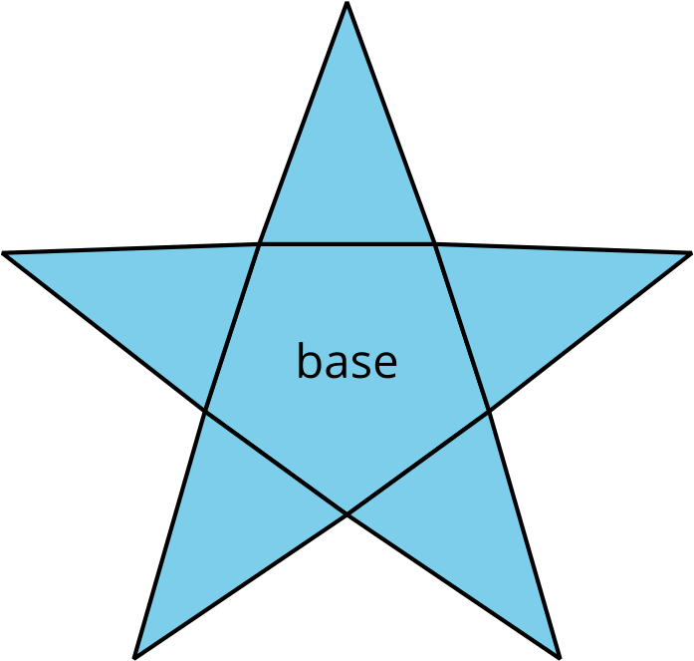
A net of a prism has two copies of the polygon that is the base. The rest of the polygons are rectangles. A pentagonal prism and its net are shown here.
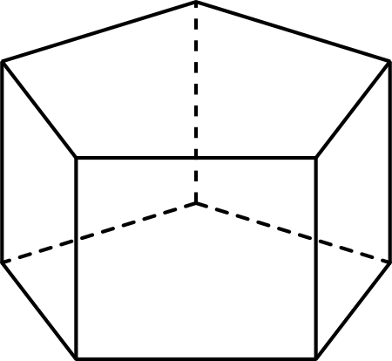
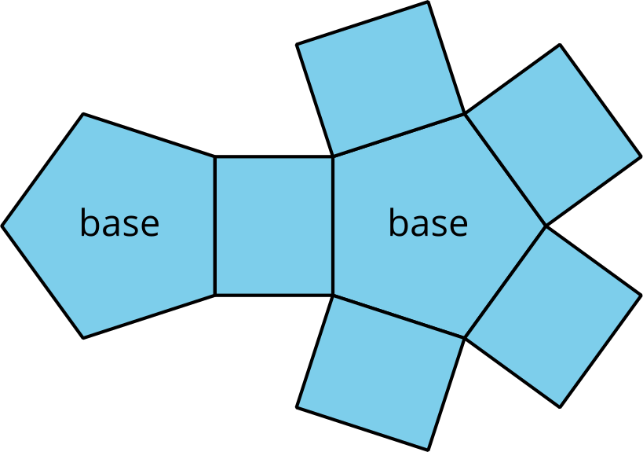
In a rectangular prism, there are three pairs of parallel and identical rectangles. Any pair of these identical rectangles can be the bases.
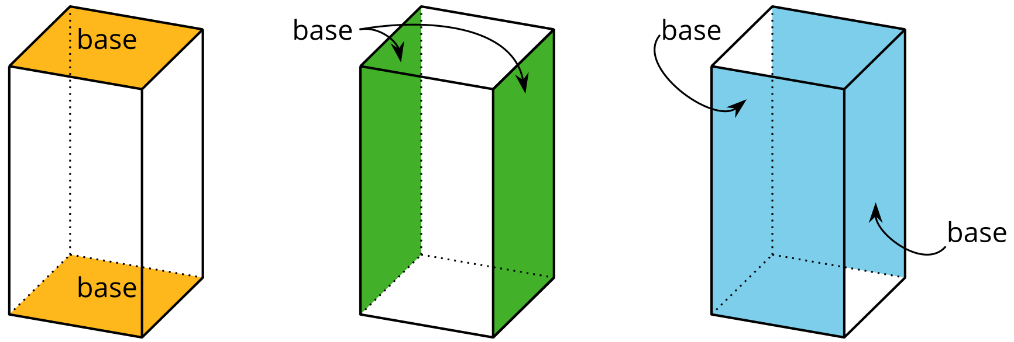
Because a net shows all the faces of a polyhedron, we can use it to find its surface area. For instance, the net of a rectangular prism shows three pairs of rectangles: 4 units by 2 units, 3 units by 2 units, and 4 units by 3 units.
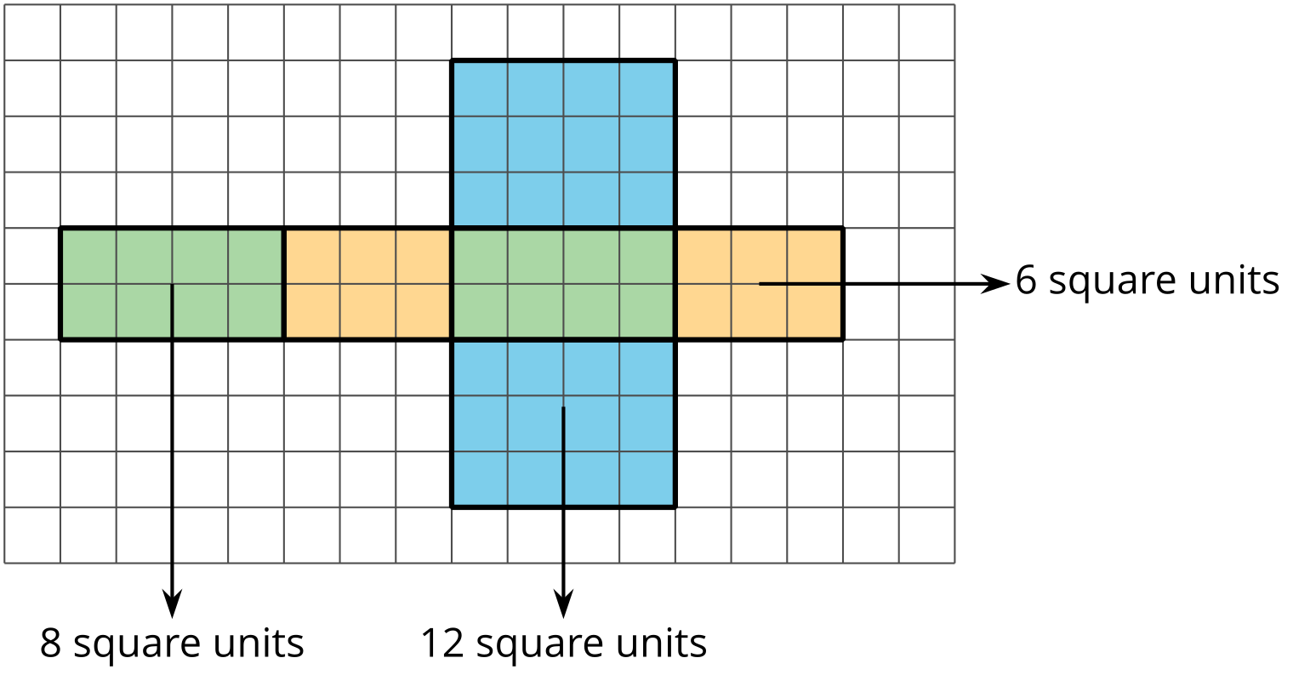
The surface area of the rectangular prism is 52 square units because $8+8+6+6+12+12=52$.

