Grade 2
Unit 5Lesson 4CC BY NC 2024 Illustrative Mathematics®
Unit 5, Lesson 4

Write 3-Digit Numbers
- Let’s represent 3-digit numbers using base-ten numerals.
Grade 2
Unit 5Lesson 4CC BY NC 2024 Illustrative Mathematics®

Warm-up How Many Do You See: Blocks
How many do you see? How do you see them?
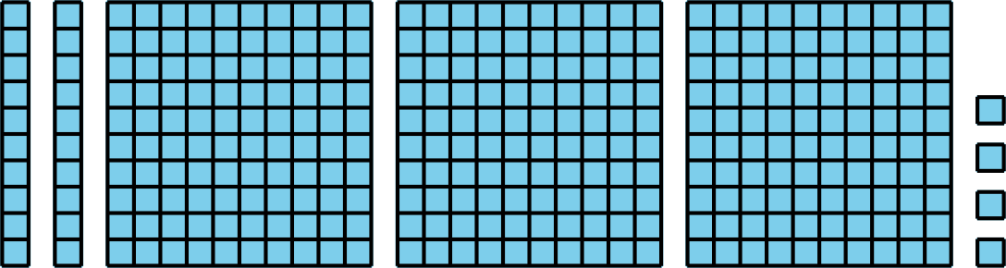
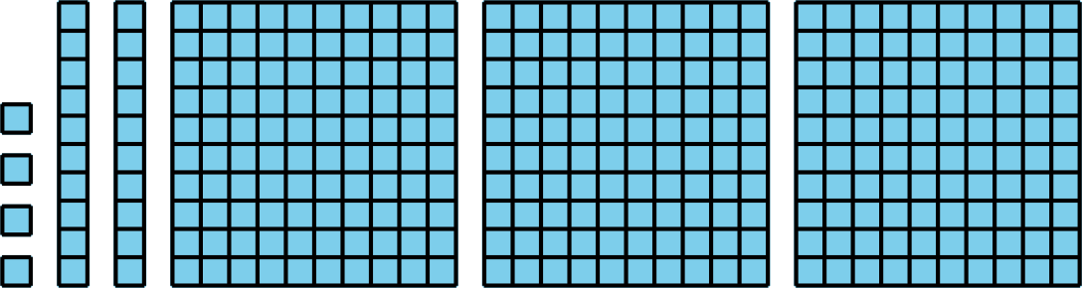
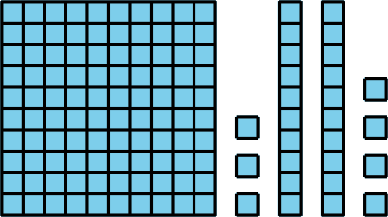
Grade 2
Unit 5Lesson 4CC BY NC 2024 Illustrative Mathematics®

Activity 1 Place Value Riddles
Solve each riddle. Write the 3-digit number. Use the table to organize the digits.
riddle | hundreds | tens | ones | 3-digit number
1
2
3
4
5
6
- I have 2 ones, 7 tens, and 6 hundreds.
- I have 3 ones, 5 tens, and 2 hundreds.
- I have 7 hundreds, 5 ones, and 3 tens.
- I have 5 hundreds, no tens, and 9 ones.
- I have 4 ones, 6 tens, and 3 hundreds.
- I have 8 tens, 1 hundred, and no ones.
Grade 2
Unit 5Lesson 4CC BY NC 2024 Illustrative Mathematics®

Activity 2 Mixed-Up Digits
Find the number that makes each equation true. Use base-ten blocks or diagrams if they help.
- 4 hundreds $+$ 6 tens $+$ 2 ones $=$ __________
- 7 ones $+$ 2 hundreds $+$ 6 tens $=$ __________
- 3 tens $+$ 5 hundreds $=$ __________
- 325 $=$ __________ hundreds $+$ __________ ones $+$ __________ tens
- 70 $+$ 300 $+$ 2 $=$ __________
- 836 $=$ 6 $+$ 800 $+$ __________
- Clare and Elena try to find the number that makes the equation true.
- 7 ones $+$ 3 hundreds $=$ __________.
- They wrote different answers.
  - Clare wrote 7 ones $+$ 3 hundreds $=$ 37.
  - Elena wrote 7 ones $+$ 3 hundreds $=$ 307.
- Who is correct? Explain how you know.

