Grade 6
Unit 4Lesson 1CC BY NC Illustrative Mathematics, based on IM 6–8 Math, CC BY Open Up Resources.
Unit 4, Lesson 1

Size of Divisor and Size of Quotient
Let’s explore quotients of different sizes.
Grade 6
Unit 4Lesson 1CC BY NC Illustrative Mathematics, based on IM 6–8 Math, CC BY Open Up Resources.

1.1Math Talk: Size of Dividend and Divisor
Find the value of each expression mentally.
- $5,​000÷5$
- $5,​000÷2,​500$
- $5,​000÷10,​000$
- $5,​000÷500,​000$
Grade 6
Unit 4Lesson 1CC BY NC Illustrative Mathematics, based on IM 6–8 Math, CC BY Open Up Resources.

1.2All Stacked Up
- Here are several types of objects. For each type of object, estimate how many are in a stack that is 5 feet high. Be prepared to explain your reasoning.
- Cardboard boxes
- 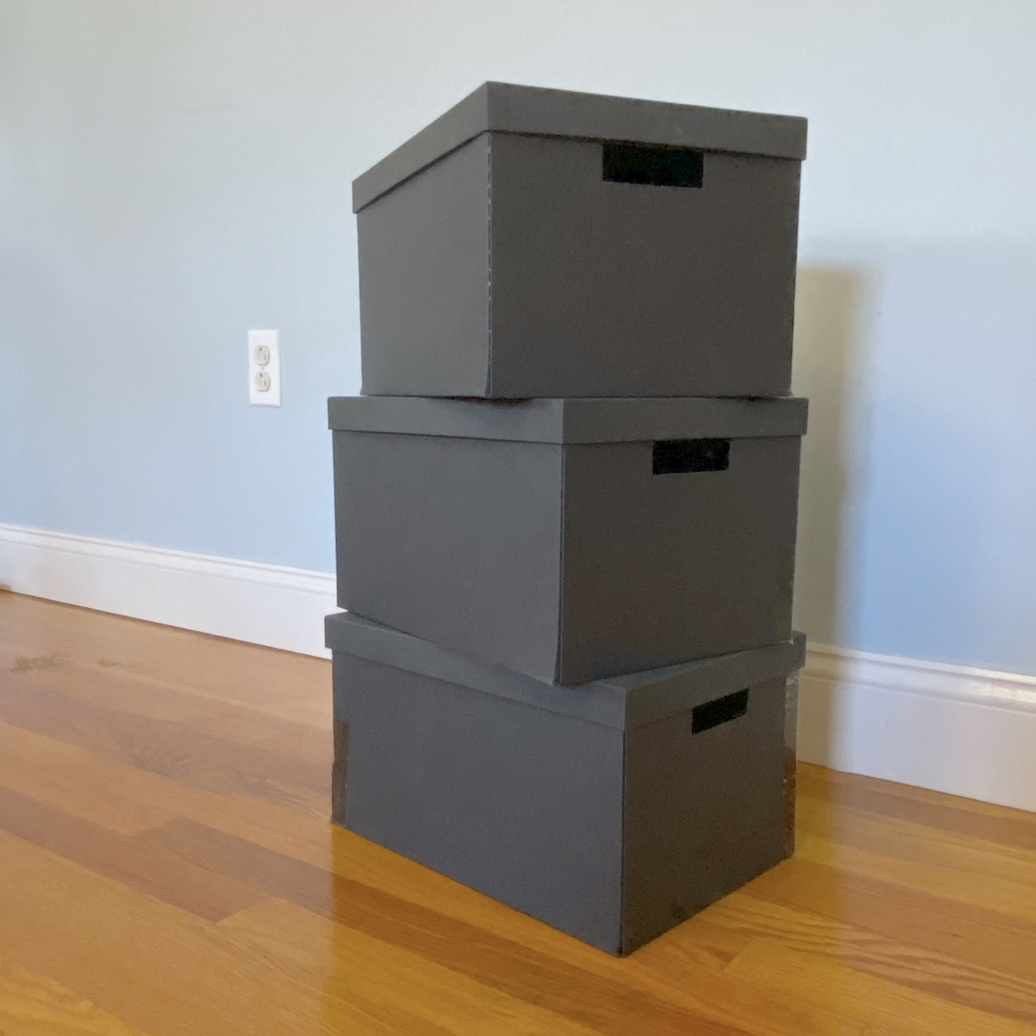
- Egg cartons
- 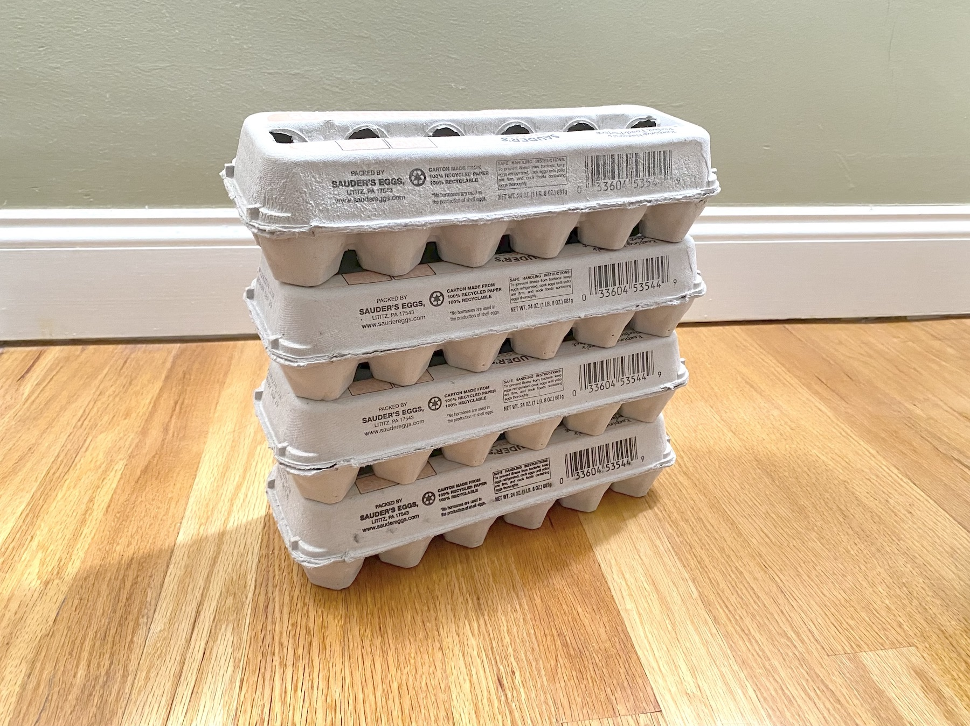
- Notebooks
- 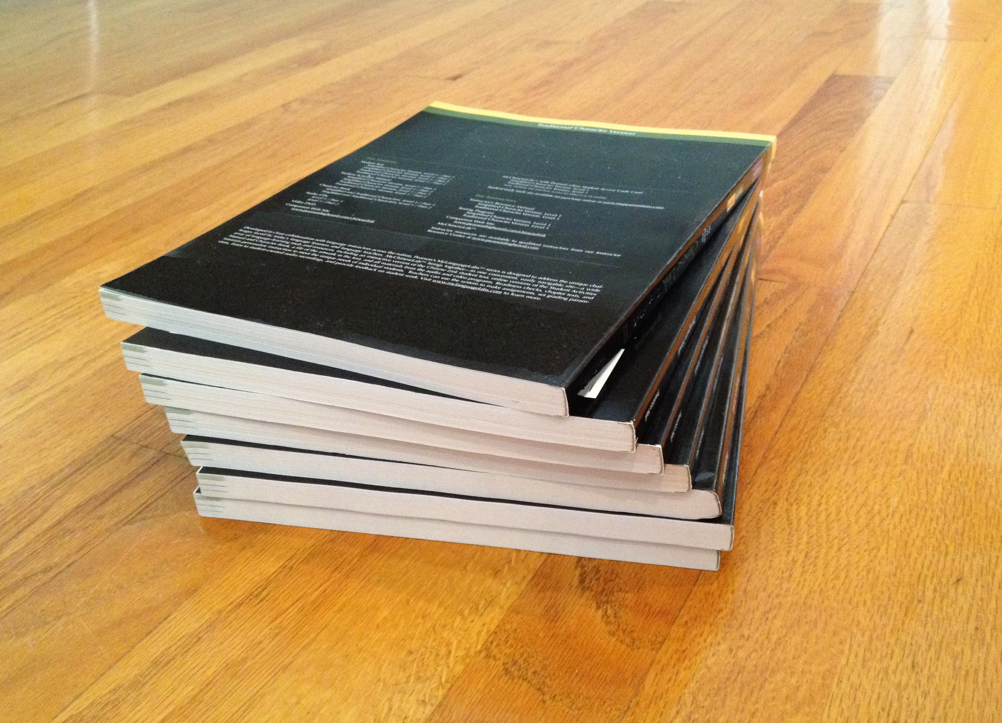
- Coins
- 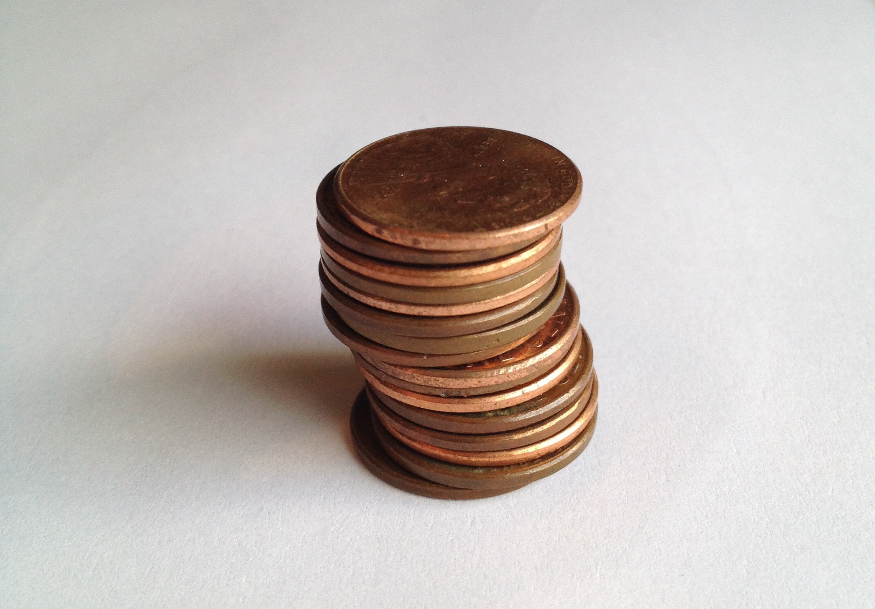
- A stack of books is 72 inches tall. Each book is 2 inches thick. Which expression tells us how many books are in the stack? Be prepared to explain your reasoning.
  - $72⋅2$
  - $72−2$
  - $2÷72$
  - $72÷2$
Grade 6
Unit 4Lesson 1CC BY NC Illustrative Mathematics, based on IM 6–8 Math, CC BY Open Up Resources.

1.3All in Order
Your teacher will give you two sets of papers with division expressions.
- Without computing, estimate the quotients in each set and order them from greatest to least.
Be prepared to explain your reasoning.
- Pause here for a discussion.
- Record the expressions in each set in order from the greatest value to the least.
  - Set 1
  - Set 2
- Without computing, estimate the quotients and sort them into the following three groups.
Be prepared to explain your reasoning.
- $30÷\frac{1}{2}$
- $30÷0.45$
- $9÷10$
- $9÷10,​000$
- $18÷19$
- $18÷0.18$
- $15,​000÷1,​500,​000$
- $15,​000÷14,​500$
  - Close to 0
  - Close to 1
  - Much larger than 1

Are you ready for more?
Write 10 expressions of the form $12÷?$ in a list ordered from least to greatest. Can you list expressions that have value near 1 without equaling 1? How close can you get to the value 1?

Lesson 1 Summary
Here is a division equation: $60÷4=15$. In this equation, we call 60 the dividend and 4 the divisor. We call the result of the division, 15, the quotient.
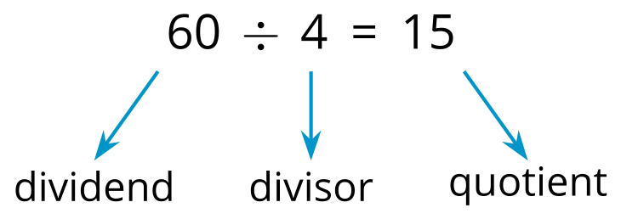
We don’t always have to make calculations to have a sense of what a quotient will be. We can reason about it by looking at the size of the dividend and the divisor. Let’s look at some examples.
$20÷9$
The divisor, 9, is very close to 10. We know that $20÷10$ is 2, so $20÷9$ is a little more than 2.
$99÷101$
The dividend, 99, is very close to 101. Because $101÷101$ is 1, $99÷101$ is a little less than 1.
$5÷98$
The divisor, 98, is very close to 100. We know that $5÷100$ is $\frac{5}{100}$ or 0.05, so $5÷98$ is around 0.05.
In general:
- When a larger number is divided by a smaller number, such as $20÷9$ or $86÷80$, the quotient is greater than 1.
- When we divide two numbers that are nearly equal to each other, such as $99÷101$ or $75÷74$, the quotient is close to 1.
- When a smaller number is divided by a larger number, such as $5÷98$ or $27÷300$, the quotient is less than 1.

