Grade 2
Unit 5Lesson 10CC BY NC 2024 Illustrative Mathematics®
Unit 5, Lesson 10

Place Value Comparisons (Part 1)
- Let’s use place value to compare 3-digit numbers.
Grade 2
Unit 5Lesson 10CC BY NC 2024 Illustrative Mathematics®

Warm-up Number Talk: Add Tens
Find the value of each expression mentally.
- $36+40$
- $46+30$
- $59+40$
- $69+30$
Grade 2
Unit 5Lesson 10CC BY NC 2024 Illustrative Mathematics®

Activity 1 Compare by Place
Who has more? How do you know?
Mai
Tyler
Write each value as a 3-digit number. Use the symbols $<$, $>$, or $=$ to compare the numbers.
- 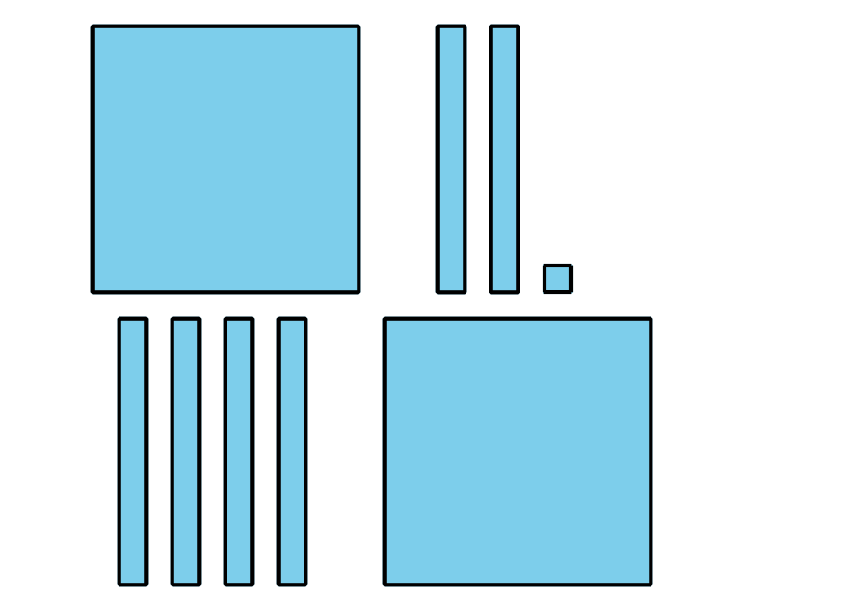
- 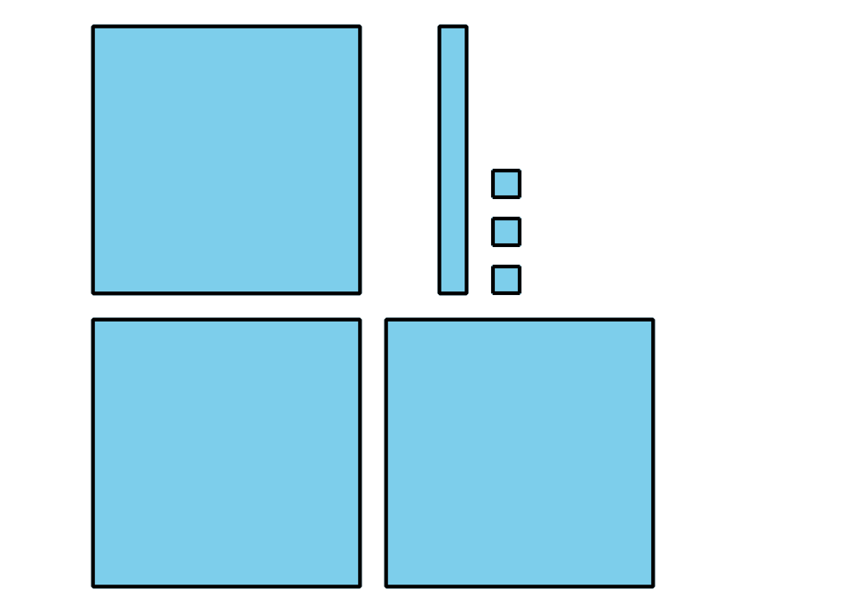
- _3333 _
- 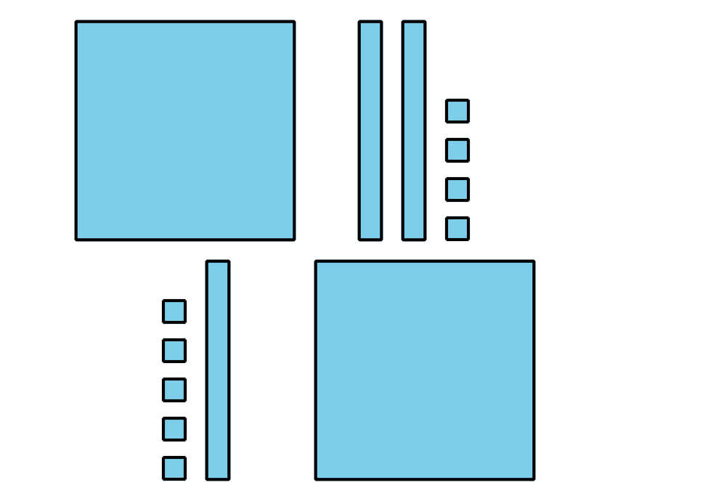
- 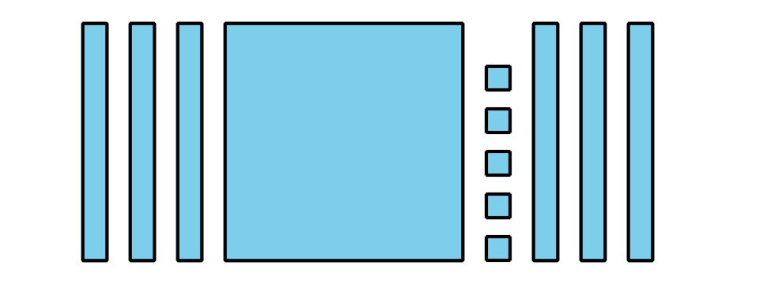
- _3333 _
- 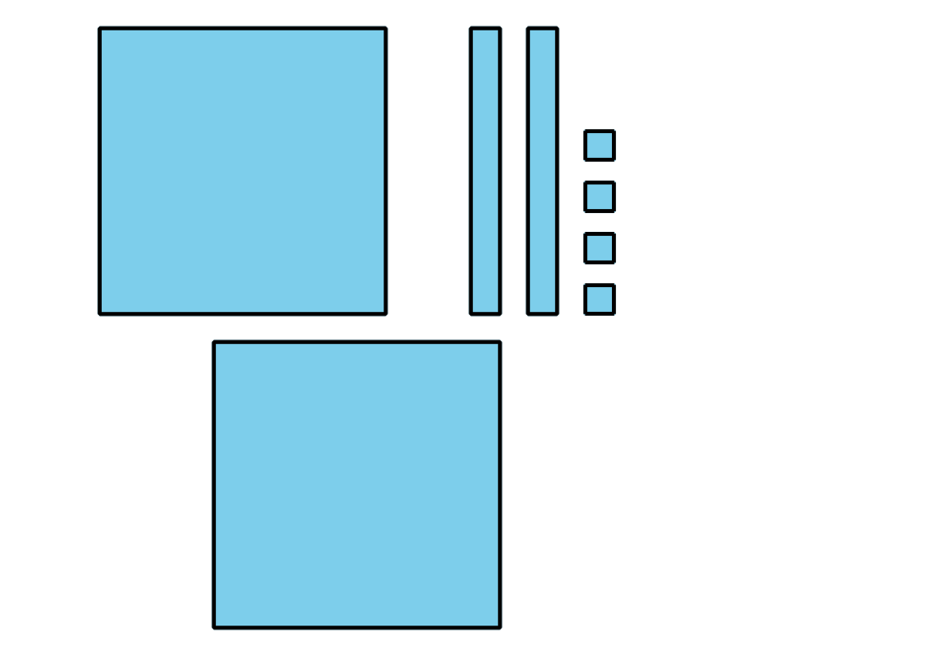
- 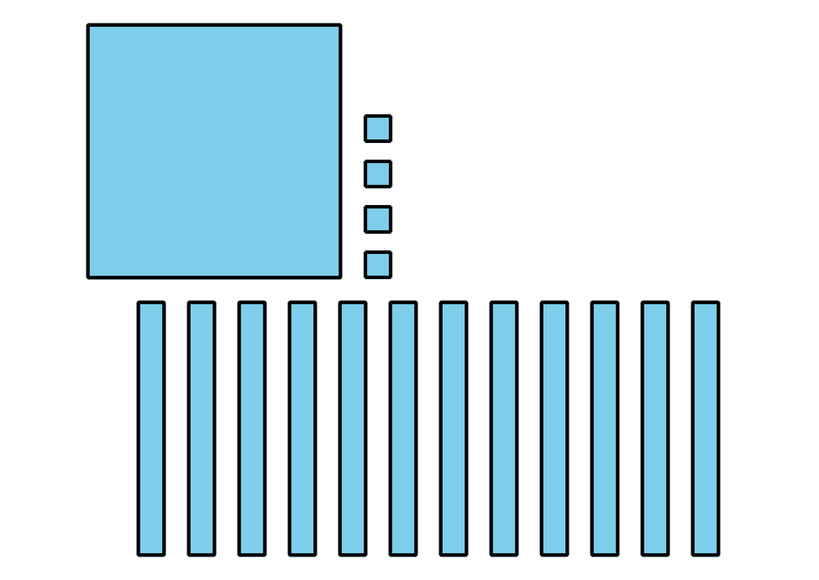
- _3333 _
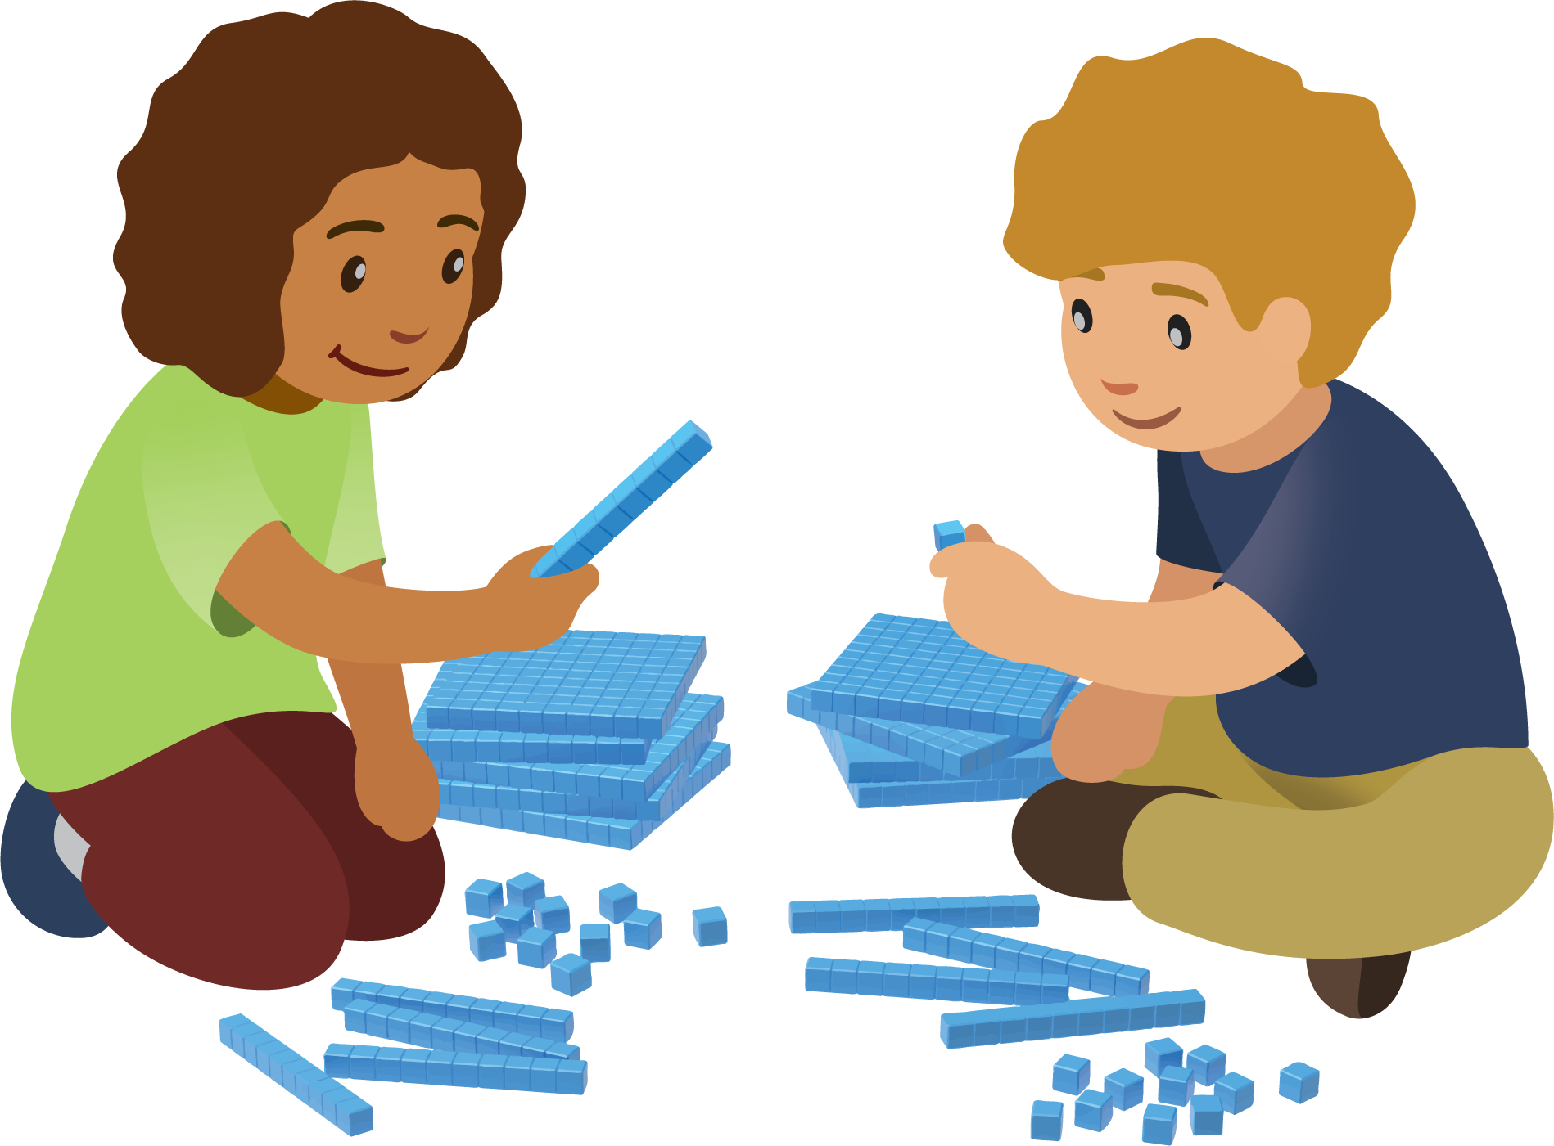
Grade 2
Unit 5Lesson 10CC BY NC 2024 Illustrative Mathematics®

Activity 2Compare Hundreds, Tens, and Ones
Compare the base-ten diagrams. Write each value as a 3-digit number. Use the symbols $>$, $<$, or $=$ to compare the numbers.
- 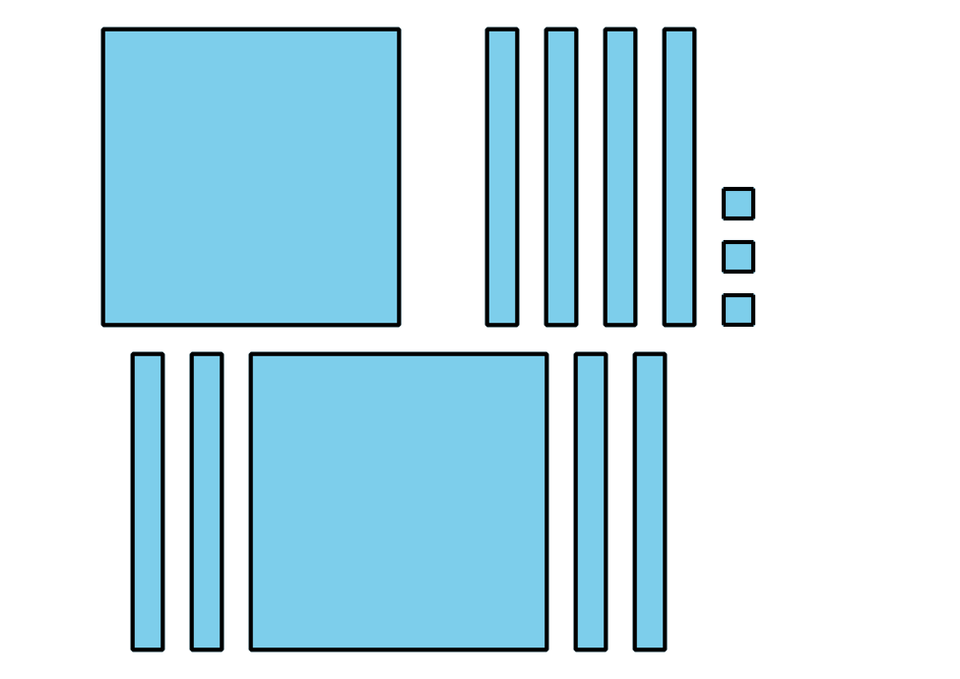
- 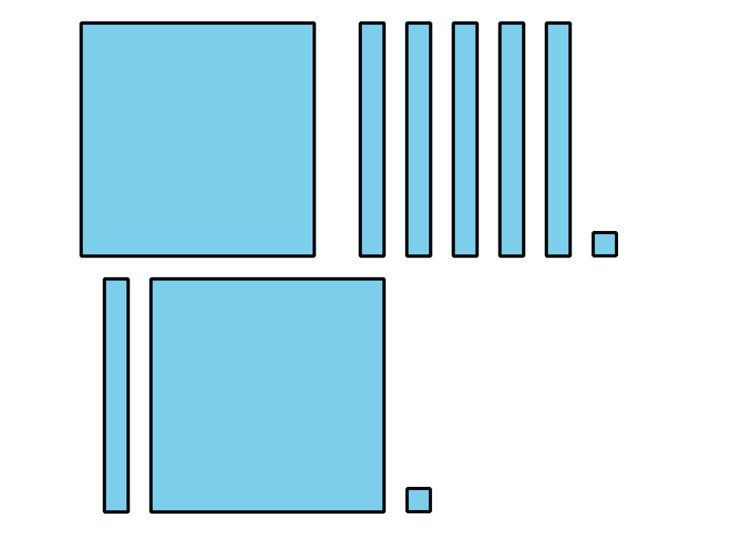
- _3333 _
- 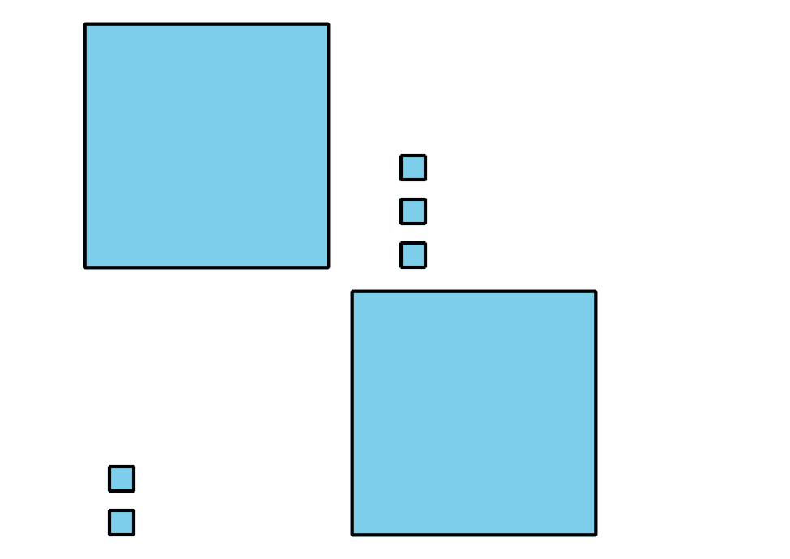
- 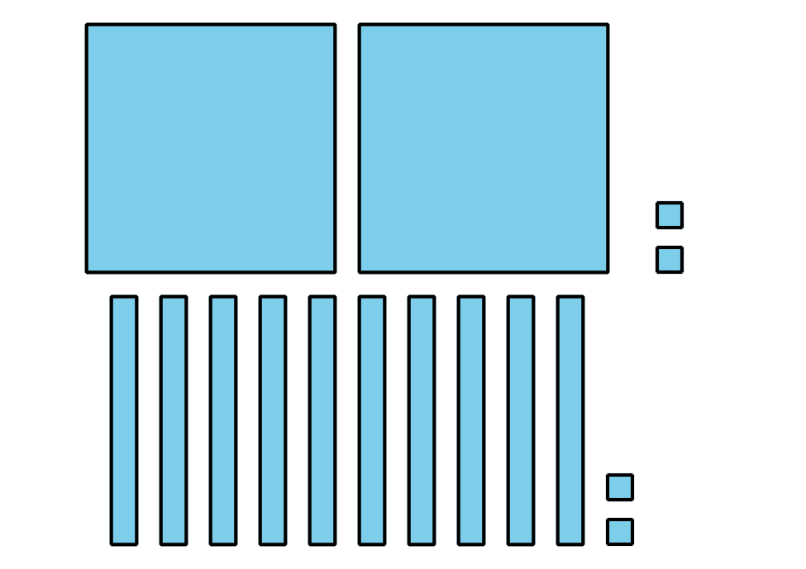
- _3333 _
- 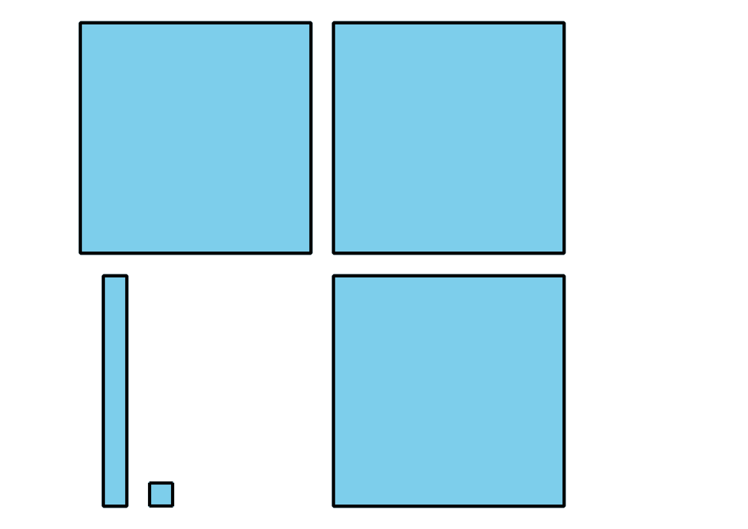
- 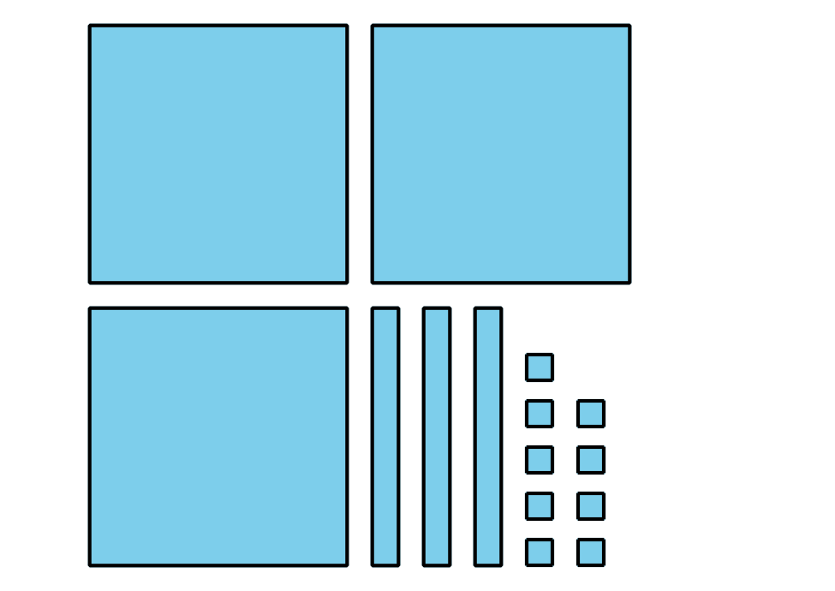
- _3333 _
- 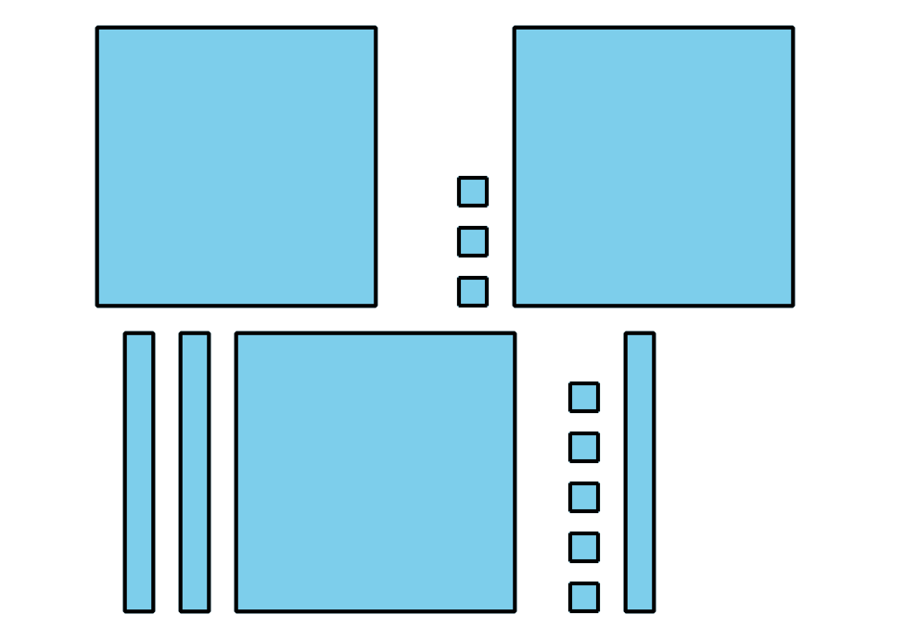
- 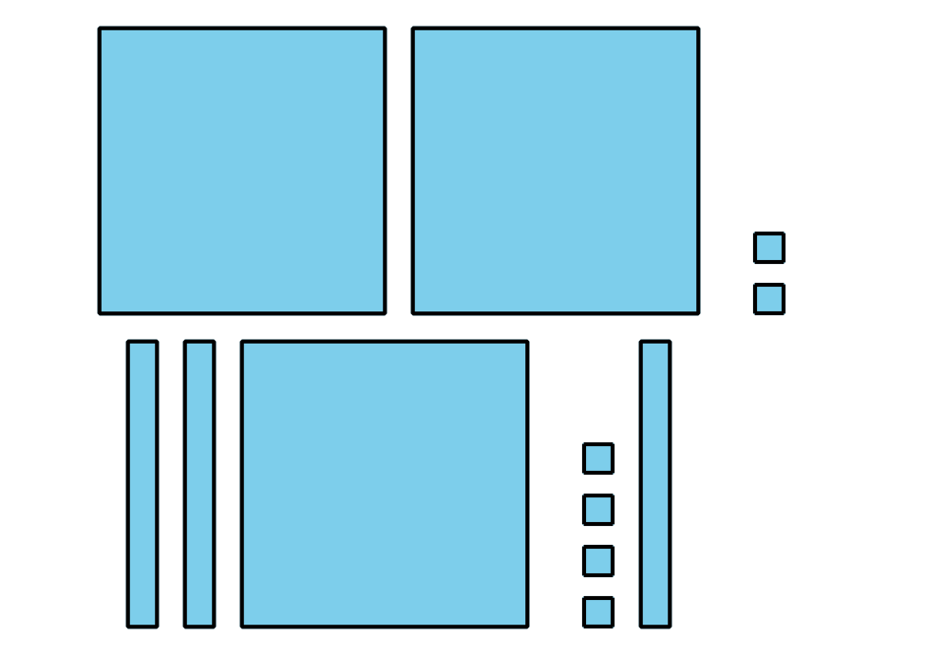
- _3333 _
- How do you know which value is greater in the last problem?

