Lesson 6: Actual Data vs. Predicted Data
- Let’s explore linear models that are fit to data

6.1: Which One Doesn’t Belong: Data Representations
Which one doesn’t belong?

A
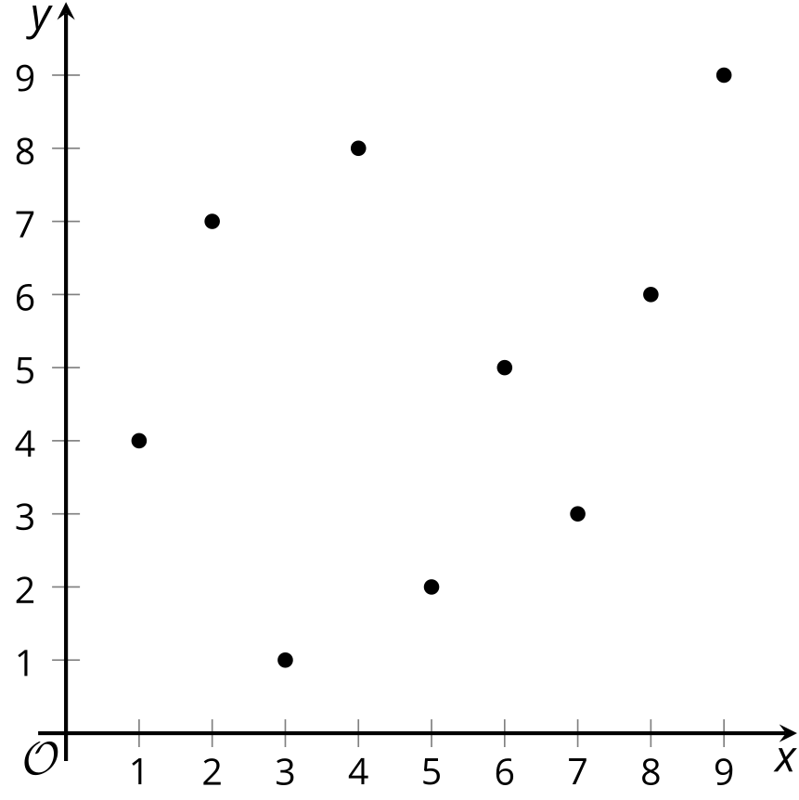

B
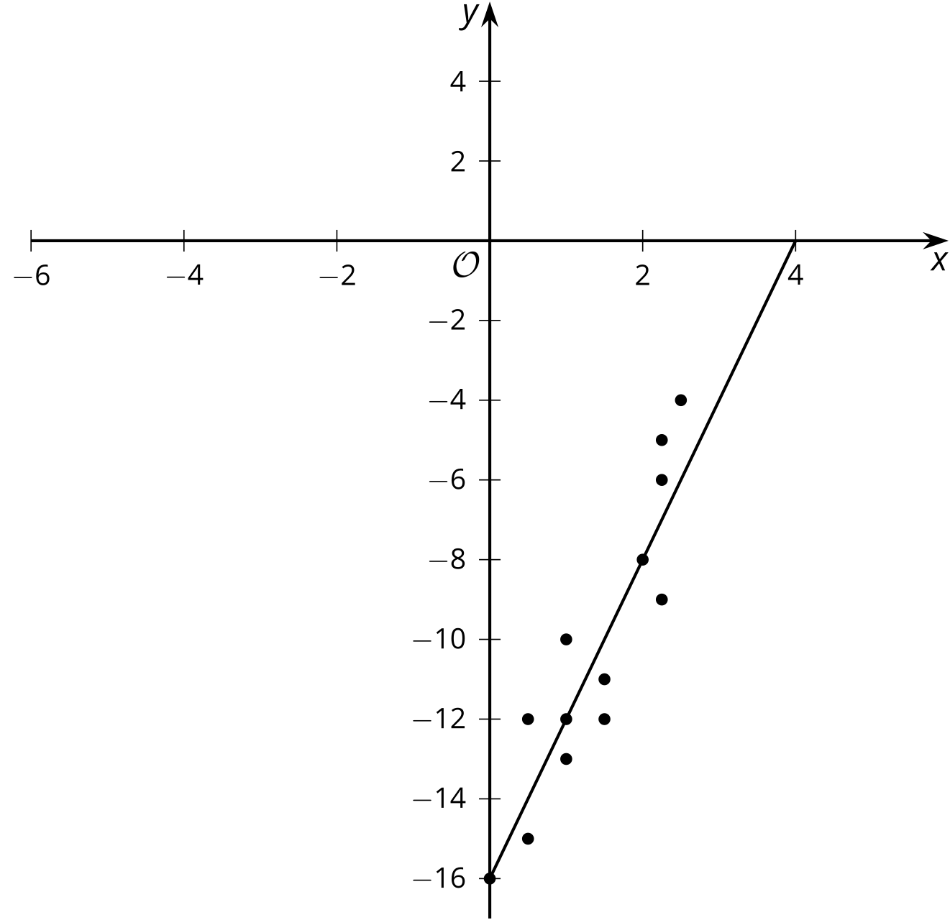

C
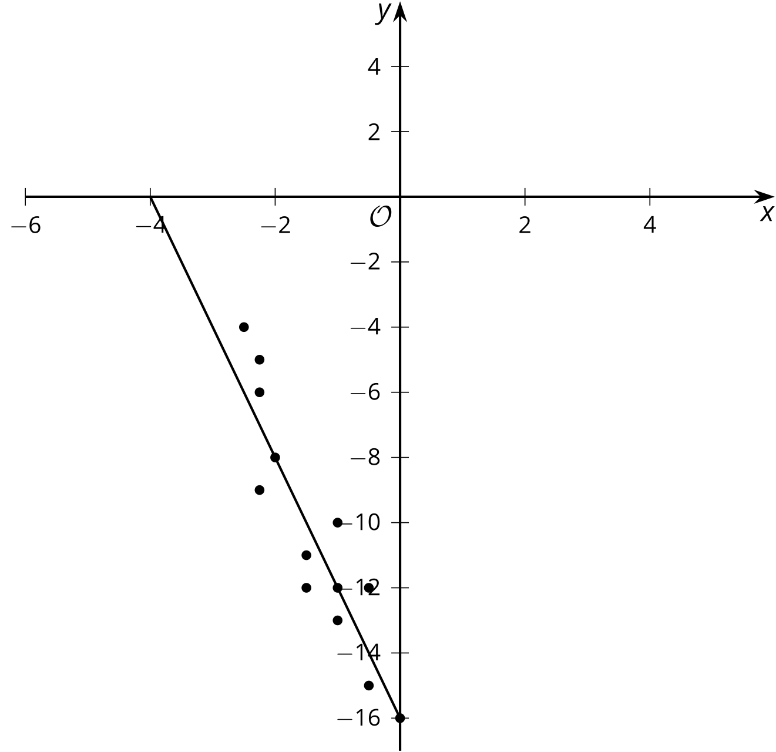

D
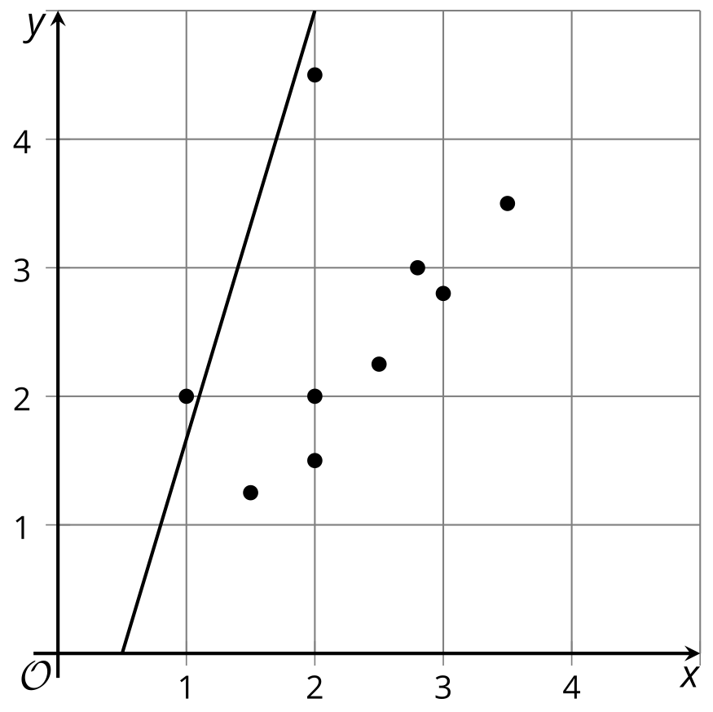

6.2: Predicting Sales
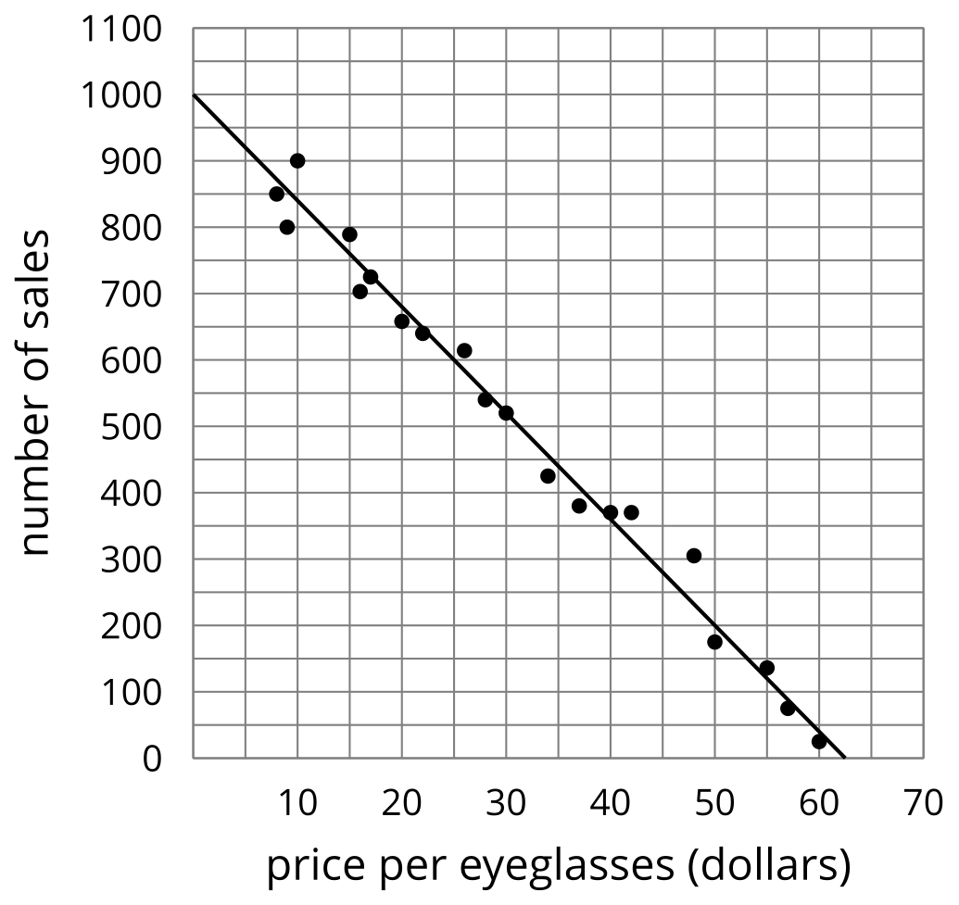
Here are a graph and a table showing the number of sales of eyeglasses based on the price in dollars. The model, represented by $y=1,​000−16x$, is graphed with a scatter plot. Use the graph and the table to answer the questions.
price per eyeglasses (dollars) | 8 | 9 | 10 | 15 | 16 | 17 | 20 | 22 | 26 | 28
number of sales | 850 | 800 | 900 | 789 | 703 | 725 | 658 | 640 | 614 | 540

price per eyeglasses (dollars) | 30 | 34 | 37 | 40 | 42 | 48 | 50 | 55 | 57 | 60
number of sales | 520 | 425 | 380 | 370 | 370 | 305 | 175 | 136 | 75 | 25
- How many sales does the model estimate will be made when the eyeglasses are $50 each? Explain or show your reasoning.
- How many sales were actually made when the eyeglasses were $50 each?
- How many times did the model estimate fewer sales than what were actually made? List the coordinates.
- How many times were the predicted number of sales and actual number of sales equivalent? List the coordinates.
- Find a point for which the model predicted there would be at least 25 more sales than were actually made?

6.3: Predictions
Priya’s family keeps track of the number of miles on each trip they take over the summer and the amount spent on gas for the trip. The model, represented by $y=50+0.15x$, is graphed with a scatter plot.
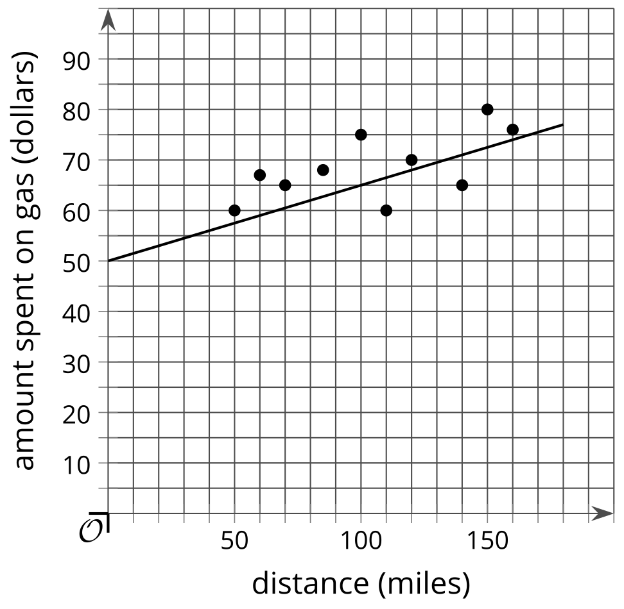
Use the graph and equation to complete the table. Then, use the graph, equation, and table to answer the questions.
distance (miles) | amount spent on gas (dollars) | estimated amount spent on gas (dollars)
50 | 60
70 | 65
100 | 75
60 | 67
110 | 60
140 | 65
80 | 68
150 | 80
160 | 76
- When Priya’s family drove 85 miles, they spent $68 on gas. How much did they expect to spend based on the linear model?
- How far had the family gone when they spent $80 on gas?
- How far does the model estimate the family should have driven when they spent $80 on gas?
- Are there any instances for which the model’s estimated amount spent on gas is equivalent to the actual amount spent on gas?
- Circle one option.
  - In general, the model predicts the family will spend more on gas than they actually spend.
  - In general, the model predicts the family will spend less on gas than they actually spend.
© CC BY 2019 by Illustrative Mathematics®

