Grade 2
Unit 2Lesson 14CC BY NC 2024 Illustrative Mathematics®
Unit 2, Lesson 14

Solve It Your Way
- Let’s solve story problems and share our thinking with others.
Grade 2
Unit 2Lesson 14CC BY NC 2024 Illustrative Mathematics®

Warm-upNumber Talk: Multiple Addends
Find the value of each expression mentally.
- $5+9+5$
- $25+9+5$
- $25+15+19$
- $25+30+15+19$
Grade 2
Unit 2Lesson 14CC BY NC 2024 Illustrative Mathematics®

Activity 1Put It All Together
- Andre gathers seeds. He has 25 sunflower seeds and 17 squash seeds. How many seeds does he have? Show your thinking using drawings, numbers, and words.
- Andre gathers more seeds. He has 35 cucumber seeds. How many seeds does Andre have in all? Show your thinking using drawings, numbers, and words.
- Compare your thinking with your partner.
- 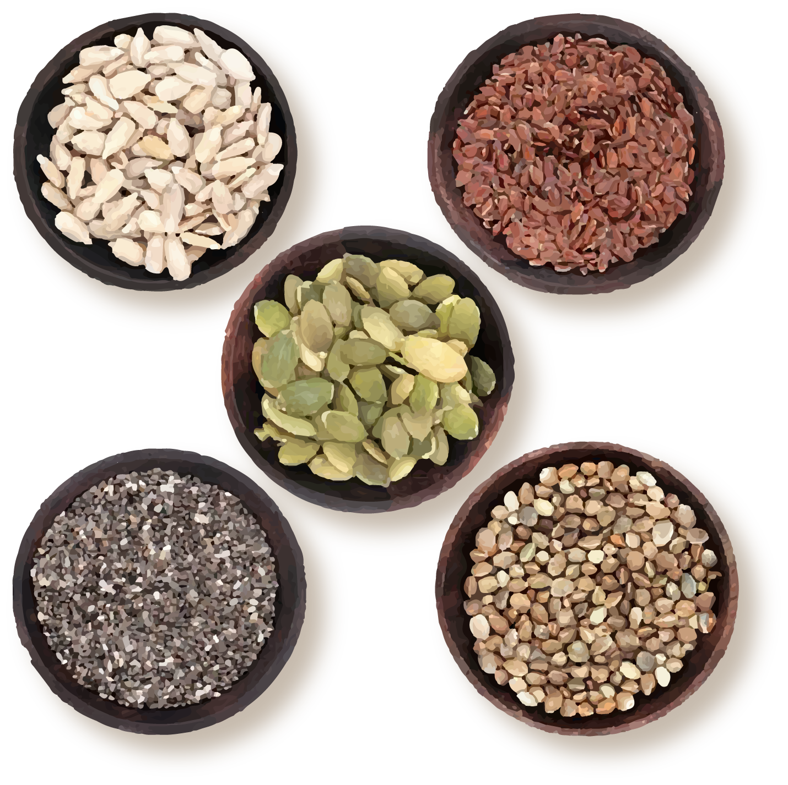
Grade 2
Unit 2Lesson 14CC BY NC 2024 Illustrative Mathematics®

Activity 2Make Sense of 2 Steps
Priya and Tyler play a game with seeds. Priya starts with 22 seeds. She captures 7 seeds in the first round. Then she captures 18 more seeds in the second round. How many seeds does she have now?
Solve the problem in any way that makes sense to you. Show your thinking using drawings, numbers, or words.

Section C Summary
We solved many kinds of story problems. We used diagrams and equations to make sense of problems .
Jada starts with some seeds. Then she wins 28 seeds from Elena. Now she has 65 seeds. How many seeds did she have at the start?
Unable to process <img src="/tikz_files/237000.svg">Failed: rsvg-convert --format png --dpi-x 300 --dpi-y 300 /app/tmp/svgtopng-1786380767.3205664.svg --output /app/tmp/svgtopng-1786380767.3205664.png Backtrace: /app/app/services/script/runner.rb:34:in `block in run_cmd' <internal:kernel>:90:in `tap' /app/app/services/script/runner.rb:32:in `run_cmd' /app/app/services/script/svg_to_png.rb:27:in `convert_svg_to_png' /app/app/services/script/svg_to_png.rb:17:in `to_png' /app/vendor/bundle/ruby/3.3.0/gems/embeddable_content-1.1.0/app/services/embeddable_content/images/image_downloader.rb:37:in `png_rendered_from_svg' /app/vendor/bundle/ruby/3.3.0/gems/embeddable_content-1.1.0/app/services/embeddable_content/images/image_downloader.rb:33:in `raw_image_data' /app/vendor/bundle/ruby/3.3.0/gems/embeddable_content-1.1.0/app/services/embeddable_content/images/image_downloader.rb:13:in `block in save' <internal:kernel>:90:in `tap' /app/vendor/bundle/ruby/3.3.0/gems/embeddable_content-1.1.0/app/services/embeddable_content/images/image_downloader.rb:13:in `save'
$?+28=65$
We shared how to make sense of story problems and how to solve them.

