Grade 6
Unit 2Lesson 13CC BY NC Illustrative Mathematics, based on IM 6–8 Math, CC BY Open Up Resources.
Unit 2, Lesson 13

Tables and Double Number Line Diagrams
Let’s contrast double number lines and tables.
Grade 6
Unit 2Lesson 13CC BY NC Illustrative Mathematics, based on IM 6–8 Math, CC BY Open Up Resources.

13.1Running 3,000 Meters
Han can run 100 meters in 20 seconds. He wonders how long it would take him to run 3,000 meters at this rate. He made a table of equivalent ratios.
- Do you agree that this table represents the situation? Explain your reasoning.
- 20 | - 100
- 10 | - 50
- 1 | - 5
- 3,000
- Complete the last row with the missing number.
Grade 6
Unit 2Lesson 13CC BY NC Illustrative Mathematics, based on IM 6–8 Math, CC BY Open Up Resources.

13.2Biking 3,000 Meters
- Priya can bike 150 meters in 20 seconds. At this rate, how long would it take her to bike 3,000 meters?
- Priya’s neighbor has a dirt bike that can go 360 meters in 15 seconds. At this rate, how long would it take her neighbor to go 3,000 meters? Show your reasoning.
Grade 6
Unit 2Lesson 13CC BY NC Illustrative Mathematics, based on IM 6–8 Math, CC BY Open Up Resources.

13.3The International Space Station
The International Space Station orbits around the Earth at a constant speed. Your teacher will give you either a double number line or a table that represents this situation. Your partner will get the other representation.
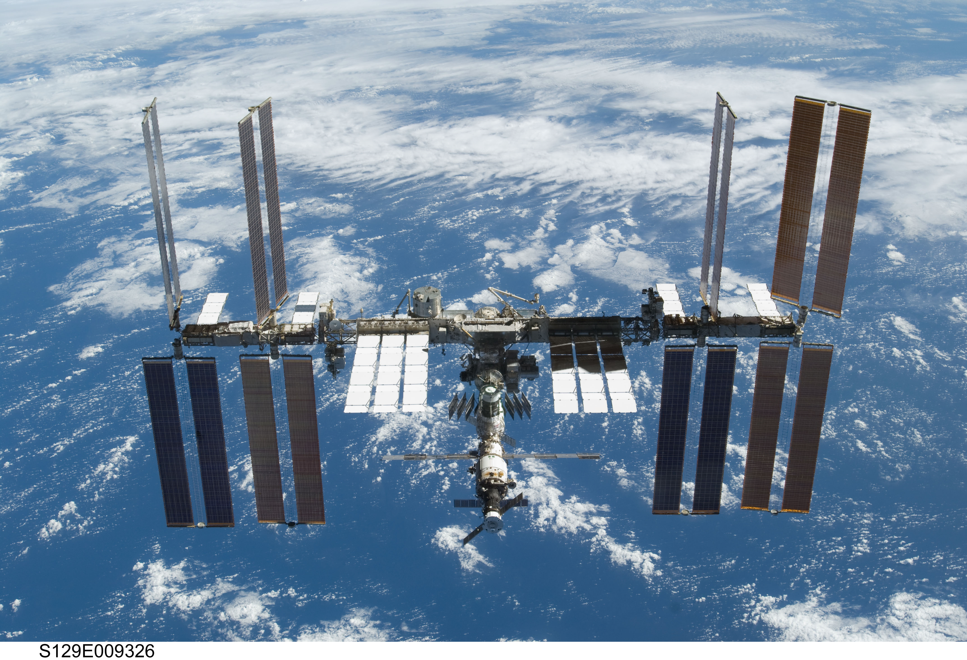
- Complete the parts of your representation that you can figure out for sure.
- Share information with your partner, and use the information that your partner shares to complete your representation.
- What is the speed of the International Space Station?
- Place the two completed representations side by side. Discuss with your partner some ways in which they are the same and some ways in which they are different.
- Record at least one way that they are the same and one way they are different.

Are you ready for more?
Earth’s circumference is about 40,000 kilometers and the orbit of the International Space Station is just a bit more than this. About how long does it take for the International Space Station to orbit Earth?

Lesson 13 Summary
On a double number line diagram, we put labels in front of each line to tell what the numbers represent. On a table, we put labels at the top of each column to tell what the numbers represent.
Here are two different ways we can represent the situation: “A snail is moving at a constant speed down a sidewalk, traveling 6 centimeters per minute.”
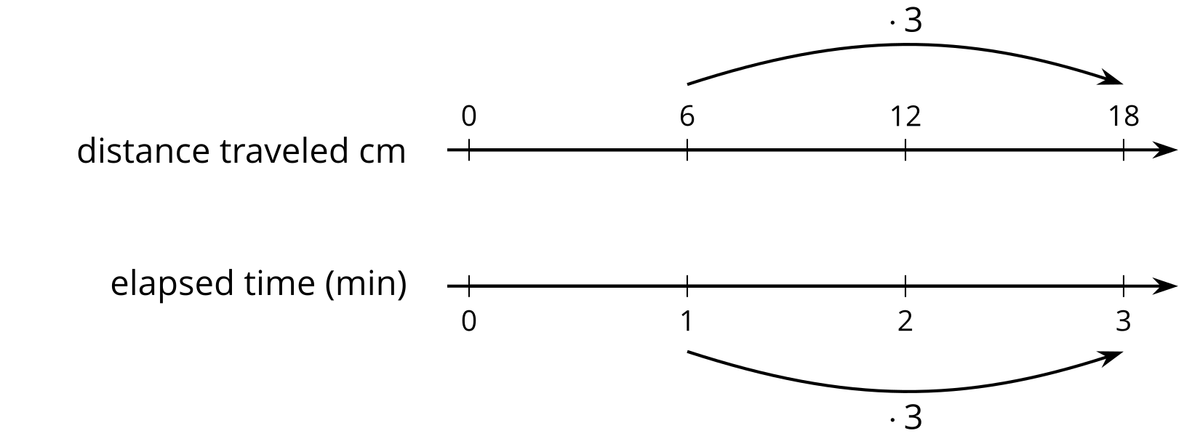
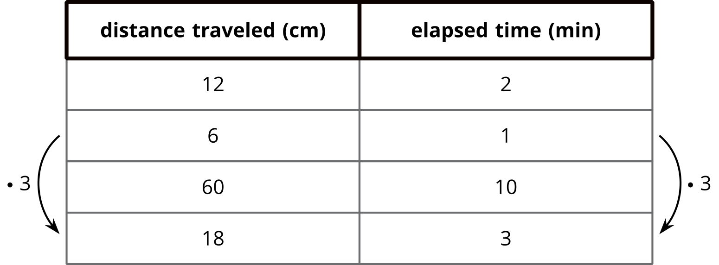
Both double number lines and tables can help us use multiplication to make equivalent ratios, but there is an important difference between the two representations.
On a double number line, the numbers on each line are listed in order. With a table, you can write the ratios in any order. For this reason, sometimes a table is easier to use to solve a problem.
For example, what if we wanted to know how far the snail travels in 10 minutes? Notice that 60 centimeters in 10 minutes is shown on the table, but there is not enough room for this information on the double number line.

