Grade 2
Unit 6Lesson 2CC BY NC 2024 Illustrative Mathematics®
Unit 6, Lesson 2

Draw Shapes
- Let’s recognize and draw triangles, quadrilaterals, pentagons, and hexagons.
Grade 2
Unit 6Lesson 2CC BY NC 2024 Illustrative Mathematics®

Warm-up Which Three Go Together: 5-Sided Shapes
Which 3 go together?
A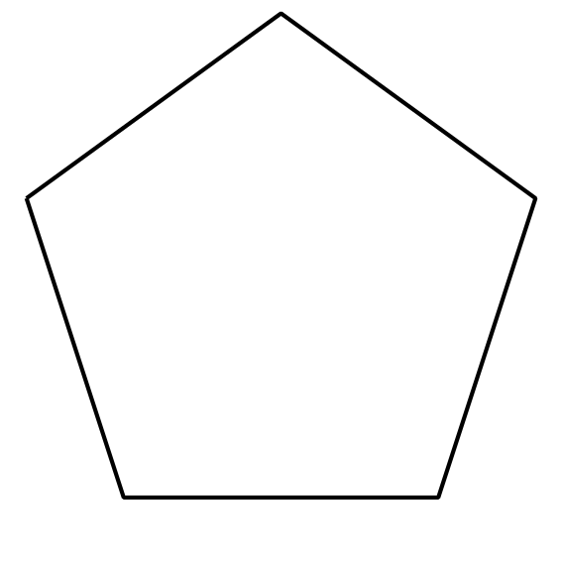
B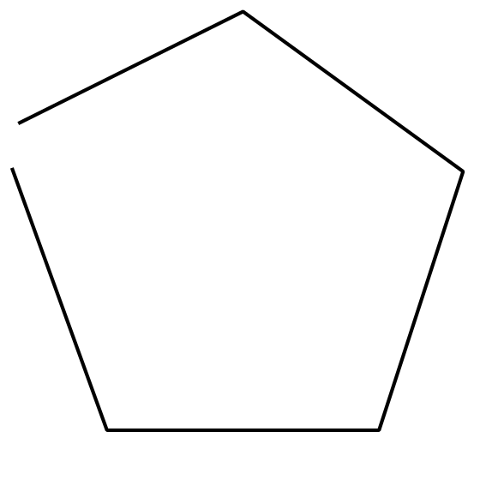
C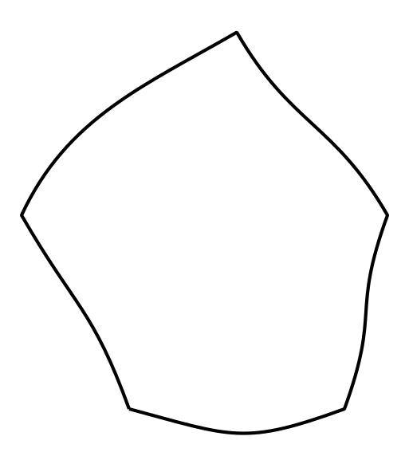
D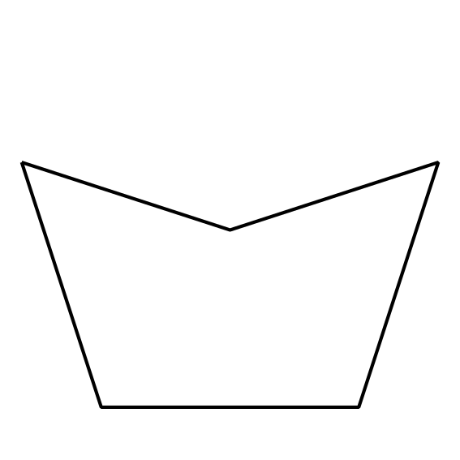
Grade 2
Unit 6Lesson 2CC BY NC 2024 Illustrative Mathematics®

Activity 1 Draw Shapes
- Complete the shape to make a quadrilateral. Then draw a different 4-sided shape.
- 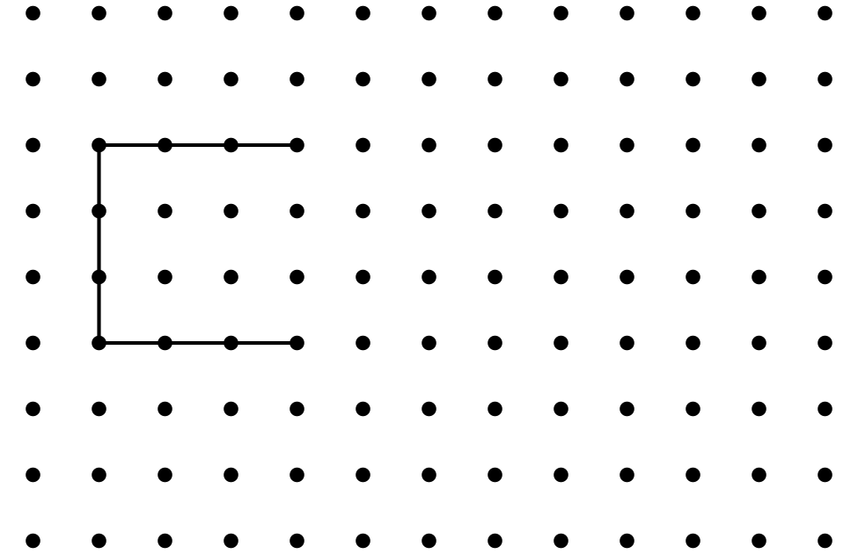
- Complete the shape to make a pentagon. Then draw a different 5-sided shape.
- Complete the shape to make a hexagon. Then draw a different 6-sided shape.
- Compare your shapes with your partner. How are the shapes alike? How are they different?
Grade 2
Unit 6Lesson 2CC BY NC 2024 Illustrative Mathematics®

Activity 2 What Shape Could It Be?
- Clare draws a shape with fewer than 5 sides. Circle shapes that could be her shape.
- 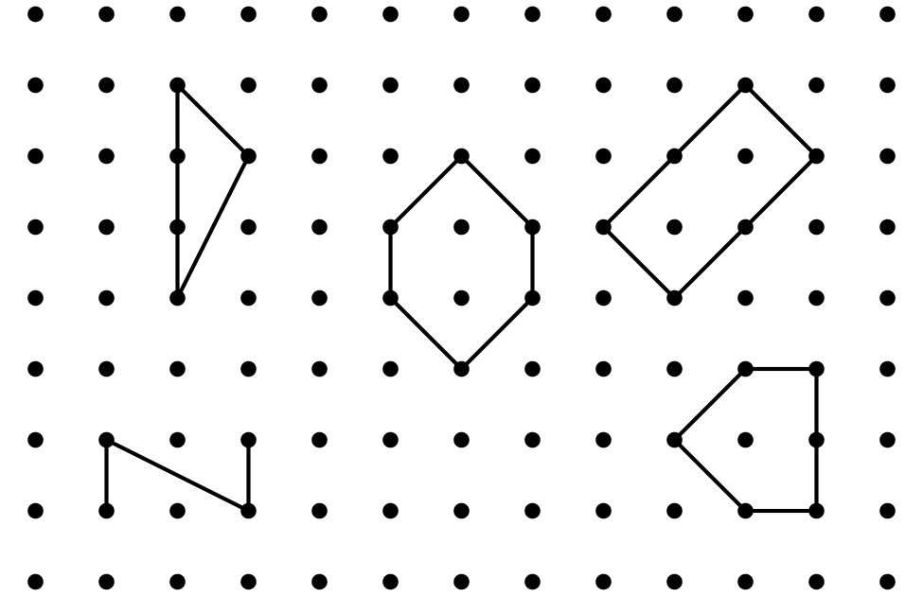
- Draw a different shape that could be Clare’s shape.
- 
- Andre draws a shape with 4 corners. Circle shapes that could be his shape.
- 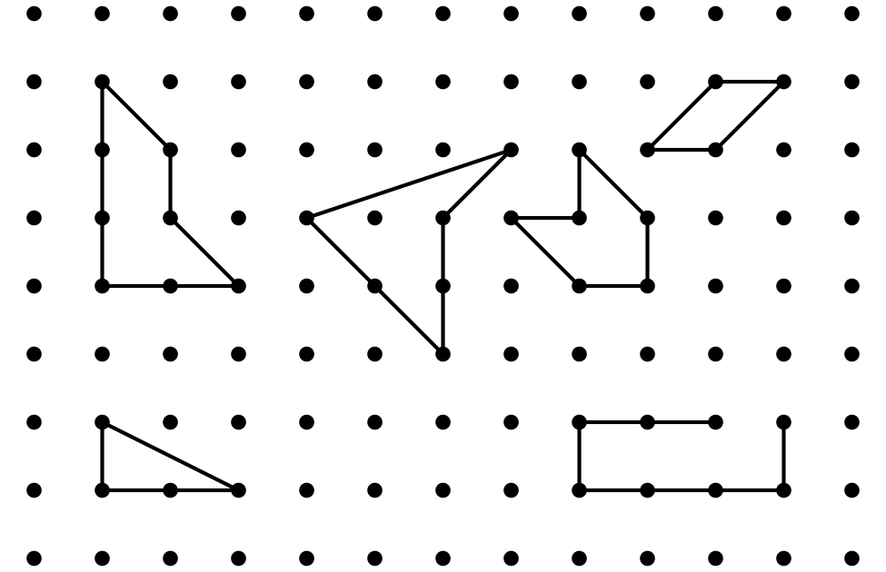
- Draw a different shape that could be Andre’s shape.
- Han draws a shape with more corners than Andre’s shape. Draw 2 shapes that could be Han’s shape.

