Grade 2
Unit 1Lesson 18CC BY NC 2024 Illustrative Mathematics®
Unit 1, Lesson 18

Class Surveys
- Let’s create our own surveys to get to know our classmates.
Grade 2
Unit 1Lesson 18CC BY NC 2024 Illustrative Mathematics®

Warm-upWhat Do You Know about Bar Graphs?
What do you know about bar graphs?
Grade 2
Unit 1Lesson 18CC BY NC 2024 Illustrative Mathematics®

Activity 1Classroom Survey and Graph
- What is your survey question?
- What are your categories?
  - Category 1: __________________________________
  - Category 2: __________________________________
  - Category 3: __________________________________
  - Category 4: ___________________________________
- Record the data.
- Organize and represent the data in a bar or picture graph.
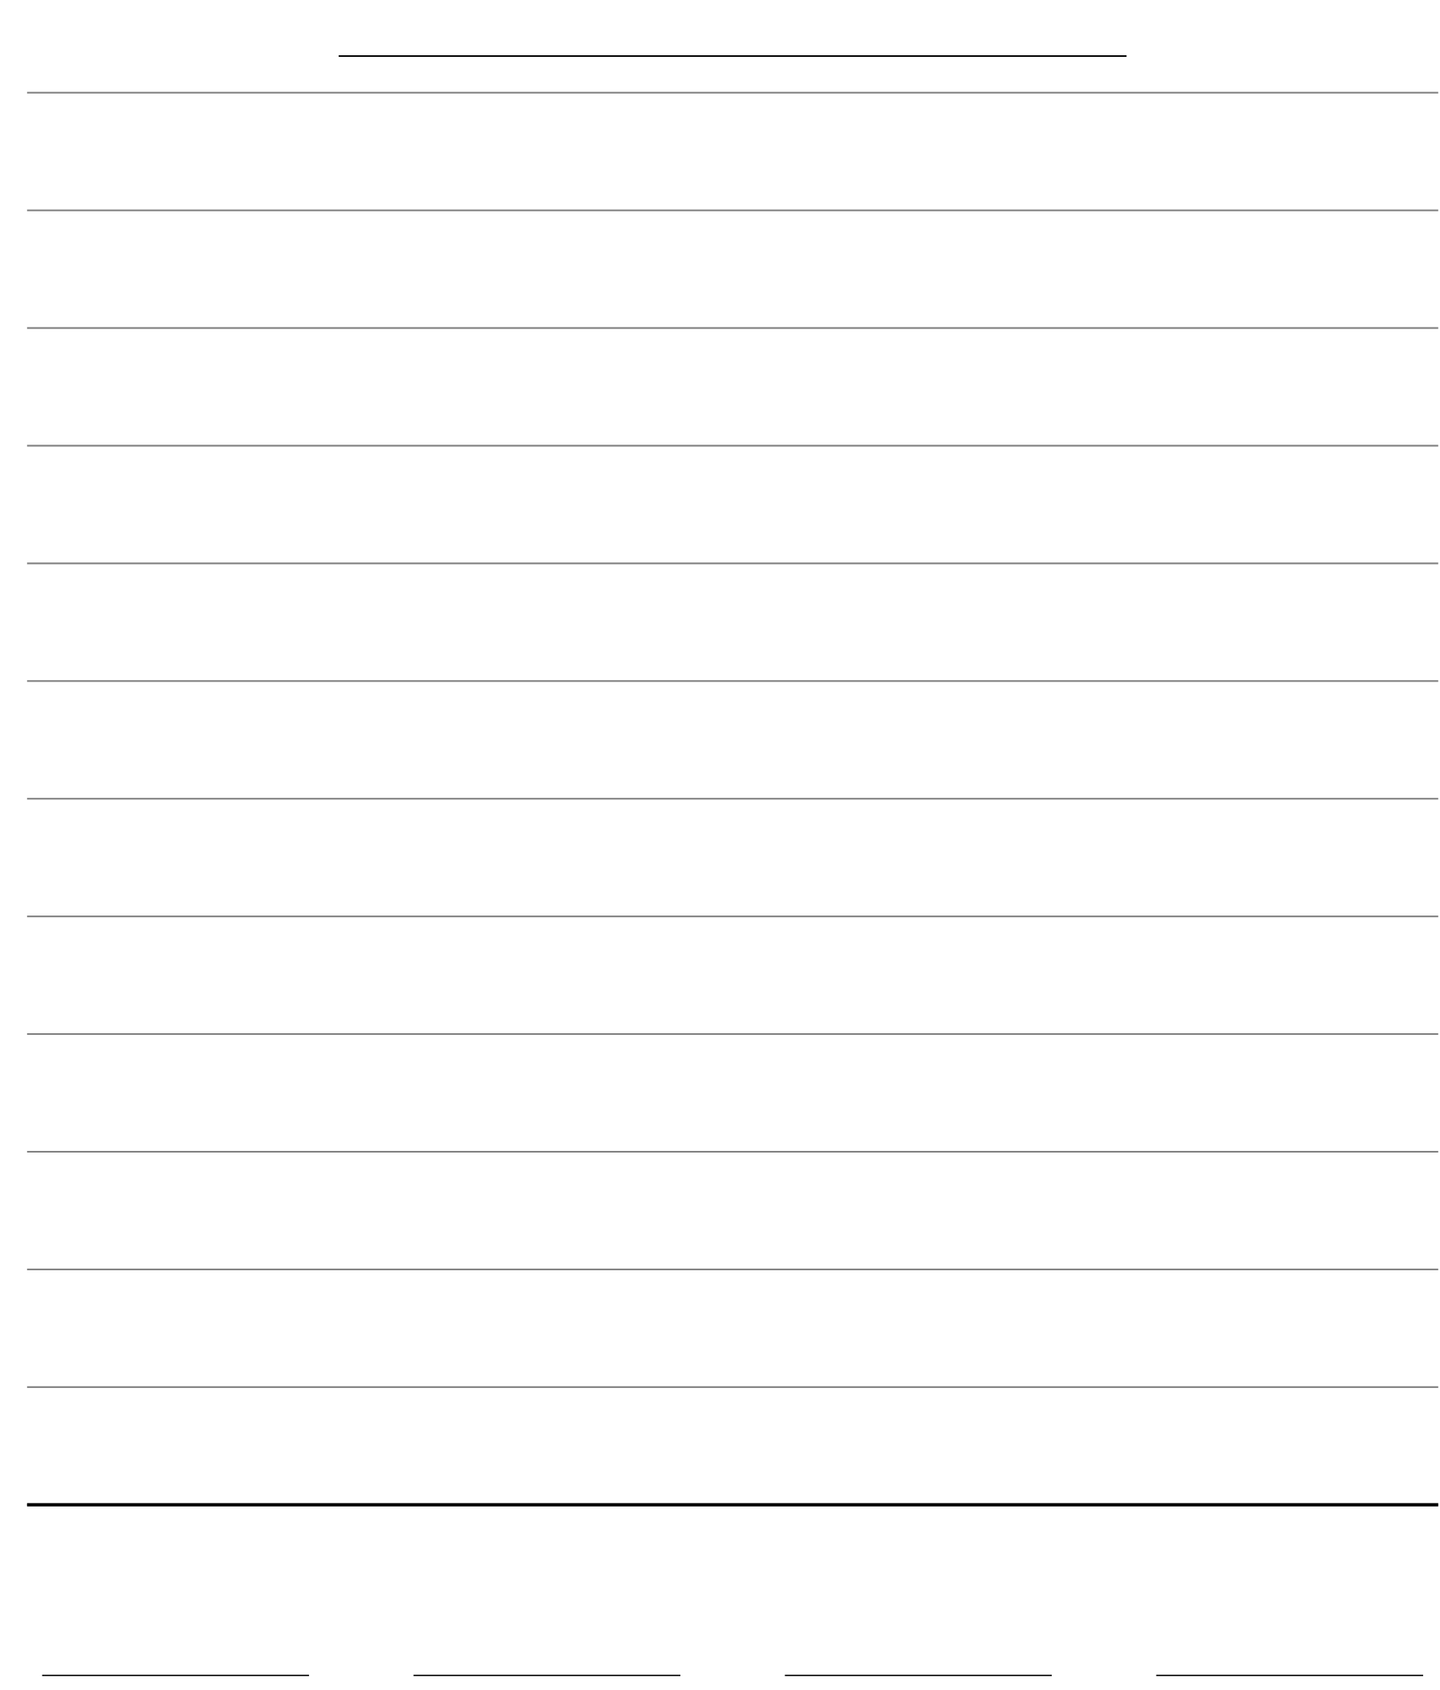
Grade 2
Unit 1Lesson 18CC BY NC 2024 Illustrative Mathematics®

Activity 2Analyze the Data with Diagrams
- Draw a diagram. Your diagram should compare 2 facts you learned from your survey.
- Write an equation that represents the comparison.

