Grade 6
Unit 7Lesson 7CC BY NC Illustrative Mathematics, based on IM 6–8 Math, CC BY Open Up Resources.
Unit 7, Lesson 7

Comparing Numbers and Distance from Zero
Let’s use absolute value and negative numbers to think about elevation.
Grade 6
Unit 7Lesson 7CC BY NC Illustrative Mathematics, based on IM 6–8 Math, CC BY Open Up Resources.

7.1Submarine
A submarine is at an elevation of -100 feet (100 feet below sea level). These statements compare the elevations of four people to that of the submarine:
- Clare’s elevation is greater than the elevation of the submarine. Clare is farther from sea level than the submarine.
- Andre’s elevation is less than the elevation of the submarine. Andre is farther away from sea level than the submarine.
- Han’s elevation is greater than the elevation of the submarine. Han is closer to sea level than is the submarine.
- Lin’s elevation is the same distance away from sea level as the submarine’s.
Plot and label a possible location for each person’s elevation on the vertical number line.
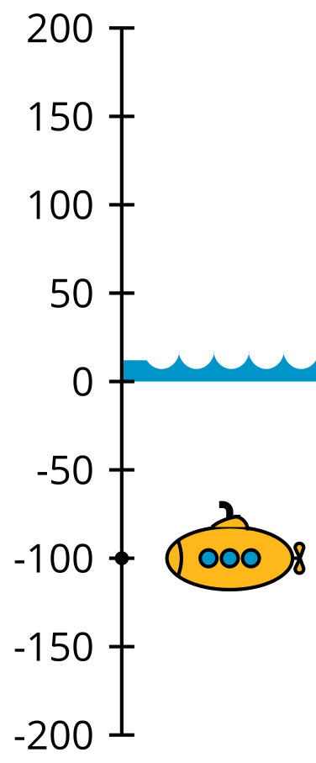
Grade 6
Unit 7Lesson 7CC BY NC Illustrative Mathematics, based on IM 6–8 Math, CC BY Open Up Resources.

7.2Info Gap: Points on the Number Line
Your teacher will give you either a problem card or a data card. Do not show or read your card to your partner.
If your teacher gives you the problem card:
- Silently read your card, and think about what information you need to answer the question.
- Ask your partner for the specific information that you need. “Can you tell me $\underset{_}{​}$?”
- Explain to your partner how you are using the information to solve the problem. “I need to know $\underset{_}{​}$ because . . . .”
Continue to ask questions until you have enough information to solve the problem.
- Once you have enough information, share the problem card with your partner, and solve the problem independently.
- Read the data card, and discuss your reasoning.
If your teacher gives you the data card:
- Silently read your card. Wait for your partner to ask for information.
- Before telling your partner any information, ask, “Why do you need to know $\underset{_}{​}$?”
- Listen to your partner’s reasoning, and ask clarifying questions. Only give information that is on your card. Do not figure out anything for your partner!
These steps may be repeated.
- Once your partner says they have enough information to solve the problem, read the problem card, and solve the problem independently.
- Share the data card, and discuss your reasoning.

Grade 6
Unit 7Lesson 7CC BY NC Illustrative Mathematics, based on IM 6–8 Math, CC BY Open Up Resources.

7.3Inequality Mix and Match
Here are some numbers and symbols. Take turns with your partner to write true comparison statements. One partner will use 2 numbers and 1 symbol to write a true statement. The other partner will use one of the following phrases to write a sentence with the same meaning:
- "Is equal to"
- "Is the absolute value of"
- "Is greater than"
- "Is less than"
-0.7
$\text{-}\frac{3}{5}$
1
4
$\left|\text{-}8\right|$
$<$
$\text{-}\frac{6}{3}$
-2.5
2.5
8
$\left|0.7\right|$
$=$
-4
0
$\frac{7}{2}$
$\left|3\right|$
$\left|\text{-}\frac{5}{2}\right|$
$>$
- For each statement that you write, explain your reasoning to your partner.
- For each statement that your partner writes, listen carefully to their explanation. If you disagree, discuss your thinking, and work to reach an agreement.

Are you ready for more?
For each question, choose a value for each variable to make the whole statement true. (When the word “and” is used in math, both parts have to be true for the whole statement to be true.) Is it true if one variable is negative and one is positive? Is it true if both values are negative?
- $x<y$, and $\left|x\right|<y$.
- $a<b$, and $\left|a\right|<\left|b\right|$.
- $c<d$, and $\left|c\right|>d$.
- $t<u$, and $\left|t\right|>\left|u\right|$.

Lesson 7 Summary
We can use situations about elevation to help us compare two rational numbers or two absolute values.
- Suppose an anchor has an elevation of -10 meters and a house has an elevation of 12 meters. To describe the anchor having a lower elevation than the house, we can write "$\text{-}10<12$" and say, “-10 is less than 12.”
- The anchor is closer to sea level than the house is to sea level (or elevation of 0). To describe this, we can write, "$\left|\text{-}10\right|<\left|12\right|$" and say, "the distance between -10 and 0 is less than the distance between 12 and 0.”
We can use similar descriptions to compare rational numbers and their absolute values in situations not about elevation.
- To compare the distance of -47.5 and 5.2 from 0, we can say that $\left|\text{-}47.5\right|$ is 47.5 units away from 0, and $\left|5.2\right|$ is 5.2 units away from 0, so $\left|\text{-}47.5\right|>\left|5.2\right|$.
- $\left|\text{-}18\right|>4$ means that the absolute value of -18 is greater than 4. This is true because 18 is greater than 4.

