Algebra 1
Unit 6Lesson 7CC BY NC 2024 Illustrative Mathematics®
Unit 6, Lesson 7

Using Negative Exponents
Let’s look more closely at exponential graphs and equations.
Algebra 1
Unit 6Lesson 7CC BY NC 2024 Illustrative Mathematics®

7.1Exponent Rules
How would you rewrite each of the following as an equivalent expression with a single exponent?
- $2^{4}⋅2^{0}$
- $2^{4}⋅2^{\text{-}1}$
- $2^{4}⋅2^{\text{-}3}$
- $2^{4}⋅2^{\text{-}4}$
Algebra 1
Unit 6Lesson 7CC BY NC 2024 Illustrative Mathematics®

7.2Coral in the Sea
A marine biologist estimates that a structure of coral has a volume of 1,200 cubic centimeters and that its volume doubles each year.

- Write an equation of the form $y=a⋅b^{t}$ representing the relationship, where $t$ is the time in years since the coral was measured, and $y$ is the volume of coral in cubic centimeters. (You need to figure out what numbers $a$ and $b$ are in this situation.)
- Find the volume of the coral when $t$ is 5, 1, 0, -1, and -2.
- What does it mean, in this situation, when $t$ is -2?
- In a certain year, the volume of the coral is 37.5 cubic centimeters. Which year is this? Explain your reasoning.
Algebra 1
Unit 6Lesson 7CC BY NC 2024 Illustrative Mathematics®

7.3Windows of Graphs
The volume, $y$, of coral in cubic centimeters is modeled by the equation $y=1,​200⋅2^{x}$ where $x$ is the number of years since the coral was measured. Three students used graphing technology to graph the equation that represents the volume of coral as a function of time.

A
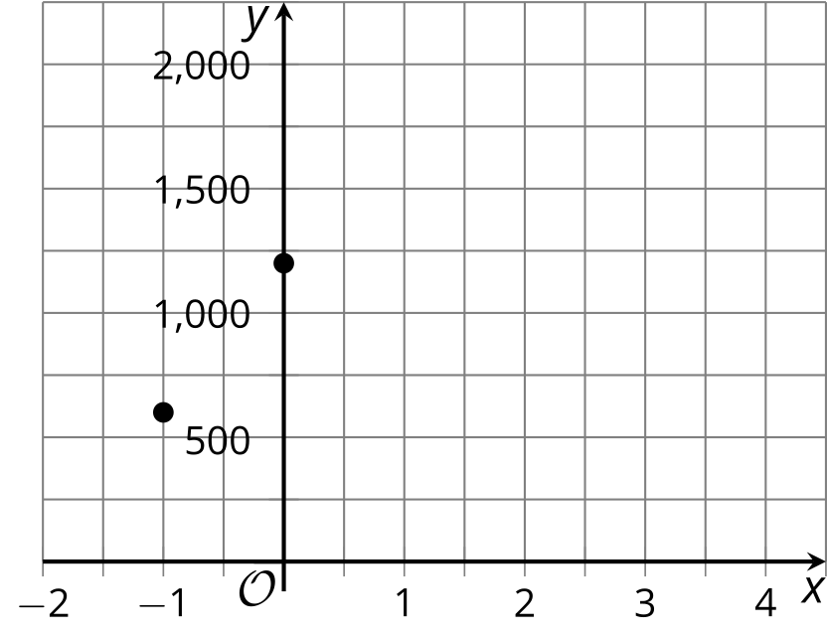

B
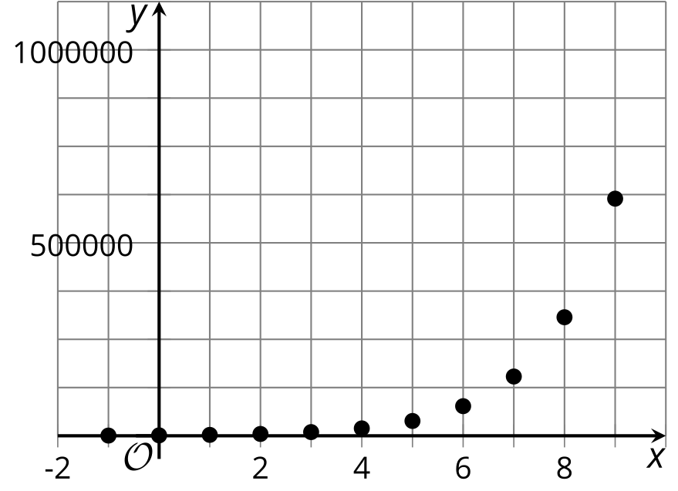

C
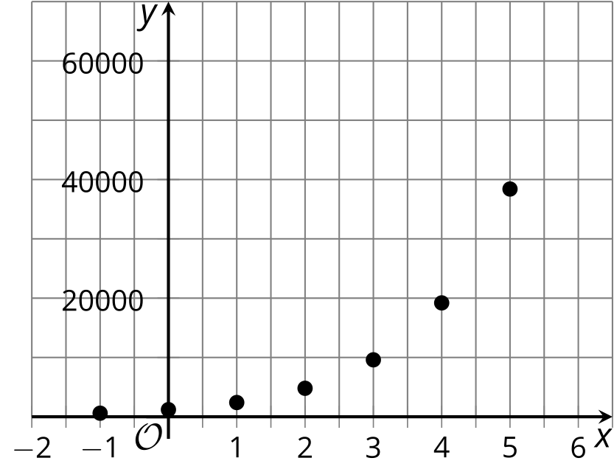
For each graph:
- Describe how well each graphing window does, or does not, show the behavior of the function.
- For each graphing window that you think does not show the behavior of the function well, describe how you would change it.
- Make the change(s) you suggested, and sketch the revised graph using graphing technology.
Algebra 1
Unit 6Lesson 7CC BY NC 2024 Illustrative Mathematics®

7.4Ghost Town Population
A town’s population decreased exponentially from the late 1800’s until the mid 1900’s, when the last residents left the town, leaving it a ghost town.

  - The population of the town, $p$, for a number of years since 1900, $t$, is shown in the table. What is the growth factor? That is, what is $b$ in an equation of the form $p=a⋅b^{t}$? What is $a$?
  - Find the population of the town when $t$ is -1 and -3. Record them in the table.
- $t$, years since 1900 | - $p$, population
- 0 | - 1,500
- 1 | - 1,350
- 2 | - 1,215
- What do $t=0$, $t=\text{-}1$, and $t=\text{-}3$ mean in this situation?
- The town’s population was at its greatest in 1895. What was that population? Explain your reasoning.
- Plot the points whose coordinates are shown in the table.
- 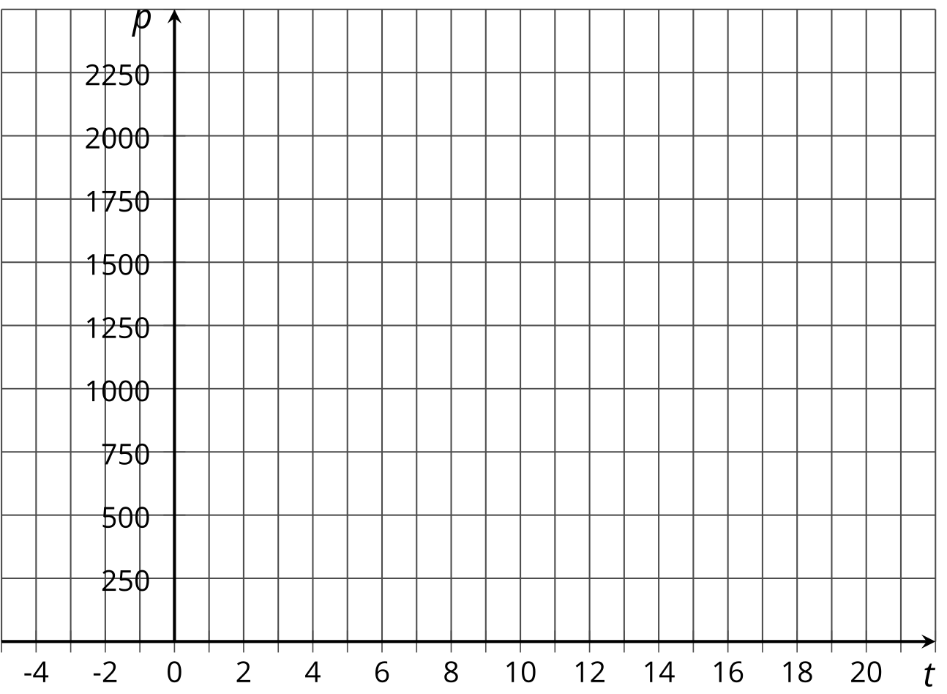
- Based on your graph:
  - When did the town have about 2,000 people?
  - What was the population in 1905?

Are you ready for more?
Without evaluating them, describe each of the following quantities as close to 0, close to 1, or much larger than 1.
$\frac{1}{1−2^{\text{-}10}} \frac{2^{10}}{2^{10}+1} \frac{2^{\text{-}10}}{2^{10}+1} \frac{1−2^{\text{-}10}}{2^{10}} \frac{1+2^{10}}{2^{\text{-}10}}$

Lesson 7 Summary
Equations are useful not only for representing relationships that change exponentially, but also for answering questions about these situations.
Suppose a bacteria population of 1,000,000 has been increasing by a factor of 2 every hour. What was the size of the population 5 hours ago? How many hours ago was the population less than 1,000?
We could go backward and calculate the population of bacteria 1 hour ago, 2 hours ago, and so on. For example, if the population doubled each hour and was 1,000,000 when first observed, an hour before then it must have been 500,000, and two hours before then it must have been 250,000, and so on.
Another way to reason through these questions is by representing the situation with an equation. If $t$ measures time in hours since the population was 1,000,000, then the bacteria population can be described by the equation:
$p=1,​000,​000⋅2^{t}$
The population is 1,000,000 when $t$ is 0, so 5 hours earlier, $t$ would be -5 and here is a way to calculate the population:
$\begin{matrix}1,​000,​000⋅2^{\text{-}5} & =1,​000,​000⋅\frac{1}{2^{5}} \\ & =1,​000,​000⋅\frac{1}{32} \\ & =31,​250\end{matrix}$
Likewise, substituting -10 for $t$ gives us $1,​000,​000⋅2^{\text{-}10}$ (or $1,​000,​000⋅\frac{1}{2^{10}}$), which is a little less than 1,000. This means that 10 hours before the initial measurement the bacteria population was less than 1,000.

