Unit 6 Lesson 5: Building Quadratic Functions to Describe Situations (Part 1)

1 Notice and Wonder: An Interesting Numerical Pattern (Warm up)

Student Task Statement
Study the table. What do you notice? What do you wonder?
$x$ | 0 | 1 | 2 | 3 | 4 | 5
$y$ | 0 | 16 | 64 | 144 | 256 | 400

2 Falling from the Sky

Student Task Statement
A rock is dropped from the top floor of a 500-foot tall building. A camera captures the distance the rock traveled, in feet, after each second.
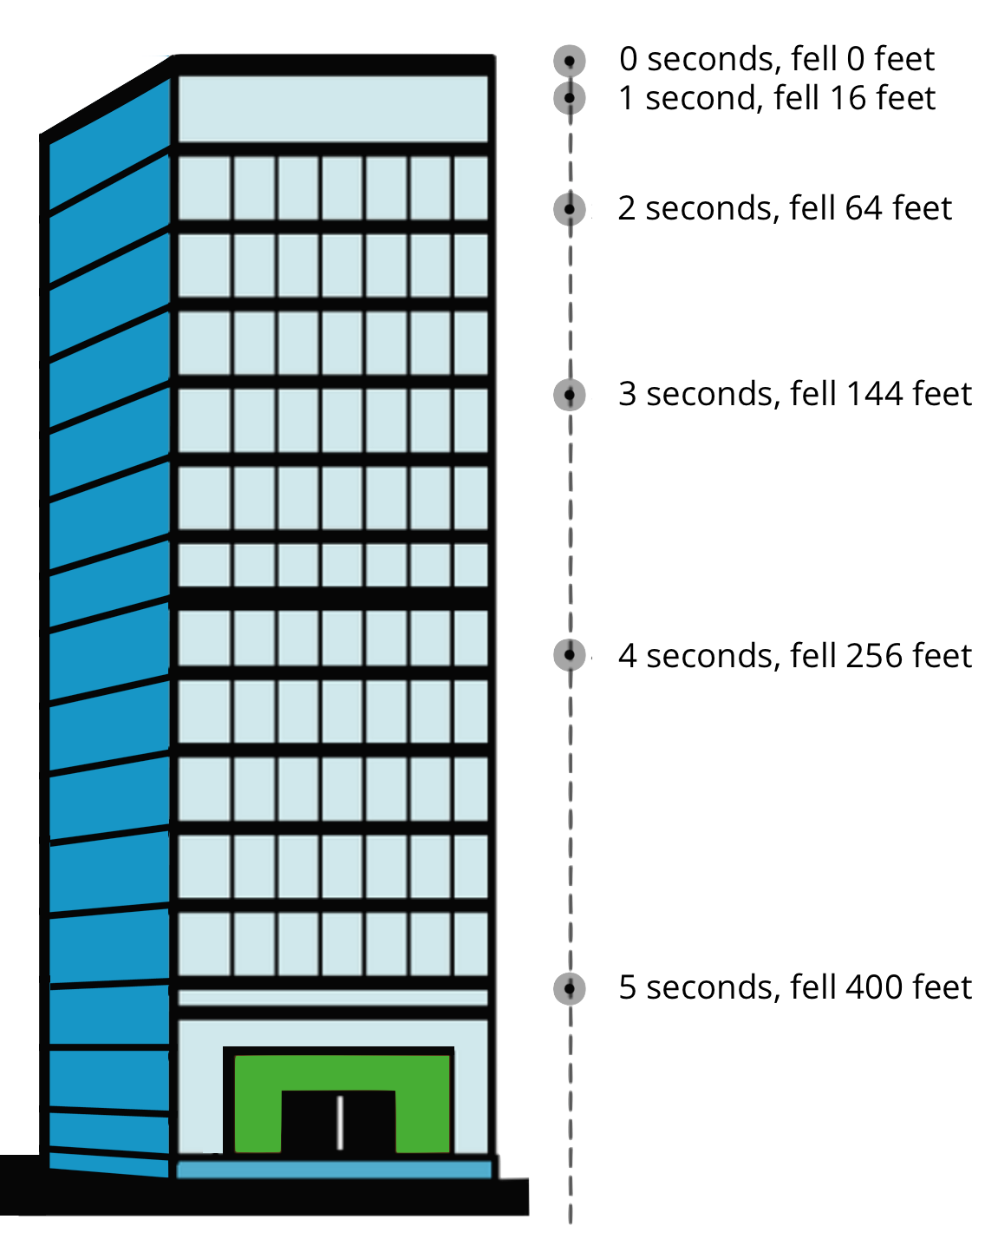
- How far will the rock have fallen after 6 seconds? Show your reasoning.
- Jada noticed that the distances fallen are all multiples of 16.
- She wrote down:
- $\begin{matrix}16 & =16⋅1 \\ 64 & =16⋅4 \\ 144 & =16⋅9 \\ 256 & =16⋅16 \\ 400 & =16⋅25\end{matrix}$
Then, she noticed that 1, 4, 9, 16, and 25 are $1^{2},2^{2},3^{2},4^{2}$ and $5^{2}$.
  - Use Jada’s observations to predict the distance fallen after 7 seconds. (Assume the building is tall enough that an object dropped from the top of it will continue falling for at least 7 seconds.) Show your reasoning.
  - Write an equation for the function, with $d$ representing the distance dropped after $t$ seconds.

3 Galileo and Gravity

Student Task Statement
Galileo Galilei, an Italian scientist, and other medieval scholars studied the motion of free-falling objects. The law they discovered can be expressed by the equation $d=16⋅t^{2}$, which gives the distance fallen in feet, $d$, as a function of time, $t$, in seconds.
An object is dropped from a height of 576 feet.
- How far does it fall in 0.5 seconds?
- To find out where the object is after the first few seconds after it was dropped, Elena and Diego created different tables.
- Elena’s table:
- time (seconds) | - distance fallen  (feet)
- 0 | - 0
- 1 | - 16
- 2 | - 64
- 3
- 4
- $t$
- Diego’s table:
- time (seconds) | - distance from the ground (feet)
- 0 | - 576
- 1 | - 560
- 2 | - 512
- 3
- 4
- $t$
  - How are the two tables are alike? How are they different?
  - Complete Elena’s and Diego’s tables. Be prepared to explain your reasoning.

Activity Synthesis
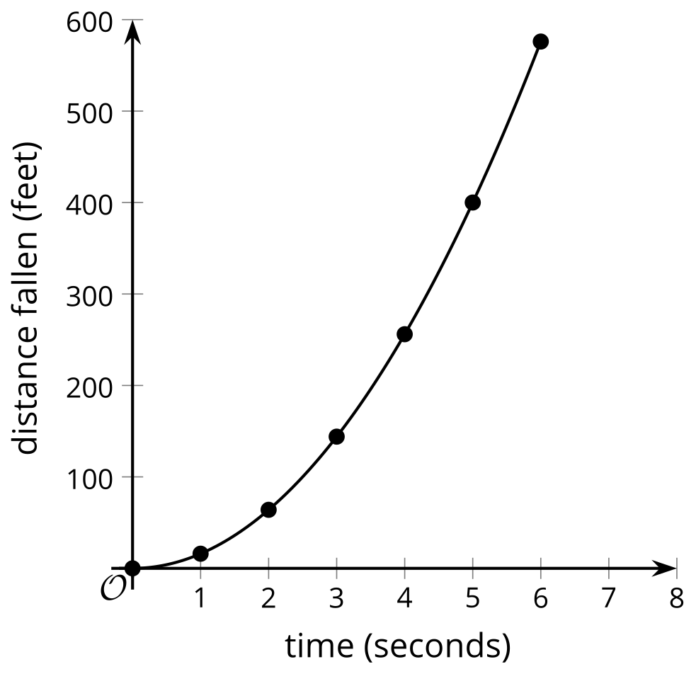
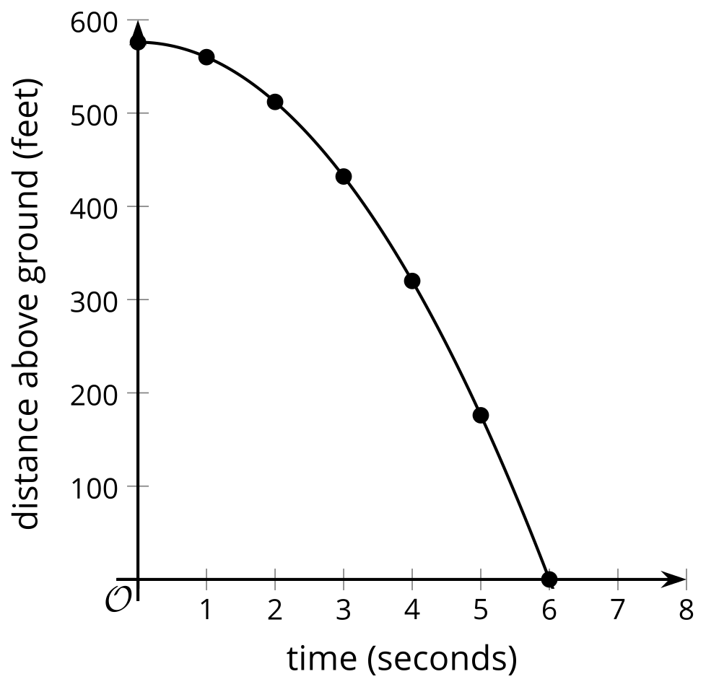
© CC BY 2019 by Illustrative Mathematics®

