Grade 2
Unit 2Lesson 12CC BY NC 2024 Illustrative Mathematics®
Unit 2, Lesson 12

Story Problems and Diagrams
- Let’s make sense of diagrams and solve story problems.
Grade 2
Unit 2Lesson 12CC BY NC 2024 Illustrative Mathematics®

Warm-upNotice and Wonder: Mancala
What do you notice? What do you wonder?
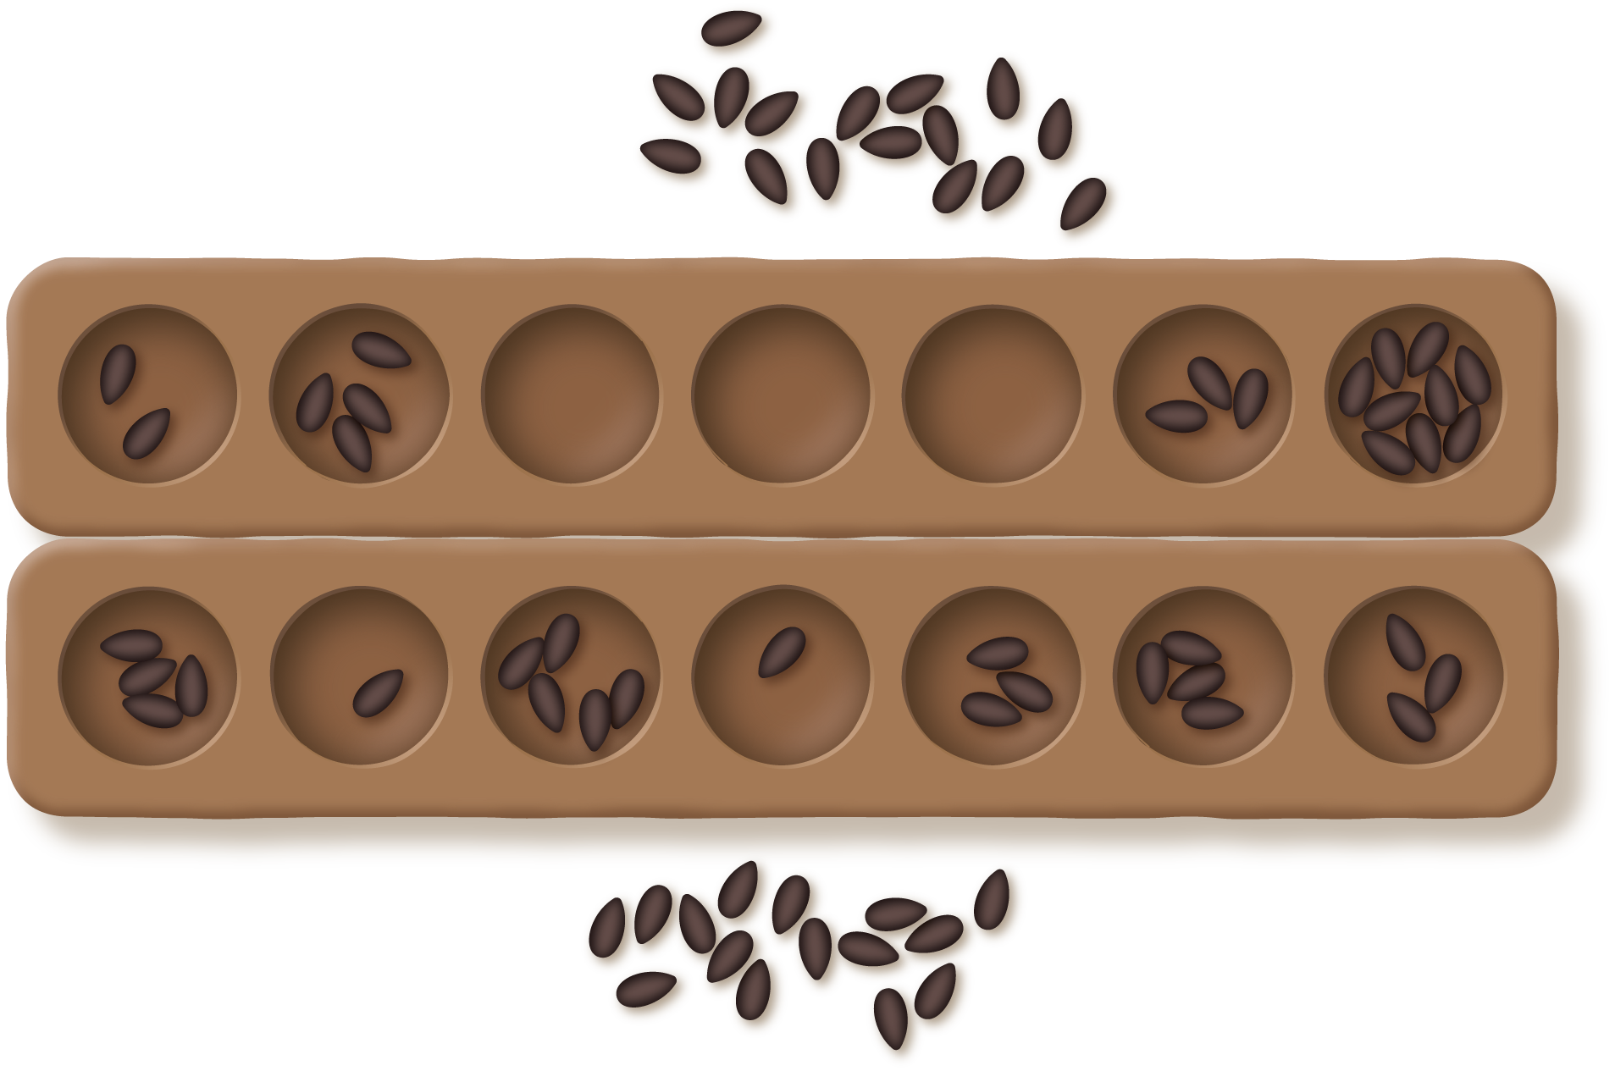
Grade 2
Unit 2Lesson 12CC BY NC 2024 Illustrative Mathematics®

Activity 1Interpret the Diagram
Circle the matching diagram for each story. Then explain your match to your partner.
- Clare captures 54 seeds. Han captures 16 fewer seeds than her. How many seeds does Han capture?
- Unable to process <img src="/tikz_files/237870.svg">Failed: rsvg-convert --format png --dpi-x 300 --dpi-y 300 /app/tmp/svgtopng-1786380763.803964.svg --output /app/tmp/svgtopng-1786380763.803964.png Backtrace: /app/app/services/script/runner.rb:34:in `block in run_cmd' <internal:kernel>:90:in `tap' /app/app/services/script/runner.rb:32:in `run_cmd' /app/app/services/script/svg_to_png.rb:27:in `convert_svg_to_png' /app/app/services/script/svg_to_png.rb:17:in `to_png' /app/vendor/bundle/ruby/3.3.0/gems/embeddable_content-1.1.0/app/services/embeddable_content/images/image_downloader.rb:37:in `png_rendered_from_svg' /app/vendor/bundle/ruby/3.3.0/gems/embeddable_content-1.1.0/app/services/embeddable_content/images/image_downloader.rb:33:in `raw_image_data' /app/vendor/bundle/ruby/3.3.0/gems/embeddable_content-1.1.0/app/services/embeddable_content/images/image_downloader.rb:13:in `block in save' <internal:kernel>:90:in `tap' /app/vendor/bundle/ruby/3.3.0/gems/embeddable_content-1.1.0/app/services/embeddable_content/images/image_downloader.rb:13:in `save'
- Unable to process <img src="/tikz_files/237871.svg">Failed: rsvg-convert --format png --dpi-x 300 --dpi-y 300 /app/tmp/svgtopng-1786380763.8566372.svg --output /app/tmp/svgtopng-1786380763.8566372.png Backtrace: /app/app/services/script/runner.rb:34:in `block in run_cmd' <internal:kernel>:90:in `tap' /app/app/services/script/runner.rb:32:in `run_cmd' /app/app/services/script/svg_to_png.rb:27:in `convert_svg_to_png' /app/app/services/script/svg_to_png.rb:17:in `to_png' /app/vendor/bundle/ruby/3.3.0/gems/embeddable_content-1.1.0/app/services/embeddable_content/images/image_downloader.rb:37:in `png_rendered_from_svg' /app/vendor/bundle/ruby/3.3.0/gems/embeddable_content-1.1.0/app/services/embeddable_content/images/image_downloader.rb:33:in `raw_image_data' /app/vendor/bundle/ruby/3.3.0/gems/embeddable_content-1.1.0/app/services/embeddable_content/images/image_downloader.rb:13:in `block in save' <internal:kernel>:90:in `tap' /app/vendor/bundle/ruby/3.3.0/gems/embeddable_content-1.1.0/app/services/embeddable_content/images/image_downloader.rb:13:in `save'
- Unable to process <img src="/tikz_files/237872.svg">Failed: rsvg-convert --format png --dpi-x 300 --dpi-y 300 /app/tmp/svgtopng-1786380763.916187.svg --output /app/tmp/svgtopng-1786380763.916187.png Backtrace: /app/app/services/script/runner.rb:34:in `block in run_cmd' <internal:kernel>:90:in `tap' /app/app/services/script/runner.rb:32:in `run_cmd' /app/app/services/script/svg_to_png.rb:27:in `convert_svg_to_png' /app/app/services/script/svg_to_png.rb:17:in `to_png' /app/vendor/bundle/ruby/3.3.0/gems/embeddable_content-1.1.0/app/services/embeddable_content/images/image_downloader.rb:37:in `png_rendered_from_svg' /app/vendor/bundle/ruby/3.3.0/gems/embeddable_content-1.1.0/app/services/embeddable_content/images/image_downloader.rb:33:in `raw_image_data' /app/vendor/bundle/ruby/3.3.0/gems/embeddable_content-1.1.0/app/services/embeddable_content/images/image_downloader.rb:13:in `block in save' <internal:kernel>:90:in `tap' /app/vendor/bundle/ruby/3.3.0/gems/embeddable_content-1.1.0/app/services/embeddable_content/images/image_downloader.rb:13:in `save'
- Clare has 54 seeds on her side of the board. Han has 16 seeds on his. How many seeds are on the board?
- Unable to process <img src="/tikz_files/237873.svg">Failed: rsvg-convert --format png --dpi-x 300 --dpi-y 300 /app/tmp/svgtopng-1786380763.9652903.svg --output /app/tmp/svgtopng-1786380763.9652903.png Backtrace: /app/app/services/script/runner.rb:34:in `block in run_cmd' <internal:kernel>:90:in `tap' /app/app/services/script/runner.rb:32:in `run_cmd' /app/app/services/script/svg_to_png.rb:27:in `convert_svg_to_png' /app/app/services/script/svg_to_png.rb:17:in `to_png' /app/vendor/bundle/ruby/3.3.0/gems/embeddable_content-1.1.0/app/services/embeddable_content/images/image_downloader.rb:37:in `png_rendered_from_svg' /app/vendor/bundle/ruby/3.3.0/gems/embeddable_content-1.1.0/app/services/embeddable_content/images/image_downloader.rb:33:in `raw_image_data' /app/vendor/bundle/ruby/3.3.0/gems/embeddable_content-1.1.0/app/services/embeddable_content/images/image_downloader.rb:13:in `block in save' <internal:kernel>:90:in `tap' /app/vendor/bundle/ruby/3.3.0/gems/embeddable_content-1.1.0/app/services/embeddable_content/images/image_downloader.rb:13:in `save' Unable to process <img src="/tikz_files/237874.svg">Failed: rsvg-convert --format png --dpi-x 300 --dpi-y 300 /app/tmp/svgtopng-1786380764.0102684.svg --output /app/tmp/svgtopng-1786380764.0102684.png Backtrace: /app/app/services/script/runner.rb:34:in `block in run_cmd' <internal:kernel>:90:in `tap' /app/app/services/script/runner.rb:32:in `run_cmd' /app/app/services/script/svg_to_png.rb:27:in `convert_svg_to_png' /app/app/services/script/svg_to_png.rb:17:in `to_png' /app/vendor/bundle/ruby/3.3.0/gems/embeddable_content-1.1.0/app/services/embeddable_content/images/image_downloader.rb:37:in `png_rendered_from_svg' /app/vendor/bundle/ruby/3.3.0/gems/embeddable_content-1.1.0/app/services/embeddable_content/images/image_downloader.rb:33:in `raw_image_data' /app/vendor/bundle/ruby/3.3.0/gems/embeddable_content-1.1.0/app/services/embeddable_content/images/image_downloader.rb:13:in `block in save' <internal:kernel>:90:in `tap' /app/vendor/bundle/ruby/3.3.0/gems/embeddable_content-1.1.0/app/services/embeddable_content/images/image_downloader.rb:13:in `save'
- Clare has 54 seeds. She holds 16 in her hand. The rest are on the game board. How many of her seeds are on the game board?
- Unable to process <img src="/tikz_files/237875.svg">Failed: rsvg-convert --format png --dpi-x 300 --dpi-y 300 /app/tmp/svgtopng-1786380764.0732586.svg --output /app/tmp/svgtopng-1786380764.0732586.png Backtrace: /app/app/services/script/runner.rb:34:in `block in run_cmd' <internal:kernel>:90:in `tap' /app/app/services/script/runner.rb:32:in `run_cmd' /app/app/services/script/svg_to_png.rb:27:in `convert_svg_to_png' /app/app/services/script/svg_to_png.rb:17:in `to_png' /app/vendor/bundle/ruby/3.3.0/gems/embeddable_content-1.1.0/app/services/embeddable_content/images/image_downloader.rb:37:in `png_rendered_from_svg' /app/vendor/bundle/ruby/3.3.0/gems/embeddable_content-1.1.0/app/services/embeddable_content/images/image_downloader.rb:33:in `raw_image_data' /app/vendor/bundle/ruby/3.3.0/gems/embeddable_content-1.1.0/app/services/embeddable_content/images/image_downloader.rb:13:in `block in save' <internal:kernel>:90:in `tap' /app/vendor/bundle/ruby/3.3.0/gems/embeddable_content-1.1.0/app/services/embeddable_content/images/image_downloader.rb:13:in `save' Unable to process <img src="/tikz_files/237876.svg">Failed: rsvg-convert --format png --dpi-x 300 --dpi-y 300 /app/tmp/svgtopng-1786380764.1309369.svg --output /app/tmp/svgtopng-1786380764.1309369.png Backtrace: /app/app/services/script/runner.rb:34:in `block in run_cmd' <internal:kernel>:90:in `tap' /app/app/services/script/runner.rb:32:in `run_cmd' /app/app/services/script/svg_to_png.rb:27:in `convert_svg_to_png' /app/app/services/script/svg_to_png.rb:17:in `to_png' /app/vendor/bundle/ruby/3.3.0/gems/embeddable_content-1.1.0/app/services/embeddable_content/images/image_downloader.rb:37:in `png_rendered_from_svg' /app/vendor/bundle/ruby/3.3.0/gems/embeddable_content-1.1.0/app/services/embeddable_content/images/image_downloader.rb:33:in `raw_image_data' /app/vendor/bundle/ruby/3.3.0/gems/embeddable_content-1.1.0/app/services/embeddable_content/images/image_downloader.rb:13:in `block in save' <internal:kernel>:90:in `tap' /app/vendor/bundle/ruby/3.3.0/gems/embeddable_content-1.1.0/app/services/embeddable_content/images/image_downloader.rb:13:in `save' Unable to process <img src="/tikz_files/237877.svg">Failed: rsvg-convert --format png --dpi-x 300 --dpi-y 300 /app/tmp/svgtopng-1786380764.1910412.svg --output /app/tmp/svgtopng-1786380764.1910412.png Backtrace: /app/app/services/script/runner.rb:34:in `block in run_cmd' <internal:kernel>:90:in `tap' /app/app/services/script/runner.rb:32:in `run_cmd' /app/app/services/script/svg_to_png.rb:27:in `convert_svg_to_png' /app/app/services/script/svg_to_png.rb:17:in `to_png' /app/vendor/bundle/ruby/3.3.0/gems/embeddable_content-1.1.0/app/services/embeddable_content/images/image_downloader.rb:37:in `png_rendered_from_svg' /app/vendor/bundle/ruby/3.3.0/gems/embeddable_content-1.1.0/app/services/embeddable_content/images/image_downloader.rb:33:in `raw_image_data' /app/vendor/bundle/ruby/3.3.0/gems/embeddable_content-1.1.0/app/services/embeddable_content/images/image_downloader.rb:13:in `block in save' <internal:kernel>:90:in `tap' /app/vendor/bundle/ruby/3.3.0/gems/embeddable_content-1.1.0/app/services/embeddable_content/images/image_downloader.rb:13:in `save'
- There are 54 seeds on the game board. Some seeds are on Han’s side. 16 seeds are on Clare’s side. How many seeds are on Han’s side?
- Choose the 2 matching diagrams.
- Unable to process <img src="/tikz_files/237878.svg">Failed: rsvg-convert --format png --dpi-x 300 --dpi-y 300 /app/tmp/svgtopng-1786380764.2516117.svg --output /app/tmp/svgtopng-1786380764.2516117.png Backtrace: /app/app/services/script/runner.rb:34:in `block in run_cmd' <internal:kernel>:90:in `tap' /app/app/services/script/runner.rb:32:in `run_cmd' /app/app/services/script/svg_to_png.rb:27:in `convert_svg_to_png' /app/app/services/script/svg_to_png.rb:17:in `to_png' /app/vendor/bundle/ruby/3.3.0/gems/embeddable_content-1.1.0/app/services/embeddable_content/images/image_downloader.rb:37:in `png_rendered_from_svg' /app/vendor/bundle/ruby/3.3.0/gems/embeddable_content-1.1.0/app/services/embeddable_content/images/image_downloader.rb:33:in `raw_image_data' /app/vendor/bundle/ruby/3.3.0/gems/embeddable_content-1.1.0/app/services/embeddable_content/images/image_downloader.rb:13:in `block in save' <internal:kernel>:90:in `tap' /app/vendor/bundle/ruby/3.3.0/gems/embeddable_content-1.1.0/app/services/embeddable_content/images/image_downloader.rb:13:in `save'
- Unable to process <img src="/tikz_files/237879.svg">Failed: rsvg-convert --format png --dpi-x 300 --dpi-y 300 /app/tmp/svgtopng-1786380764.325428.svg --output /app/tmp/svgtopng-1786380764.325428.png Backtrace: /app/app/services/script/runner.rb:34:in `block in run_cmd' <internal:kernel>:90:in `tap' /app/app/services/script/runner.rb:32:in `run_cmd' /app/app/services/script/svg_to_png.rb:27:in `convert_svg_to_png' /app/app/services/script/svg_to_png.rb:17:in `to_png' /app/vendor/bundle/ruby/3.3.0/gems/embeddable_content-1.1.0/app/services/embeddable_content/images/image_downloader.rb:37:in `png_rendered_from_svg' /app/vendor/bundle/ruby/3.3.0/gems/embeddable_content-1.1.0/app/services/embeddable_content/images/image_downloader.rb:33:in `raw_image_data' /app/vendor/bundle/ruby/3.3.0/gems/embeddable_content-1.1.0/app/services/embeddable_content/images/image_downloader.rb:13:in `block in save' <internal:kernel>:90:in `tap' /app/vendor/bundle/ruby/3.3.0/gems/embeddable_content-1.1.0/app/services/embeddable_content/images/image_downloader.rb:13:in `save'
- Unable to process <img src="/tikz_files/237880.svg">Failed: rsvg-convert --format png --dpi-x 300 --dpi-y 300 /app/tmp/svgtopng-1786380764.4248185.svg --output /app/tmp/svgtopng-1786380764.4248185.png Backtrace: /app/app/services/script/runner.rb:34:in `block in run_cmd' <internal:kernel>:90:in `tap' /app/app/services/script/runner.rb:32:in `run_cmd' /app/app/services/script/svg_to_png.rb:27:in `convert_svg_to_png' /app/app/services/script/svg_to_png.rb:17:in `to_png' /app/vendor/bundle/ruby/3.3.0/gems/embeddable_content-1.1.0/app/services/embeddable_content/images/image_downloader.rb:37:in `png_rendered_from_svg' /app/vendor/bundle/ruby/3.3.0/gems/embeddable_content-1.1.0/app/services/embeddable_content/images/image_downloader.rb:33:in `raw_image_data' /app/vendor/bundle/ruby/3.3.0/gems/embeddable_content-1.1.0/app/services/embeddable_content/images/image_downloader.rb:13:in `block in save' <internal:kernel>:90:in `tap' /app/vendor/bundle/ruby/3.3.0/gems/embeddable_content-1.1.0/app/services/embeddable_content/images/image_downloader.rb:13:in `save' Unable to process <img src="/tikz_files/237881.svg">Failed: rsvg-convert --format png --dpi-x 300 --dpi-y 300 /app/tmp/svgtopng-1786380764.5549722.svg --output /app/tmp/svgtopng-1786380764.5549722.png Backtrace: /app/app/services/script/runner.rb:34:in `block in run_cmd' <internal:kernel>:90:in `tap' /app/app/services/script/runner.rb:32:in `run_cmd' /app/app/services/script/svg_to_png.rb:27:in `convert_svg_to_png' /app/app/services/script/svg_to_png.rb:17:in `to_png' /app/vendor/bundle/ruby/3.3.0/gems/embeddable_content-1.1.0/app/services/embeddable_content/images/image_downloader.rb:37:in `png_rendered_from_svg' /app/vendor/bundle/ruby/3.3.0/gems/embeddable_content-1.1.0/app/services/embeddable_content/images/image_downloader.rb:33:in `raw_image_data' /app/vendor/bundle/ruby/3.3.0/gems/embeddable_content-1.1.0/app/services/embeddable_content/images/image_downloader.rb:13:in `block in save' <internal:kernel>:90:in `tap' /app/vendor/bundle/ruby/3.3.0/gems/embeddable_content-1.1.0/app/services/embeddable_content/images/image_downloader.rb:13:in `save'
Grade 2
Unit 2Lesson 12CC BY NC 2024 Illustrative Mathematics®

Activity 2Card Sort: Story Problems and Diagrams
Your teacher will give you a set of cards that show story problems and diagrams.
- Match each story problem to a diagram. Be ready to explain your reasoning.
- Choose 2 story problems. Solve them. Show your thinking using drawings, numbers, or words.

