Grade 6
Unit 4Lesson 12CC BY NC Illustrative Mathematics, based on IM 6–8 Math, CC BY Open Up Resources.
Unit 4, Lesson 12

Fractional Lengths
Let’s solve problems about fractional lengths.
Grade 6
Unit 4Lesson 12CC BY NC Illustrative Mathematics, based on IM 6–8 Math, CC BY Open Up Resources.

12.1Which Three Go Together: Working with $\frac{3}{4}$
Which three go together? Why do they go together?
- A string that is $\frac{3}{4}$ meter long is cut into 15 equal pieces. How long is each piece?
- $?⋅\frac{3}{4}=15$
- A driver drove $\frac{3}{4}$ km from home to a gas station and then drove 15 times as far to go to work. What is the distance between the gas station and his work?
- Mai built a tower that is 21 inches tall by stacking $\frac{3}{4}$-inch tall cubes. How many cubes did she use?
Grade 6
Unit 4Lesson 12CC BY NC Illustrative Mathematics, based on IM 6–8 Math, CC BY Open Up Resources.

12.2Info Gap: How Many Would It Take?
Your teacher will give you either a problem card or a data card. Do not show or read your card to your partner.
If your teacher gives you the problem card:
- Silently read your card, and think about what information you need to answer the question.
- Ask your partner for the specific information that you need. “Can you tell me $\underset{_}{​}$?”
- Explain to your partner how you are using the information to solve the problem. “I need to know $\underset{_}{​}$ because . . . .”
Continue to ask questions until you have enough information to solve the problem.
- Once you have enough information, share the problem card with your partner, and solve the problem independently.
- Read the data card, and discuss your reasoning.
If your teacher gives you the data card:
- Silently read your card. Wait for your partner to ask for information.
- Before telling your partner any information, ask, “Why do you need to know $\underset{_}{​}$?”
- Listen to your partner’s reasoning and ask clarifying questions. Only give information that is on your card. Do not figure out anything for your partner!
These steps may be repeated.
- Once your partner says there is enough information to solve the problem, read the problem card, and solve the problem independently.
- Share the data card, and discuss your reasoning.

Are you ready for more?
Lin has a work of art that is $14$ inches by $20$ inches. She wants to frame it with large paper clips laid end to end.
- If each paper clip is $1\frac{3}{4}$ inch long, how many paper clips would she need? Show your reasoning and be sure to think about potential gaps and overlaps. Consider making a sketch that shows how the paper clips could be arranged.
- How many paper clips are needed if the paper clips are spaced $\frac{1}{4}$ inch apart? Describe the arrangement of the paper clips at the corners of the frame.
Grade 6
Unit 4Lesson 12CC BY NC Illustrative Mathematics, based on IM 6–8 Math, CC BY Open Up Resources.

12.3How Many Times as Tall or as Far?
Write a division expression that can help answer each question. Then find the answer and show your reasoning. You can draw a tape diagram if you find it helpful.
- A young giraffe is 4 meters tall. An adult giraffe is $5\frac{2}{3}$ meters tall.
  - How many times as tall as the young giraffe is the adult giraffe?
  - What fraction of the adult giraffe’s height is the young giraffe’s height?

  - A runner ran $1\frac{4}{5}$ miles on Monday and $6\frac{3}{10}$ miles on Tuesday. How many times her Monday’s distance was her Tuesday’s distance?
  - A cyclist planned to ride $9\frac{1}{2}$ miles but only managed to travel $3\frac{7}{8}$ miles. What fraction of his planned trip did he travel?
Grade 6
Unit 4Lesson 12CC BY NC Illustrative Mathematics, based on IM 6–8 Math, CC BY Open Up Resources.

12.4Comparing Paper Rolls
The photo shows a situation that involves fractions.
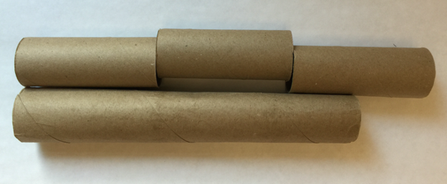
- Complete the sentences. Be prepared to explain your reasoning.
  - The length of the long tube is about $\underset{_}{​}$ times the length of a short tube.
  - The length of a short tube is about $\underset{_}{​}$ times the length of the long tube.
- If the length of the long paper roll is $11\frac{1}{4}$ inches, what is the length of each short paper roll?

Lesson 12 Summary
Division can help us solve comparison problems in which we find out how many times as large or as small one number is compared to another. For example, a student is playing two songs for a music recital. The first song is $1\frac{1}{2}$ minutes long. The second song is $3\frac{3}{4}$ minutes long.
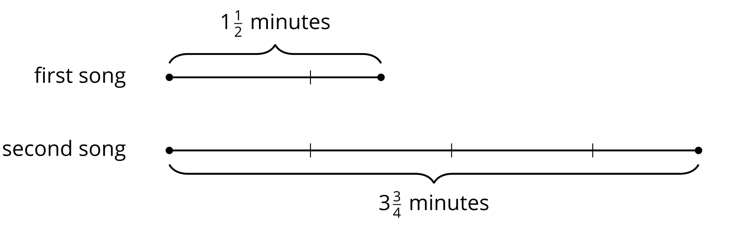
We can ask two different comparison questions and write different multiplication and division equations to represent each question.
- How many times as long as the first song is the second song?
$?⋅1\frac{1}{2}=3\frac{3}{4}$
$3\frac{3}{4}÷1\frac{1}{2}=?$
- What fraction of the second song is the first song?
$?⋅3\frac{3}{4}=1\frac{1}{2}$
$1\frac{1}{2}÷3\frac{3}{4}=?$
We can use the algorithm we learned to calculate the quotients.
$\begin{matrix} & =\frac{15}{4}÷\frac{3}{2} \\ & =\frac{15}{4}⋅\frac{2}{3} \\ & =\frac{30}{12} \\ & =\frac{5}{2}\end{matrix}$
This means the second song is $2\frac{1}{2}$ times as long as the first song.
$\begin{matrix} & =\frac{3}{2}÷\frac{15}{4} \\ & =\frac{3}{2}⋅\frac{4}{15} \\ & =\frac{12}{30} \\ & =\frac{2}{5}\end{matrix}$
This means the first song is $\frac{2}{5}$ as long as the second song.

