Unit 7 Lesson 9: Describing Large and Small Numbers Using Powers of 10

1 Thousand Million Billion Trillion (Warm up)

Student Task Statement
- Match each expression with its corresponding value and word.
- expression
- ${10}^{\text{-}3}$
- ${10}^{6}$
- ${10}^{9}$
- ${10}^{\text{-}2}$
- ${10}^{12}$
- ${10}^{3}$

- value
- 1,000,000,000,000
- $\frac{1}{100}$
- 1,000
- 1,000,000,000
- 1,000,000
- $\frac{1}{1,000}$

- word
- billion
- milli-
- million
- thousand
- centi-
- trillion
- For each of the numbers, think of something in the world that is described by that number.

2 Base-ten Representations Matching

Images for Launch
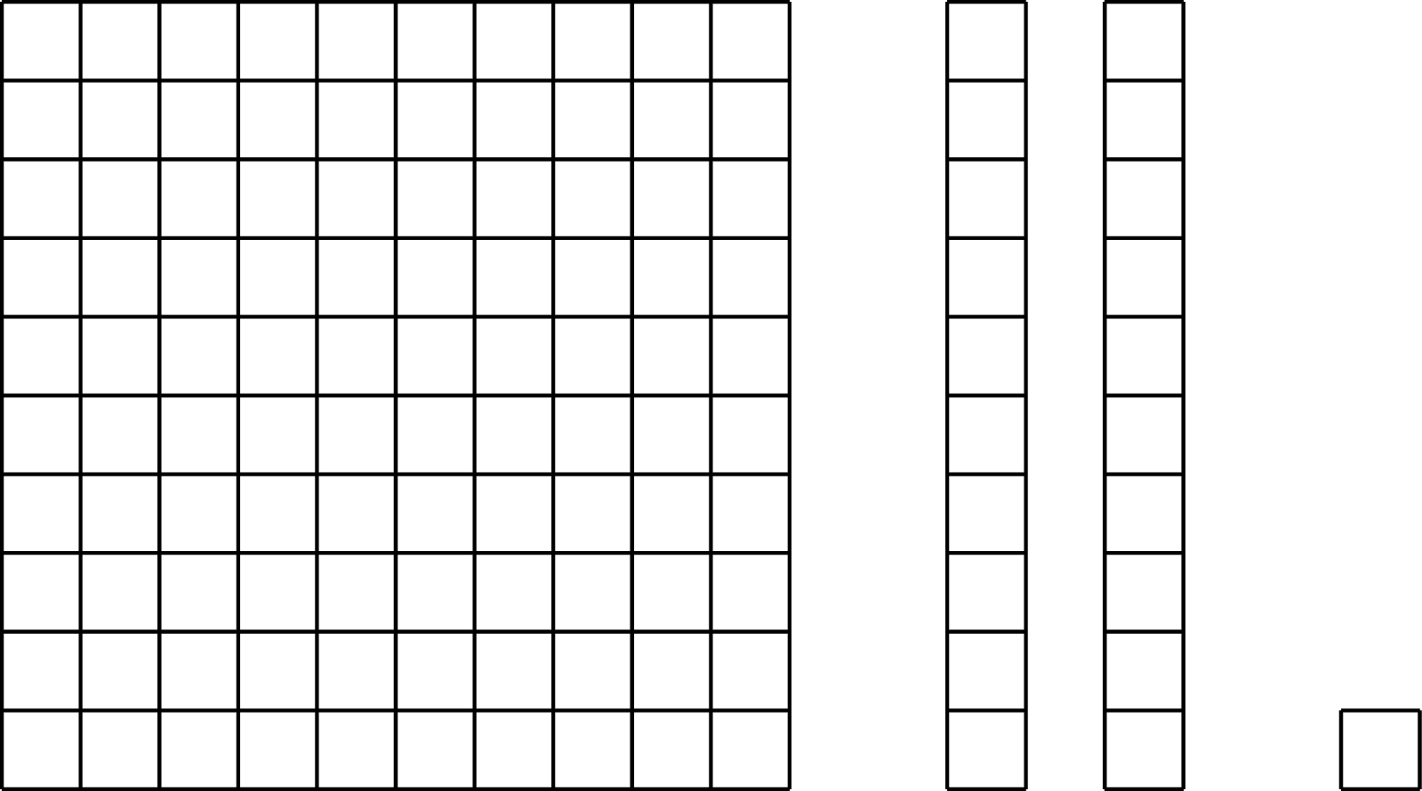

Student Task Statement
- Match each expression to one or more diagrams that could represent it. For each match, explain what the value of a single small square would have to be.
  - $2⋅{10}^{\text{-}1}+4⋅{10}^{\text{-}2}$
  - $2⋅{10}^{\text{-}1}+4⋅{10}^{\text{-}3}$
  - $2⋅{10}^{3}+4⋅{10}^{1}$
  - $2⋅{10}^{3}+4⋅{10}^{2}$
- 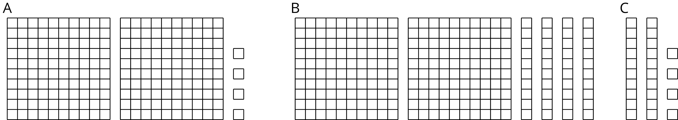

  - Write an expression to describe the base-ten diagram if each small square represents ${10}^{\text{-}4}$. What is the value of this expression?
  - 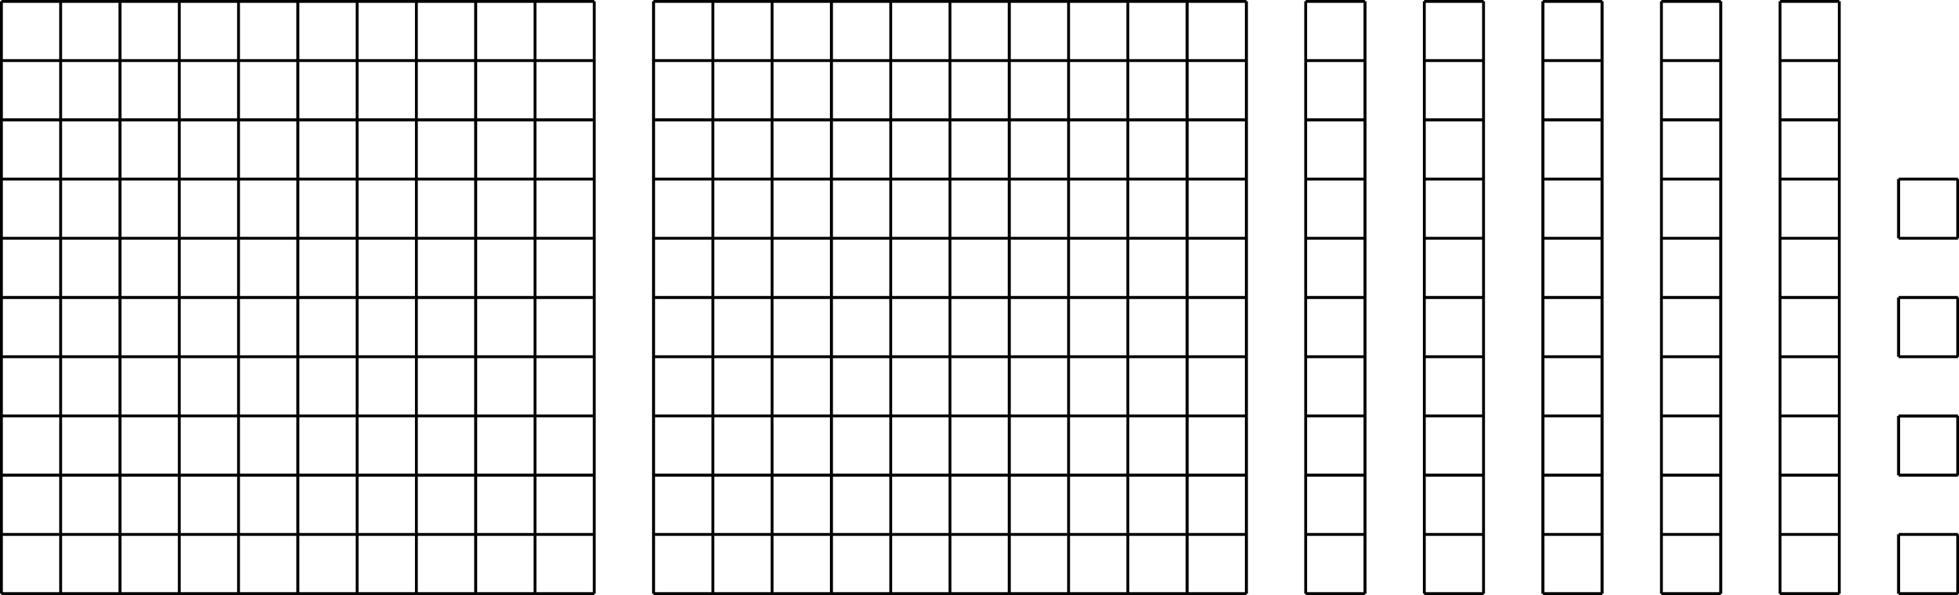
  - How does changing the value of the small square change the value of the expression? Explain or show your thinking.
  - Select at least two different powers of 10 for the small square, and write the corresponding expressions to describe the base-ten diagram. What is the value of each of your expressions?

3 Using Powers of 10 to Describe Large and Small Numbers

Student Task Statement
Your teacher will give you a card that tells you whether you are Partner A or B and gives you the information that is missing from your partner’s statements. Do not show your card to your partner.
Read each statement assigned to you, ask your partner for the missing information, and write the number your partner tells you.
Partner A’s statements:
- Around the world, about ______________________ pencils are made each year.
- The mass of a proton is ______________________ kilograms.
- The population of Russia is about ______________________ people.
- The diameter of a bacteria cell is about ______________________ meter.
Partner B’s statements:
- Light waves travel through space at a speed of ______________________ meters per second.
- The population of India is about ______________________ people.
- The wavelength of a gamma ray is _______________________ meters.
- The tardigrade (water bear) is ______________ meters long.
© CC BY Open Up Resources. Adaptations CC BY IM.

