Algebra 1
Unit 4Lesson 5CC BY NC 2024 Illustrative Mathematics®
Unit 4, Lesson 5

Graphing Linear Inequalities in Two Variables (Part 2)
- Let’s write inequalities in two variables and make sense of the solutions by reasoning and by graphing.
Algebra 1
Unit 4Lesson 5CC BY NC 2024 Illustrative Mathematics®

5.1Landscaping Options
A homeowner is making plans to landscape her yard. She plans to hire professionals to install grass sod in some parts of the yard and flower beds in other parts.
Grass sod installation costs $2 per square foot, and flower bed installation costs $12 per square foot. Her budget for the project is $3,000.

- Write an equation that represents the square feet of grass sod, $x$, and the square feet of flower beds, $y$, that she could afford if she used her entire budget.
- On the coordinate plane, sketch a graph that represents your equation. Be prepared to explain your reasoning.
- 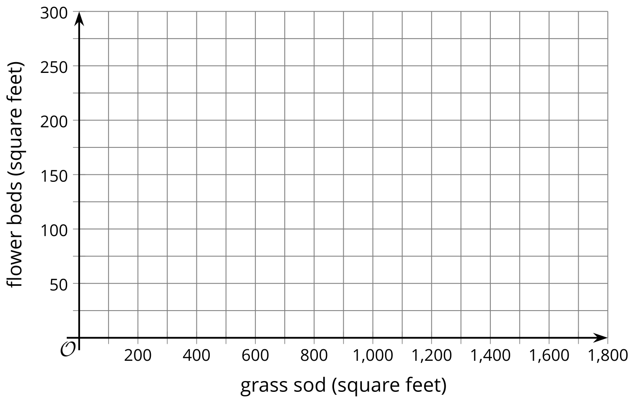
Algebra 1
Unit 4Lesson 5CC BY NC 2024 Illustrative Mathematics®

5.2Rethinking Landscaping
The homeowner is worried about the work needed to maintain a grass lawn and flower beds, so she is now looking at some low-maintenance materials.
She is considering artificial turf, which costs $15 per square foot to install, and gravel, which costs $3 per square foot. She may use a combination of the two materials in different parts of the yard. Her budget is still $3,000.
Here is a graph representing some constraints in this situation.
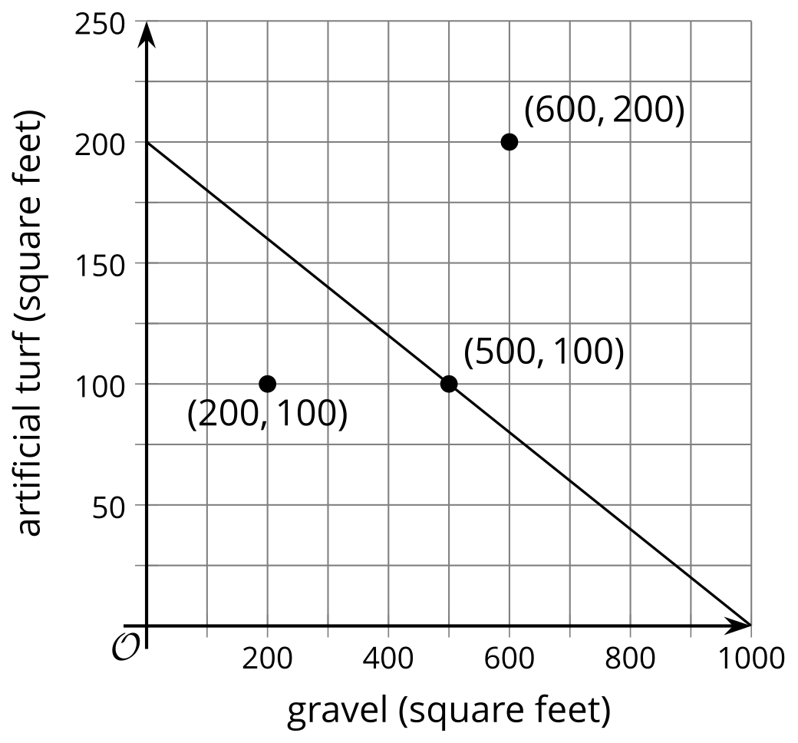
- The graph shows a line going through $\left(500,100\right)$.
  - In this situation, what does the point $\left(500,100\right)$ mean?
  - Write an equation that the line represents.
  - What do the solutions to the equation mean?
- The point $\left(600,200\right)$ is located to the right and above the line.
  - Does that combination of turf and gravel meet the homeowner’s constraints? Explain or show your reasoning.
  - Choose another point in the same region (to the right and above the line). Check if the combination meets the homeowner’s constraints.
- The point $\left(200,100\right)$ is located to the left and below the line.
  - Does that combination of turf and gravel meet the homeowner’s constraints? Explain or show your reasoning.
  - Choose another point in the same region (to the left and below the line). Check if the combination meets the homeowner’s constraints.
- Write an inequality that represents the constraints in this situation. Explain what the solutions mean, and show the solution region on the graph.
Algebra 1
Unit 4Lesson 5CC BY NC 2024 Illustrative Mathematics®

5.3The Saturday Market
A vendor at the Saturday Market makes $9 profit on each necklace she sells and $5 profit on each bracelet.
- Find a combination of necklaces and bracelets that she could sell in order to make:
  - exactly $100 profit
  - more than $100 profit
- Write an equation whose solution is the combination of necklaces and bracelets she could sell to make exactly $100 profit.
- Write an inequality whose solutions are the combinations of necklaces and bracelets she could sell to make more than $100 profit.
- Graph the solutions to your inequality.
- 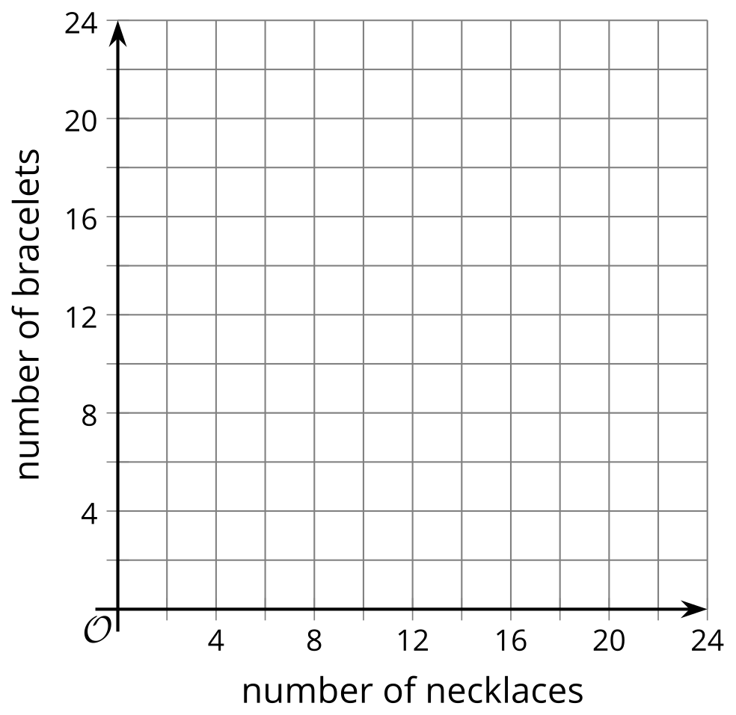
- Is $\left(3,18.6\right)$ a solution to the inequality? Explain your reasoning.

Are you ready for more?
- Write an inequality using two variables $x$ and $y$ where the solution would be represented by shading the entire coordinate plane.
- Write an inequality using two variables $x$ and $y$ where the solution would be represented by not shading any of the coordinate plane.
Algebra 1
Unit 4Lesson 5CC BY NC 2024 Illustrative Mathematics®

5.4Charity Concerts
A popular band is trying to raise at least $20,000 for charity by holding multiple concerts at a park. It plans to sell tickets at $25 each. For each 2-hour concert, the band would need to pay the park $1,250 in fees for security, cleaning, and traffic services.
The band needs to find the combinations of number of tickets sold, $t$, and number of concerts held, $c$, that would allow it to reach its fundraising goal.
- Write an inequality to represent the constraints in this situation.
- Graph the solutions to the inequality on the coordinate plane.
- 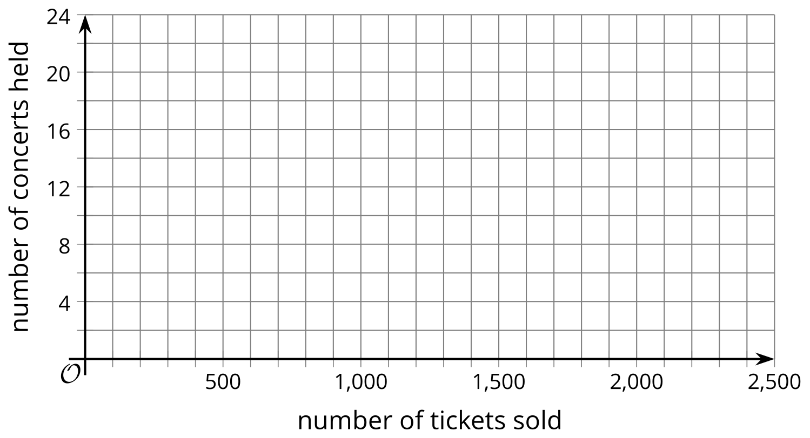
- Name two possible combinations of number of tickets sold and number of concerts held that would allow the band to meet its goal.
- Which combination of tickets and concerts would mean more money for charity:
  - 1,300 tickets and 10 concerts, or 1,300 tickets and 5 concerts?
  - 1,600 tickets and 16 concerts, or 1,200 tickets and 9 concerts?
  - 2,000 tickets and 4 concerts, or 2,500 tickets and 10 concerts?

Lesson 5 Summary
Inequalities in two variables can represent constraints in real-life situations. Graphing their solutions can enable us to solve problems.
Suppose a café is purchasing coffee and tea from a supplier and can spend up to $1,000. Coffee beans cost $12 per kilogram, and tea leaves cost $8 per kilogram.
Buying $c$ kilograms of coffee beans and $t$ kilograms of tea leaves will therefore cost $12c+8t$. To represent the budget constraints, we can write: $12c+8t≤1,​000$.
The solution to this inequality is any pair of $c$ and $t$ that makes the inequality true. In this situation, it is any combination of the kilograms of coffee and tea that the café can order without going over the $1,000 budget.
We can try different pairs of $c$ and $t$ to see what combinations satisfy the constraint, but it would be difficult to capture all the possible combinations this way. Instead, we can graph a related equation, $12c+8t=1,​000$, and then find out which region represents all possible solutions.
Here is the graph of that equation.
To determine the solution region, let’s take one point on the line and one point on each side of the line, and see if the pairs of values produce true statements.
A point on the line: $\left(30,80\right)$
$\begin{matrix}12\left(30\right)+8\left(80\right)≤1,​000 \\ 360+640≤1,​000 \\ 1,​000≤1,​000\end{matrix}$
This is true.
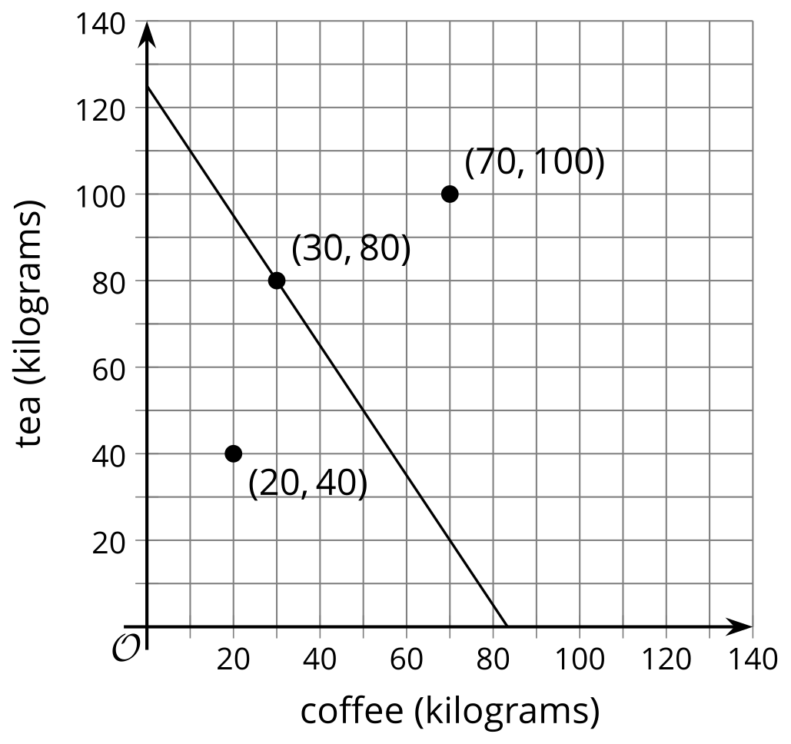
A point below the line: $\left(20,40\right)$
$\begin{matrix}12\left(20\right)+8\left(40\right)≤1,​000 \\ 240+320≤1,​000 \\ 560≤1,​000\end{matrix}$
This is true.
A point above the line: $\left(70,100\right)$
$\begin{matrix}12\left(70\right)+8\left(100\right)≤1,​000 \\ 840+800≤1,​000 \\ 1,​640≤1,​000\end{matrix}$
This is false.
The points on the line and in the region below the line are solutions to the inequality. Let's shade the solution region.
It is easy to read solutions from the graph. For example, without any computation, we can tell that $\left(50,20\right)$ is a solution because it falls in the shaded region. If the café orders 50 kilograms of coffee and 20 kilograms of tea, the cost will be less than $1,000.



