Grade 6
Unit 4Lesson 9CC BY NC Illustrative Mathematics, based on IM 6–8 Math, CC BY Open Up Resources.
Unit 4, Lesson 9

How Much in Each Group? (Part 2)
Let’s practice dividing fractions in different situations.
Grade 6
Unit 4Lesson 9CC BY NC Illustrative Mathematics, based on IM 6–8 Math, CC BY Open Up Resources.

9.1Math Talk: Greater Than 1 or Less Than 1?
Decide mentally whether the value of each expression is greater than 1 or less than 1.
- $\frac{1}{2}÷\frac{1}{4}$
- $1÷\frac{3}{4}$
- $\frac{2}{3}÷\frac{7}{8}$
- $2\frac{7}{8}÷2\frac{3}{5}$
Grade 6
Unit 4Lesson 9CC BY NC Illustrative Mathematics, based on IM 6–8 Math, CC BY Open Up Resources.

9.2Two Water Containers
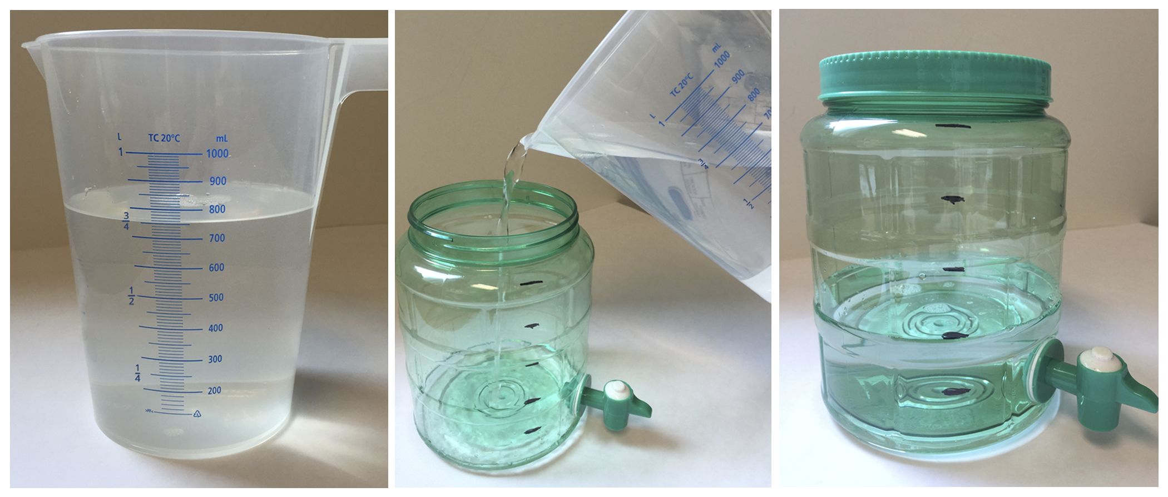
- After looking at these pictures, Lin says, “I see the fraction $\frac{2}{5}$.” Jada says, “I see the fraction $\frac{3}{4}$.” What quantities are Lin and Jada referring to?
- How many liters of water fit in the water dispenser? Show or explain your reasoning. If you get stuck, consider drawing a diagram.
- To represent the question, Lin writes $\frac{2}{5}⋅?=\frac{3}{4}$. Explain why this equation represents the question and the situation.
- Write a division equation that represents the question.
Grade 6
Unit 4Lesson 9CC BY NC Illustrative Mathematics, based on IM 6–8 Math, CC BY Open Up Resources.

9.3Amount in One Group
For each situation you choose:
- Answer the question and show your reasoning. You can draw a tape diagram if you find it helpful.
- Write a multiplication equation and a division equation to represent the question.
- Jada bought $3\frac{1}{2}$ yards of fabric for $21. How much did each yard cost?
- $\frac{4}{9}$ kilogram of baking soda costs $2. How much does 1 kilogram of baking soda cost?
- Diego can fill $1\frac{1}{5}$ bottles with 3 liters of water. How many liters of water fill 1 bottle?
- $\frac{5}{4}$ gallons of water fill $\frac{5}{6}$ of a bucket. How many gallons of water fill the entire bucket?

Are you ready for more?
In 2016, Mother India’s Crochet Queens broke the world record by creating the largest crochet blanket. The blanket measured about 120,000 square feet. It was composed of squares that are approximately 40 inches in side lengths, made by over 1,000 participants. The giant blanket was later divided into smaller blankets and donated to charity.
What fraction of the giant blanket is a single blanket square? Show your reasoning.
Grade 6
Unit 4Lesson 9CC BY NC Illustrative Mathematics, based on IM 6–8 Math, CC BY Open Up Resources.

9.4Inventing Another Situation
- Think of a situation with a question that can be represented by $\frac{1}{3}÷\frac{1}{4}=?$. Describe the situation and the question.
- Trade descriptions with a partner.
  - Review each other’s description and discuss whether each question matches the equation.
  - Revise your description based on the feedback from your partner.
- Find the answer to your question. Explain or show your reasoning. If you get stuck, consider drawing a diagram.

Lesson 9 Summary
Sometimes we have to think carefully about how to solve a problem that involves multiplication and division. Diagrams and equations can help us.
For example, $\frac{3}{4}$ of a pound of rice fills $\frac{2}{5}$ of a container. There are two whole amounts to keep track of here: 1 whole pound and 1 whole container. The equations we write and the diagram we draw depend on what question we are trying to answer.
- How many pounds fill 1 container?
- $\frac{2}{5}⋅?=\frac{3}{4}$
- $\frac{3}{4}÷\frac{2}{5}=?$
- 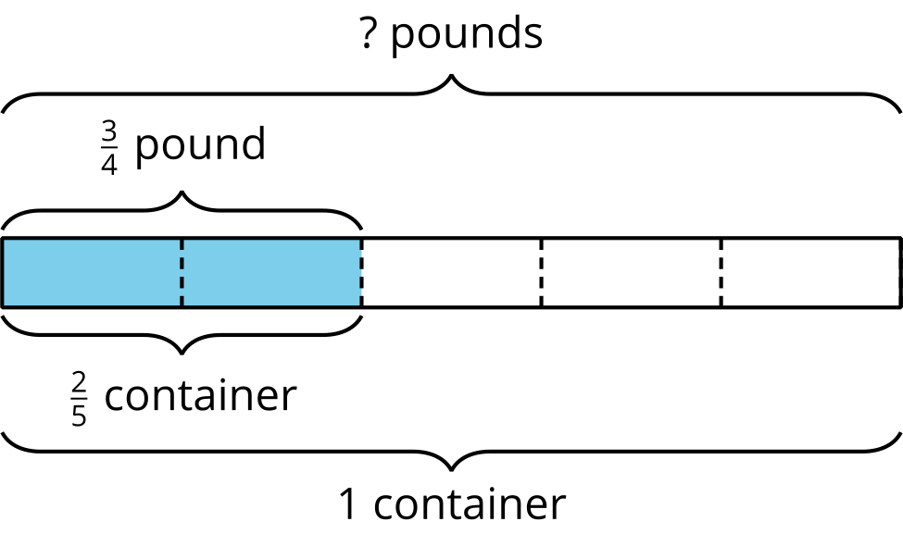
- If $\frac{2}{5}$ of a container is filled with $\frac{3}{4}$ pound, then $\frac{1}{5}$ of a container is filled with half of $\frac{3}{4}$, or $\frac{3}{8}$, pound. One whole container then has $5⋅\frac{3}{8}$ (or $\frac{15}{8}$) pounds.
- What fraction of a container does 1 pound fill?
- $\frac{3}{4}⋅?=\frac{2}{5}$
- $\frac{2}{5}÷\frac{3}{4}=?$
- 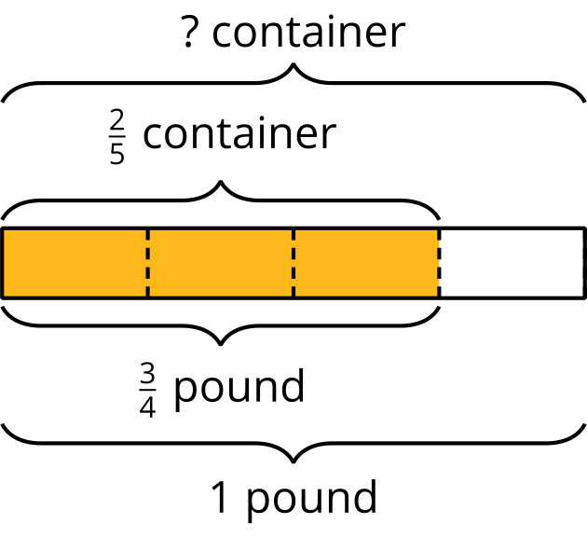
- If $\frac{3}{4}$ pound fills $\frac{2}{5}$ of a container, then $\frac{1}{4}$ pound fills a third of $\frac{2}{5}$, or $\frac{2}{15}$, of a container. One whole pound then fills $4⋅\frac{2}{15}$ (or $\frac{8}{15}$) of a container.

